UDP

[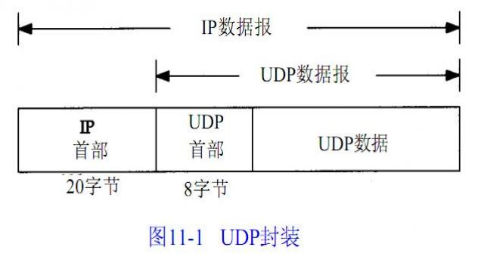](https://www.stmcu.org.cn/article/media/download/id-332570)[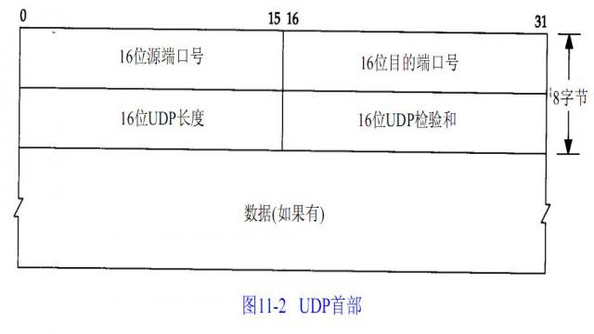](https://www.stmcu.org.cn/article/media/download/id-332565)

[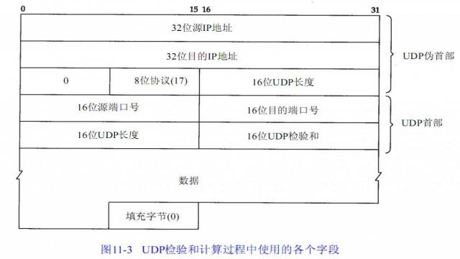](https://www.stmcu.org.cn/article/media/download/id-332566)

参考资料：

<https://www.stmcu.org.cn/article/id-328073>