Sean Summers Assignment 4.2 April 14, 2026
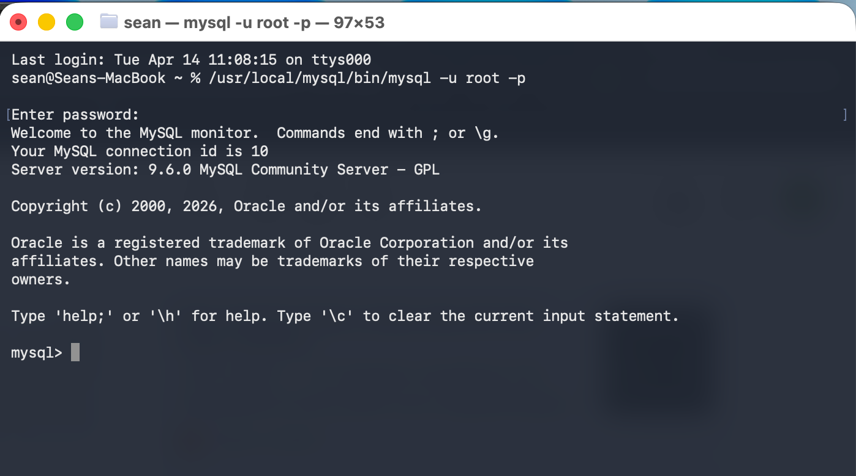
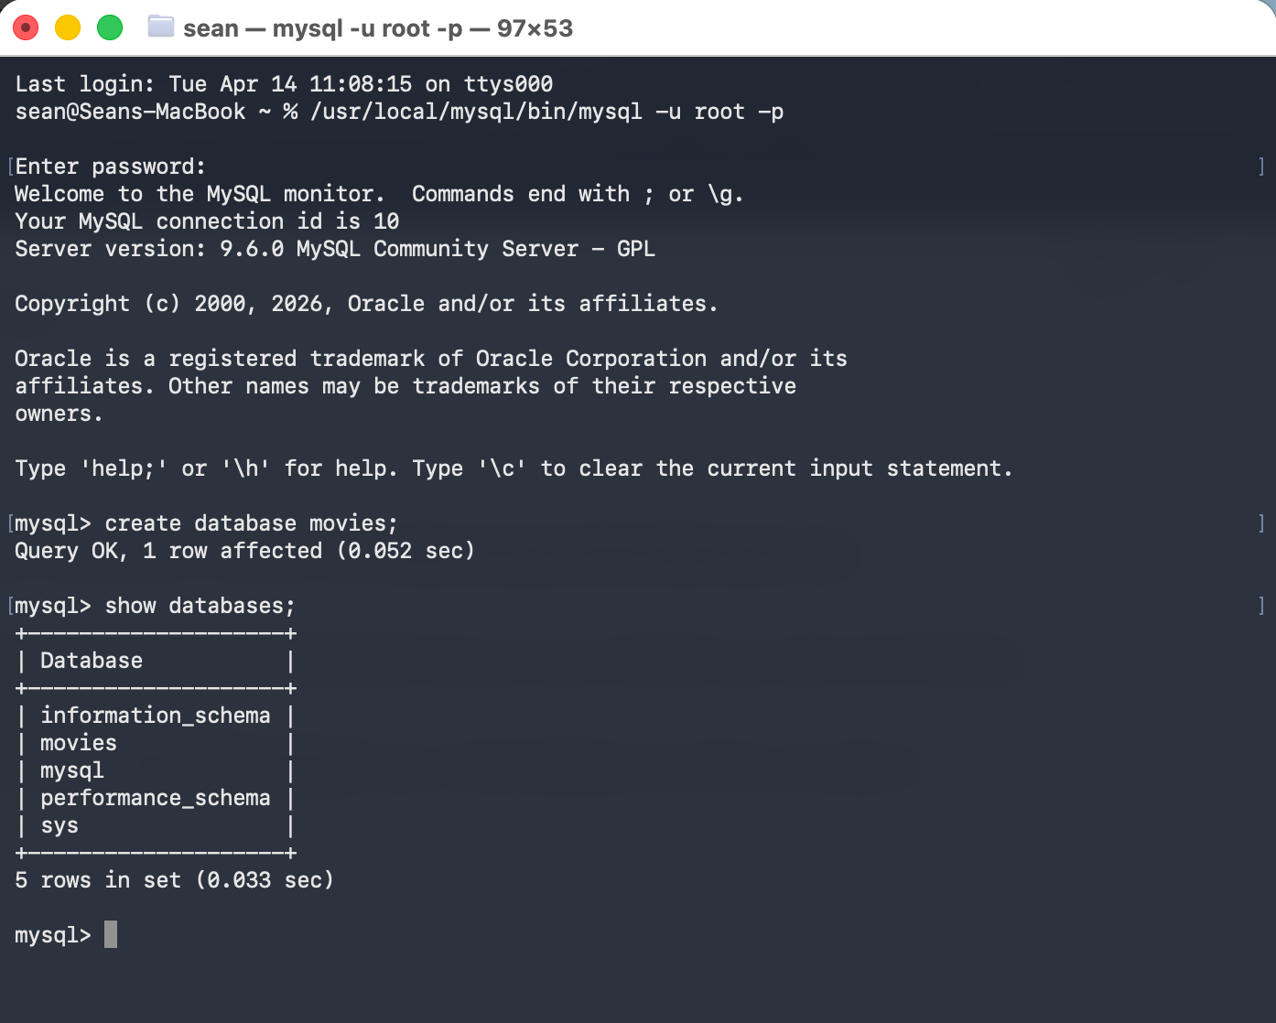
The first function I chose to experiment with is the USER() function. This function returns the current user name and host name for the MySQL connection. An example of when this might be a useful function to use is if you want to create a log of the connections to your database.
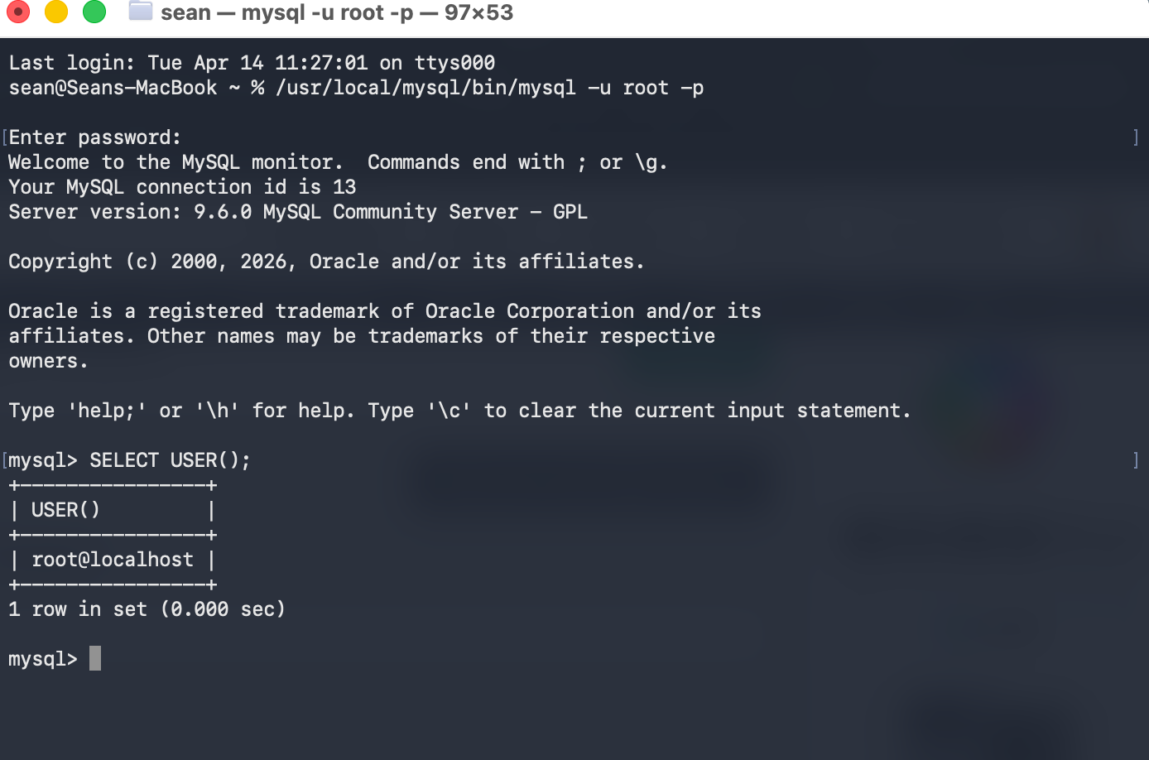
The next function I wanted to experiment with is the insert function. This function is a very basic one that is used to insert data into objects. This is useful for adding data into tables as I did in my example.

The final function I wanted to experiment with is the count function. This function is particularly useful in finding out the total number of records in a table.
