Sean Summers Assignment 10.2 May 17, 2026
To do app before modifications:
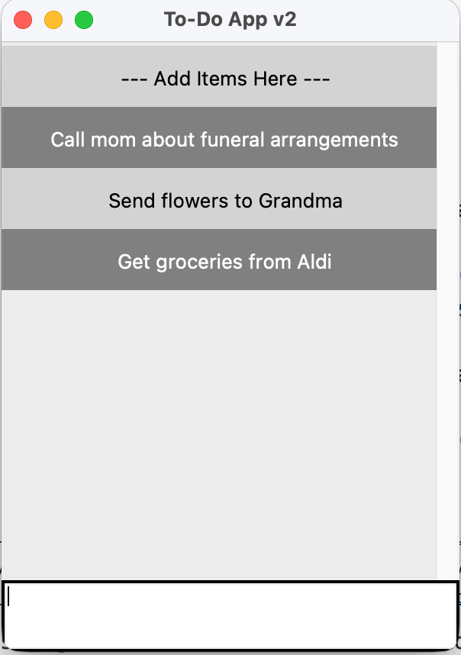
To do app after modifications:
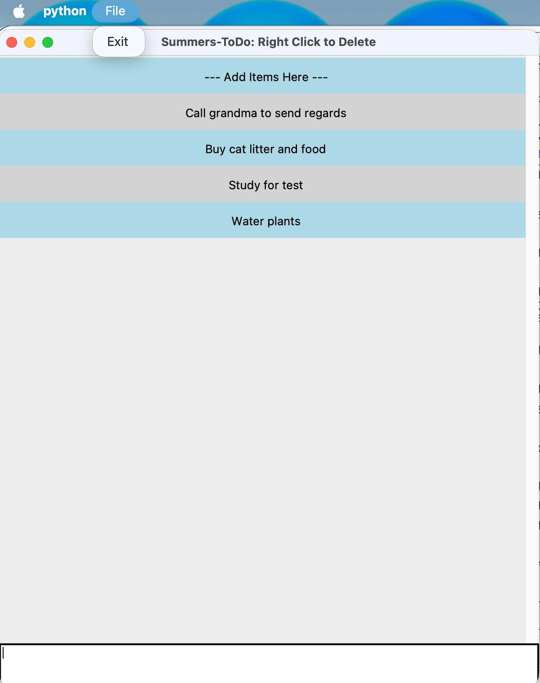
After deleting a task:
