Sean Summers Assignment 9.2 May 7, 2026
The API tutorial link in the module overview wasn’t working, so I found this API tutorial to follow instead https://www.geeksforgeeks.org/python/python-api-tutorial-getting-started-with-apis/
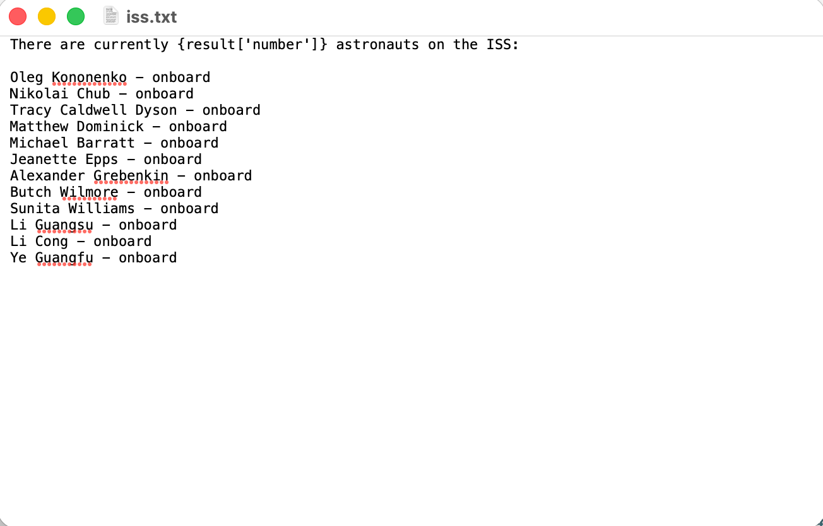
Unformatted result from my API connection
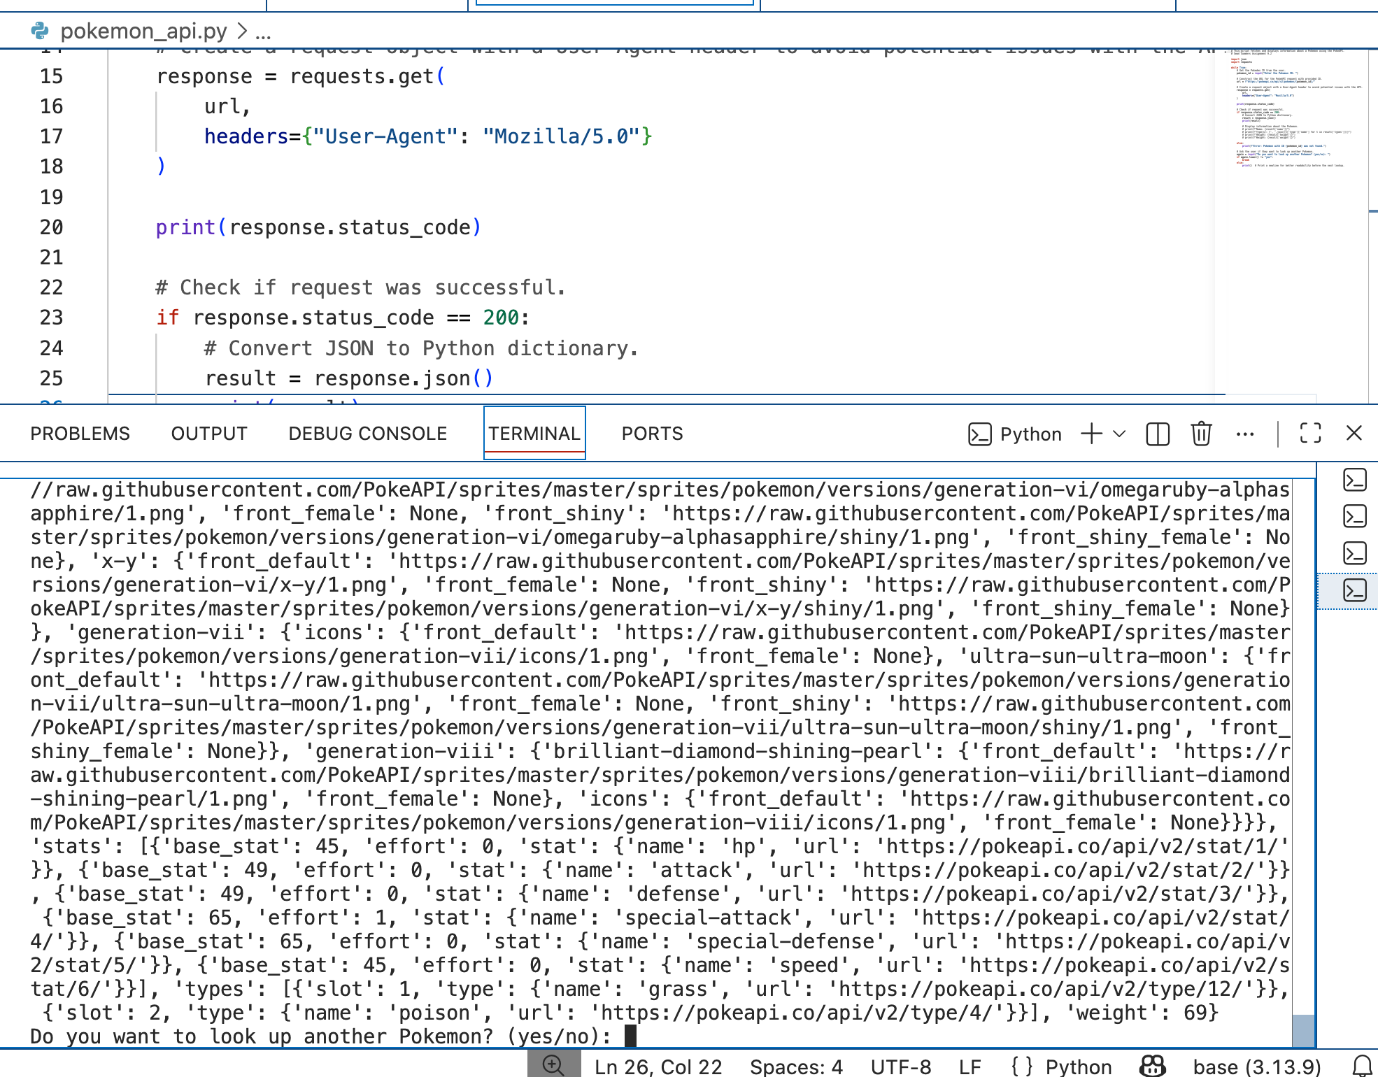
Formatted results:
