Sean Summers Assignment 4.2 April 16, 2026
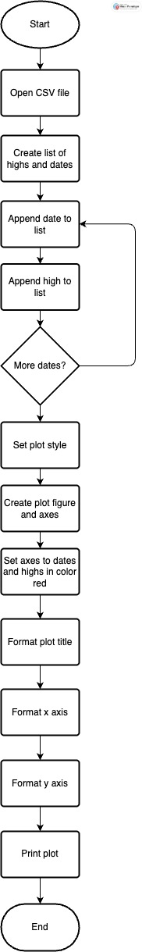
I made several changes to the program. Firstly, the entire program is inside a while loop, which is deactivated by saying ‘no’ after being prompted to try again. I gave the user the option to see highs, lows, or exit, and that input was used to determine the column of the temperatures used and the color of the graph. Finally, I made the title reflect either choice and fixed the grammar by removing the ‘s’ at the end of ‘highs’ and ‘lows’.
The revised flowchart:
