Sean Summers Assignment 2.2 April 1, 2026
Breakpoint:
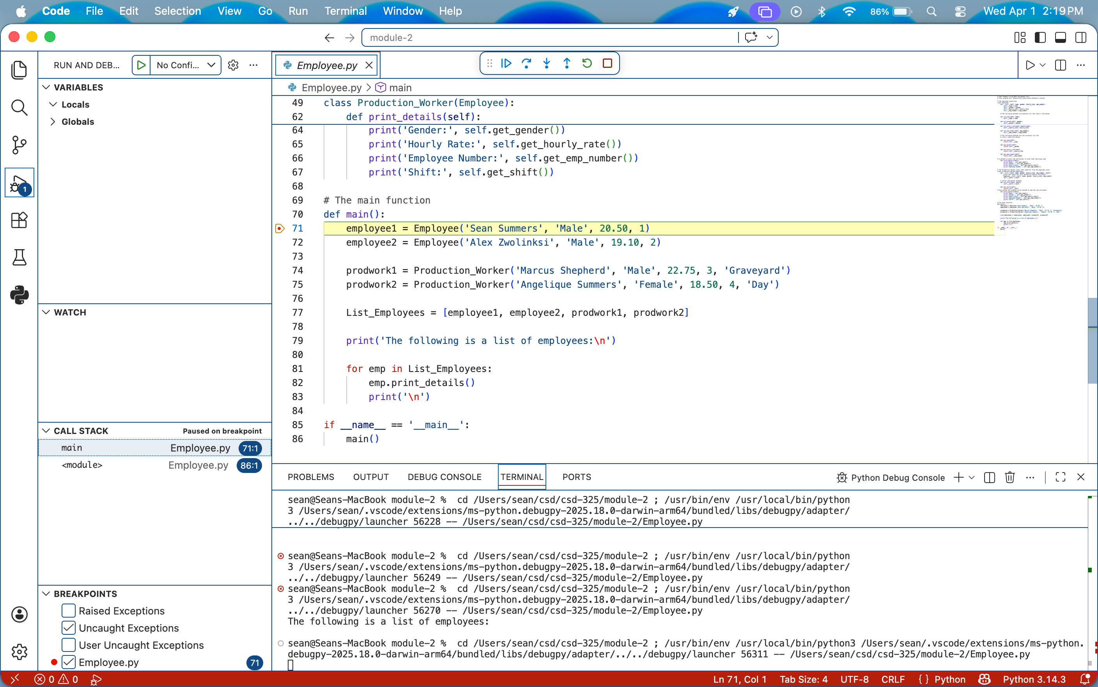
Stepping into the function:
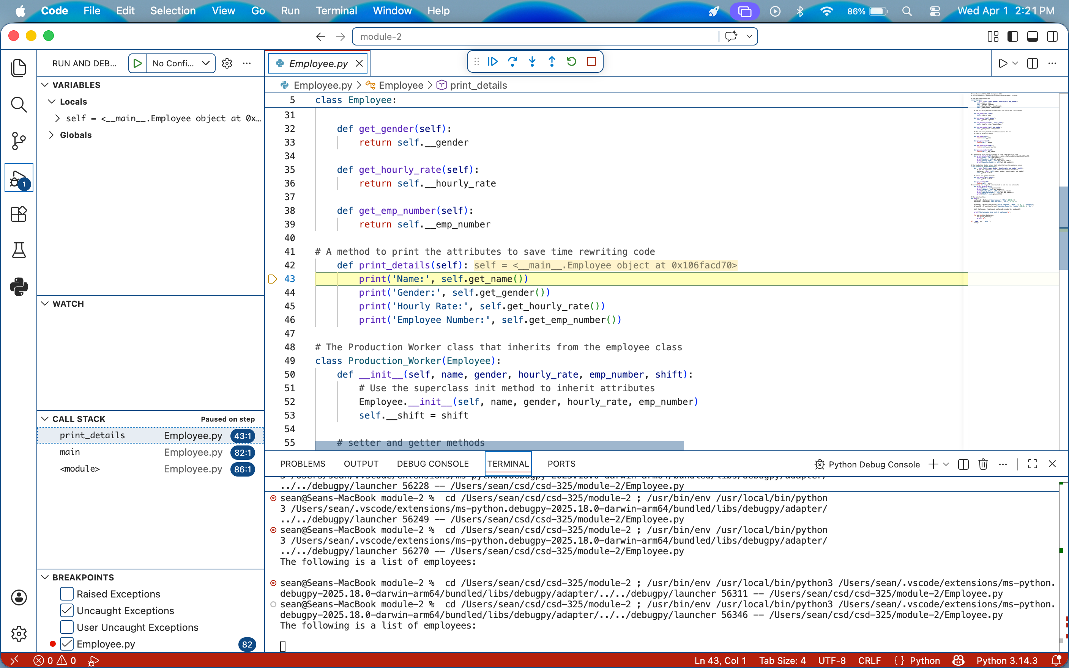
Adding an error:
