
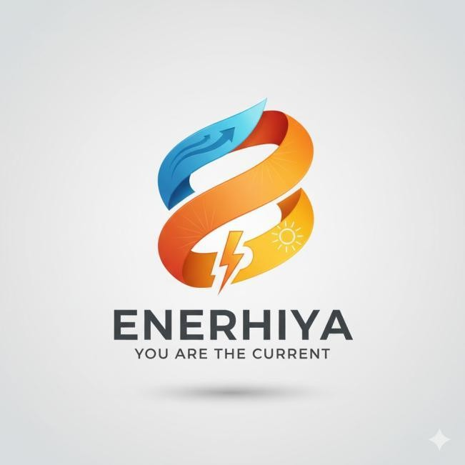

PRODUCT VALIDATION

Prepared by: Sean Darrell L. Tungcol

Section: BS CPE 3D

Date: November 12, 2025
Project Title: Task 5

Company/Institution: Pampanga State University

B. Sample questionnaire

Product Evaluation (Recipients / End Users)

(To be answered by individuals who will use or benefit from the product)

1 How often do you experience low battery issues on your phone or gadgets during the day?

- How useful do you think ENERHIYA would be in your daily life as a wearable charging device?

- Do you find the concept of generating power from your body’s movement, heat, and sunlight practical?
- Based on the prototype design (bracelet/watch strap style), do you find it comfortable and aesthetically appealing?
- How confident are you in the device’s durability and sweat/water resistance for daily Filipino use?

- Would you prefer ENERHIYA over a traditional power bank or solar charger? Why or why not?
- How much would you be willing to pay for a device like ENERHIYA V.1?
- What improvements or additional features would you like to see in ENERHIYA?

- How likely are you to recommend ENERHIYA to friends or family once it becomes available?
- In one sentence, how do you think ENERHIYA can help improve your daily routine?

Technical Evaluation (Experts / Professionals)

(To be answered by technical experts in electronics, renewable energy, or product design)

- How feasible is the integration of thermoelectric, piezoelectric, and photovoltaic systems in a compact wearable form?

- Does the proposed energy-harvesting design provide a sustainable and realistic alternative to conventional charging devices?
- How innovative is ENERHIYA’s multi-source energy approach compared to existing power solutions?
- Evaluate the expected charging efficiency (10,000 mAh) based on the described design and energy sources.

- Is the proposed design (bracelet/watch strap with integrated sensors and PV strip) ergonomically and technically viable?
- What potential improvements or alternative materials would enhance its performance?

- How would you rate ENERHIYA’s potential to scale as a commercial product in the Philippine market?

- How well does the concept align with the growing trend of sustainable and renewable energy technologies?

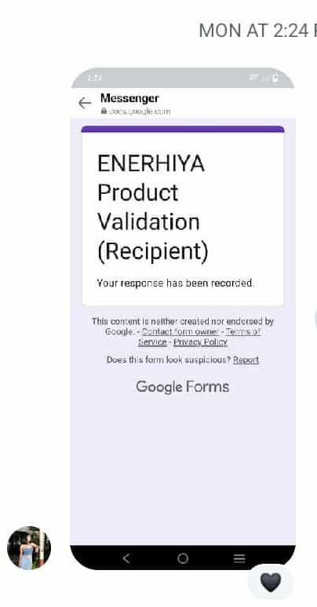
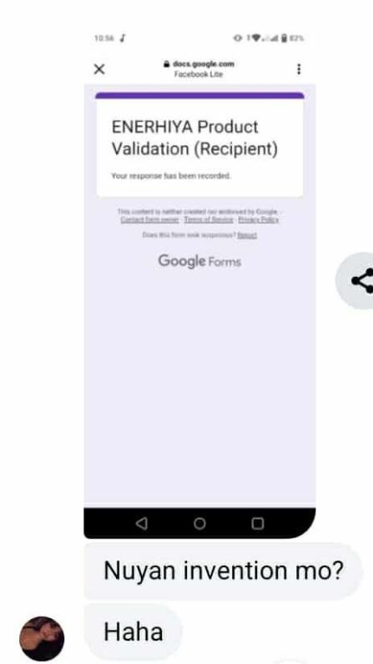
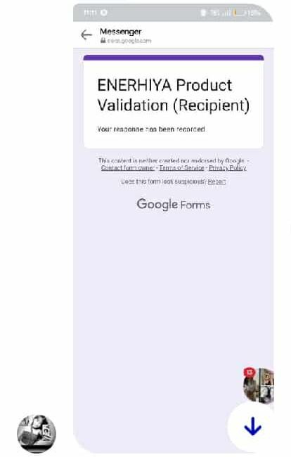
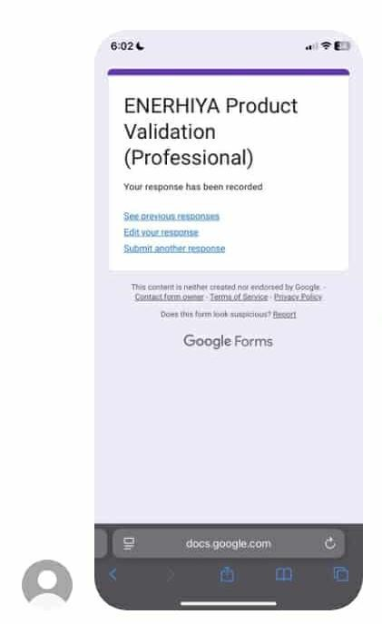
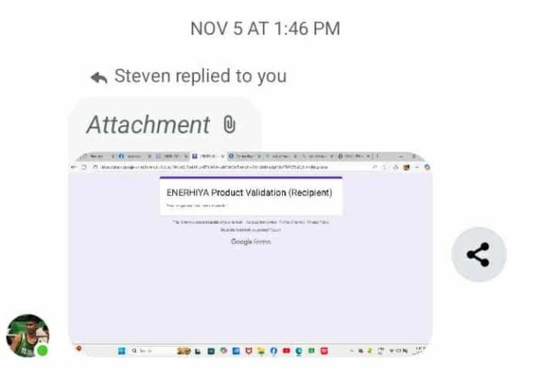
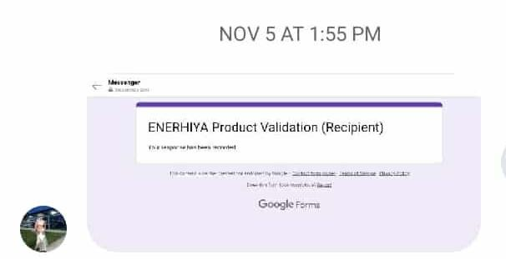
- What level of maintenance or calibration would you predict is needed for ENERHIYA’s energy-harvesting system?
- Overall, how would you rate ENERHIYA’s readiness for prototype development and real- world testing?

C. Proof / evidence you conduct interviews/survey

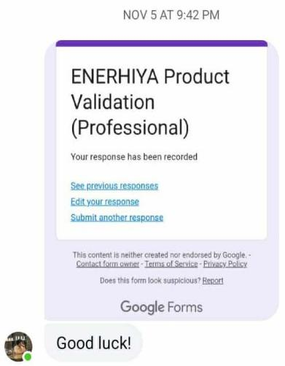
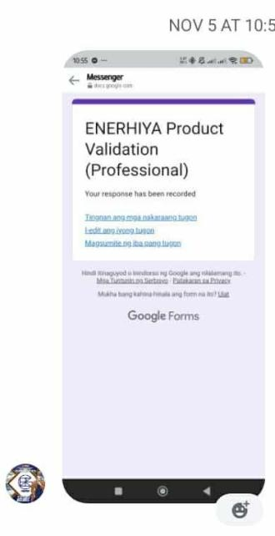
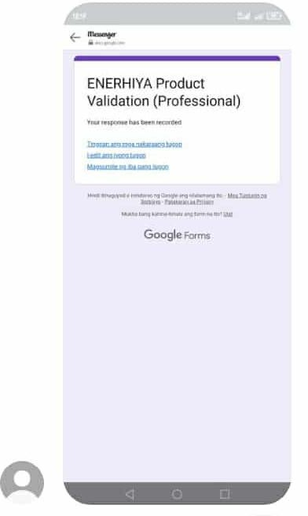
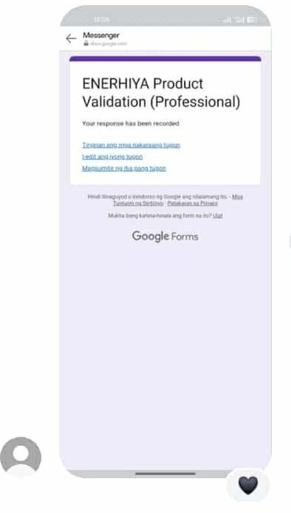

D.Results and discussion Results
- Technical Evaluation (Experts / Professionals)
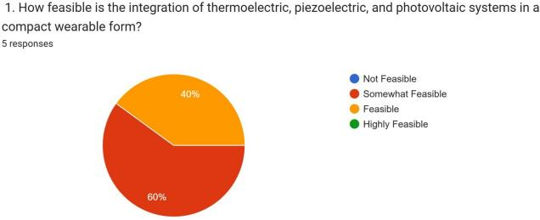
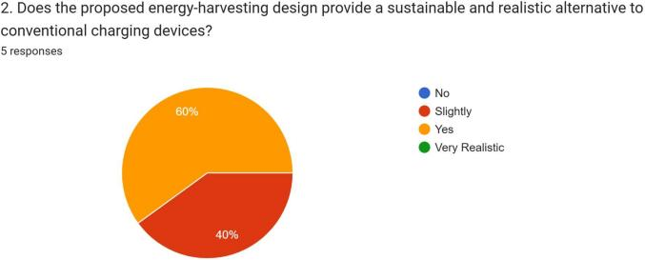
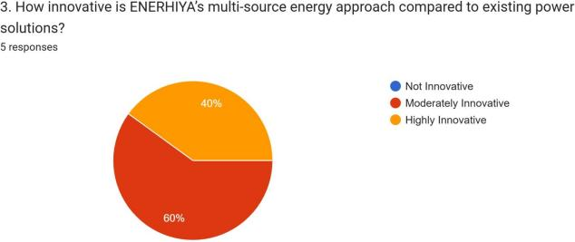
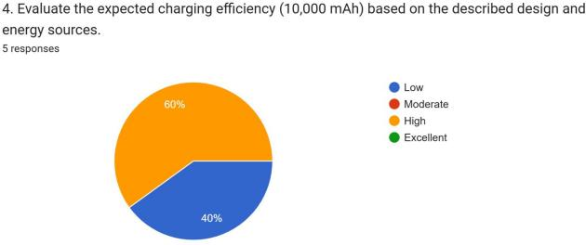
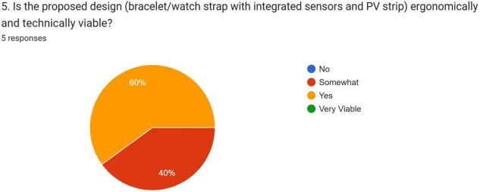
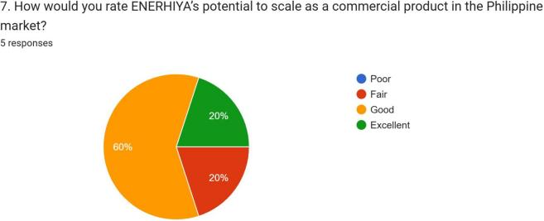

- What potential improvements or alternative materials would enhance its performance?

  - The idea is really good but base on my experience, you might experience hardship on the product size. Materials are usually bulky so its very challenging to make it comfortable to wear. and Maybe the product should be worn on the ankle instead for comfort at it could cause discomfort especially when doing something.
  - For prototyping, using a larger-capacity battery is highly recommended to ensure stable testing and accurate energy measurements. A bigger battery allows longer runtime, making it easier to observe how effectively the systems harvest and store power under different conditions. This setup also enables extended trials for power management, charging cycles, and sensor operation without frequent interruptions. Although a large battery may not be ergonomic for the final wearable version, it is ideal for early-stage prototypes to validate performance and optimize system efficiency. At the prototype stage, it is also more realistic to use larger components and batteries since most energy-harvesting modules, sensors, and control circuits are not yet miniaturized. This means the prototype may resemble a bulky wrist module or arm strap, rather than a sleek consumer-ready design. However, building it in a larger form factor allows enough physical space for wiring, heat dissipation, and testing of different energy-harvesting configurations providing crucial data for future miniaturization and refinement into a compact bracelet or watch strap design. In terms of health and safety, it poses minimal radiation risk since it does not emit harmful electromagnetic waves like smartphones or wireless transmitters. The device only converts and stores energy from natural sources, ensuring that it remains safe for continuous skin contact and long-term use as a wearable. Furthermore, it would be much better if it is supported by dedicated software or a mobile application that allows users to monitor energy generation, battery status, and performance analytics. The app could also integrate health-tracking features similar to those found in smartwatches, such as heart rate monitoring, step counting, sleep tracking, and body temperature measurement. These added functions would make it not only a self-sustaining power source but also a multifunctional health companion, combining sustainability, innovation, and personal wellness in one advanced wearable device.

  - ... I guess it better to place the device on high- motion body areas such as knees or elbows instead of wrist.
  - For potential improvements, it would be great if it could also function as a smartwatch (if possible). This would make it more versatile while still fulfilling its main purpose.

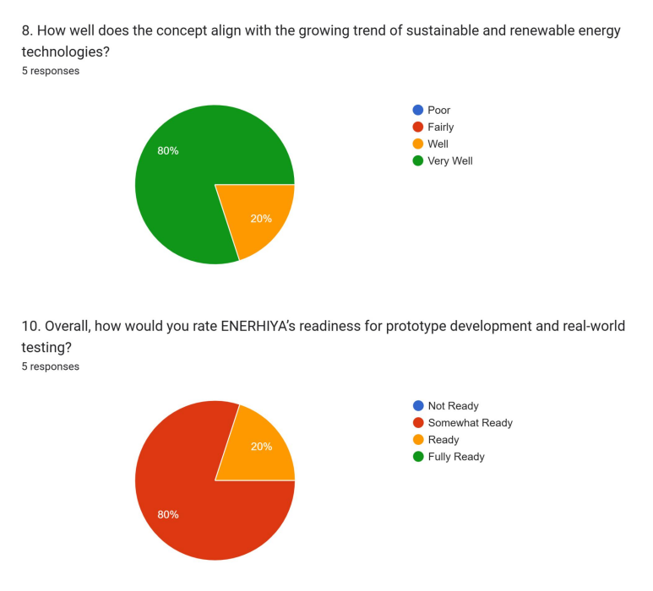
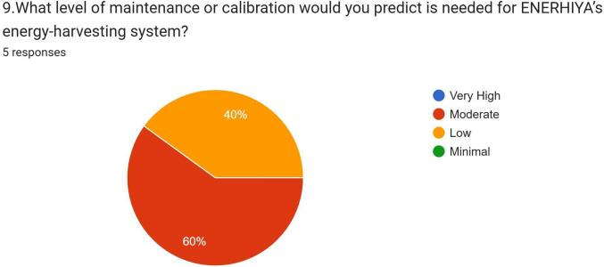
  - Product Evaluation (Recipients / End Users)
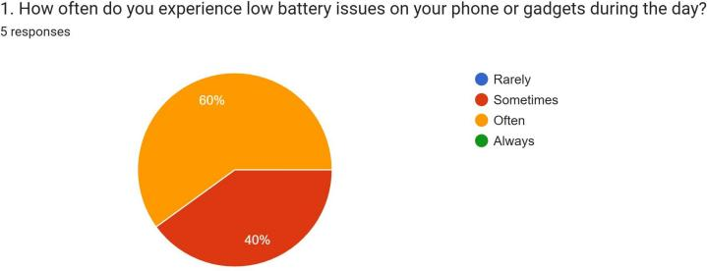
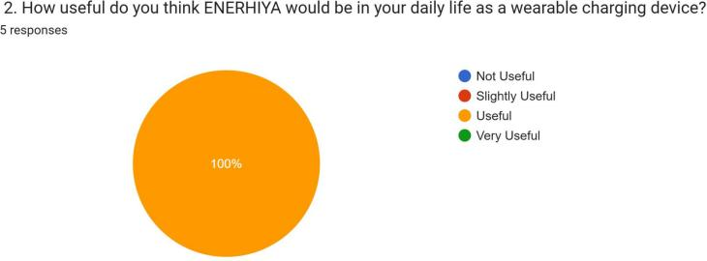
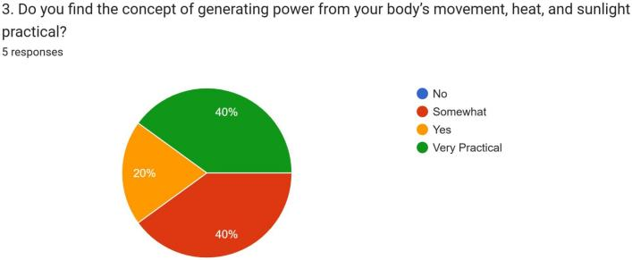
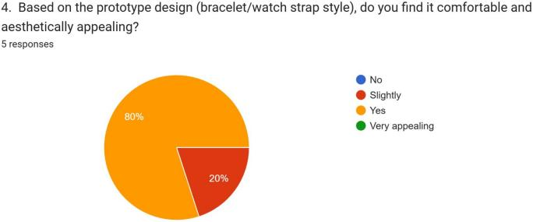
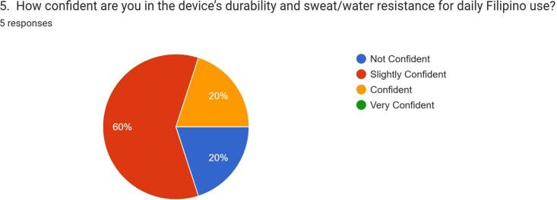
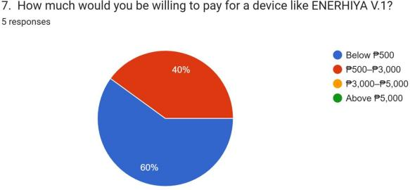

- Would you prefer ENERHIYA over a traditional power bank or solar charger? Why or why not?
  - I prefer the ENERHIYA over a traditional power bank because of it's comfortable design and it's useful for daily life
  - Yes, I’d prefer ENERHIYA because it’s more convenient and eco-friendly than a regular power bank or solar charger.
  - Why not if it helps, especially when you have an emergency and you can do something about it using ENERHIYA.

  - I prefer Enerhiya because you don't need to plug it in or rely on sunlight. It uses heat from your body to generate power, which makes it very convenient and sustainable, especially when you're on the go.
  - I love the idea of being able to charge my devices using just the sun. It's not always the fastest way, but it's perfect for camping or any time I might be off the grid

- What improvements or additional features would you like to see in ENERHIYA?
  - nothing much.
  - I'd like to see improvements in charging speed and battery capacity.
  - N/A
  - I would like to see improvements in energy efficiency, faster charging speed, and compatibility with different devices. It would also be great if ENERHIYA had a compact and waterproof design for outdoor use.
  - Integrating community features could allow users to share knowledge, discuss sustainability ideas, and track progress together. Introducing sustainability challenges could further engage the community, motivating users to understand their impact, learn how to reduce it, and collaborate with others
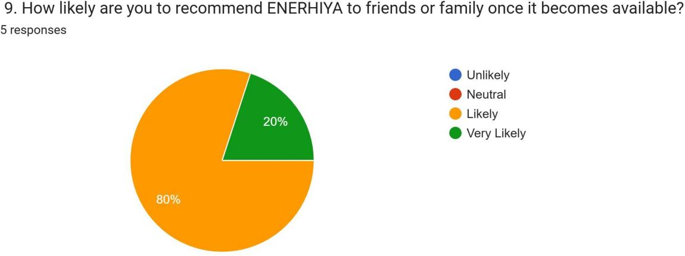

- In one sentence, how do you think ENERHIYA can help improve your daily routine?
  - ENERHIYA can improve my daily routine by ensuring my devices stay charged, reducing the stress of running out of battery while I'm on the go.
  - ENERHIYA can help me improve my daily routine by keeping my devices charged anytime, making me more productive and worry-free.
  - For me, I can use it at school or when I'm jogging, especially since phones are used every hour at school, and when jogging, I use music, and it's not a hassle to use.
  - ENERHIYA can help improve my daily routine by providing a convenient and reliable source of power from my body heat, keeping my devices charged anytime without needing an outlet.
  - If ENERHIYA could somehow magically make my phone never run out of battery while also being super eco-friendly, it would totally take away that little bit of daily anxiety I have about finding an outlet!

Discussion

The results of the customer validation survey revealed a strong positive reception from both student recipients and professional evaluators, demonstrating ENERHIYA V.1’s relevance and potential in addressing real-world charging concerns. A majority of respondents reported frequently experiencing low-battery issues during the day, emphasizing the urgent need for a sustainable and wearable power source. Both groups found ENERHIYA highly useful in daily life, praising its concept of harvesting energy from body heat, movement, and sunlight as an innovative, eco-friendly solution. Students appreciated its convenience and portability—especially for school, travel, and outdoor activities—while professionals recognized its potential as a reliable, self-sustaining energy device suitable for fast-paced work environments. Most participants found the bracelet- style design aesthetically pleasing and comfortable, though a few recommended further improvements in charging efficiency, durability, and waterproofing for long-term use. Additionally, all respondents expressed a preference for ENERHIYA over traditional power

banks and solar chargers due to its self-charging capability and independence from outlets. The willingness to pay ranged mostly from ₱500 to ₱3,000, suggesting a promising market if priced accessibly. Overall, the results indicate that both user groups view ENERHIYA as a practical and proudly Filipino innovation that merges technology, sustainability, and convenience—offering a glimpse of how renewable personal energy solutions could soon become part of everyday life.

- Introduction
In today’s fast-paced digital world, one of the most common frustrations
faced by millions of Filipinos is the constant fear of running out of
battery. From students submitting online requirements, professionals managing
digital workloads, to delivery riders relying on GPS for navigation—power
has become a lifeline. Yet, access to electricity remains inconsistent,
power banks require recharging, and solar chargers are unreliable during
rainy days. Recognizing this persistent gap between energy demand and
availability, ENERHIYA V.1 was conceptualized as a sustainable, self-sufficient, and
wearable energy solution. ENERHIYA V.1 is a next-generation wearable power
bank designed as a sleek bracelet or watch strap that converts natural human and
environmental energy into usable electrical power. It integrates three core energy-harvesting
technologies—thermoelectric (body heat), piezoelectric/electromagnetic (motion), and
photovoltaic (light)—to continuously generate and store power in a 10,000 mAh battery,
capable of charging most smartphones twice. This hybrid system ensures that even if one
energy source is unavailable, the others sustain charging capacity, effectively turning the body
into a personal renewable power plant. Customer validation through surveys and interviews
with both recipients and technical experts has provided strong support for ENERHIYA’s
practicality and market potential. Among users, 100% rated the device as useful in daily life, with 80%
finding the design comfortable and aesthetically appealing, while 60% expressed confidence in its
durability and sweat/water resistance. Users emphasized its convenience over traditional power
banks and solar chargers, highlighting its potential to reduce low-battery anxiety and improve daily
routines. Expert evaluations reinforced the technical feasibility of integrating multi-source energy
harvesting into a wearable form, with the majority rating its innovation, ergonomic viability, and
prototype readiness as moderate to high. Suggestions from both groups, such as enhancing energy
efficiency, optimizing battery capacity, and considering alternative placements for comfort, will directly
inform design improvements. The primary purpose of this validation is to refine ENERHIYA’s design
, assess its real-world performance, and ensure alignment with Filipino lifestyles and environmental conditions. ENERHIYA V.1 embodies the vision of empowering people through innovation—where every step, every ray of light, and every drop of sweat contributes to energy independence. It is not just a product; it is a movement toward sustainable living, bridging technology and human potential in a single wearable form.

f. Questionnaires with answers from your participants (Materials)

