Cenita & De Guzman, 2023

Millennial learners rated e-learning benefits with a mean of 3.68 (“highly acceptable”)
learners place high value on the convenience of digital education
Value flexibility

Pan et al(2022)

Digital Pre made flash card/personalized

This means that, over the long run, creating your own reviewers proves to be more time-efficient than depending on pre-made materials.

LJVMiranda, 2022

Digital reviewers make studying feel quicker and easier initially
Organized/ focus
repeated review sessions

Scholarly, 2023

Digital tools provide structured, accessible ways to review lessons, allowing learners to focus on difficult topics and skip mastered 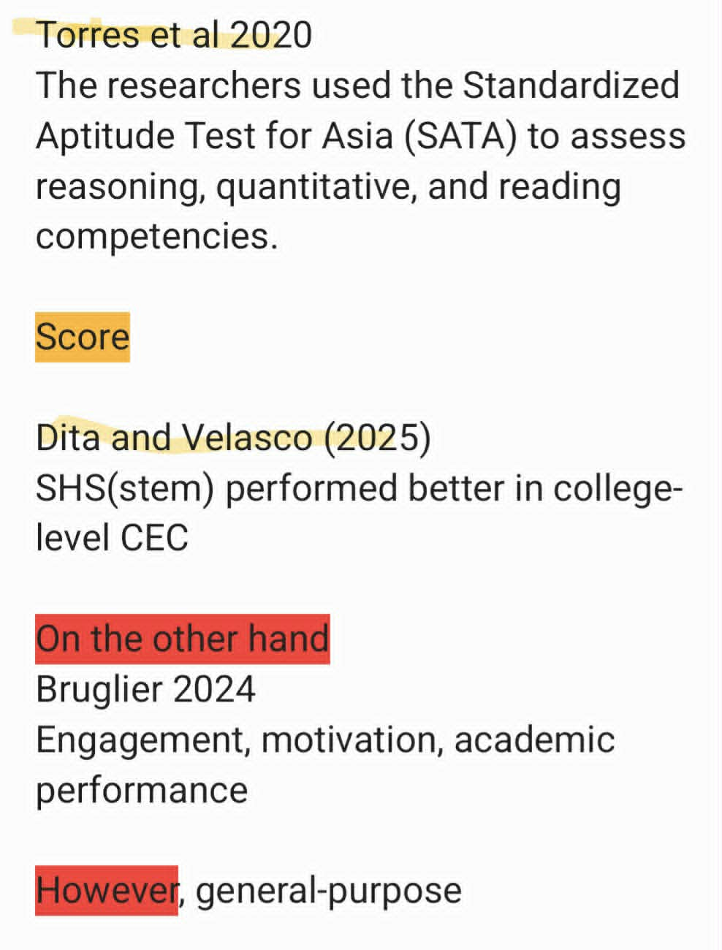

Manipulate/ compare

describe how students evaluate the REVUE website in terms of understandability, efficiency, accessibility, and effectiveness

A correlational design is also necessary because the study seeks to determine whether there is a significant relationship between two naturally occurring variables

