**Deep Learning**

Media.py

- Great link to Deep Learning GitHub repo

- When I ran the code, I got an error message:

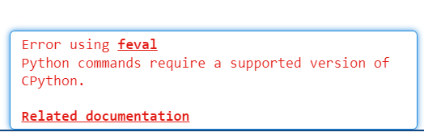

You may want to include any setup information regarding calling MediaPipe from MATLAB.

**Feature Engineering**

Good

Jon

Agreed good!

**GatherData**

Good, perhaps you can mention that readtable is good for mixed type data.

Jon

Good!

**Hyperparameter Optimization**

You can also add these links:

<https://www.mathworks.com/help/deeplearning/experiment-manager.html>

<https://www.mathworks.com/help/stats/hyperparameter-optimization-in-classification-learner-app.html>

<https://www.mathworks.com/help/stats/train-regression-model-using-hyperparameter-optimization-in-regression-learner-app.html>

Video: <https://www.mathworks.com/support/search.html/videos/applied-machine-learning-part-3-hyperparameter-optimization-1547849445386.html>

Computation time was a bit long for me, how long did it take you? If it took you long as well, maybe you can mention computer specs and expected computation time

Jon

* Agreed, run time was long. I stopped the code and changed n_samples to 100, then it ran much faster
* Maybe explain what the for loop is doing a bit more

**Neural Network Regressor**

Lines after 69 need a bit correction. Deep Learning Toolbox uses GPU by default if there is a compatible NVIDIA GPU (auto setting: 'auto' — Use a GPU if one is available. Otherwise, use the CPU.)

Otherwise, it uses CPU. If you want to manually change the execution environment, you can specify it in training options as you linked (you can highlight executionenvironment option)

Good links to training and doc

It ran pretty fast, but you can mention training time and computer specs to set expectations.

Jon

* Maybe a quick explanation on why you chose cosine as an activation function. It is because we are using sine as our input data and activation functions can help us capture nonlinearities, and in this case our data is exactly the sine function.

**Scale**

Good

You can also mention center and scale Live Task to do these interactively: <https://www.mathworks.com/help/matlab/ref/normalizedata.html>

Jon

* Add comments to the code that is missing comments. Just keep in mind that some people reading this will most likely not have the exposure to all this very specific MATLAB code

**XGBoost Classifier**

Good links, preallocation warning, but if you don’t know the matrix sizes, no big deal.

Additive Manufacturing

Good use of Create Plot

Jon

* Is there a reason for splitting the training and test 50% and 50%?