**Soil Classification**

* Project worked fine
* Looks good, I also like interactive approach references.
* Perhaps, you can add further reading for augmentation: <https://www.mathworks.com/help/deeplearning/ug/image-augmentation-using-image-processing-toolbox.html>

**Additive Manufacturing**

* Under prediction and analysis section, you can add R^2 as equation. If the original text is using “rho” symbol, you can add the symbol as equation as well. – that was my feedback last time too, since you didn’t change it, I’m assuming it is “rho” in the original text too.
* Interactive Method – you can mention that the apps are part of Statistics and Machine Learning Toolbox and it should be installed to see the apps associated with it. This is the case for the other scripts too. Perhaps, we can add a disclaimer for the course saying that the scripts require statistics and machine learning toolbox, deep learning toolbox etc.

**ARX Time Series Model**

* Nice that you mentioned Python and System Identification Toolbox. It would be good to hyperlink System Identification Toolbox Product page: <https://www.mathworks.com/products/sysid.html>
* Spellcheck under “System Identification Method”, functions is spelled as fucntions
* Clarification for GEKKO part, if Python is called from MATLAB for this section, you may want to make this clear and add additional links that would help reader setup the environment/get started. I see Python installation information, but is anything else required? <https://www.mathworks.com/help/matlab/call-python-libraries.html>

**Automotive Monitoring**

* Correct spelling of “Measurments” should be “Measurements” in Create Boxplot of Measurments title and following titles
* Errored line 243 for saving the figure. Is it really necessary to save the figure? If it is not needed, you can skip it or you can fix the error.

**Cascade Classifier**

* Good inclusion of necessary toolboxes, support packages and references.
* Video is still not catching my face all the time, catching my tshirt. If there is anything I should do for better tracking, maybe you can include such recommendations in the text (like better light, proximity to camera etc.)
* You can put a line to release the video object and shut down or you can tell in the text that user should close the window to stop.

**Draw Classification**

* Capitalize initials of classification learner app, mention that it is part of Statistics and Machine Learning Toolbox
* Errored in line 18

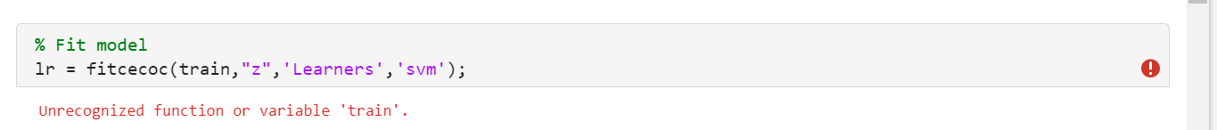

* Changing line 18 to this worked: lr = fitcecoc(train,"z",Learners='svm');

**kNN_Regression**

* Good
* Nice use of sliders

**Lithium Ion Batteries**

* Errored in line 95, fix it

**Handtracking (August 23 folder)**

* Nice use of project, seems like project worked.
* Nice mention of required tools, you can also add Simulink
* In method 3, I believe you meant Simulink in this sentence? Using the MATLAB platform
* It would be nice to change the name of the modified Simulink model (remove working)
* From past e-mails, please include the bullets on what was modified and how.