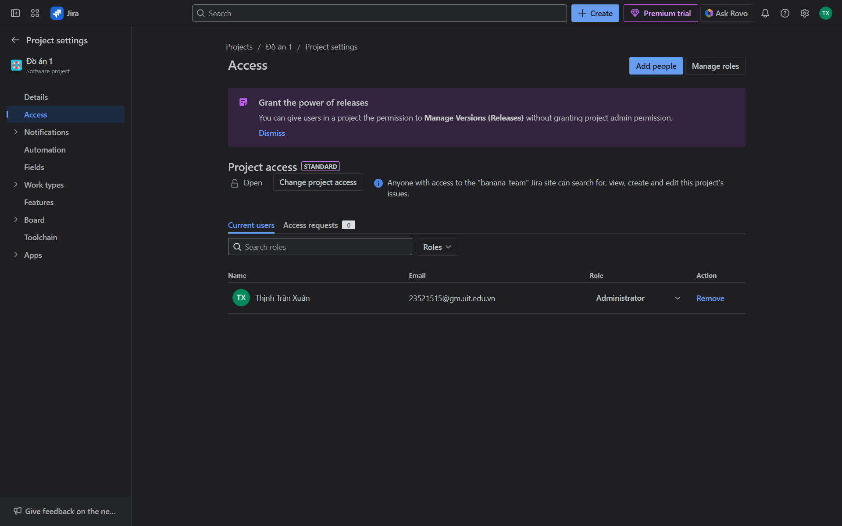
- Invite users
- Manage organization settings
- Manage roles & permissions
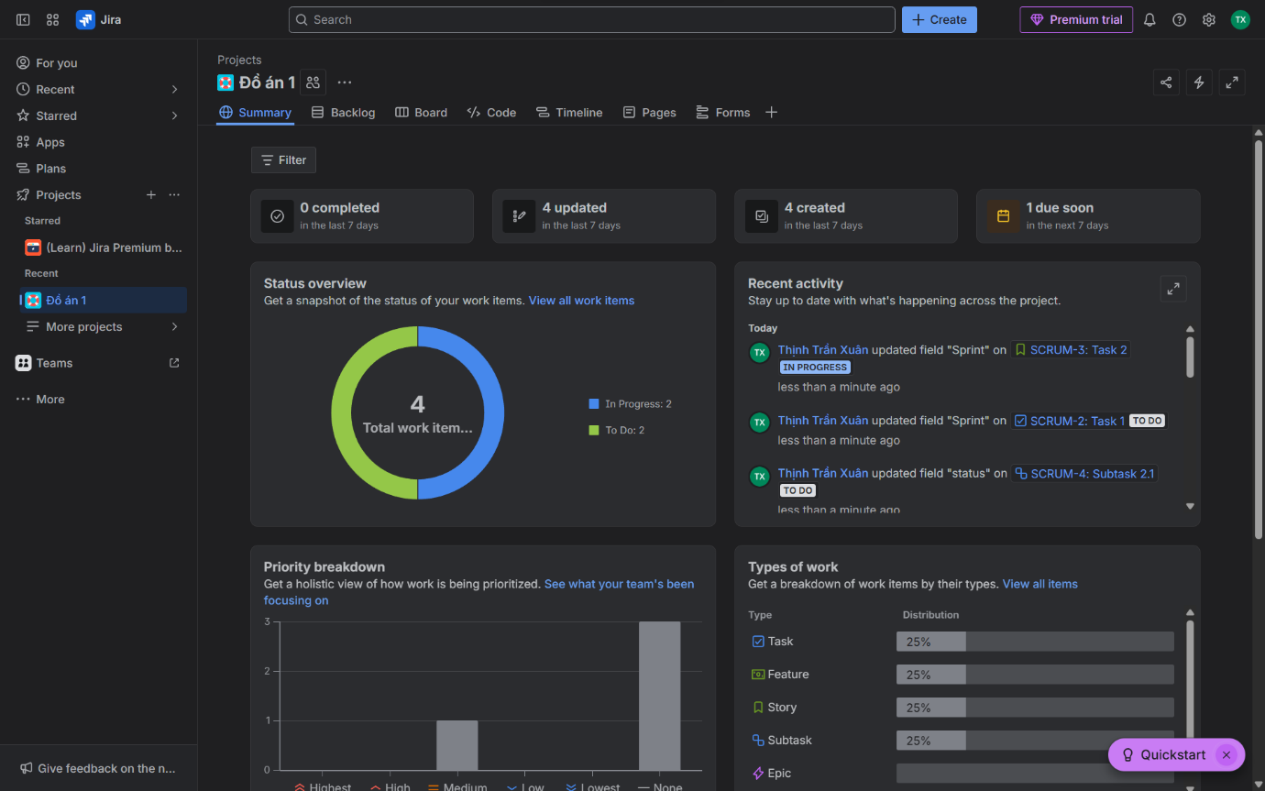
- View dashboards
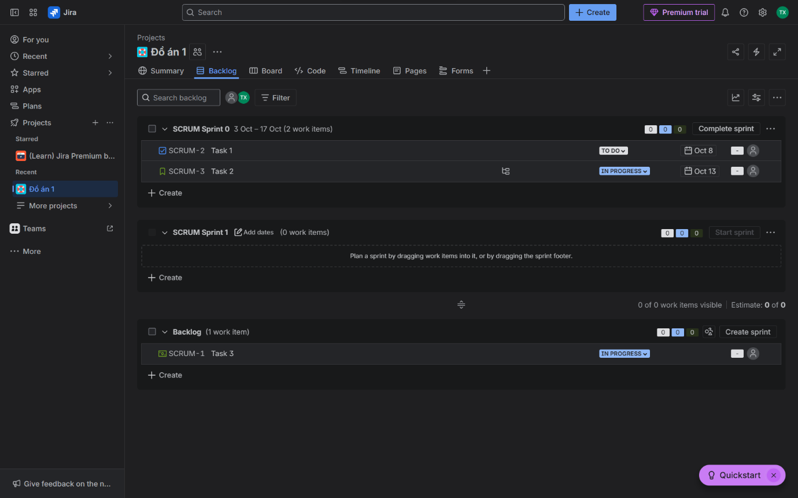
- Manage backlog
- Plan sprints
- Start/Close sprint
- Manage tasks
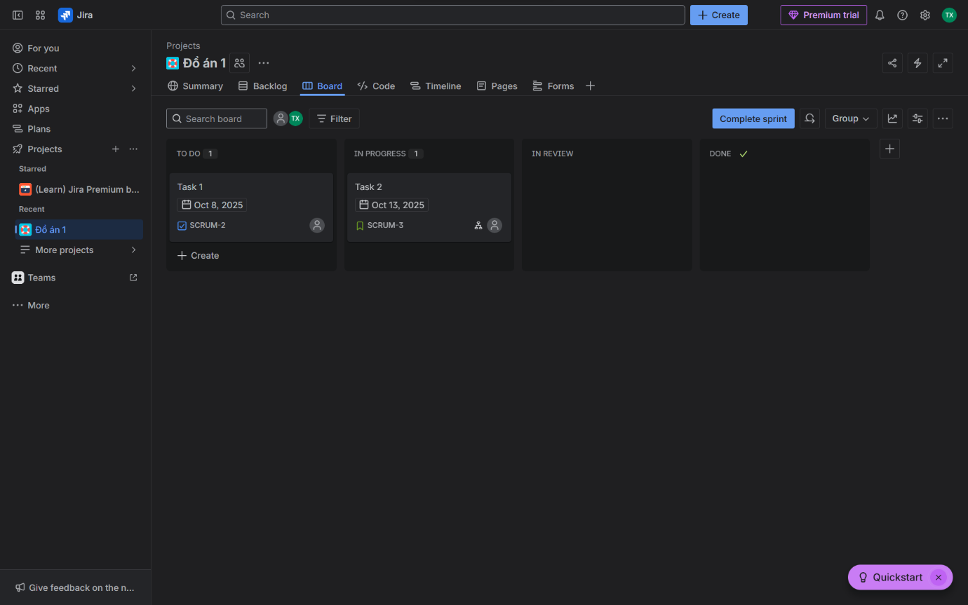
- Manage Kanban board
- Manage tasks
- Update task status
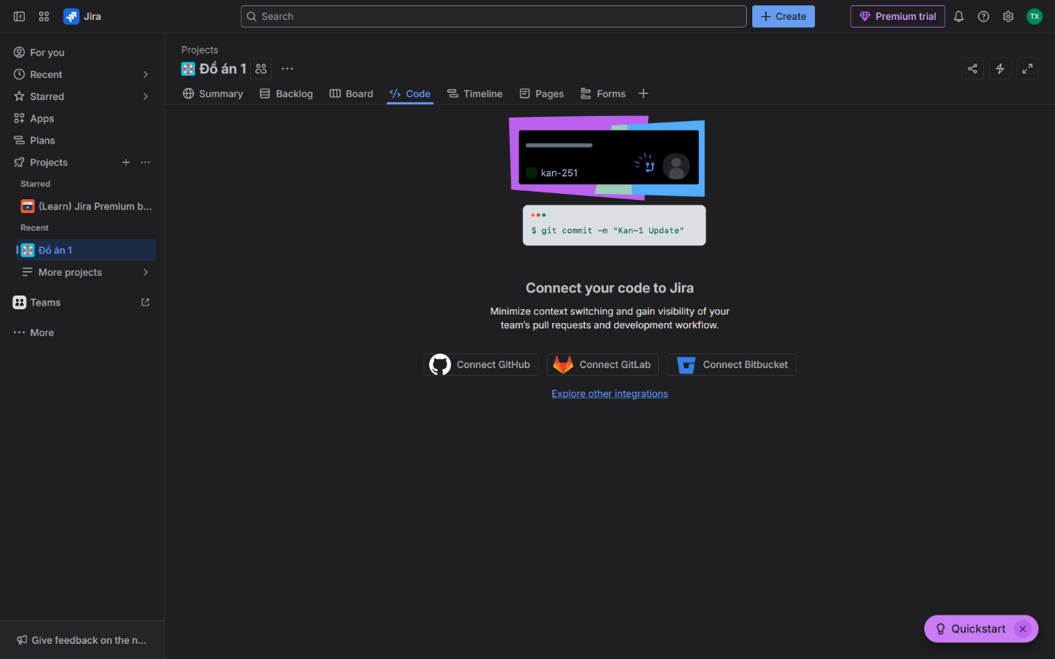
- Third party integration
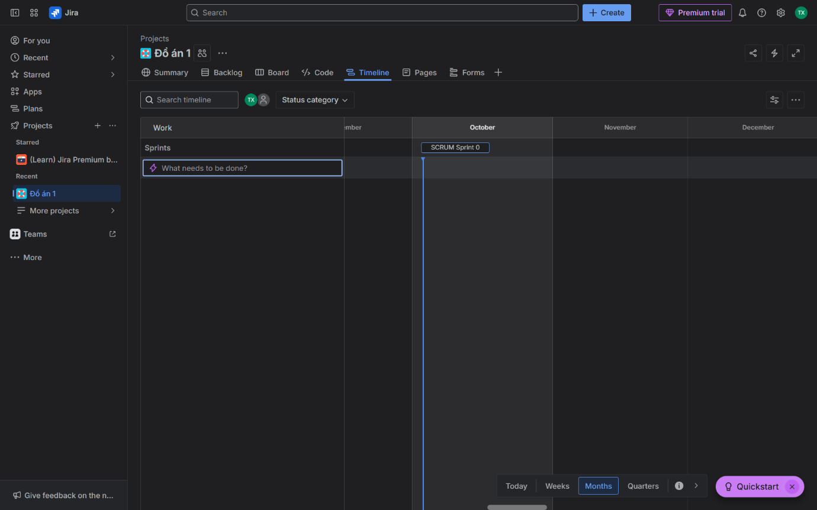
- Plan sprint
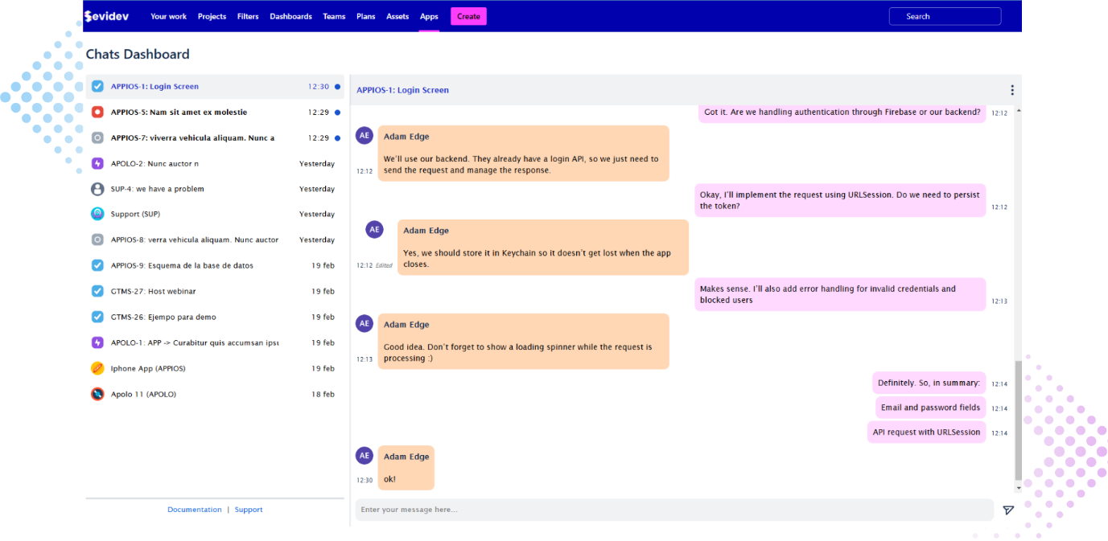
- Chat in Project/Task

