Explaining the Restraint:

There is a lack in the provision for waste segregation or proper waste management in rural areas. In a country like India the problem of lack of waste segregation is prevalent everywhere.

At the household level itself, the waste is rarely segregated. The waste of the day is packed in a polythene bag and thrown into the common dustbin. This is then collected by the municipality and the garbage, with everything, from recyclable plastics, metals, biodegradable substances such as food waste, precious resources such as lithium in old batteries end up in the landfill.

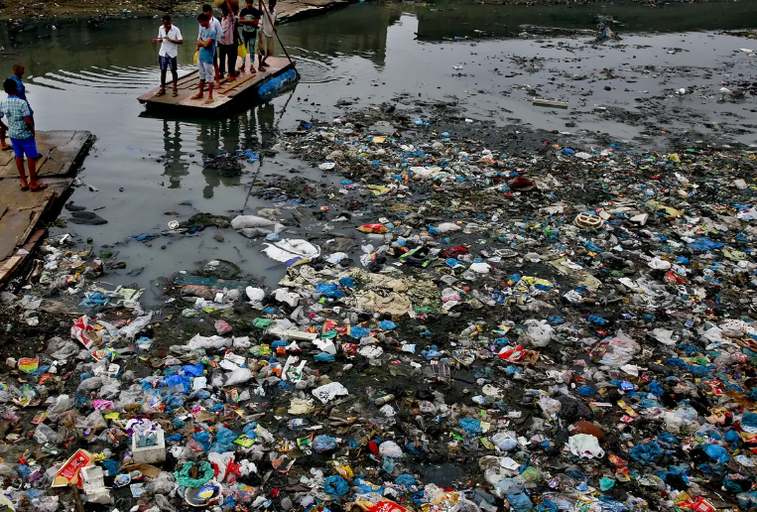

There are certain channels of recycling that do operate and buy recyclable plastics, metal, plastics from people, but these are not enough compared to the volume of waste generated.

Management of waste at the household level itself, by separating the biodegradable waste from plastics, etc can be a huge step. A household can manage its own organic waste and the recyclable waste can be sold somewhere for proper management.

But practically, people may not have the adequate knowledge or the urge to spend time and effort in differentiating between the two types of waste, and make separate arrangements and dustbins for them.

Explaining the idea:

In each village, there is a primary school. The students will carry waste from their homes, such as vegetable peels, food packets, papers, polythene bags, etc to school. Then all those will be put into the waste sorter one by one in the classroom and the teacher will teach students to differentiate between waste in an interactive class and at the same time, the waste from all the households will be properly managed. This will be the data collection and training period for the model. For each waste it receives, the correct label is indicated by turning the knob in the appropriate direction.

A simple neural network for image classification will be built and trained from datasets available online. This will then be loaded onto the board’s MCU. The nRF54L15 can run machine learning with the help of Edge Impulse.

And next the model is further trained by the teacher in case it makes some wrong classification.

After some days, each student(household) will be provided with a waste sorter with the trained model which they can place over the dustbin.

I do not have experience with the Nordic nrf development environment, but I can learn quickly.

Design explained:

A cuboidal box of dimension 250mm x 300mm x 100mm is used. It has a lid that can be slid open and waste is dropped into it. It has two holders at opposite walls for fixing camera and a light source. They are inclined such that they point towards the centre of the base of the box, where the waste falls. This assembly can be placed over a dustbin with the help of the two handles. The lid as it slides off, also activates two switches. One of them is for lighting up the light source and the other is to send a DETECT signal to the nrf board to wake it up from its OFF state. This is done to conserve energy. When the lid is closed, the switch is pressed and the light goes off and the board to OFF mode.

FIG 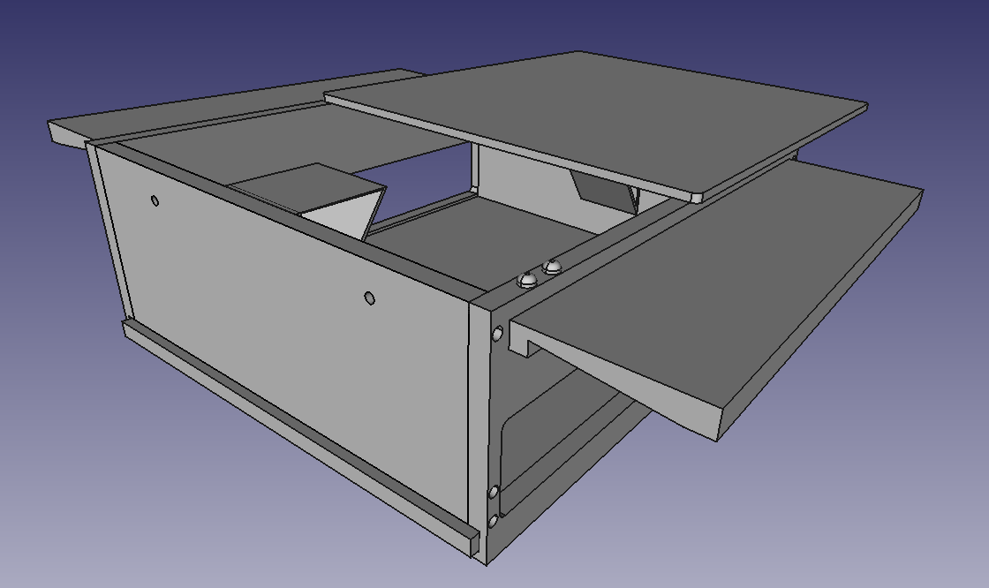

The side walls have big holes in them, which are actually the central part of the mechanism. One of this is for biodegradable, organic waste, while the other is for non-biodegradable or potentially recyclable waste. Tilt the box towards the direction that the led indicates (The front face has two small holes for LEDs) and the waste falls into its correct half.

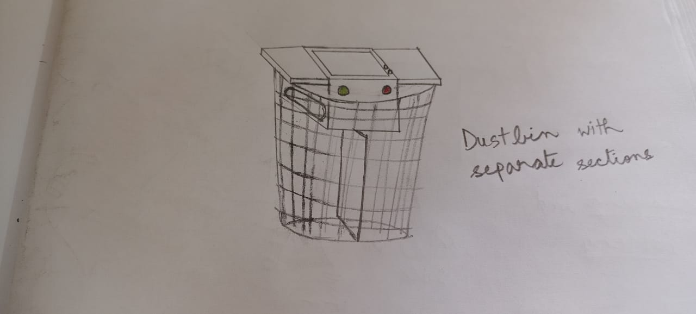

Thus, no extra arrangements needed.

When the waste falls in, the piezoelectric sensor below the base senses some change in pressure and activates the camera. The camera takes a picture and it is fed into the trained model for classification.

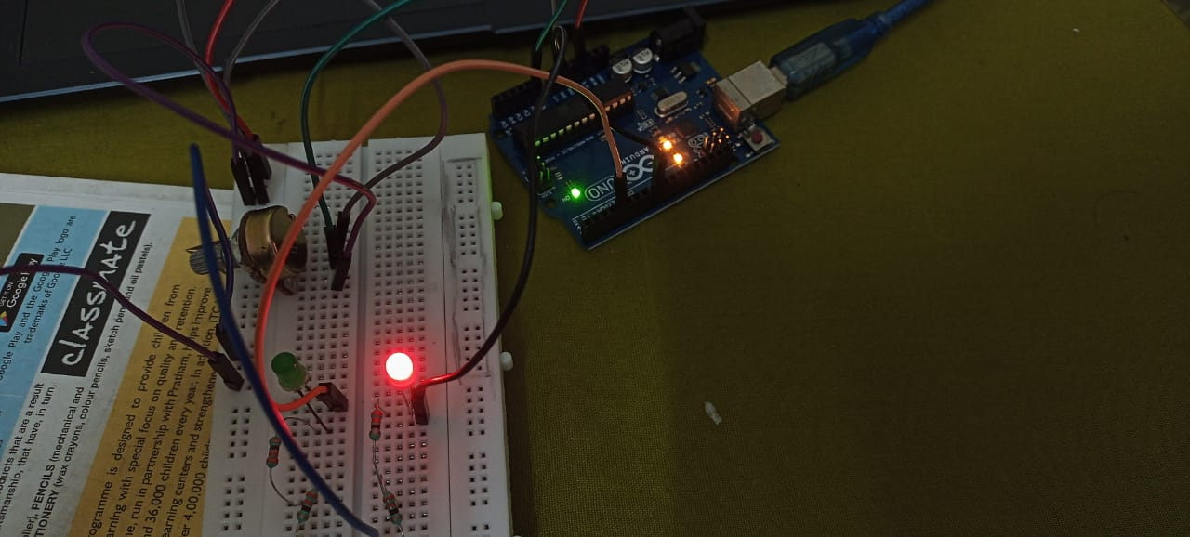

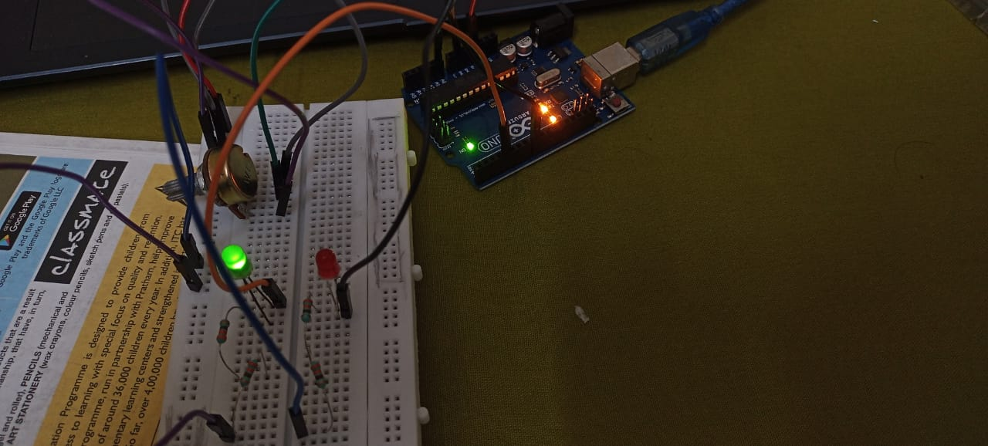

As per the result, the code sends a digital high signal to the assigned pin and lights up the appropriate LED. This gives a visual indication to the person in which way to tilt the box. Thus, anyone can quickly operate this waste sorter and it is convenient as it is already fixed over the dustbin and all we have to do is tilt it as the led indicates.

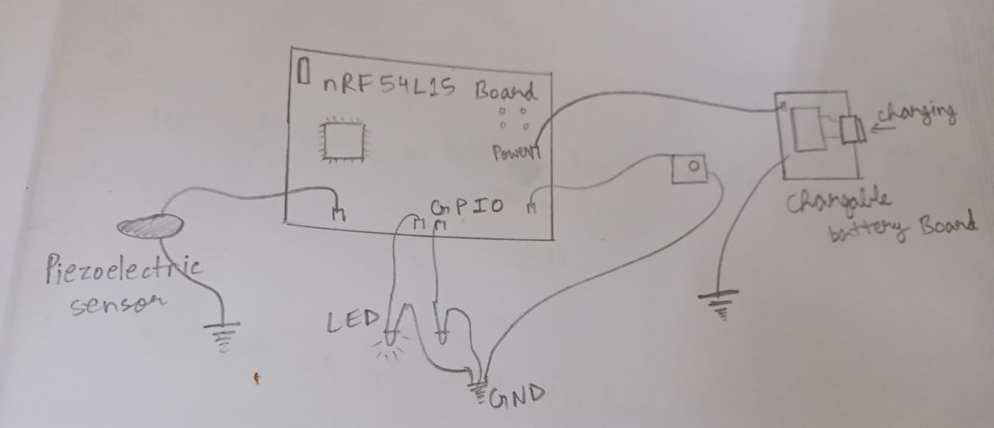

The box is not one single piece, but each of its walls and the lid and base are separate pieces. These can be easily assembled together and the walls can be fixed to each other with screws. (the holes have been made as per M3 screw size)

Apart from this, the base is not fixed to the frame in such a way that it can be easily slid out to be cleaned.

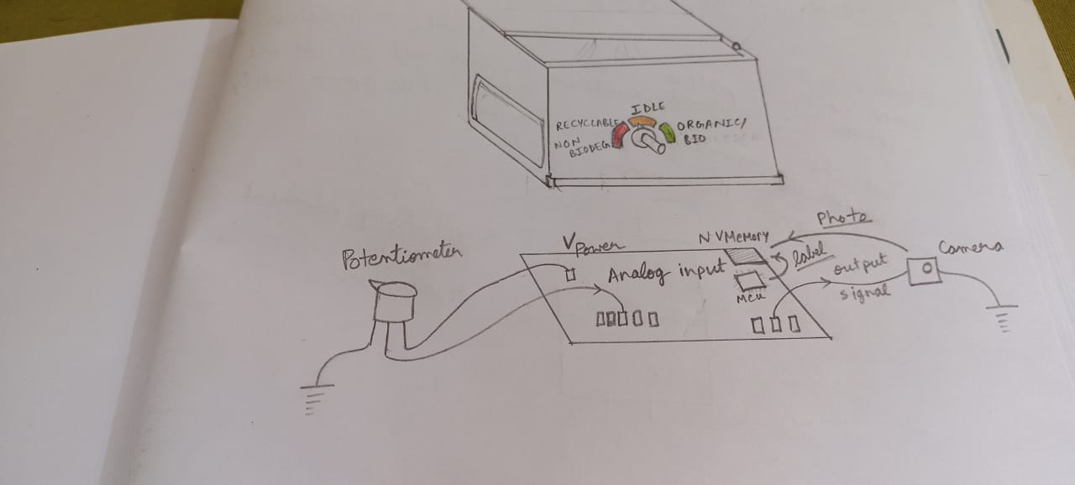

The training waste sorter box has a slightly different arrangement. The mechanical design is the same, but there is a potentiometer that acts as the indicator and two labels, organic waste and non-biodegradable and a gap for idle, in between. Normally the dial is in the idle state and the MCU does nothing. A waste is dropped, then the teacher turns the potentiometer knob to the appropriate direction and the program on the board triggers the camera to take a snap and assigns the appropriate label to the image. This data is stored in the on-board non-volatile memory and is later uploaded to the model as training data.