BRAND GUIDELINES · WEBSITE & LAUNCH MATERIALS
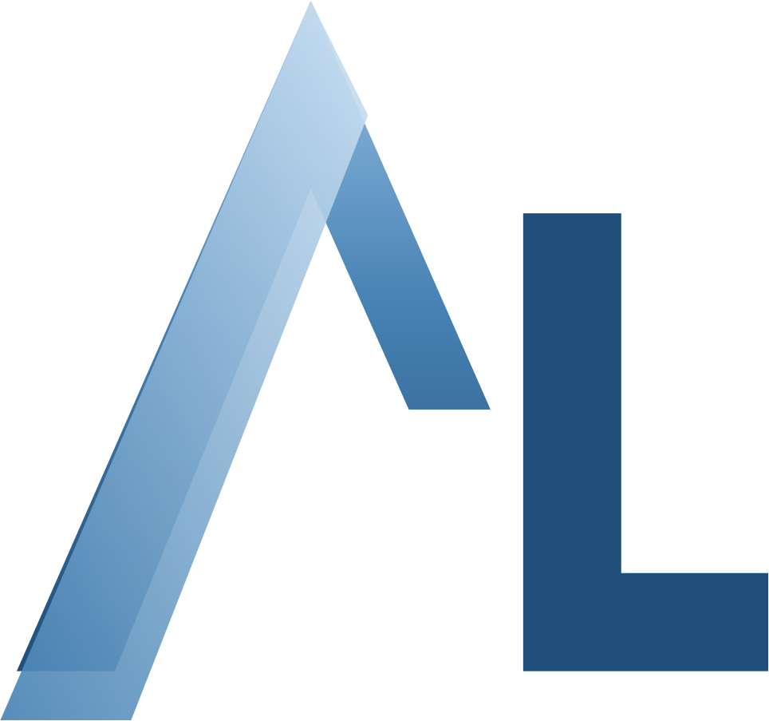
AltoLumo
Brand Book
The single source of truth for how AltoLumo looks, sounds, and shows up — on altolumo.com, in decks, and in every launch asset.

Version 8 · July 2026 · info@altolumo.com

01 · Foundation
The Brand at a Glance
Definition
AltoLumo (n.) — an AI-augmented fractional executive practice that puts a builder in your C-suite: full CTO & COO leadership for founders, startups, and growing companies.
Tagline
We build. You grow.
One-liner
I manage the projects, the people, the sprints, and the delivery outcomes — with Claude and AI streamlining every step.
Audience
Founders and executives of startups and growing companies who need executive weight without executive payroll.
Promise
Within 90 days, clients know exactly what's being built, who is building it, and when it ships.

These five lines are canonical. Copy them verbatim into new materials — never paraphrase the tagline or definition.
02 · Foundation
The Name & the Creed
Alto — high, elevated. Lumo — light, illumination. Together: elevated light — a builder who illuminates the path, then builds the road.
Always one word, capital A and capital L: AltoLumo. Never “Alto Lumo,” “ALTOLUMO” (except letterspaced labels), or “Altolumo.”
The founder's creed
“I am a builder. I work with Claude and AI to streamline your efforts, build, and keep working until outcomes are delivered. That is what I do.”
“I do not just advise. I work.”
— Kenneth Benavides, Founder

03 · Identity
The Logo — On White & On Color
The lockup is the AL ascent-peak mark plus the two-tone wordmark: “Alto” neutral, “Lumo” steel. The mark may stand alone as a favicon or avatar. Use the correct color treatment for the background it sits on.

  AltoLumo  On white — ink + steel |  |   AltoLumo  On ink navy — white + light steel

  AltoLumo  On deep steel — white + light steel |  |   AltoLumo  On warm tint — ink + steel

Color rules by background
- On light (Paper #FAF7F1, White, Warm Tint): wordmark in Ink Navy + Steel Blue. This is the default lockup.
- On dark (Ink Navy #1D2536, Deep Steel #1F4E79): wordmark in White + Light Steel #9DC3E6. Used in the hero, footer, and dark cards.
- The AL mark itself is background-agnostic — the same steel-gradient art sits on white or on ink navy (it is the favicon on ink navy).
Clearspace & sizing
- Clearspace = the height of the “A” on all sides. Keep it clear of other elements.
- Mark scales from a 16px favicon to hero size; wordmark minimum 24px / 0.35 in.
Don't
- Outline it, shadow it, or add a glow.
- Set it in serif or mono, or recolor it outside the palette.
- Break it into two words, or letterspace the wordmark.
Source art: assets/altolumo-mark.svg / .png (mark) and the two-tone wordmark. Mark alone for avatars and favicons.

04 · Identity
Color System
Paper dominates, steel is scarce. If Steel Blue exceeds ~10% of a layout it stops reading as an accent. Hex values are canonical — copy them exactly. They match the live site (altolumo.com) CSS variables.

 | Paper  #FAF7F1 | Canvas — the default background. ~60% of any layout.
 | White  #FFFFFF | Cards and content surfaces on paper. ~20%.
 | Ink Navy  #1D2536 | Dark sections, headlines, cover slides. ~15%. The darkest value — never pure black.
 | Steel Blue  #4682B4 | The accent: buttons, links, labels, emphasis. ~5%.
 | Deep Steel  #1F4E79 | Hover states, dark cards, depth behind steel.
 | Light Steel  #9DC3E6 | Accents and wordmark on dark backgrounds.
 | Warm Tint  #F2EDE3 | Section bands and subtle fills on paper.
 | Hairline  #E2DCCE | Card and table borders (1px).
 | Body Text  #3B4150 | Body copy on light. On dark, use #D9E2EF or lighter.
Accessibility: every combination must stay readable in black or white. Body is #3B4150 on light, #D9E2EF+ on dark.

05 · Identity
Typography
Web — Inter
- Display: Inter 800, tight tracking (-.02em).
- Body: Inter 400/500, 16.5px base, 1.7 line height.
- Labels: Inter 700, 11–12px, +.14 to +.22em tracking, UPPERCASE.
- Load via Google Fonts (site <head>).
Office — Calibri
- Decks & docs: Calibri throughout (Aptos-style clarity, installed everywhere). This document is set in Calibri.
- Titles 27–44pt bold · body 9.5–14pt · labels 8–10pt bold letterspaced caps.
- If Aptos is available in your Office build, it may substitute 1:1 for Calibri.
Hard rule from the founder: no serif display faces, no typewriter / mono faces, anywhere. Clean modern sans only, readable in black or white.
06 · Language
Voice & Tone
Builder-first — First person, active verbs. “I manage the projects, the people, the sprints, and the delivery outcomes.” Never hide behind “we leverage synergies.”
Plain terms — 5th–7th grade clarity sells at this level. Name the audience, the problem, and the outcome in one breath. Explain the hard thing simply, then build it.
Proof over promises — Numbers and shipped work: 15+ organizations, $30M programs, 183% revenue growth, MVP to paying-customer-ready in four weeks.
Calm confidence — Direct, warm, never salesy or breathless. No exclamation points. The discovery session is free because the work speaks.
When in doubt, read it aloud: if it sounds like a consultant wrote it, rewrite it.

07 · Language
Messaging Pillars
Every asset leads with ONE pillar, not all six.
01 | We build. You grow. | The tagline. Opens the site, closes the deck.
02 | Two full seats, one builder. | CTO + COO responsibilities, on fractional terms.
03 | Executive weight, without executive payroll. | The economic argument — 60–80% below full-time cost.
04 | Human judgment, machine speed. | The Claude / AI multiplier — days, not quarters.
05 | 90 days to clarity. | Discovery → plan → build → outcome. The promise.
06 | The work is public. Go look. | Proof: 15+ clients, GitHub, kajiro.org.
Landing hero = 01 + 04. Pitch deck Part 2 = 03 + 06. Social rotates through them. The Factory narrative (Today → Agentic; lanes Small / Medium / Consulting) is the strategic frame behind pillar 04.

08 · Identity
Imagery & Photography
What we show
- Real work: strategy sessions, whiteboards, teams building — editorial, candid, natural light.
- Kenneth's portrait: professional, warm, working — not a suit-and-handshake stock pose.
- Source: Pexels (free license) until brand photography exists.
Treatment
- Slightly desaturated (~85%) so photos sit behind the palette, not against it.
- Ink-navy gradient scrim on the lower third when text overlays.
- Rounded 14px corners + 1px warm hairline border — same radius as cards.
Never: neon AI-brain clip art, robots, glowing circuits, or generic handshakes.
09 · System
UI Components
- Buttons: pill shape (999px). Primary = steel, hover = deep steel. Ghost = hairline border.
- Section labels: numbered, uppercase, letterspaced steel (“01 · THE PRACTICE”), with a 56×3px steel rule under intros.
- Cards: white on paper, 1px #E2DCCE border, 14px radius. Hover: steel border + soft ink shadow + 2px lift. Dark cards use #27334B with #3D4A63 borders.
- Stats & chips: oversized 800-weight number + small-caps label; chips = bold name + muted one-line descriptor.
- Bullet dots: 8px steel circles — never dashes or arrows.
All components exist as working CSS in the site source (index.html) — copy from there rather than rebuilding.

10 · System
Do & Don't
Do  - Lead with outcomes and numbers.  - Keep steel blue scarce — it's the accent, not the theme.  - Write in Kenneth's first-person voice.  - Use the canonical lines verbatim (section 01).  - Keep dark sections ink navy, light sections paper.  - Copy CSS / components from the live site file. |  | Don't  - No serif display or typewriter / mono fonts — ever.  - No pure black (#000) — ink navy is the darkest value.  - No AI clip art: brains, robots, glowing circuits.  - No consultant-speak: leverage, synergy, best-in-class.  - No exclamation points, no breathless claims.  - No new colors, fonts, or taglines without updating this book.
11 · System
Assets, Domains & Wiring
Domain altolumo.com — canonical URL for all links and metadata. Hosted on Vercel; DNS & email via Javelina. Live build: web-altolumo.vercel.app.
Email info@altolumo.com — public contact and form fallback.
Public proof github.com/seasonalhawk · kajiro.org · linkedin.com/in/kennethbenavides.
OG image 1200×630 card — wordmark on ink navy with the steel orb motif — saved as /og.jpg at the site root.
Favicon The AL ascent-peak mark on ink navy, rounded square. Source: assets/altolumo-mark.svg.

Build it once. Use it everywhere.
Questions, exceptions, or new asset types: the book gets updated first, the asset second.
Kenneth Benavides · info@altolumo.com · altolumo.com

