ROV Flight Protocols

Table of Contents
Gear Checklist ……………………………………………………………………………………..……………… 1
- Assessing topside and underwater conditions ……………………………………..……………… 1
- Set up topside flight area ………………………………………………………...………..…………….. 2
- Power ROV …………………………………………………….…...………..……………………………….. 2
- Stage for launch at the dive ramp ………………………………………………………………………. 4
- Connect to the ROV …………………………………………………….…...………..…….…………….. 6
- Deploy and fly the ROV …………………………………………………….…...………..…………..….. 8
- In-flight Operation …………………………………………………….…...………….…..…………..….. 9
- Docking, undocking, and wirelessly charging the ROV ……………………………….……..… 11
- Retrieve ROV ………………………………………………………………………….………….……..….. 12
- Post-flight care …………………………………………………….…………………………….……..….. 13

Gear Checklist
- ROV Cart
- Orange Pelican Case
- ROV Laptop
- AB1 Key
- Radio
- Cell phone
- Personal Flotation Device (PFD; stored in closet opposite ramp)
- Pop-up tent + sandbags (optional unless direct summer sun or rainy conditions)

1. Assessing topside and underwater conditions
- Check weather, tides, and sea surface state before initiating flight protocol.
  - Do not operate on a tide lower than 1 foot (the ramp will be too steep / can’t reach the sea surface)
  - Do not operate with winds greater than 15 knots out of the north (blowing into you on flight deck).
    - Winds out of the south are largely blocked by Pier 59, though you may have water movement / chop.
- (Optional) Check water conditions via docking station camera for visibility at-depth
  - http://10.59.165.221/extensionv2/cockpitlite/#/
  - Do not fly if you have less than 1m of visibility
- Once you determine that conditions are good to fly, call Seattle Harbor Patrol at (206)-684-4072 to notify them of your plans.
  - "Hello, this is [insert name] with the Seattle Aquarium. We will be operating our Remotely Operated Vehicle over the side of the Aquarium from [time] to [time] today. We will operate between Piers 59 and 62 and do not intend to go past the end of Pier 59."

2. Set up topside flight area
- Set up a pop-up tent to alleviate rain / bright sun (be mindful of wind).
- Unlock ramp power box lever using AB1 key and power the ramp by moving the lever up to the “on” position.
- Descend the ramp slightly, then ascend the ramp slightly to verify functioning.
- Move cart to the dive ramp, positioned such that the cart is just to the right of the end of the ramp.
- Plug in the cart to the power outlet.
- Plug in the HDMI cord between the TV and ROV laptop.
- Plug in ethernet cord between ROV laptop and lower ethernet port (located in gray box to the right of the power outlet)
- Plug the laptop into the cart’s power strip to charge while in use.
- Turn on and sign into the laptop, verify that TV extends computer screen.

3. Power ROV
- Check the status of the ROV battery with the voltage reader by connecting the white terminals to pins (-) - 4.
- Pull out the battery enclosure lock (white cord with black ring poking out from top of battery enclosure).
- Remove the blue vent plug from battery enclosure and set it somewhere safe.
  - Note: there are three blue vent plugs on the ROV – make sure to remove only the middle one for the battery enclosure and avoid the upper one on the electronics tube and lower on the recharge box.
- Use the small Blue Robotics enclosure key to gently open the ROV battery enclosure.
  - Find an opening groove between the end cap and battery enclosure, insert the middle protrusion of the key, then twist the key.
- Pull the rear end cap off.
- Check the status of silicone lubrication on the two rear endcap O-rings.
  - If they are dry and/or if removal of the end cap is challenging, you can either:
  - Remove the O-rings with the O-ring pick, clean them with a dust cloth, apply silicone grease, and reapply the O-rings, or apply a small amount of silicone grease to the outside of the x2 O-rings.
  - Remove any hairs or particles from the O-rings as even small debris can compromise the seal and flood the battery enclosure.
    - Remove and clean with dust cloth if necessary, then reapply silicone grease and replace.
- Connect the ROV battery: attach the ROV battery’s cell balancer connector (white) first, then connect the main connector (yellow).
  - You should hear an initial chime when the battery is first connected, then a second chime approximately one minute later when the Pi and Navigator have fully booted
  - The ROV will not be ready to fly unless both series of chimes occur.
- Gently replace the end cap; the cap should rest flush against the tube, with two solid black lines forming inside where the O-rings make contact with the tube.
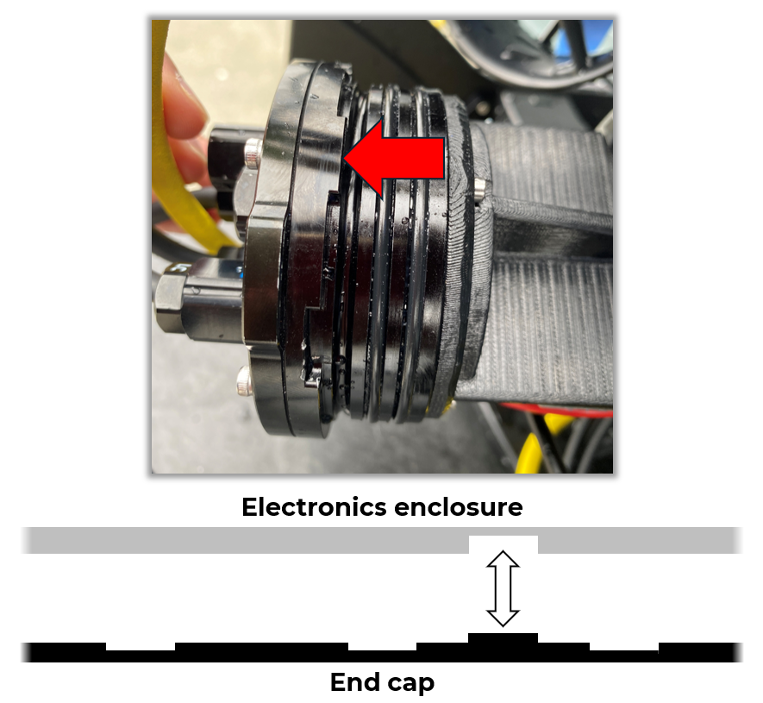
- Care is required when re-connecting the end cap – ensure that all cables are out of the way and that the end cap can seat properly, then match the rectangular notch to fit the groove in the acrylic tube. Pause if you feel resistance when attempting to replace the end cap.

- Reattach and tighten the vent plug.
- Replace the battery enclosure lock; the lock will easily slide in if you replaced the end cap properly but will resist if not.

4. Stage for launch at the dive ramp
- Double-check that the tether is securely clipped to ROV (i.e., that the tether is plugged in and that its carabiner is attached – should you have to manually pull in the ROV mid-flight, this clip will better protect the tether from damage).
- You will require x2 people familiar with ramp operations – the Pilot and the Copilot – both personnel are required to wear a Personal Floatation Device (PFD; found on the inside door of the closet opposite the dive ramp) when walking on the ramp.
- Designate an individual to attach the dive buoy (found in same closet as PFDs) to the railing at end of the ramp, then return to the ROV.
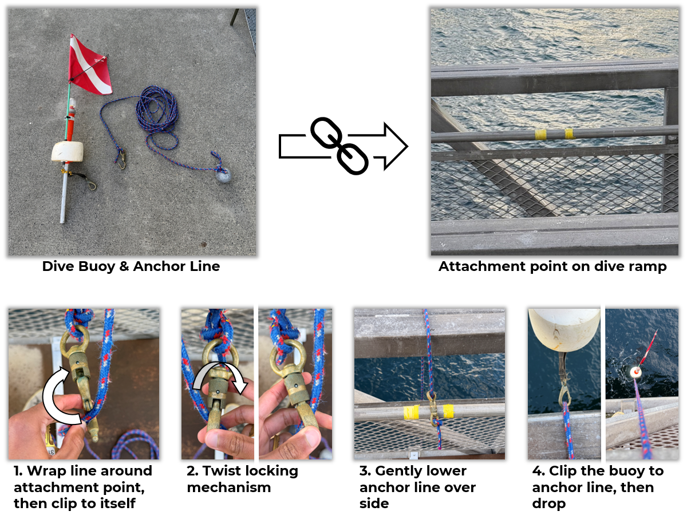
- With the Pilot carrying the ROV and Copilot carrying the tether spool both walk out and place their items at the end of the ramp.
- The Copilot stays at the end of the ramp; the Pilot returns to the cart, closing but not locking the ramp (keep the unlocked lock threaded in its spot so as not to lose it).
- The Copilot hands the tether spool to the Pilot from the ramp, where, upon handoff, the Pilot will verify their grip on the spool via a verbal “Got it!” before the Copilot releases their grip.
- The Pilot sets the tether on the ground to the left of the cart.

5. Connect to the ROV
- Connect the FXTI-Spool Connector to the FXTI box and tether spool:
  - Ensure the black end piece of the connector (with the lock icons) is turned all the way left before aligning the white arrow with the white line on both the spool and FXTI ports.
  - You must insert the cable and rotate the top piece into the "lock" position, otherwise the cable will eject.
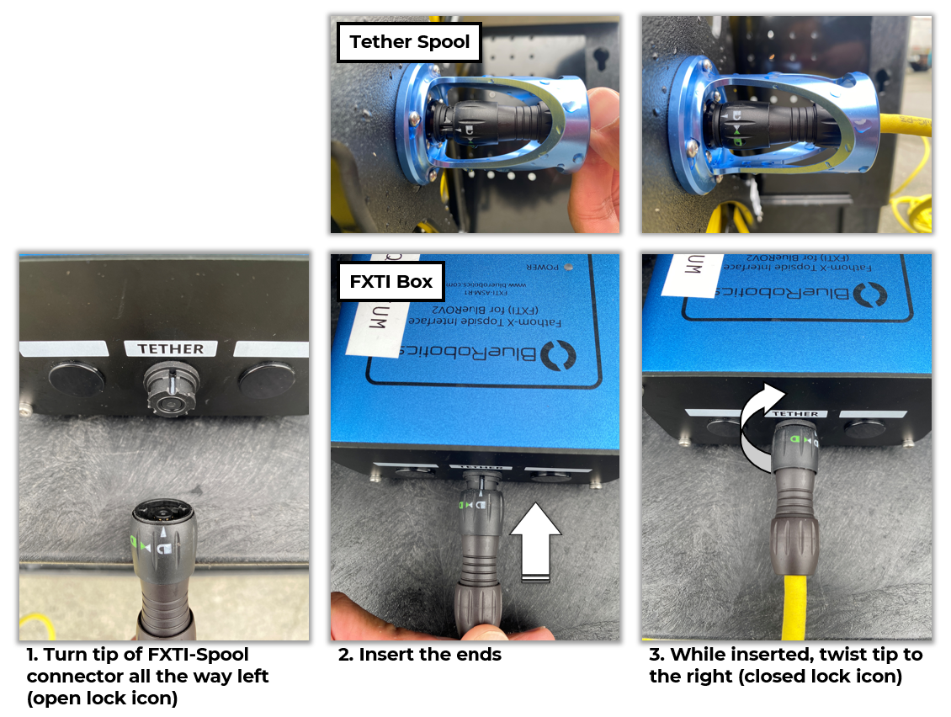
- Ensure the connector is routed such that does not impede the tether, i.e., ensure the tether can freely unspool.
- Connect the ethernet-USB cable to the FXTI box and to the flight laptop’s USB port.
- Connect the Xbox controller to another flight laptop USB port.
- Access BlueOS by opening Chrome and proceeding to 192.168.2.2 (type this directly into the search bar).
  - Verify BlueOS connection.
- If the page does not load, wait a moment, then close the tab and try unplugging and re-plugging the FXTI USB wire.
  - Verify ROV voltage and heartbeat from the BlueOS homepage by clicking the heart icon on the top right.
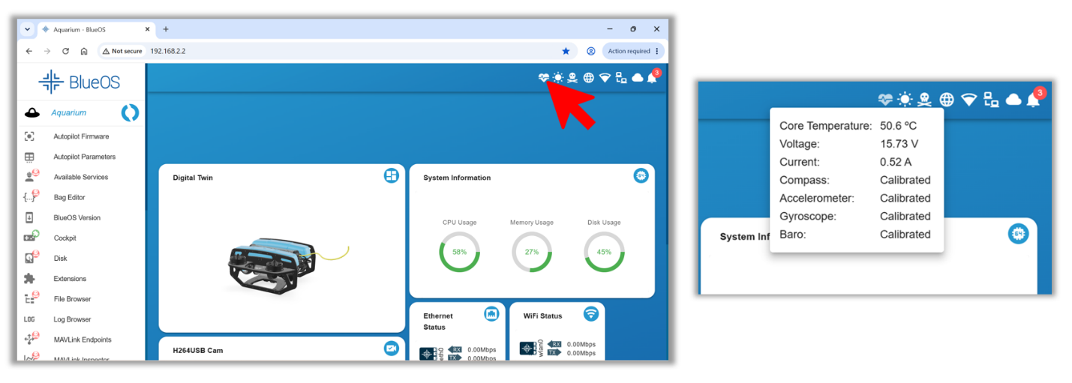
- Open desktop application "Cockpit", or, if the desktop version proves challenging, default to "Cockpit Lite" found on the BlueOS homepage (it will open in a browser tab).
  - If prompted, select "Aquarium" from the profile prompt.
  - Verify both downward and forward camera feeds are visible on-screen.
  - Use the Xbox controller to arm the vehicle (see control map).
  - Verify control: check "pilot gain" (AKA thrust power; hereafter referred to as "gain") seen on the left side of the bottom ribbon.
  - Briefly activate thrusters.
  - (Optional) Cycle lights up and down.
- The vehicle is now ready to deploy.

6. Deploy and fly the ROV
- Pilot lowers ramp with Copilot and ROV until just above water level.
- Copilot makes a final check to ensure vent plugs are in place and tight.
- Copilot issues a verbal “Are you ready?” to the Pilot.
- Pilot verifies that the vehicle is armed and set to "Manual" flight mode.
- Copilot gently sets the ROV in the water.
- Copilot returns to cart and ascends the ramp to be slightly above the water line.
- Pilot motors the ROV on the surface northwest (using compass on Cockpit UI) about 10 meters away from the ramp and ascent piling; visually confirms ROV flight controls are responding as expected.
- Pilot descends the ROV.
- (Optional) Operate the x2 downward and x2 forward lights as desired.
Notes
- CCR team surveys with the ROV at 20-40% thruster gain, depending upon current.
- 20-40% gain works well for smaller movements when investigating and exploring.
- 40-70% gain can be utilized to cover longer distances quickly.
- It is not recommended to run the thrusters at 100% as not only does the ROV become difficult to control but it may fry the electronics if used for extended periods.

7. In-flight Operation
- The Copilot manages the tether while the Pilot flies; they should let out and pull in slack as needed.
- Communication is key! Communicate so the Copilot understands:
  - where the ROV is;
  - where the Pilot wants to go;
  - when the Copilot should anticipate the need to spool out or recover tether slack (see slack figure on next page).
- The Copilot should take the lead on interacting with guests when the flight deck becomes crowded so the Pilot may focus on flying.
  - Optionally, recruit a volunteer to fulfil this role/assist with general tasks, such as tether management.
  - In stressful situations, your primary focus should be managing the ROV – inform guests as such and/or call in back up to assist with crowd control.
- If the ROV’s forward movement is sluggish, or it cannot move forward, you may need to let out tether.
  - Be mindful that the tether can be repositioned by wind, current, and other water movement.
- If the tether gets wrapped around something, you can likely undo the wrap using the ROV and the Copilot's position on land.
  - Stay calm; be patient; conduct movements carefully.
  - Locate the tether via the forward-facing camera and see how the ROV's movements can "undo" the snag.
- Do not let an excess amount of tether gather at the surface – actively manage the tether.
  - Be especially aware and alert of hazards in the flight area.

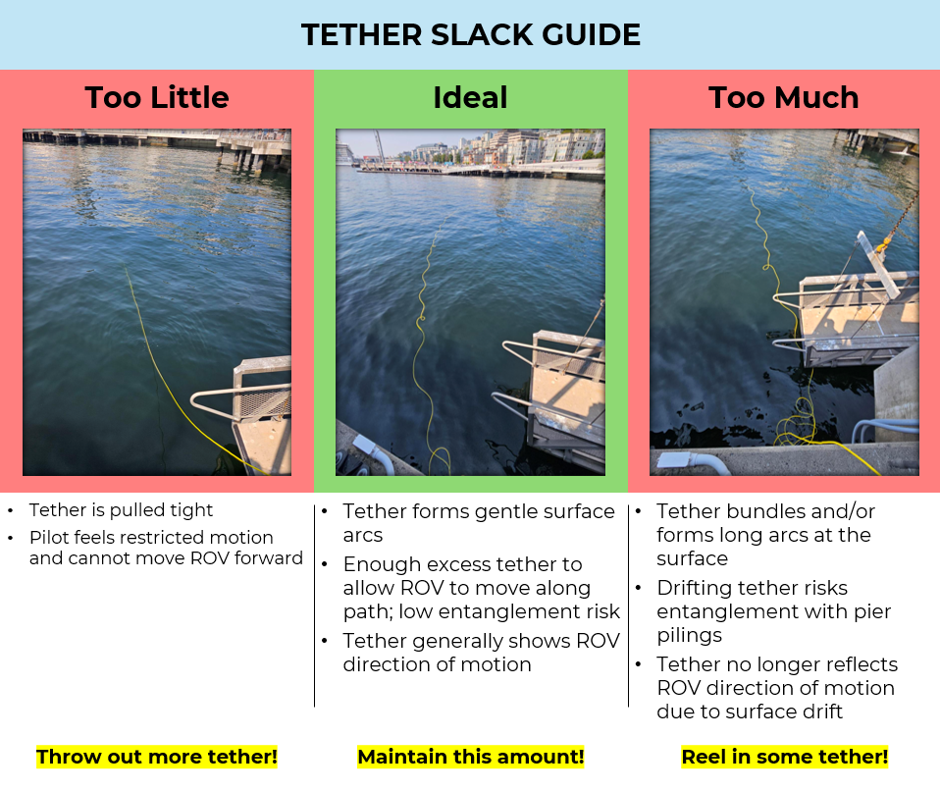

Notes
- Monitor the battery voltage throughout the flight and do not let it dip below 12.5V as this may damage the battery!
- Do not fly outside of the range (in an arc shape) from the end of Pier 59 to just past the harbor seal habitat and avoid the floating dock at Pier 62 especially.
- The ROV’s tether is buoyant and serves as your only visual locator for the ROV when at-depth.
- Sun glare shining down into the water can obscure the yellow tether.
- You can always ascend the vehicle to the surface to visually locate it.
8. Docking, undocking, and wirelessly charging the ROV
- With the ROV camera angled slightly downward such that the ROV's "nose" is somewhat within view, align the ROV in front of the docking station.
- Position the target cross on the docking station in the center of your screen.
- Gently motor forward such that the ROV's "nose" enters the docking station port (the black hole with bristles lining it).
- With the ROV positioned on-center to the station, up the gain to at least 70% and fully push the joystick forward to ensure a full connection.
  - Note: This will not look pretty, but don't worry!
- Switch the ROV into Manual flight mode; observe the ROV affixed in place – it may jostle but display a clear hold to the station (i.e., doesn’t float up/out).
- On the ROV laptop, navigate to the WiBotic dashboard web interface at http://10.59.165.222/#/overview.
- Turn the "Transmitter" and "Charger" toggles on.
  - You should observe charging via the on-screen metrics and visualizations.
- Upon completing the charge, or upon wanting to disembark the station, arm the ROV (if disarmed), set gain to 70%, and gently but firmly reverse.
- Return gain to 20-40% and resume normal ROV flight operations.

9. Retrieve ROV
- Pilot fully angles the ROV camera to the up position, turns to locate the tether on screen, and follows back to ramp.
- Pilot positions the ROV at the surface clear of the ramp and maintains position.
- Copilot dons PFD and lowers ramp to touching water level.
- Copilot unlocks gate, hangs lock in its hold, and descends along the ramp.
- Pilot approaches ramp with the ROV, then switches to Manual flight mode.
- Pilot makes final approach to the ramp and turns the ROV to the side for easy removal via the handles on the vehicle.
- Copilot, with one hand on the rail, puts the other hand on the ROV and issues a verbal “Got it!” to the Pilot.
- Pilot then responds “Manual!” to verify the ROV is ready to retrieve.
  - Pulling the ROV out of the water in "Stabilize" or "Depth Hold" flight modes will result in the thrusters continuing to fire in an attempt to minimize ROV movement (i.e., you will get splashed as the ROV is pulled out of the water!).
- Copilot lifts ROV out of the water and gently sets on ramp.
- Pilot disarms vehicle and raises ramp.
- Copilot observes the tether and makes sure it will raise properly as the ramp ascends.
- Pilot spools up and clears excess tether.
- On the BlueOS webpage, Pilot navigates to the bottom of the left-hand side bar and clicks the power icon.
- Pilot selects "Power Off" and waits ~30 seconds for the message "System is off. You can disconnect power now."
- Pilot disconnects FXTI-Spool Connector from spool, then hands spool over to Copilot (again, verifying a grip before letting go).
- Pilot dons PFD and joins the Copilot on ramp before returning with ROV and spool.

10. Post-flight care
- Take the ROV and tether spool to the back of Pier 59 and spray thoroughly with freshwater from the hose.
  - Focus particularly on:
    - thrusters
    - areas with wire connections
    - any exposed metal
  - Be mindful of items left on or near the cart while away, especially the Xbox controller, laptop, and personal items. Alternatively, bring the cart to the back deck with you.
- Once the ROV has been rinsed, use a microfiber towel to remove excess water from the battery enclosure area.
- Power down the ROV: remove the enclosure lock and vent plug from the battery enclosure and store somewhere safe, open the enclosure using the key, and disconnect the battery wires.
  - Be careful not to tug the connectors apart by the wires themselves – pull only from the white and yellow terminal pieces.
- Reattach the battery enclosure panel without the battery inside.
- Replace enclosure lock and vent plug.
- Stow ROV and tether in the cart and wheel to old PCR habitats in shark holding.
  - Avoid getting any electronics, including the power strip and TV power cable, wet when stowing the ROV.

For troubleshooting and helpful visuals, visit:
https://seattle-aquarium.github.io/ROV_underwater_wireless_charging/

