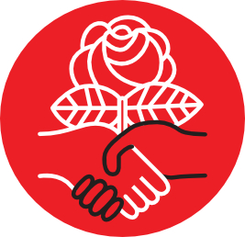
Seattle Democratic

Socialists of America

For Immediate Release
10/10/2019

For More Information Contact
Seattle Democratic Socialists of America
Email: info@seattledsa.org Telephone:

SEATTLE RALLIES FOR ABOLITION: ABOLISH POLICE, INVEST IN COMMUNITY!
Seattle, Washington – Community organizers will convene hundreds for a rally on Tuesday, October 17, 2019. The coalition will make their shared demands known to Seattle Mayor Jenny Durkan and the City of Seattle to:
1. End the lawsuits that prevent justice.
2. Defund and abolish policing.
3. Reinvest in Community.
4. Resign Mayor Turdurkan.
5. Release the Protestors.
On the anniversary of Seattle’s fire department being formed, we demand that we fight the fire of racial capitalism with the water of peoples’ solidarity through immediate divestment of Seattle Police and into Black, Indigenous, and People of Color Communities (BIPOC) abandoned by the political establishment.
What: Rally demanding abolition of policing and then reinvesting in BIPOC communities.
Who: Coalition Partner 1, Coalition Partner 2, Seattle Democratic Socialists of America
When: Tuesday, October 17, 2019 from 5:00 PM to 8:00 PM PDT
Where: Magnuson Park baseball fields, 65th Ave NE, Seattle, WA 98115
Northwest of Magnuson Frog Pond Park and Ride, Due South of Magnuson Tennis Center Lot
###

