About InstantSVC – Design and Structure
- Strukturierung in Requirements-Teil und Design-Teil
- Requirements-Teil (Overview) max. 2 Seiten
  - What is the component about?
  - Welches Problem wird gelöst? which problem is solved?
    - Was macht es und was nicht
  - Which features will it provide?
    - Wie kann es genutzt werden

  - Konzeption und Aufbau
    - FMC-Aufbaubild aus Präsentation
    - Grobe Ziele des Designs
    - Funktion erklären
  - Verwendete Formate
- Design-Teil (den vielleicht noch nicht in der Intro mail) (Implementational Overview)
  - Erklärung der Designentscheidungen, Begründung
  - Soweit vorhanden, verwendete Algorithmen erklären
  - Eventuelle Datenstrukturen erklären (externe und interne)
  - Liste und Kurzbeschreibung der Enduser Tools
  - Liste der Klassen
  - aufbauend auf Package Diagramm

Overview
Web Services are one of the key elements in modern software architectures like the Service-oriented Architecture for instance. It is not only a hype or a buzzword, it is actually useful, too.

PHP as a dynamic and object oriented language has proven to serve well for writing web applications. So it is good choice to create Web Services, too. With PHP5 a build-in extension has enriched the possibilities to provide high-performance and reliable service supporting the SOAP (http://www.w3.org/TR/soap/) protocol. But at this point the support for tool based software development ends without adding features like support for enhanced Web Services Standards or generation of Web Services descriptions with WSDL.

Ok, at this point one could mention SOAP is not suitable for all applications and REST (http://www.ics.uci.edu/~fielding/pubs/dissertation/top.htm) could serve this much better, but tools are a nice to have at this point, too.
So what is missing for REST and SOAP Web Service in a standard PHP development environment?

It would be really nice to have a tool based solution to add Web APIs to an application core without necessarily implementing this API on top of the application just to compensate environment specific issues.

Most non-design related issues can be solved easily with tool support.
For SOAP Web Services necessary WSDL can be generated from the service description already defined by the APIs implemented with PHP. Support for advanced WS-* Standards could be added by configuration using a set of libraries.
For REST Services the design approach is different, but tool based support to map the service to a object-oriented application core can be provided, too. The main issues here are data formats and URL-to-API mapping which can be solved with a REST Server. This server works with configuration rules describing the (de)serializer to be used on a specific request and the API method to be called in the application core.

To fulfill this needs the following features are provided.

Features
- Extended Reflection API
  - add type information to PHP via PHPDoc comments
  - add annotations mechanism
- WS-I conform WSDL-Generator
  - generate WSDL from your PHP files
- document/literal-Adapter-Generator
- Handler-Chain-Mechanism for SOAP processing
  - useful to provided WS-* support
  - implementation of WS-Security and Username Token Profile
- rich support for REST Web Services
  - rule based request to API mapping
- Administration Tool for comfortable creation und management of SOAP-und REST-Services

Usage
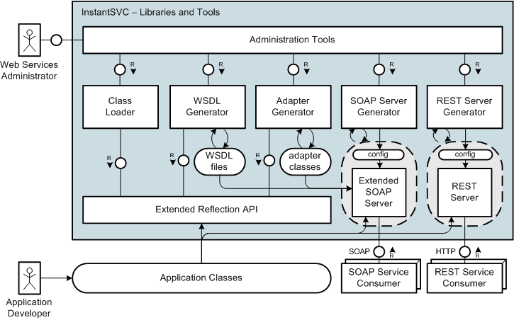

  - What is the component about?
  - Welches Problem wird gelöst? which problem is solved?
    - Was macht es und was nicht
  - Which features will it provide?
    - Wie kann es genutzt werden

  - Konzeption und Aufbau
    - FMC-Aufbaubild aus Präsentation
    - Grobe Ziele des Designs
    - Funktion erklären
  - Verwendete Formate
