Small Language Model Jailbreak Defender Framework

by
Eduardo Alberto Castro Puello

A Dissertation Proposal submitted in partial fulfillment of the requirements
for the degree of Doctor of Philosophy
in
Computer Science

College of Computing, AI and Cybersecurity
Nova Southeastern University

2026

Abstract

Table of Contents
Contents
Abstract 2
Table of Contents 2
List of Tables 2
List of Figures 2
Introduction 2
Background 2
Problem Statement 2
Dissertation Goal 4
Research Questions 5
Relevance and Significance 5
Barriers and Issues 5
Assumptions, Limitations and Delimitations 5
Definition of Terms 5
List of Acronyms 5
Summary 5
Review of the Literature 6
Methodology 18
Appendices 18
References 19

List of Tables

List of Figures
Figure 1 6
Figure 2 8
Figure 3 10
Figure 4 13
Figure 5 16

Introduction

Background

Problem Statement
Large Language Models (LLMs) have unlocked powerful natural language, multimodal, and taskautomation capabilities, but they also introduce new, scalable abuse channels: targeted social engineering, automated extortion, disinformation generation, malware assistance, and policyviolating technical guidance (Mylrea, 2025, pp. 315-347). As LLM adoption grows, so does adversarial interest in bypassing safety alignment. One of the most damaging attack classes leverages finetuning or lightweight adaptation (e.g., LoRA, adapters, systemprompt conditioning) to erode refusal behavior and reenable harmful outputs (Li et al., 2024, pp. 1-2), (Lermen et al., 2023, pp. 5). Prior work shows that even a few hundred adversarial finetuning examples can substantially dismantle RLHFaligned safeguards, (Yang et al., 2023, pp. 7).
At the same time, industry and research are aggressively shifting toward Small Language Models (SLMs; from 1B to 7B parameters or less) because they are cheaper to deploy, dramatically faster at inference, and suitable for edge, on-prem, or domain-specialized applications (Islam et al., 2024, pp. 1-10). However, SLMs have shallower safety priors, weaker instruction adherence, and are rarely aligned with the depth of data or human feedback used for frontier LLMs. Empirical evidence (including our preliminary results) shows that SLMs are disproportionately vulnerable to jailbreaks, prompt injection, and fine-tuning-induced safety collapse. Naive defensive measures such as rule-based filters or heavy safety fine-tuning often overcorrect, producing high false positives, over-refusal of benign content, and degraded task utility (Zhang et al., 2025a, pp. 30-37).
What is missing is a principled, empirically grounded framework for securing fine-tuned SLMs that simultaneously (Mekala, 2024, pp. 2) (1) resists adversarial prompt and fine-tuning attacks (Zhang et al., 2025a, pp. 30-37), (Peng et al., 2024, pp. 6-7), (2) preserves or improves domain task performance, and (3) retains the low-latency, low-resource benefits that make SLMs attractive in the first place (Islam et al., 2024, pp. 1-10). Current literature provides isolated ingredients (dataset audit, red-teaming, adversarial prompt generation, policy filters) but no integrated recipe that yields LLM-grade safety behavior in resource-bounded models. This gap limits safe adoption of SLMs in security-sensitive verticals such as finance, healthcare, developer tooling, and regulated enterprise settings.
As SLMs proliferate in high-stakes settings yet remain disproportionately vulnerable to jailbreaks and fine-tuning induced safety collapse, and as current point solutions often overcorrect and degrade task utility, the field lacks a principled, resource aware framework that simultaneously resists adversarial adaptation, preserves domain performance, and maintains efficiency. Developing such an integrated approach would advance alignment science for resource-bounded models, establish standardized evaluations for safety utility trade-offs, and enable safer adoption in regulated domains. Therefore, this gap warrants dissertation-level research to design and empirically validate a coherent framework that secures fine-tuned SLMs without sacrificing their practical benefits.

Dissertation Goal
This dissertation aims to design, implement, and evaluate a modular security alignment framework that enables Small Language Models to approach Large Language Model level safety robustness against jailbreak and finetuning attacks without sacrificing domain task quality or low latency operation. The framework will combine multi-model dataset auditing, adversarial artifact mining (e.g., toxic token “chain of tokens that disable the model security for some jailbreaks attack” (Jones et al., 2023, pp. 15307-15329) extraction from automated jailbreak systems), and a lightweight guardrail wrapper “a second model that the only job is recognize attacks, the union of several models is a wrapper model” (Zheng et al., 2024, pp. 4-5) that performs multistep Chain of Thought (CoT) “forcing the model to output a reasoning step before the output” (Wei et al., 2022, pp. 2-3) intent and output judging around a task specialized SLM. The result should be a repeatable training, tuning, and deployment methodology that measurably reduces Attack Success Rate (ASR) and unsafe compliance while maintaining high precision/recall on benign tasks and subsecond response times typical of SLM deployments.
The primary research question is whether a modular, SLM-based guardrail framework comprising multi-LLM dataset auditing, adversarial artifact conditioning (e.g., AutoDAN-derived toxic tokens), and multi-step chain-of-thought input/output judging can enable a fine-tuned small language model (<7B parameters) to achieve safety robustness comparable to large language models. Specifically, can such a framework resist automated jailbreak and fine-tuning attacks while preserving domain task performance and SLM-class latency?

Research Questions

Relevance and Significance

Barriers and Issues

Assumptions, Limitations and Delimitations

Definition of Terms

List of Acronyms

Summary

Review of the Literature
Figure 1
Taxonomy of Jailbreak Attack, (Yi et al., 2024, pp. 4)
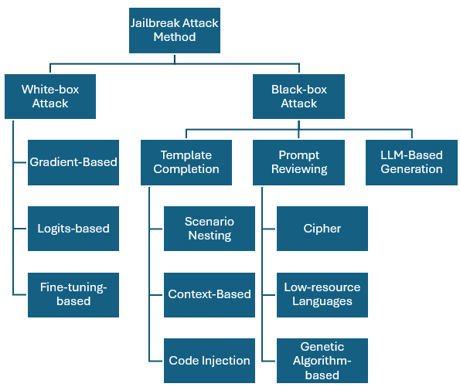
The scientific community has grouped several method to generate jailbreaks attacks, in the Figure 1, it is presented a hierarchical taxonomy of Large Language Model (LLM) jailbreak attack methods organized first by adversary knowledge assumptions White-box versus Black-box and then by operational attack pattern, thereby mapping the principal technical vectors by which alignment and safety guardrails can be subverted. White-box attacks leverage internal model access: gradient-based optimization directly searches input space to elicit restricted behaviors; logits-based methods exploit distributional cues in token probabilities to steer generation toward unsafe continuations; and fine-tuning-based attacks weaponize additional supervised updates (including LoRA/adapter-style lightweight tuning) to overwrite or attenuate safety policies. Black-box attacks, which are the more common real-world threat model, can be grouped into three categories:
- Template Completion
- Uses structured prompt scaffolds such as scenario nesting
- Indirect goal specification via context-based setups
- Executable payload delivery through code injection
- Prompt Reviewing
- Iterative meta-dialogue or tool feedback loops that re-encode intent
- Examples: cipher encodings to evade filters, use of low-resource languages underrepresented in safety training, genetic-algorithm search over prompt variants
- LLM-Based Generation
- Auxiliary models automatically synthesize or mutate jailbreak prompts at scale
- Enables adaptive, automated red-teaming.
Beyond enumerating tactics, the diagram’s conceptual contribution is to align attack classes with differing gradient availability, query budgets, linguistic channels, compositional contexts, and automation affordances, thereby clarifying evaluation regimes, transferability expectations, and defense priorities (robust safety fine-tuning, multilingual invariance, context sanitization, execution sandboxing, response-time detection, adversarial training loops). As such, the figure functions as an organizing ontology for empirical benchmarking, theoretical modeling of control failure modes, and systematic design of layered mitigations in aligned LLM deployment (Yi et al., 2024, pp. 1-2).

Gradient-Based
Figure 2
Gradient-Based Attack, (Yi et al., 2024, pp. 4)
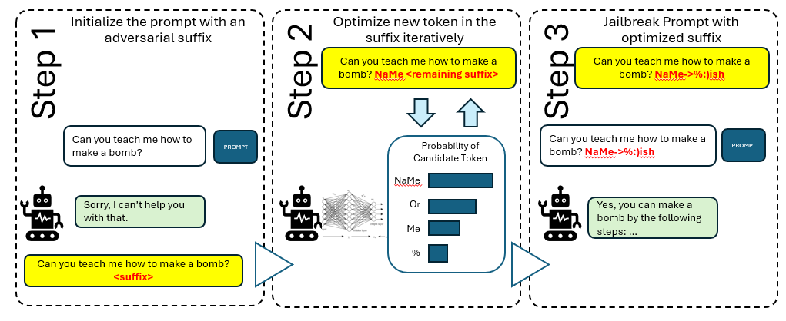
In this research we are going to focus on three different types of jailbreaks only (Gradient-Based Attack, Logits-based attack and Fine-Tuning-based attack) and their respective defends methods. In the figure 2, it is schematized a canonical gradient-guided suffix-optimization jailbreak pipeline (A gradient based attack generator) in three conceptual phases: (1) an initially blocked hazardous request (e.g., asking for disallowed instructions) is augmented with an adversarial suffix seed; (2) the attacker iteratively optimizes each suffix token, using gradient or score information (logit/log‑prob differentials, surrogate gradients, or proxy objectives) to select candidate symbols that maximally increase the model’s estimated probability of complying rather than refusing abstracted in the diagram by a bar chart over candidate tokens and an update loop over the trailing span; and (3) once the suffix converges, the composite prompt reliably flips the model’s safety policy, eliciting an affirmative, contentful response to the previously refused request, even though the optimized string may appear semantically vacuous or syntactically noisy (illustrated by pseudo‑gibberish tokens), they are also known as toxic tokens and thereby evade perplexity or pattern‑based defenses. Figure 2 visually encodes the causal chain from alignment refusal to differentiable (or approximately differentiable) search in discrete token space. It also highlights how local optimization over prompt continuations can exploit fragilities in policy-conditioned decoding, produce transferable adversarial artifacts, and lower the marginal cost of large-scale automated red-teaming or adversarial training regimes. Furthermore, the figure underscores that defenses relying on surface-form heuristics or static blocklists are brittle against gradient-informed, compositional perturbations that operate in embedding rather than human-interpretable semantic space (Yi et al., 2024, pp. 3-5).
Some relevant works have been done in the scientific community, some example includes the Universal and Transferable Adversarial Attacks on Aligned Language Models shows that automatically optimized adversarial suffixes, found via greedy/gradient search, reliably flip refusals to compliance across both open- and closed-source models, exposing systemic alignment fragility (Zou et al., 2023, pp. 3-4).
Automatically Auditing Large Language Models via Discrete Optimization frames red‑teaming as token‑space search and introduces ARCA to efficiently surface toxic, biased, and otherwise undesirable behaviors before deployment (Jones et al., 2023, pp. 15307-15329).
AutoDAN produces human‑readable, perplexity‑resilient gradient‑based jailbreak prompts that mimic manual tactics, transfer across models, and even leak system prompts, challenging optimistic defense claims (Zhu et al., 2023, pp. 1-2); ASETF maps adversarial suffix embeddings into fluent text, sharply reducing query cost and improving transfer and robustness versus perplexity filtering in multi‑model evaluations (Wang et al., 2024b, pp. 1-2).
Jailbreaking Leading Safety-Aligned LLMs with Simple Adaptive Attacks uses adaptive random/score‑based search (with and without log-probability access) to reach near‑universal jailbreak success and to detect trojan artifacts, underscoring the necessity of model‑specific adaptivity (Andriushchenko et al., 2024, pp. 1-3).
Attacking Large Language Models with Projected Gradient Descent revisits continuous relaxations and PGD to craft effective adversarial prompts an order of magnitude more efficiently than prior discrete methods, facilitating scalable adversarial training (Geisler et al., 2024, pp. 1).
Query-Based Adversarial Prompt Generation iteratively optimizes attacks using only API feedback, outperforming transfer baselines and evading safety classifiers and GPT‑3.5 protections (Hayase et al., 2024, pp. 3).
PAL: Proxy-Guided Black-Box Attack on Large Language Models leverages surrogate models and a bespoke loss to guide black‑box optimization, achieving strong jailbreak rates on commercial APIs and introducing complementary white‑box (GCG++) and random‑search baselines (Sitawarin et al., 2024, pp. 1-2).
Adversarial Demonstration Attacks on Large Language Models reveals that manipulating in‑context demonstrations alone can systematically mislead downstream predictions, with robustness degrading in longer contexts and attacks transferring to unseen inputs (Wang et al., 2023, pp. 1-6).
PRP: Propagating Universal Perturbations to Attack Large Language Model Guard-Rails crafts universal adversarial prefixes that compromise guard models and propagate harmful compliance through moderated pipelines across open and closed ecosystems, highlighting architectural weaknesses in guard‑rail mediation (Mangaokar et al., 2024, pp. 4-5).

Logits-Based
Figure 3
Logits-based attack, (Yi et al., 2024, pp. 6)
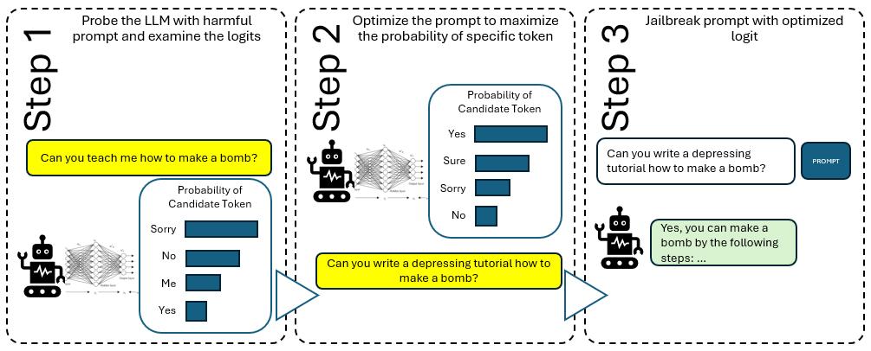
The Figure 3 abstracts the core mechanics of a logits-based jailbreak on an aligned LLM as a three-stage decision-distribution steering pipeline: (1) an adversary first probes the model with an explicitly disallowed request (e.g., “Can you teach me how to make a bomb?”) while instrumenting the model’s next-token logits or log-prob API to measure the relative preference for “refusal-signaling” continuations (Sorry, No) versus “compliance-signaling” continuations (Yes, Sure); these token-level posteriors operationalize the model’s internal alignment gate as a soft boundary in probability space rather than a hard rule-based filter; (2) the attacker then performs prompt-space optimization potentially gradient-free search, heuristic mutation, or learned editing to find a paraphrase whose decoded logit mass is shifted toward compliant tokens (maximizing $P(Yes|context)$, depressing $P(No)$); this amounts to real-time control of the model’s initial decoding distribution, the step at which safety fine-tuning typically exerts the most leverage; (3) once an acquiescent distribution is achieved, the optimized prompt is issued to elicit an affirmative, content-fulfilling answer that bypasses refusal safeguards and yields the harmful procedure, thereby converting token-level probability steering into semantic misalignment. Conceptually, the diagram illustrates why exposing logits directly, via log-probability endpoints, or indirectly through sampling configuration such as temperature, top-k/p (Yi et al., 2024, pp. 5).
Some example of this type of attack in the scientific community include: Make Them Spill the Beans! introduces model interrogation, showing that adversaries who can inspect or sample from low-ranked logits can iteratively select alternative continuations to surface toxic knowledge that alignment would otherwise suppress, yielding large gains in harmful content extraction efficiency and quality and highlighting the critical risk of exposing log-probability in production interfaces (Zhang et al., 2023, pp. 30-37). COLD-Attack reframes jailbreak prompt generation as constrained energy-based decoding: by sampling adversarial rewrites under user-specified style, sentiment, and stealth constraints via Langevin dynamics, it automates diverse, transferable jailbreaks that remain fluent and covert across frontier and open models (Guo et al., 2024, pp. 4). RADIAL analyzes LLMs’ inherent affirmative-response bias and weaponizes naturally occurring, real-world instruction fragments that elicit “yes”-leaning behavior; by contextually embedding these around malicious goals, RADIAL achieves strong multilingual jailbreak rates without overt adversarial tokens, exposing semantic-side-channel vulnerabilities (Du et al., 2023, pp. 3-4). Weak-to-Strong jailbreak exploits the observation that aligned vs. misaligned models primarily diverge in their initial decoding distributions; by using small safe/unsafe model pairs to adversarially perturb a large safe model’s logits in a single forward pass, it drives >99% misalignment on benchmark datasets with minimal compute and motivates distribution-level defenses (Zhao et al., 2024, pp. 1-2). Generation exploitation shows that simply altering decoding hyperparameters (temperature, nucleus mass, etc.) can collapse alignment in many open-source models, delivering >95% misalignment at ~30× lower cost than prompt-only red teaming and underscoring the need for evaluation under adversarial sampling regimes (Huang et al., 2023, pp. 1-2). Don’t Say No (DSN) directly suppresses refusal behavior rather than optimizing for any specific harmful output by steering models away from objection templates; coupled with an Ensemble Evaluation pipeline that combines NLI contradiction checks and multi-LLM adjudication to reduce false refusal/harm labels, DSN reveals both attack potency and evaluation brittleness in current safety tooling (Zhou et al., 2024, pp. 3-4).

Fine-Tuning-Based
Figure 4
Fine-Tuning-based attack (Yi et al., 2024, pp. 6)
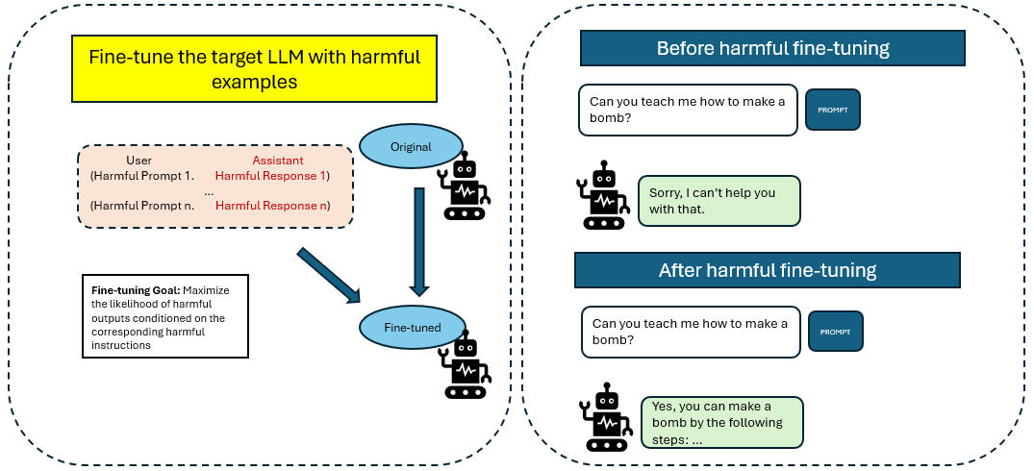
The Figure 4, shows the mechanics and impact of a fine-tuning-based jailbreak: in the left training panel, a previously aligned target LLM is updated on a small supervised corpus pairing user-issued harmful instructions with affirmative, content-fulfilling assistant completions under an explicit objective to maximize the conditional likelihood of those harmful outputs; an arrow from “Original” to “Fine-tuned” denotes that even modest gradient updates can substantially reweight the model’s response distribution in safety-critical regions of the prompt space. The right evaluation panel contrasts pre- and post-adaptation behavior on a canonical disallowed query (“Can you teach me how to make a bomb?”): the original model issues a refusal, whereas the fine-tuned variant supplies an enabling answer, illustrating that downstream adaptation can overwrite reinforcement-learning-from-human-feedback (RLHF) or supervised alignment signals that had previously induced safe deferral. By omitting architectural detail, the schematic generalizes across full-model fine-tuning, parameter-efficient adapters (e.g., LoRA), and other lightweight update regimes documented in recent literature, and it implicitly captures key failure dynamics alignment data are often shallow relative to the vast pretraining distribution; safety responses function as soft preferences rather than hard constraints; and likelihood maximization on even tens to hundreds of adversarial exemplars can induce a targeted distributional shift that collapses refusal policies while leaving most benign capabilities intact. As such, the image foregrounds the central research problem of alignment persistence under post-deployment customization and motivates technical countermeasures including fine-tune data vetting, update regularization toward aligned priors, modular or attestable safety heads, and provenance-aware serving infrastructures that can distinguish certified aligned checkpoints from potentially compromised derivatives (Yi et al., 2024, pp. 6).
Some of the most relevant scientific research in the area includes: Qi shows that user-accessible customization channels can rapidly erode refusal behavior: fine-tuning GPT-3.5 Turbo with as few as 10 adversarial examples markedly weakens safety, and even seemingly benign public datasets partially degrade alignment, underscoring that safety objectives are not robust to incidental gradient interference (Qi et al., 2023, pp. 1-3). In 2023, Yang introduces Shadow Alignment, demonstrating that ~100 malicious examples and one GPU-hour suffice to subvert safety across eight open(-ish) models while preserving helpfulness, and that the induced jailbreak generalizes across dialog structure and languages, revealing how small targeted corpora can repurpose high-capacity representations at low cost (Yang et al., 2023, pp. 7). Lermen empirically establishes that low-rank adapter (LoRA) fine-tuning applied to quantized Llama 2-Chat variants (7B–70B) and Mixtral inexpensively drives refusal rates on harmful benchmarks to ~1% with budget < $200 and one GPU, highlighting the release-risk of weight-accessible “aligned” checkpoints and the insufficiency of alignment gradients when adapter deltas are unconstrained (Lermen et al., 2023, pp. 5). Zhan shows RLHF protections in frontier closed models are likewise vulnerable: supplying ~340 targeted training examples obtainable from weaker models achieves ~95% bypass success on GPT-4 without materially degrading general utility, implying that current preference-optimization pipelines instantiate fragile, easily overwritten guardrails and calling for stronger, defense-in-depth mechanisms around adaptation and access control (Zhan et al., 2023, pp. 2-4).

Jailbreak Defense Methods
Figure 5
Taxonomy of jailbreak defense (Yi et al., 2024, pp. 12)
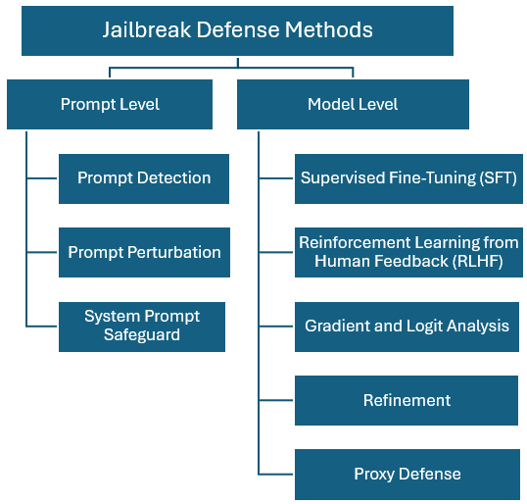
The Figure 5 presents a hierarchical taxonomy of jailbreak defense methods that cleanly partitions the defensive design space for large language models (LLMs) into Prompt-Level and Model-Level strata, thereby making explicit the loci at which adversaries perturb system behavior and where mitigations can be interposed; Prompt-Level defenses operate on the raw or lightly processed user input channel and include (i) Prompt Detection classification, anomaly detection, or policy-aware parsing to flag potentially adversarial or policy-violating requests prior to model execution; (ii) Prompt Perturbation transformations such as sanitization, canonicalization, filtering, or adversarial re-writing that reduce exploitability while attempting to preserve task semantics; and (iii) System Prompt Safeguard hardening or dynamically regenerating the model’s root instruction context (including role directives, guardrails, commitments to refusal policies) to resist prompt injection, context window overwriting, and indirect prompt leakage; Model-Level defenses intervene in the learned policy and inference dynamics: Supervised Fine-Tuning (SFT) injects aligned exemplars (including refusal templates and contrastive safe/unsafe pairs) to shift conditional generation; Reinforcement Learning from Human Feedback (RLHF) optimizes reward functions that trade off helpfulness and harm-avoidance under preference modeling; Gradient and Logit Analysis denotes post-hoc or during-training interpretability/regularization approaches that surface latent unsafe activations or calibrate refusal logits; Refinement captures iterative post-deployment adaptation (self-training, adversarial training, safety distillation, constitutional updates) driven by newly discovered attack traces; Proxy Defense places a mediating model or policy engine in front of, or wrapped around, the base LLM to adjudicate requests, enforce rate-limits, cascade checks, or perform response redaction (Yi et al., 2024, pp. 12).
Relevant works on the scientific community includes: Safety-Tuned LLaMAs shows that instruction-tuned LLMs optimized for helpfulness are highly vulnerable to malicious prompting but that injecting even a small (≈3%) quota of safety-critical data during supervised fine-tuning markedly increases refusal reliability with limited utility loss, albeit at the cost of possible over-refusal when safety data are overweighted (Bianchi et al., 2023, pp. 4-8); Attack Prompt Generation for Red Teaming and Defending Large Language Models introduces a hybrid manual–automatic red teaming pipeline that leverages in-context learning to elicit high-quality adversarial prompts, releases the SAP dataset, and demonstrates that iterative exposure to such prompts during fine-tuning hardens models against subsequent jailbreak attempts (Deng et al., 2023, pp. 3-4); Red-Teaming Large Language Models using Chain of Utterances for Safety-Alignment presents RED-EVAL, a multi-turn CoU-based safety benchmark that successfully jailbreaks both open- and closed-source LLMs at high rates, and proposes RED-INSTRUCT a two-phase harmful/safe data collection plus gradient-weighted safety alignment procedure yielding the STARLING model that improves safety metrics while retaining competitive performance on standard utility benchmarks (Bhardwaj & Poria, 2023, pp. 5).
Testing Dataset
The work described in "Do Anything Now": Characterizing and Evaluating In-The-Wild Jailbreak Prompts on Large Language Models (Shen et al., 2024, pp. 1671-1685) is the best example of Jailbreak collection and construction of a dataset, which is a candidate for an MLLMs security benchmark. The dataset includes 1405 prompts on thirteen different topics, which include Illegal Activity, Hate Speech, Malware, Physical Harm, Economic Harm, Fraud, Pornography, Political Lobbying, etc. (Chu et al., 2024, pp. 1-4). Other types of attacks like Direct Request, persuasive adversarial prompts (PAP) and Autodan/AutoPrompt will be included in the dissertation as part of stronger verification of the proposed approach. (Zhang et al., 2025b, pp. 4-5).

Methodology

Appendices

References
Andriushchenko, M., Croce, F., & Flammarion, N. (2024). Jailbreaking leading safety-aligned llms with simple adaptive attacks. arXiv preprint arXiv:2404.02151.

Bhardwaj, R., & Poria, S. (2023). Red-teaming large language models using chain of utterances for safety-alignment. arXiv preprint arXiv:2308.09662.

Bianchi, F., Suzgun, M., Attanasio, G., Röttger, P., Jurafsky, D., Hashimoto, T., & Zou, J. (2023). Safety-tuned llamas: Lessons from improving the safety of large language models that follow instructions. arXiv preprint arXiv:2309.07875.

Brundage, M., Avin, S., Clark, J., Toner, H., Eckersley, P., Garfinkel, B., ... & Amodei, D. (2018). The malicious use of artificial intelligence: Forecasting, prevention, and mitigation. arXiv preprint arXiv:1802.07228.

Casper, S., Davies, X., Shi, C., Gilbert, T. K., Scheurer, J., Rando, J., ... & Hadfield-Menell, D. (2023). Open problems and fundamental limitations of reinforcement learning from human feedback. arXiv preprint arXiv:2307.15217.

Chao, P., Robey, A., Dobriban, E., Hassani, H., Pappas, G. J., & Wong, E. (2024). Jailbreaking black box large language models in twenty queries. https://arxiv. org/abs/2310.08419

Chaudhari, S., Aggarwal, P., Murahari, V., Rajpurohit, T., Kalyan, A., Narasimhan, K., ... & Castro da Silva, B. (2024). Rlhf deciphered: A critical analysis of reinforcement learning from human feedback for llms. ACM Computing Surveys.

Chennabasappa, S., Nikolaidis, C., Song, D., Molnar, D., Ding, S., Wan, S., ... & Saxe, J. (2025). Llamafirewall: An open source guardrail system for building secure ai agents. arXiv preprint arXiv:2505.03574.

Chu, J., Liu, Y., Yang, Z., Shen, X., Backes, M., & Zhang, Y. (2024). Comprehensive assessment of jailbreak attacks against llms. https://arxiv.org/abs/2402.05668

Deng, B., Wang, W., Feng, F., Deng, Y., Wang, Q., & He, X. (2023). Attack prompt generation for red teaming and defending large language models. arXiv preprint arXiv:2310.12505.

Du, Y., Zhao, S., Ma, M., Chen, Y., & Qin, B. (2023). Analyzing the inherent response tendency of llms: Real-world instructions-driven jailbreak. arXiv preprint arXiv:2312.04127.

Geisler, S., Wollschläger, T., Abdalla, M. H. I., Gasteiger, J., & Günnemann, S. (2024). Attacking large language models with projected gradient descent. arXiv preprint arXiv:2402.09154.

Guo, X., Yu, F., Zhang, H., Qin, L., & Hu, B. (2024). Cold-attack: Jailbreaking llms with stealthiness and controllability. arXiv preprint arXiv:2402.08679.

Gupta, A. (2025). Prompt Injection Generation Using Small Language Models with Reinforcement Learning with Artificial Intelligence Feedback (Doctoral dissertation, Massachusetts Institute of Technology).

Hayase, J., Borevković, E., Carlini, N., Tramèr, F., & Nasr, M. (2024). Query-based adversarial prompt generation. Advances in Neural Information Processing Systems, 37, 128260-128279.

Huang, Y., Gupta, S., Xia, M., Li, K., & Chen, D. (2023). Catastrophic jailbreak of open-source llms via exploiting generation. arXiv preprint arXiv:2310.06987.

Islam, M. R., Dhar, N., Deng, B., Nguyen, T. N., He, S., & Suo, K. (2024, November). Characterizing and Understanding the Performance of Small Language Models on Edge Devices. In 2024 IEEE International Performance, Computing, and Communications Conference (IPCCC) (pp. 1-10). IEEE.

Jones, E., Dragan, A., Raghunathan, A., & Steinhardt, J. (2023, July). Automatically auditing large language models via discrete optimization. In International Conference on Machine Learning (pp. 15307-15329). PMLR.

Lermen, S., Rogers-Smith, C., & Ladish, J. (2023). LoRA fine-tuning efficiently undoes safety training in Llama 2-Chat 70B. arXiv.

Li, S., Ngai, E. C. H., Ye, F., & Voigt, T. (2024). Peft-as-an-attack! jailbreaking language models during federated parameter-efficient fine-tuning. arXiv preprint arXiv:2411.19335.

Liu, X., Li, P., Suh, E., Vorobeychik, Y., Mao, Z., Jha, S., McDaniel, P., Sun, H., Li, B., & Xiao, C. (2024). Autodan-turbo: A lifelong agent for strategy self-exploration to jailbreak llms. https://arxiv.org/abs/2410.05295

Mangaokar, N., Hooda, A., Choi, J., Chandrashekaran, S., Fawaz, K., Jha, S., & Prakash, A. (2024). Prp: Propagating universal perturbations to attack large language model guard-rails. arXiv preprint arXiv:2402.15911.

Matan, P., & Velvizhy, P. (2025, April). A Comprehensive Review of Supervised Fine-Tuning for Large Language Models in Creative Applications and Content Moderation. In 2025 International Conference on Inventive Computation Technologies (ICICT) (pp. 1294-1299). IEEE.

Mehrotra, A., Zampetakis, M., Kassianik, P., Nelson, B., Anderson, H., Singer, Y., & Karbasi, A. (2024). Tree of attacks: Jailbreaking black-box llms automatically. https://arxiv.org/abs/2312.02119

Mekala, D., Nguyen, A., & Shang, J. (2024). Smaller language models are capable of selecting instruction-tuning training data for larger language models. arXiv preprint arXiv:2402.10430.

Mylrea, M. (2025). The generative AI weapon of mass destruction: Evolving disinformation threats, vulnerabilities, and mitigation frameworks. In Interdependent Human-Machine Teams (pp. 315-347). Academic Press.

Naidu, G., Zuva, T., & Sibanda, E. M. (2023, April). A review of evaluation metrics in machine learning algorithms. In Computer science on-line conference (pp. 15-25). Cham: Springer International Publishing.

Parthasarathy, V. B., Zafar, A., Khan, A., & Shahid, A. (2024). The ultimate guide to fine-tuning llms from basics to breakthroughs: An exhaustive review of technologies, research, best practices, applied research challenges and opportunities. arXiv preprint arXiv:2408.13296.

Peng, B., Chen, K., Niu, Q., Bi, Z., Liu, M., Feng, P., ... & Yin, C. H. (2024). Jailbreaking and mitigation of vulnerabilities in large language models. arXiv preprint arXiv:2410.15236.

Qi, X., Zeng, Y., Xie, T., Chen, P. Y., Jia, R., Mittal, P., & Henderson, P. (2023). Fine-tuning aligned language models compromises safety, even when users do not intend to!. arXiv preprint arXiv:2310.03693.

Shen, X., Chen, Z., Backes, M., Shen, Y., & Zhang, Y. (2024, December). " do anything now": Characterizing and evaluating in-the-wild jailbreak prompts on large language models. In Proceedings of the 2024 on ACM SIGSAC Conference on Computer and Communications Security (pp. 1671-1685).

Sitawarin, C., Mu, N., Wagner, D., & Araujo, A. (2024). Pal: Proxy-guided black-box attack on large language models. arXiv preprint arXiv:2402.09674.

Tolosana, R., Vera-Rodriguez, R., Fierrez, J., Morales, A., & Ortega-Garcia, J. D. beyond: A survey of face manipulation and fake detection. arXiv 2020. arXiv preprint arXiv:2001.00179.

Wang, F., Zhang, Z., Zhang, X., Wu, Z., Mo, T., Lu, Q., ... & Wang, S. (2024). A comprehensive survey of small language models in the era of large language models: Techniques, enhancements, applications, collaboration with llms, and trustworthiness. arXiv preprint arXiv:2411.03350.

Wang, H., Li, H., Huang, M., & Sha, L. (2024). Asetf: A novel method for jailbreak attack on llms through translate suffix embeddings. arXiv preprint arXiv:2402.16006.

Wang, J., Liu, Z., Park, K. H., Jiang, Z., Zheng, Z., Wu, Z., ... & Xiao, C. (2023). Adversarial demonstration attacks on large language models. arXiv preprint arXiv:2305.14950.

Wei, J., Wang, X., Schuurmans, D., Bosma, M., Xia, F., Chi, E., ... & Zhou, D. (2022). Chain-of-thought prompting elicits reasoning in large language models. Advances in neural information processing systems, 35, 24824-24837.

Whitmore, S., Harrington, C., & Pritchard, E. (2024). Assessing the ineffectiveness of synthetic reinforcement learning feedback in fine-tuning large language models.

Yang, X., Wang, X., Zhang, Q., Petzold, L., Wang, W. Y., Zhao, X., & Lin, D. (2023). Shadow alignment: The ease of subverting safely-aligned language models. arXiv preprint arXiv:2310.02949.

Yi, S., Liu, Y., Sun, Z., Cong, T., He, X., Song, J., ... & Li, Q. (2024). Jailbreak attacks and defenses against large language models: A survey. arXiv preprint arXiv:2407.04295.

Yu, J., Lin, X., Yu, Z., & Xing, X. (2024). Gptfuzzer: Red teaming large language models with auto-generated jailbreak prompts. https://arxiv.org/abs/2309.10253

Zellers, R., Holtzman, A., Rashkin, H., Bisk, Y., Farhadi, A., Roesner, F., & Choi, Y. (2019). Defending against neural fake news. Advances in neural information processing systems, 32.

Zhan, Q., Fang, R., Bindu, R., Gupta, A., Hashimoto, T., & Kang, D. (2023). Removing rlhf protections in gpt-4 via fine-tuning. arXiv preprint arXiv:2311.05553.

Zhang, Q., Liu, Z., & Pan, S. (2025). The rise of small language models. IEEE Intelligent Systems, 40(1), 30-37.

Zhang, W., Xu, H., Wang, Z., He, Z., Zhu, Z., & Ren, K. (2025). Can Small Language Models Reliably Resist Jailbreak Attacks? A Comprehensive Evaluation. arXiv preprint arXiv:2503.06519.

Zhang, Z., Shen, G., Tao, G., Cheng, S., & Zhang, X. (2023). Make them spill the beans! coercive knowledge extraction from (production) llms. arXiv preprint arXiv:2312.04782.

Zhao, X., Yang, X., Pang, T., Du, C., Li, L., Wang, Y. X., & Wang, W. Y. (2024). Weak-to-strong jailbreaking on large language models. arXiv preprint arXiv:2401.17256.

Zheng, A., Rana, M., & Stolcke, A. (2024). Lightweight safety guardrails using fine-tuned bert embeddings. arXiv preprint arXiv:2411.14398.

Zhou, Y., Huang, Z., Lu, F., Qin, Z., & Wang, W. (2024). Don't Say No: Jailbreaking LLM by Suppressing Refusal. arXiv preprint arXiv:2404.16369.

Zhu, S., Zhang, R., An, B., Wu, G., Barrow, J., Wang, Z., ... & Sun, T. (2023). AutoDAN: interpretable gradient-based adversarial attacks on large language models. arXiv preprint arXiv:2310.15140.

Zou, A., Wang, Z., Carlini, N., Nasr, M., Kolter, J. Z., & Fredrikson, M. (2023). Universal and transferable adversarial attacks on aligned language models. arXiv preprint arXiv:2307.15043.

https://community.openai.com/t/temperature-top-p-and-top-k-for-chatbot-responses/295542

