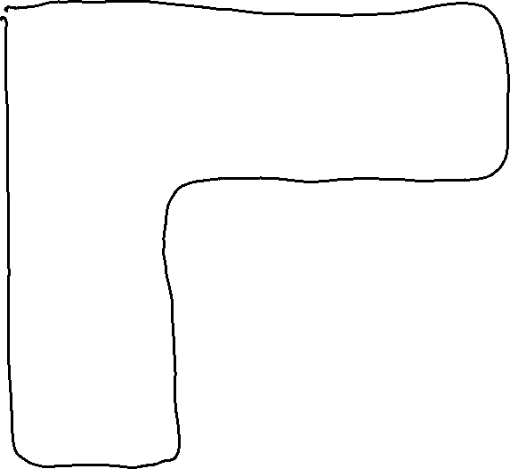

Clearer on a larger sample, 3 vertices edited then 5 left stationary in both axis

