Task 1: Working AgentCore Harness with Knowledge Base Retrieval
System: Northstar Assist. Account: Udacity Cloud Lab (…4976), us-east-1. Date: 2026-10-10.

1. What was deployed
Resource | Name / ID | Key settings | Evidence
S3 bucket | northstar-assist-kb-5ca661ad | 30 documents, public access blocked, SSE-S3, versioning on | evidence/task1/s3_*.json
Managed Knowledge Base | northstar-assist-kb (WUWHZC06MP) | Type MANAGED, Titan Text Embeddings V2 (amazon.titan-embed-text-v2:0), 1024 dimensions, FLOAT32 | evidence/task1/kb_details.jpg, knowledge_base.json
Data source | northstar-documents (DR2JEWLD2V) | S3, managed parser, default chunking, on-demand sync | evidence/task1/kb_sync.jpg
AgentCore Gateway | northstar-assist-gateway (northstar-assist-gateway-hd1uvsa8f3) | MCP, inbound auth AWS_IAM | evidence/task1/gateway.json
Gateway target | northstar-kb (5QFJRBLA4V) | Connector bedrock-knowledge-bases, tool Retrieve, standard retrieval, 5 results | evidence/task1/gateway_target_5QFJRBLA4V.json
AgentCore Harness | NorthstarAssist (NorthstarAssist-XSASd9gyWX) | Claude Haiku 4.5 via US inference profile, course system prompt, memory disabled, gateway tool only | evidence/task1/harness.json
Request path:
Employee → Harness (Claude Haiku 4.5) → Gateway tool → AgentCore Gateway → Managed KB → S3 documents

2. Knowledge base sync completed without errors
The data-source sync job ZBL4LAMGLO finished with status COMPLETE: 30 scanned, 30 indexed, 0 failed, 0 skipped.
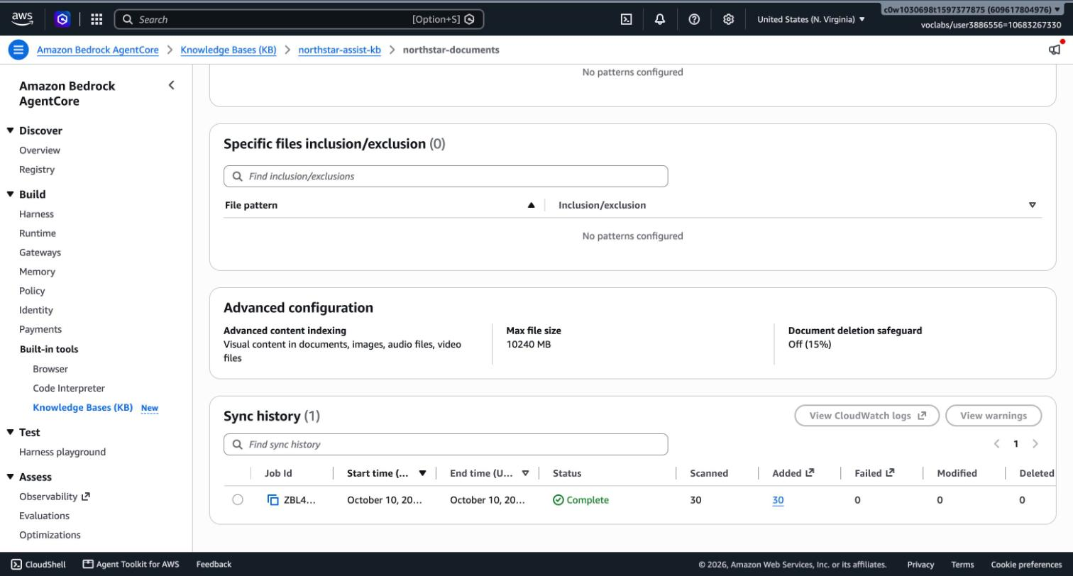
The same result from the API is saved in evidence/task1/kb_ingestion_jobs.json.
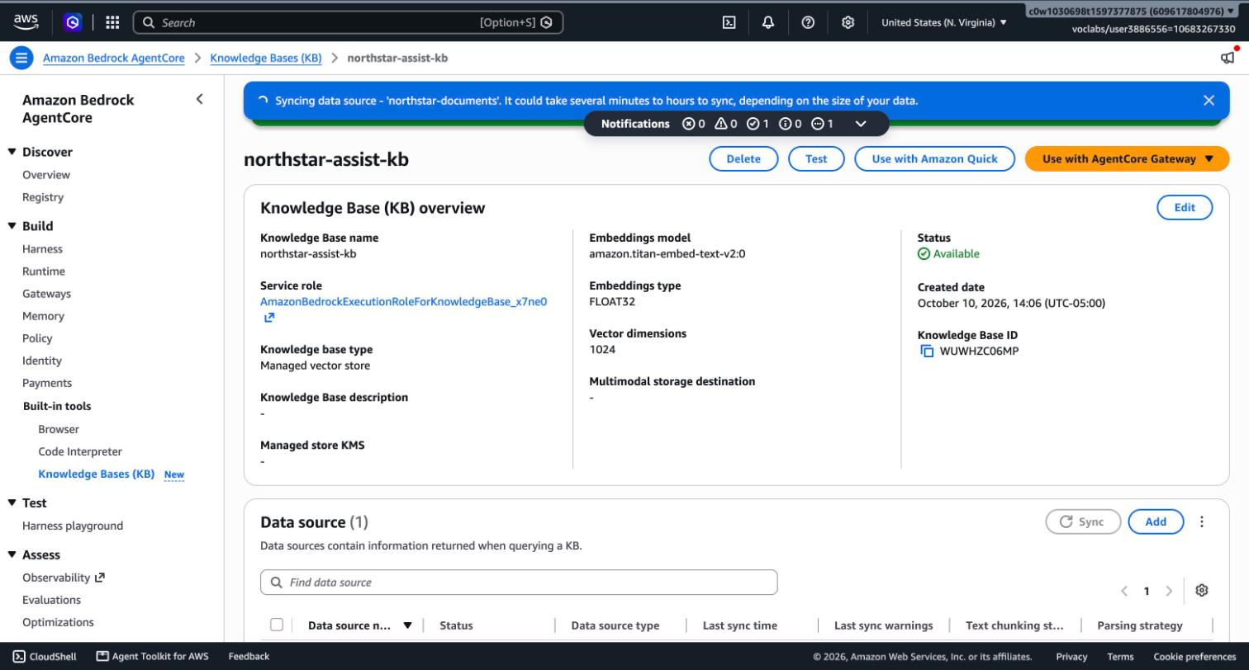

3. The harness answers a prompt using a foundation model
Prompt sent in the Harness playground and through the InvokeHarness API:
What is Northstar's hybrid work policy? Name the source document.
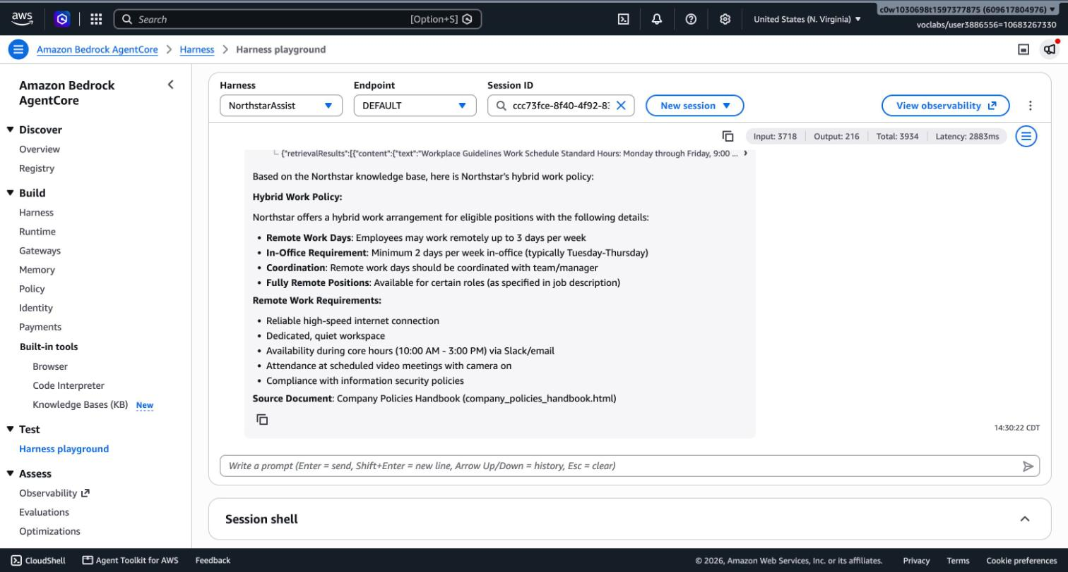
Playground metrics for this turn: 3,718 input tokens, 216 output tokens, 2,883 ms.

4. The answer uses content retrieved from the knowledge base
The Agent trace shows the harness calling the Northstar-Kb Retrieve tool (status Success) before answering.
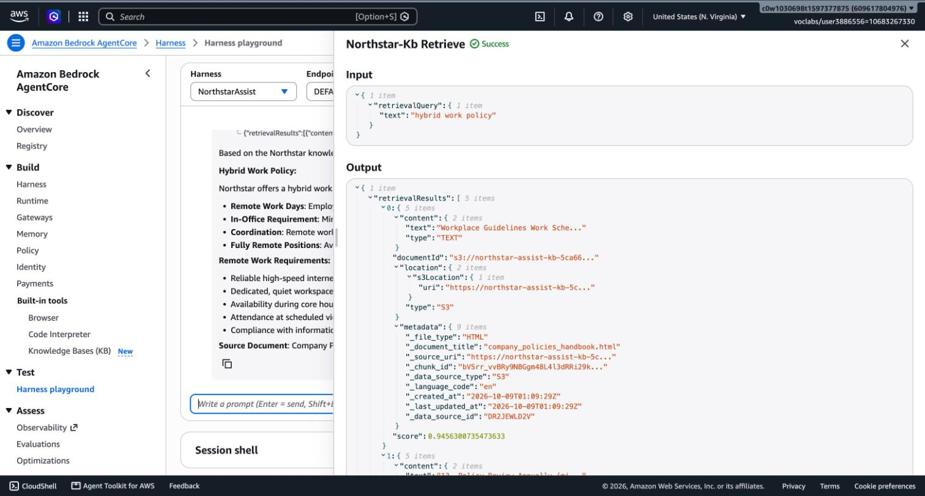
Trace field | Value
Tool | northstar-kb___Retrieve
Input | {"retrievalQuery": {"text": "hybrid work policy"}}
Results returned | 5 chunks
Top result | company_policies_handbook.html, relevance score 0.946
Sources across the 5 chunks | html/company_policies_handbook.html, docx/security_policy.docx

Scripted transcript (InvokeHarness API)
Produced by tools/run_suite.py --smoke; the full record, including every retrieved chunk, is in evidence/task1/smoke_baseline_20261010T192934Z.json. Verdict: ANSWERED_WITH_RETRIEVAL, 5 chunks.
I'll search the Northstar knowledge base for information about the hybrid work policy.Based on the knowledge base search, here is Northstar's hybrid work policy:
**Hybrid Work Policy:**
Northstar offers a hybrid work arrangement for eligible positions with the following guidelines:
- **Remote Work Allowance:** Employees may work remotely up to 3 days per week
- **In-Office Requirement:** Minimum 2 days per week in-office (typically Tuesday-Thursday)
- **Coordination:** Remote work days should be coordinated with team/manager
- **Fully Remote Positions:** Available for certain roles (as specified in job description)
**Remote Work Requirements:**
When working remotely, employees must have:
- Reliable high-speed internet connection
- Dedicated, quiet workspace
- Availability during core hours (10:00 AM - 3:00 PM) via Slack/email
- Attendance at scheduled video meetings with camera on
- Compliance with information security policies
**Source Document:** Company Policies Handbook (company_policies_handbook.html)
The answer's facts (up to 3 remote days, minimum 2 in-office days, core hours 10:00–15:00) all appear in the first retrieved chunk, and the answer names the source document. This is the retrieved content in the model's context window, not model memory.

5. Notes for the later tasks
- Console issue. The console's Create Harness form created the default execution role and its policies, then stayed on "being provisioned" without creating the harness. The harness was then created with aws bedrock-agentcore-control create-harness, using that console-created role and the same settings. The role and its policies are therefore the unmodified console defaults that Task 4 reviews (iam/before/).
- Baseline IAM is broad. The default harness role allows model invocation on foundation-model/* and on every Bedrock resource in the account, plus Browser, Code Interpreter, EFS, S3 Files and Memory statements that this harness does not use.
- Invocation-time overrides. The playground and the InvokeHarness API accept a per-request model, system prompt and tool list. Whether a caller can use this to bypass the guardrail was tested and closed in Task 4 (deliverables/04_iam_hardening.md).
- Chunks reach the model unfiltered. Each retrieved chunk carries document text and metadata straight into the model's context. No guardrail is attached at this stage.
- Runtime log group exists: /aws/bedrock-agentcore/runtimes/harness_NorthstarAssist-92Prr07JAK-DEFAULT.

