qonto-receipt-hunter
Zero missing receipts — the hunter that finds receipts in Gmail & Drive and attaches them to Qonto transactions
Qonto × Anthropic MCP Hackathon · Hunts Gmail & Drive · Originals only — never fabricated

🎯 Why this matters
Roughly one transaction in five is missing its receipt. Every one of them is recoverable VAT left on the table, a deduction at risk, and a question your accountant will ask. The skill turns the chore into a hunt:
- 1. Prioritized inventory — transactions missing a receipt (attachment_ids empty + attachment_required), ranked by urgency: recoverable VAT at stake, amount, age — tagged 🔴 urgent · 🟠 soon · 🟢 low
- 2. Hunt across connected sources — Gmail (merchant + amount + date window around emitted_at) and Google Drive, detected dynamically
- 3. Confirmed attaching — the match is shown (transaction ↔ original document), one explicit confirmation per receipt, then request_attachment_upload + upload_attachment; never in bulk
- 4. Hunt report — attached ✅, to attach 📎, not found ❌ with one concrete lead each + completeness score before/after
🧾 The guardrail that matters most: the skill attaches originals only (merchant PDFs, email attachments). It never generates or reconstructs a receipt — a fabricated document has zero probative value and is a tax-audit liability.
Would someone use this on a Monday morning? It's the end-of-month chore everyone postpones — now it runs itself.
📋 Prerequisites
Prerequisite | Detail | Required
Qonto production account | Adapts to any organization — get_organization first, nothing hardcoded | ✅ Yes
Country | Works for every Qonto country. The 20/120 VAT-ceiling estimate applies to France only; elsewhere only tagged vat_amount is used — rates are never guessed | ℹ️ Detected
Qonto MCP connected | Official connector (claude.ai / Claude Desktop), OAuth login | ✅ Yes
Gmail MCP | Powers the email hunt. Absent: the skill says so and still delivers the prioritized inventory + where to look | ⭕ Recommended
Google Drive MCP | Powers the file hunt | ⭕ Optional
Scope | Last 90 days by default — widen (quarter, fiscal year) on request | ⭕ Optional

⚙️ How it works
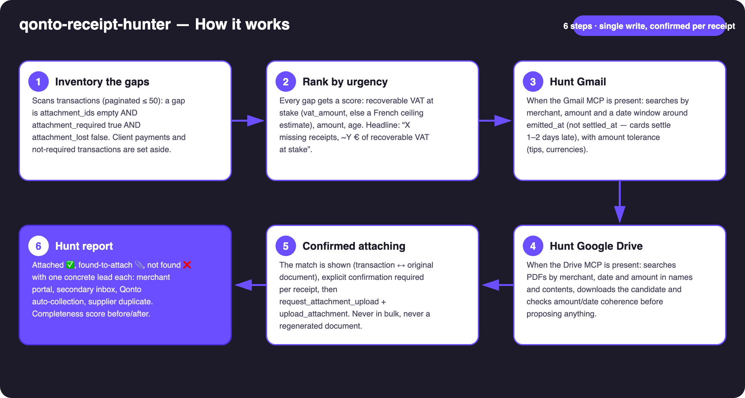
Diagram 1 — How it works, 6 steps (single write, confirmed per receipt)
Holds up on messy data
- Matched on the purchase date, not the settlement date: the window is anchored on emitted_at — card payments settle 1–2 days later (settled_at), exactly where other tools miss the receipt
- Disclosed amount tolerance: tips, foreign-currency conversion, partial captures — if the exact amount misses, a merchant + date-window retry pass runs
- Garbled labels handled (“SUMUP *COFFEE PARIS”): name variants from clean_counterparty_name and the raw label
- Email attachment binary not exposed by the connector → the skill hands over the direct email pointer (one-drag manual attach), stated honestly
- No Gmail/Drive: the Qonto-only core still delivers the prioritized inventory + VAT at stake + where to look
- attachment_required: false, client payments and attachment_lost excluded from the score · several plausible candidates → the skill asks · pagination ≤ 50 everywhere

🏗 Functional diagram
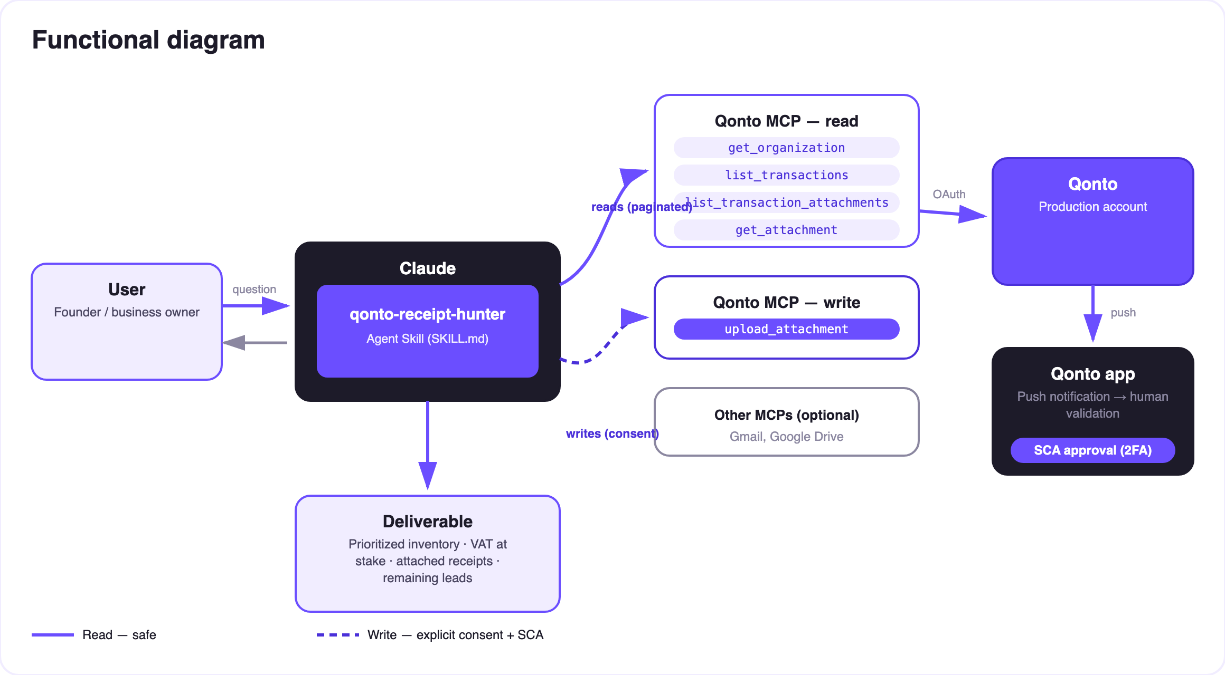
Diagram 2 — Actors and flows: risk-free reads (solid), write behind per-receipt confirmation (dashed)
🔒 Document integrity: the only write adds a document to a transaction — it never touches money — and requires explicit per-receipt confirmation. Originals only: a fabricated receipt has zero probative value and is a tax-audit liability — the skill will never produce one.
🧮 Urgency ranking
Criterion | Signal | Effect
Recoverable VAT at stake | Tagged vat_amount; else (France) an amount × 20/120 ceiling, disclosed as an estimate | Main weight
Amount | Big debits first — that's where the lost deduction hurts | Strong
Age | The older the gap, the closer the accounting close and the harder the duplicate | Strong
Exclusions | attachment_required: false · client payments (side: credit) · attachment_lost | Out of the score

🔎 Hunt sources
Source | Method | Condition
Gmail | Merchant (name variants) + amount + window around emitted_at, amount tolerance; target: the merchant's original PDF | Gmail MCP connected
Google Drive | Search by merchant/date/amount in names and contents, download + coherence check before proposing | Drive MCP connected
Not found? | One concrete lead per gap: merchant portal, secondary or personal inbox, Qonto's native receipt auto-collection, supplier duplicate | Always

📤 Output formats
Output | Format | When
Conversation reply | Markdown tables (prioritized inventory, VAT at stake, hunt report) | Always — the baseline
Qonto attachments | Real attachments on the transactions, visible immediately in the app | On every confirmation
Completeness report | Before/after score + remaining leads; HTML when the host renders files, tables otherwise | End of session

🎬 Demo video
The ≤ 3-minute demo attached to the PR walks through: the problem → the prioritized inventory (7 missing receipts, VAT at stake quantified) → the live Gmail hunt → 5 receipts found and attached, one click each → the final report with leads for the remaining 2. It runs live on a real production account.
💡 Roadmap ideas
Idea | Effort | Note
Gmail draft emails asking suppliers for duplicates | Low | Drafts only — the user sends
Monthly ritual: completeness score tracked month over month (streak) | Low | Reuses the existing report
More mailboxes (Outlook/M365) detected dynamically | Medium | Same hunt logic, different MCP
Duplicate-attachment cleanup (remove_transaction_attachment, behind confirmation) | Medium | The reverse cleanup, same guardrails
Fine-grained amount/VAT verification by reading the PDF (multi-line, currencies) | Medium | Strengthens the coherence check

🛡 Guardrails
- NEVER fabricates a receipt: no generated PDFs, no reconstructed invoices, no doctored screenshots — with no original, the transaction stays ❌ with a lead
- Never attaches without explicit confirmation of the displayed match; several plausible candidates → it asks; no silent batches, ever
- Matched on emitted_at with a disclosed amount tolerance
- Absent Gmail/Drive MCPs announced plainly — the Qonto-only inventory ships anyway
- IBANs and card numbers masked · pagination ≤ 50 everywhere
qonto-receipt-hunter · English documentation · Qonto × Anthropic MCP Hackathon · July 2026 · PR deliverable: SKILL.md · French version: doc-qonto-receipt-hunter.fr.docx

