qonto-rgpd-register
Your bank account knows your data processors better than you do — the GDPR Article 30 register, drafted from the spending
Qonto × Anthropic MCP Hackathon · 100% read — zero write · Pan-European (GDPR = the whole EU) · Draft to validate (DPO/lawyer)

🎯 Why this matters
The record of processing activities (GDPR Article 30) is the document 90% of small businesses don't have — and the first thing a supervisory authority asks for. Yet the list of processors handling personal data is already written somewhere: in the debits. The skill reads it:
- 1. Processor detection — the SaaS tools that process personal data (CRM, email marketing, analytics, AI, cloud, payroll, support), recognized by Claude's general knowledge from their first occurrence
- 2. Classification by processing activity — purpose, typical data categories, data subjects, EU / non-EU headquarters and hosting — every attribute tagged "to validate"
- 3. Draft Article 30 register in the CNIL card format — one card per activity, controller header filled from get_organization, visible placeholders for the human decisions
- 4. Actionable flags — 🔴 non-EU transfer → standard contractual clauses to verify · 🟠 DPA to locate or sign · 🟡 tool gone from the debits for 6 months → retire it from the register?
Would someone use this on a Monday morning? It's the Monday a client's security questionnaire — or an authority letter — lands.
📋 Prerequisites
Prerequisite | Detail | Required
Qonto production account | Adapts to any organization — get_organization first, nothing hardcoded | ✅ Yes
Country | GDPR = the whole EU — a pan-European skill. France: CNIL card format and references; other Qonto countries: same register, local authority (BfDI/LfDI, AEPD, Garante, DSB, AP, APD/GBA, CNPD) | ℹ️ Detected
Qonto MCP connected | Official connector (claude.ai / Claude Desktop), OAuth login | ✅ Yes
Spending history | Ideally 12–24 months; thin account → register skeleton + missing parts named explicitly | ⭕ Optional
A DPO or lawyer to validate | The skill produces a draft: qualification, legal bases and retention remain human decisions | ✅ At the end

⚙️ How it works
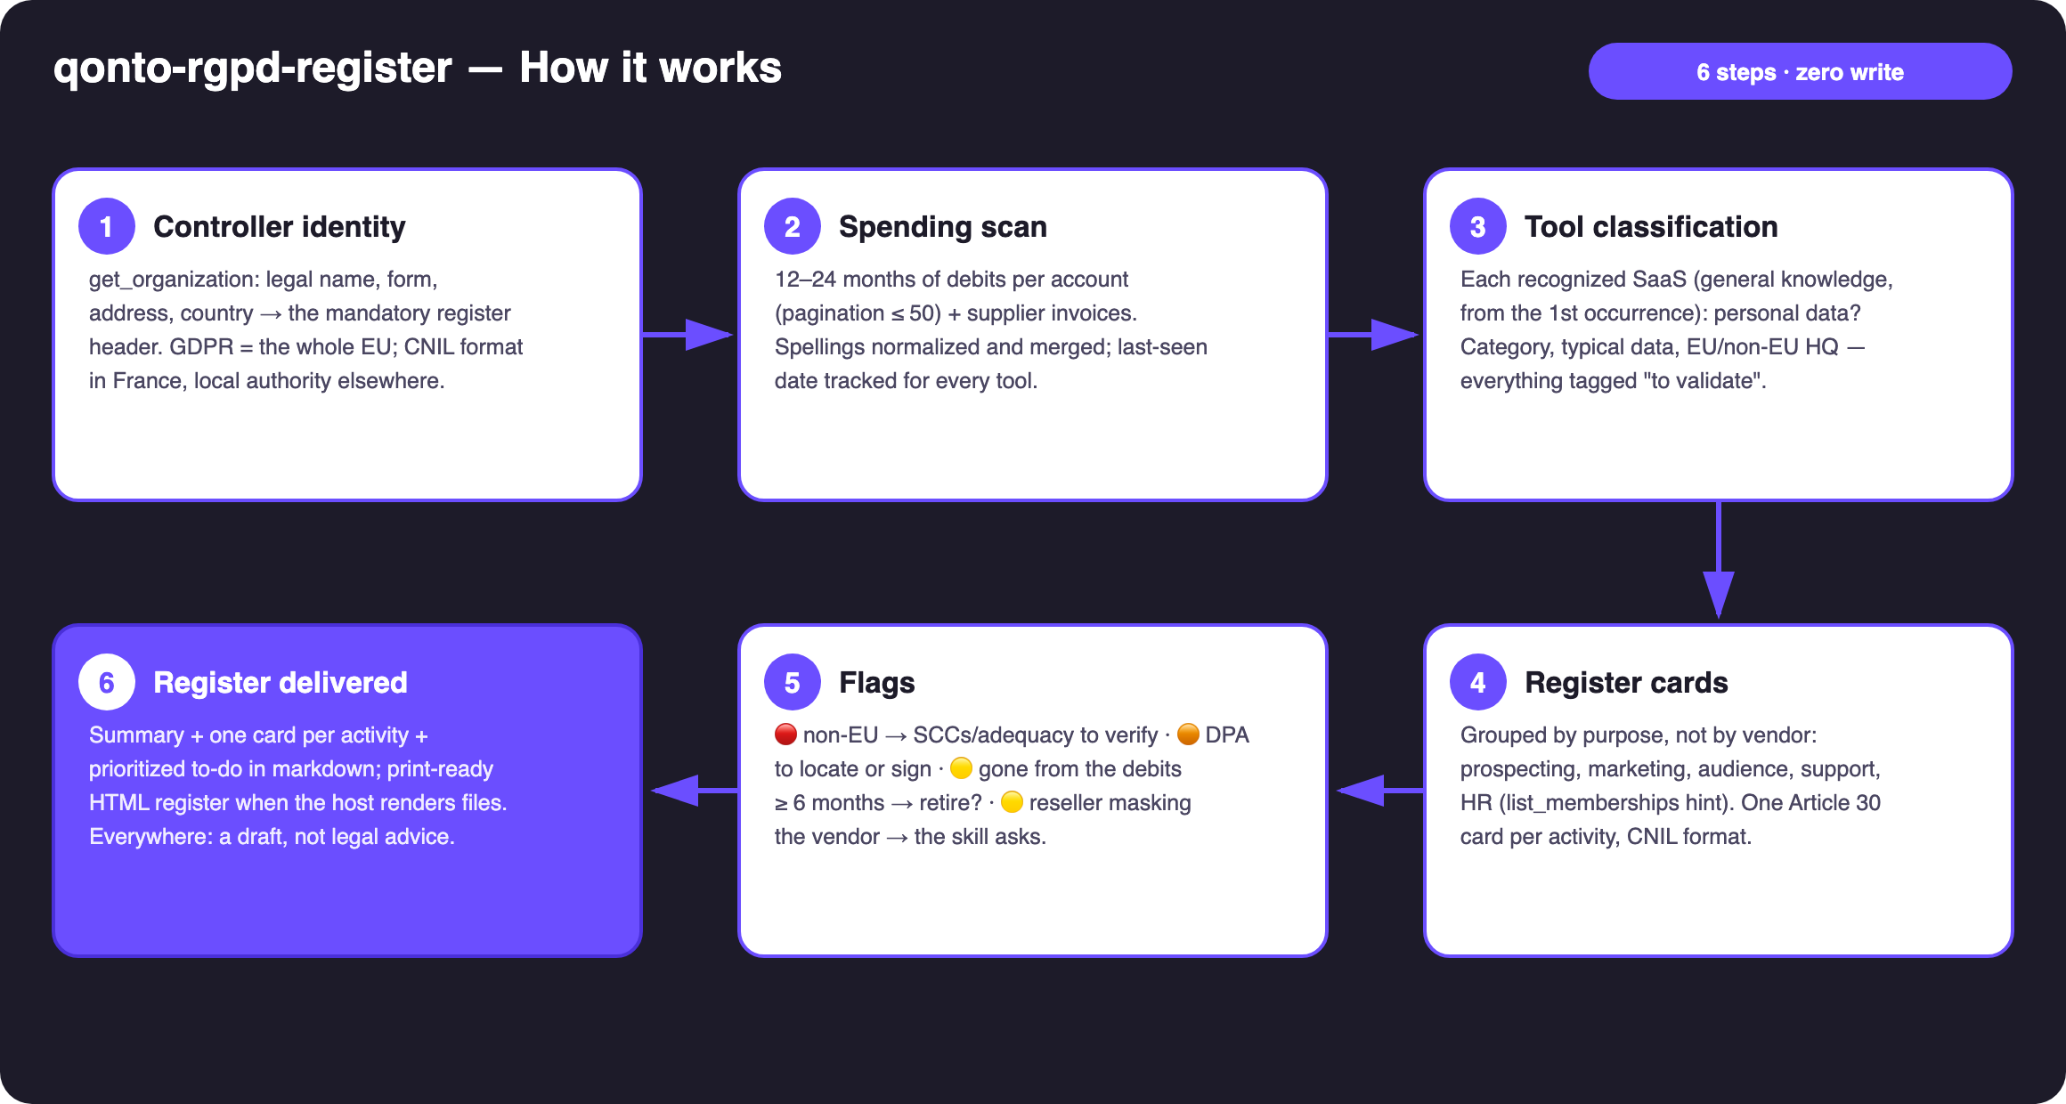
Diagram 1 — How it works, 6 steps (zero write)
Holds up on messy data
- Recognition from the first occurrence: Claude's general knowledge identifies the vendor (HQ, role, typical data) — no recurrence threshold, so yearly-billed tools are caught too
- Spellings normalized and merged (GOOGLE *WORKSPACE / GOOGLE IRELAND LTD / Google Cloud EMEA = one vendor); cross-checked with supplier invoices, cleaner than card labels
- Nothing silently disappears: out-of-scope spend (bank fees, travel, hardware) is listed in an "out of scope" appendix
- Ambiguity stated, never decided: genuinely ambiguous roles (payment providers are often independent controllers) → announced as such, "to validate"
- Vendor masked by a reseller, marketplace or app store → 🟡 flag, the skill asks instead of guessing
- Unknown vendor → "unidentified — check the invoice", never an invented HQ · pagination ≤ 50 · emitted_at (not settled_at) for the last-used date

🏗 Functional diagram
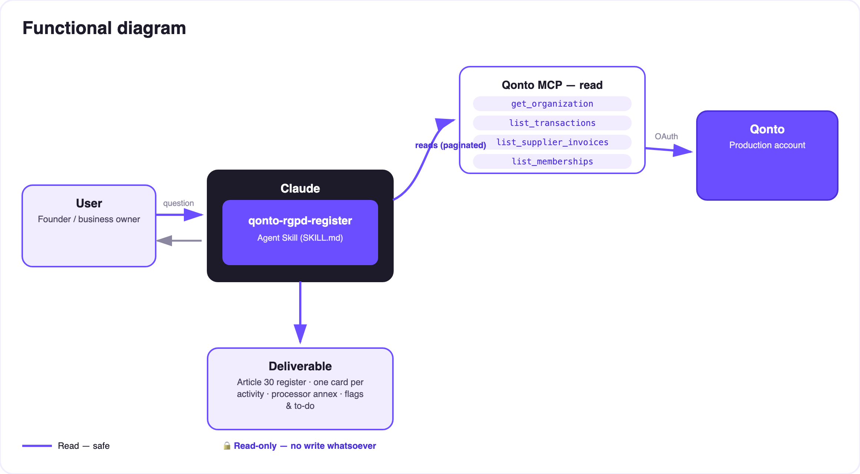
Diagram 2 — Actors and flows: four reads, no write, human validation at the end of the chain
🔒 Zero write, by design: four read tools, no write tool. Nothing moves on the account, no vendor is contacted. And the document produced is a draft register, not legal advice — qualification, legal bases and retention periods are validated by a DPO or lawyer. The skill repeats this on every output.
🗂 Recognized processor categories (illustrative examples, not from a real account)
Category | Example tools | Typical data | Watch-out
CRM & prospecting | HubSpot, Pipedrive, Salesforce | Identity, contact details, sales history | US headquarters → transfer mechanism to verify
Email & marketing | Mailchimp, Brevo, Mailjet | Emails, open behavior, segments | Consent & legal basis to document
Analytics | Google Analytics, Matomo, Plausible | Online identifiers, browsing | Non-EU vs self-hosted: very different regimes
AI | OpenAI, Anthropic, Mistral | Prompt content (sometimes customer data!) | Check the "no training on your data" option
Cloud & hosting | AWS, Google Cloud, OVHcloud, Scaleway | Everything hosted | EU hosting region available? enabled?
Payroll & HR | PayFit, Silae, Lucca | Employee data (sensitive: IDs, salaries) | HR card mandatory, specific legal retention
Customer support | Zendesk, Intercom, Crisp | Identity, conversations, metadata | Conversations = personal data, often forgotten
E-commerce & payments | Shopify, Stripe | End customers, transactions | Controller/processor role ambiguous → to validate

🚩 The flags
Flag | Trigger | Suggested action
🔴 Non-EU transfer | Non-EU headquarters or hosting detected | Verify adequacy decision / standard contractual clauses / DPA annexes
🟠 DPA to check | Processor with no known signed DPA | Find the vendor's DPA page, sign or archive it
🟡 Ghost tool | No debit for ≥ 6 months | Confirm it's gone → retire from the register + data deletion request
🟡 Masked vendor | Reseller, marketplace or app store in the label | The skill asks which product sits behind the charge — never a guess

📤 Output formats
Output | Format | When
Conversation reply | Markdown tables: summary, one card per activity, prioritized to-do | Always — the baseline
Print-ready register | HTML file/artifact: controller header, Article 30 cards, processor annex, to-do | When the host renders files; fallback to tables
Disclaimer banner | "Draft register, not legal advice — validate with a DPO or lawyer" | On every output, no exception

🎬 Demo video
The ≤ 3-minute demo attached to the PR walks through: the problem (the document nobody has) → the spending scan → classification & cards → the full Article 30 register generated from a bank statement → the DPA/transfer to-do. It runs live on a real production account. (Shooting script kept internal, outside the repository.)
💡 Roadmap ideas
Idea | Effort | Note
Optional multi-MCP: scan Gmail/Drive for already-signed DPAs | Medium | Dynamic detection — activates when the MCP is present, otherwise the skill says so and continues
Register diff: rerun 6 months later → entrants / retirees | Low | Reuses the last-seen date
Ready-to-send "DPA request" and "data deletion request" templates | Low | Still zero write — text to copy
DPIA appendix: activities likely to need an impact assessment | Medium | Always "to validate", never a definitive qualification

🛡 Guardrails
- Never a definitive legal qualification (processor vs controller vs joint, legal basis, retention) — every card is tagged "to validate", undecided fields stay visible placeholders
- Never invents vendor facts: unknown HQ or hosting → stated as unknown, "check the invoice / the vendor's DPA page" as the next step
- A register draft ≠ GDPR compliance: one required document, not the whole program — DPO/legal validation recommended in every report
- 100% read, zero write · IBANs masked (last 4 digits) · pagination ≤ 50 everywhere · all examples in the docs are invented
qonto-rgpd-register · English documentation · Qonto × Anthropic MCP Hackathon · July 2026 · PR deliverable: SKILL.md · French version: doc-qonto-rgpd-register.fr.docx

