qonto-meeting-invoice
From call to quote, before the meeting ends — careful extraction, draft first, confirmed send
Qonto × Anthropic MCP Hackathon · Nothing invented, everything quoted · Draft first, send after confirmation

🎯 Why this matters
A great sales call, everyone's excited… and the quote goes out three days later. By then the momentum is gone. Call-to-invoice is a known dream — this skill's bet is making it trustworthy: what wasn't said on the call never enters the document.
- 1. Transcript in — a file, a Notion/Drive note (when that MCP is connected), or pasted text: no third-party MCP required
- 2. Careful extraction — deliverables, quantities, prices, discounts, terms, deadlines: only what was said, every term quoted. The rest: a question, never a guess
- 3. Matched against real Qonto data — product catalog (prices, VAT), client records (confirmed creation for new prospects), duplicate check on existing quotes
- 4. Draft, then send — create_quote (or create_client_invoice) as a draft, line-by-line recap, sent only after an explicit 'yes, send it'
Would someone use this on a Monday morning? Every call that ends with "I'll send you a quote" is this skill's Monday morning.
📋 Prerequisites
Prerequisite | Detail | Required
Qonto production account | Adapts to any organization — get_organization first, nothing hardcoded | ✅ Yes
Country | All Qonto countries; legal mentions come from the country's invoicing settings, VAT rates never assumed (catalog or confirmation) | ℹ️ Detected
Qonto MCP connected | Official connector (claude.ai / Claude Desktop), OAuth login | ✅ Yes
Qonto invoicing configured | Numbering, legal mentions, payment details — set once in the app; the skill builds on them | ✅ Yes
A call transcript | File, Notion/Google Drive note, or text pasted into the conversation | ✅ Yes
Product catalog | Services with prices and VAT (list_products) — without it, the skill asks for each missing price | ⭕ Recommended
Notion / Google Drive MCP | Transcript source, detected dynamically — when absent, the skill says so and asks for a paste | ⭕ Optional

⚙️ How it works
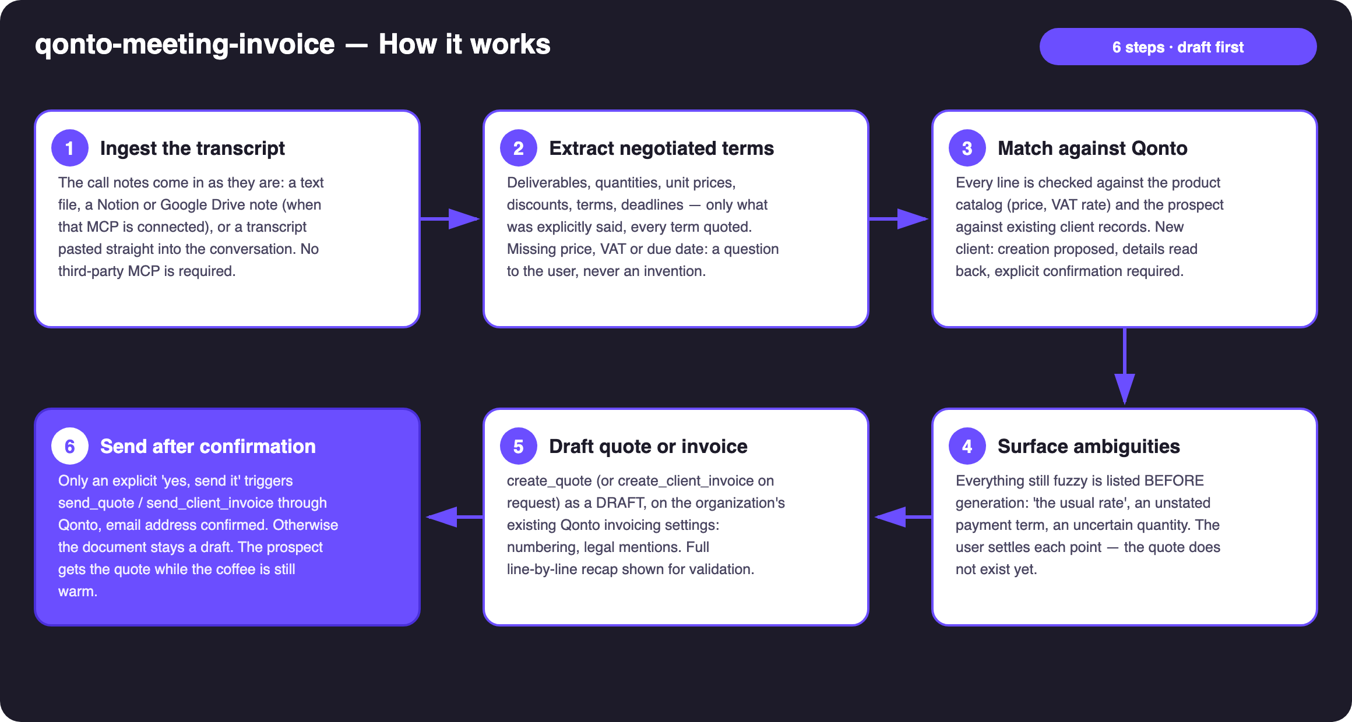
Diagram 1 — How it works, 6 steps (draft first, confirmed send)
Holds up on messy data
- Quoted extraction, never guessed: every extracted term is backed by its transcript line — filler words, several speakers and mixed languages are the normal case
- "The usual rate" → matched against the catalog and confirmed; call/catalog divergences flagged ("the call says €850/day, your catalog says €900"), never settled silently
- No catalog: lines built from the call, missing prices asked one by one
- New prospect with half an address: create_client proposed with known fields read back; list_clients first (duplicate check)
- Payment term not stated: asked, or the organization's Qonto default offered — explicitly
- Non-French organization: same workflow; VAT and legal mentions follow that country's Qonto settings · pagination ≤ 50 everywhere

🏗 Functional diagram
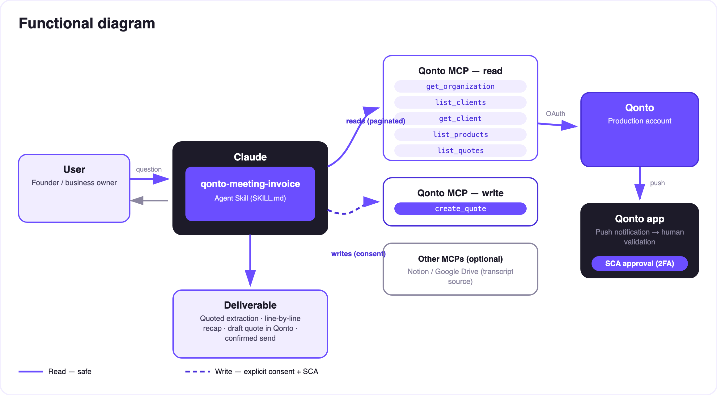
Diagram 2 — Actors and flows: risk-free reads (solid), write = draft behind consent (dashed)
🔒 Documents created via MCP are real: reads (catalog, clients, quotes) are risk-free; the write only produces a draft. Sending to the prospect requires explicit confirmation in the conversation, after the line-by-line recap. Nothing leaves without the user's go.
📞 From call to document — what the skill extracts
Heard on the call | Becomes | Checked against
"Three workshop days in September" | Line item: Workshop · qty 3 · start date | Catalog: canonical title, unit price, VAT
"We'll take 10% off the audit" | Discount on the Audit line | Catalog price before discount
"The usual rate" | ⚠️ Listed ambiguity → confirmation requested | Catalog + the user's answer
"It's Acme, contact marie@…" | The quote's client | list_clients — match or confirmed creation
Payment term never mentioned | ⚠️ Listed ambiguity → question or Qonto default offered | The organization's invoicing settings
VAT never discussed | Rate from the product record, else confirmation | Catalog — never an invented default

📤 Output formats
Output | Format | When
Conversation reply | Markdown tables: quoted extraction, ambiguities, line-by-line recap | Always — the baseline
Draft in Qonto | Quote or invoice on the organization's own invoicing template (native numbering & legal mentions) | After ambiguities are settled
Email to the prospect | Native Qonto sending (send_quote / send_client_invoice) | Only after explicit confirmation

🎬 Demo video
The ≤ 3-minute demo attached to the PR walks through: the problem (the quote that ships three days late) → pasted transcript and quoted extraction → catalog/client matching and the ambiguity list → the complete quote in Qonto ~90 seconds after the meeting ends, then the send → the guardrails. It runs live on a real production account.
💡 Roadmap ideas
Idea | Effort | Note
Automatic deposit ("30% upfront") via create_payment_link | Low | Official MCP tool, same confirmation logic
Follow-up on unsigned quotes after N days (list_quotes) | Low | Pairs with an invoice-chasing skill
Direct audio transcription (file → text) when the host supports it | Medium | The skill stays text-transcript-first
A/B quotes (with/without an option) from the same call | Medium | Two drafts compared side by side
Quote in the prospect's language | Low | Qonto handles the templates; the skill adapts the wording

🛡 Guardrails
- Documents created via MCP are real: draft first, always; NEVER sent without explicit confirmation; never presented as sent while it is a draft
- Nothing invented: a price, VAT rate, quantity or due date missing from the call → a question — no default VAT
- create_client only after details are read back; list_clients first (duplicate check)
- Rehearsals: fictitious client + delete_quote / delete_client_invoice (drafts only — a finalized invoice cannot be deleted)
- Pagination ≤ 50 · personal data masked · no legal or tax advice — Qonto settings and the accountant remain the reference
qonto-meeting-invoice · English documentation · Qonto × Anthropic MCP Hackathon · July 2026 · PR deliverable: SKILL.md · French version: doc-qonto-meeting-invoice.fr.docx

