qonto-reimburse-batch
N expense reimbursements, three checks each, one SCA approval — no more spreadsheet
Qonto × Anthropic MCP Hackathon · 3 checks per claim · Single write, behind SCA · Universal (SEPA)

🎯 Why this matters
Teammates pay out of pocket — client dinners, taxis, small gear — and the reimbursement sits in a spreadsheet for weeks. Nobody enjoys chasing it, nobody enjoys checking it. The skill does both (all examples in this document are invented):
- 1. Collects the claims — from a Slack expenses channel or a Notion base when that MCP is connected; otherwise pasted straight into the conversation or as a markdown table. The core stays 100% Qonto
- 2. Three checks per claim — receipt present and consistent (amount/date) · not a duplicate of a company-card expense already in the account (list_transactions, transaction cited) nor of a past reimbursement · expense policy respected (per-category caps the user defines)
- 3. ONE grouped request — the N validated claims become a single create_multi_transfer_request: N pending transfers, IBANs taken from the claims (never invented)
- 4. One-gesture SCA approval — the owner gets a push notification and approves the whole batch with their own 2FA in the Qonto app; money moves only there
Would someone use this on a Monday morning? It's the end-of-month expenses ritual — minus the spreadsheet.
📋 Prerequisites
Prerequisite | Detail | Required
Qonto production account | Adapts to any organization — get_organization first, nothing hardcoded | ✅ Yes
Country | Universal (SEPA): EUR SEPA transfers — every Qonto country (FR, DE, ES, IT, AT, NL, BE, PT). Non-SEPA IBAN or non-EUR claim → on hold, stated plainly | ℹ️ Detected
Qonto MCP connected | Official connector (claude.ai / Claude Desktop), OAuth login | ✅ Yes
Employee IBANs | Provided by the claims or a user-maintained employee sheet — the skill NEVER invents an IBAN; a claim without one stays on hold | ✅ Yes
Expense policy | Per-category caps (meals, taxi, equipment…) defined once; no policy → stated, the other checks still run | ⭕ Recommended
Slack or Notion (MCP) | Claims source, detected dynamically; otherwise degraded mode: claims pasted in the conversation | ⭕ Optional

⚙️ How it works
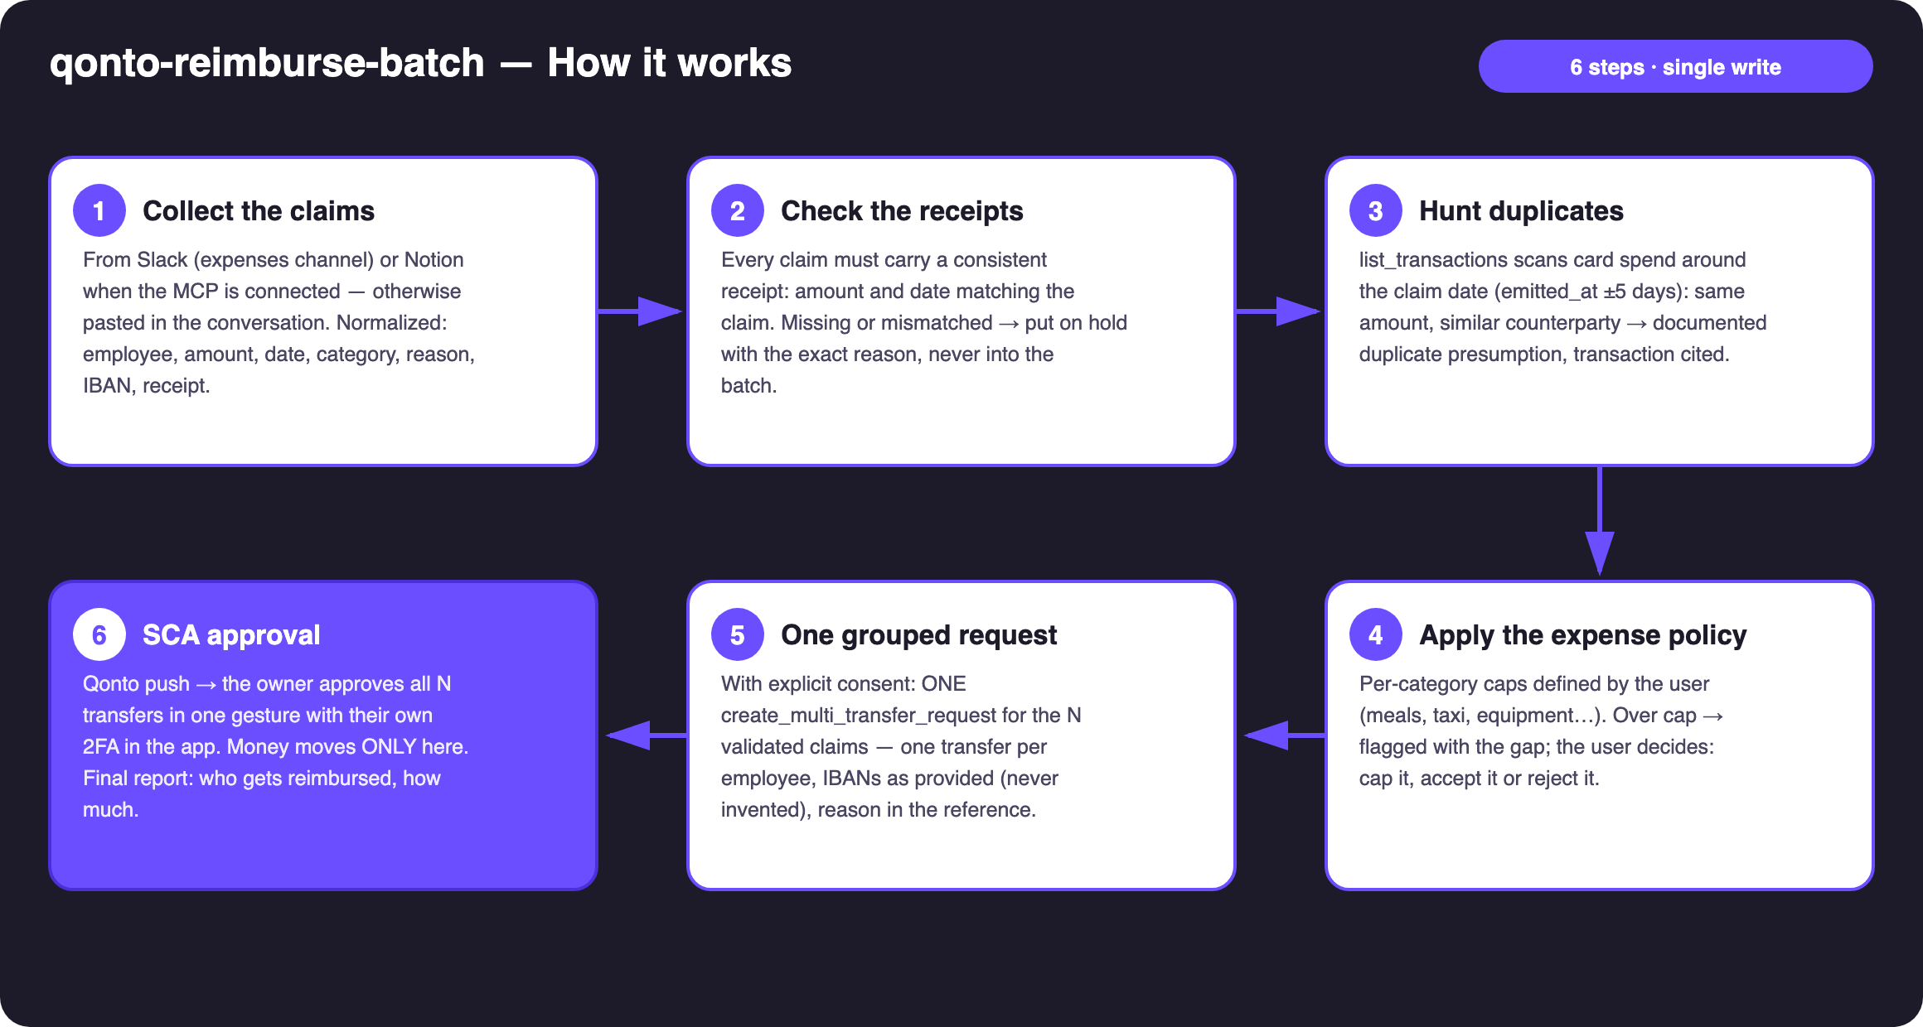
Diagram 1 — How it works, 6 steps (single write, behind SCA)
Holds up on messy data
- Free-text Slack messages, half-filled Notion rows: everything is normalized first (employee, amount, date, category, reason, IBAN, receipt) — the skill asks only for what's genuinely missing
- No Slack/Notion MCP? The skill says so once and continues: claims pasted in the conversation, checks and batch unchanged
- Card settlement delays handled: cards settle 1–2 days late → duplicate matching runs on emitted_at ±5 days, not settled_at
- A duplicate is a documented presumption (transaction cited: date · amount · counterparty), never a silent rejection — the user decides
- Missing receipt, amount mismatch, missing IBAN → on hold with the exact reason; the rest of the batch ships anyway
- Claimant not in list_memberships → flagged, not blocked (contractors exist) · pagination ≤ 50 everywhere

🏗 Functional diagram
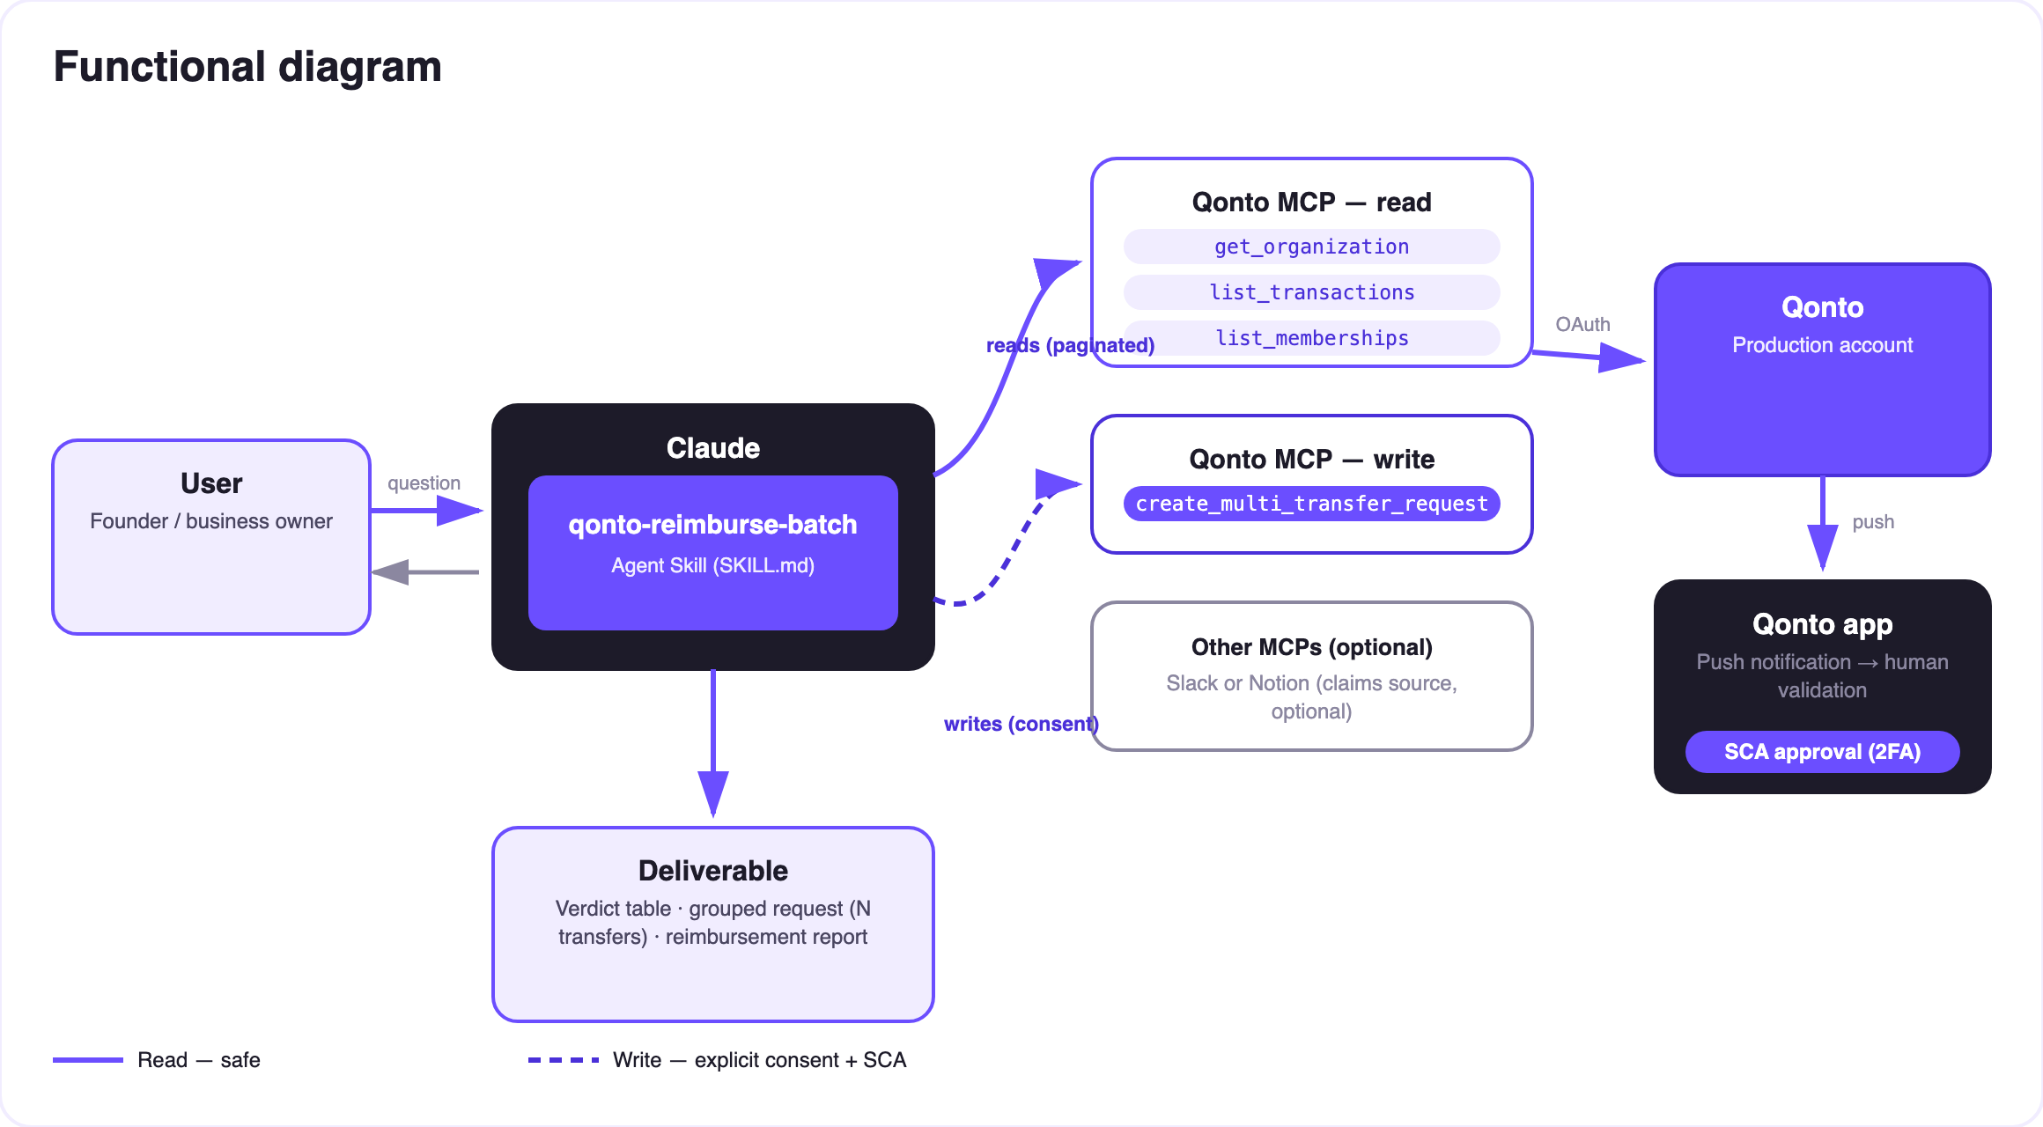
Diagram 2 — Actors and flows: risk-free reads (solid), write behind consent + SCA (dashed)
🔒 The security model, not a limitation: reads are risk-free; the write requires explicit consent in the conversation and only produces a request. The account holder's own SCA (2FA), in the Qonto app, is what moves money — all N transfers in one gesture, or declined in one tap. Neither Claude nor the MCP can.
🔍 The three checks (the heart of the skill)
Check | Source | Possible outcome
Receipt | Attachment/reference on the claim — amount and date confronted with the claim | ✅ consistent · ⚠️ missing or mismatched → on hold, exact reason shown
Duplicate | list_transactions: card spend (emitted_at ±5 days, same amount, similar counterparty) + recent reimbursement transfers ("NDF" references) | ❌ documented presumption (transaction cited) → out of the batch, the user decides
Expense policy | Per-category caps defined by the user | ⚠️ overage flagged with the gap → cap / accept / reject

Sample verdict table (invented data)
Claim | Amount | Checks | Verdict
Client dinner | €84.00 | receipt ✓ · no duplicate · under cap | ✅ in the batch
Airport taxi | €32.50 | receipt ✓ · no duplicate · under cap | ✅ in the batch
Portable screen | €129.00 | already paid with the company card on 06/03 (transaction cited) | ❌ rejected — evidence attached

Result: ONE grouped request of 2 transfers in the Qonto app, ready to approve in a single gesture.
📤 Output formats
Output | Format | When
Conversation reply | Markdown tables: verdicts (claim · checks · verdict), batch content, holds | Always — the baseline
Grouped Qonto request | N pending transfers (Requests section), batch summary in the note, visible at SCA approval | Every validated batch
Reimbursement report | Markdown recap (who · how much · why rejected, with evidence) — or an HTML artifact when the host renders files | After approval (status via list_requests)

🎬 Demo video
The ≤ 3-minute demo attached to the PR walks through: the problem → claims collected & checked → the verdicts (one duplicate rejected, cited transaction on screen) → the one-gesture SCA approval filmed on a phone → the final report. All claims in the demo are invented. (Shooting script kept internal, out of the repository.)
💡 Roadmap ideas
Idea | Effort | Note
Verdict posted back into each claim's Slack thread | Low | Optional multi-MCP — activates when the Slack MCP is present
Post-execution reconciliation (tick off outgoing transfers) | Low | Reuses list_transactions + the "NDF" references
OCR on attached receipts (amount/date extracted) | Medium | Strengthens check #1 on messy data
Per-team caps via list_teams | Low | Different policies for sales / tech / management
Monthly accounting export of reimbursements | Medium | Pairs with qonto-accountant-handoff

🛡 Guardrails
- NEVER creates the transfer request without explicit confirmation of the final list in the current conversation; never presented as executed — pending the user's SCA approval
- A duplicate is a documented presumption (transaction cited), never a silent rejection — the user decides
- No failed claim enters the batch without an explicit user override (recorded in the note)
- IBANs never invented; masked (last 4 digits) · pagination ≤ 50 everywhere
- Rehearsals: decline_request after each test (request_type "multi_transfers", plural)
qonto-reimburse-batch · English documentation · Qonto × Anthropic MCP Hackathon · July 2026 · PR deliverable: SKILL.md · French version: doc-qonto-reimburse-batch.fr.docx

