qonto-grant-scout
The grant hunter — your bank account knows what you invest in; public databases know who gets helped for it
Qonto × Anthropic MCP Hackathon · Read-only — zero writes · Dated sources (data.gouv.fr)

🎯 Why this matters
France runs hundreds of public aid schemes for small businesses — training funds, energy-transition grants, regional investment aid, digital vouchers. Most SMEs claim none of them, because nobody has time to dig. Yet the account already tells the story of what the company invests in. The skill makes the introduction:
- 1. Real company profile — sector (NAF code when present, inferred from the flows otherwise), region, size (incoming volume), age: get_organization first, zero forms
- 2. Real spending structure — 12–24 months of flows classified into aid-relevant categories: training, equipment, digital, hiring, export, energy — each priced in €/year with evidence
- 3. Cross-reference with public aid referentials via the Datagouv MCP (optional, detected dynamically) — every dataset's update date is checked and displayed
- 4. Honest shortlist — every lead: criteria to confirm, dated source, one concrete next step. Never “you are eligible” — always “worth checking, here's why”
Would someone use this on a Monday morning? “Am I leaving public money on the table?” is a question every founder asks — and never has time to answer.
📋 Prerequisites
Prerequisite | Detail | Required
Qonto production account | Adapts to any organization — get_organization first, nothing hardcoded | ✅ Yes
Country | Scheme cross-referencing: France only (aid is national/regional). Other Qonto countries (DE, ES, IT…): spending profile only, generic aid families, no scheme ever invented | ℹ️ Detected
Qonto MCP connected | Official connector (claude.ai / Claude Desktop), OAuth login | ✅ Yes
Datagouv MCP | Unlocks the referential search. Absent: the skill says so and still delivers profile + aid families + official portals | ⭕ Recommended
≥ 12 months of history | Below that, fragile spending signals — stated (🟡 tags) | ⭕ Optional
Qonto labels maintained | Sharpen spending classification (list_labels); counterparty-based otherwise | ⭕ Optional

⚙️ How it works
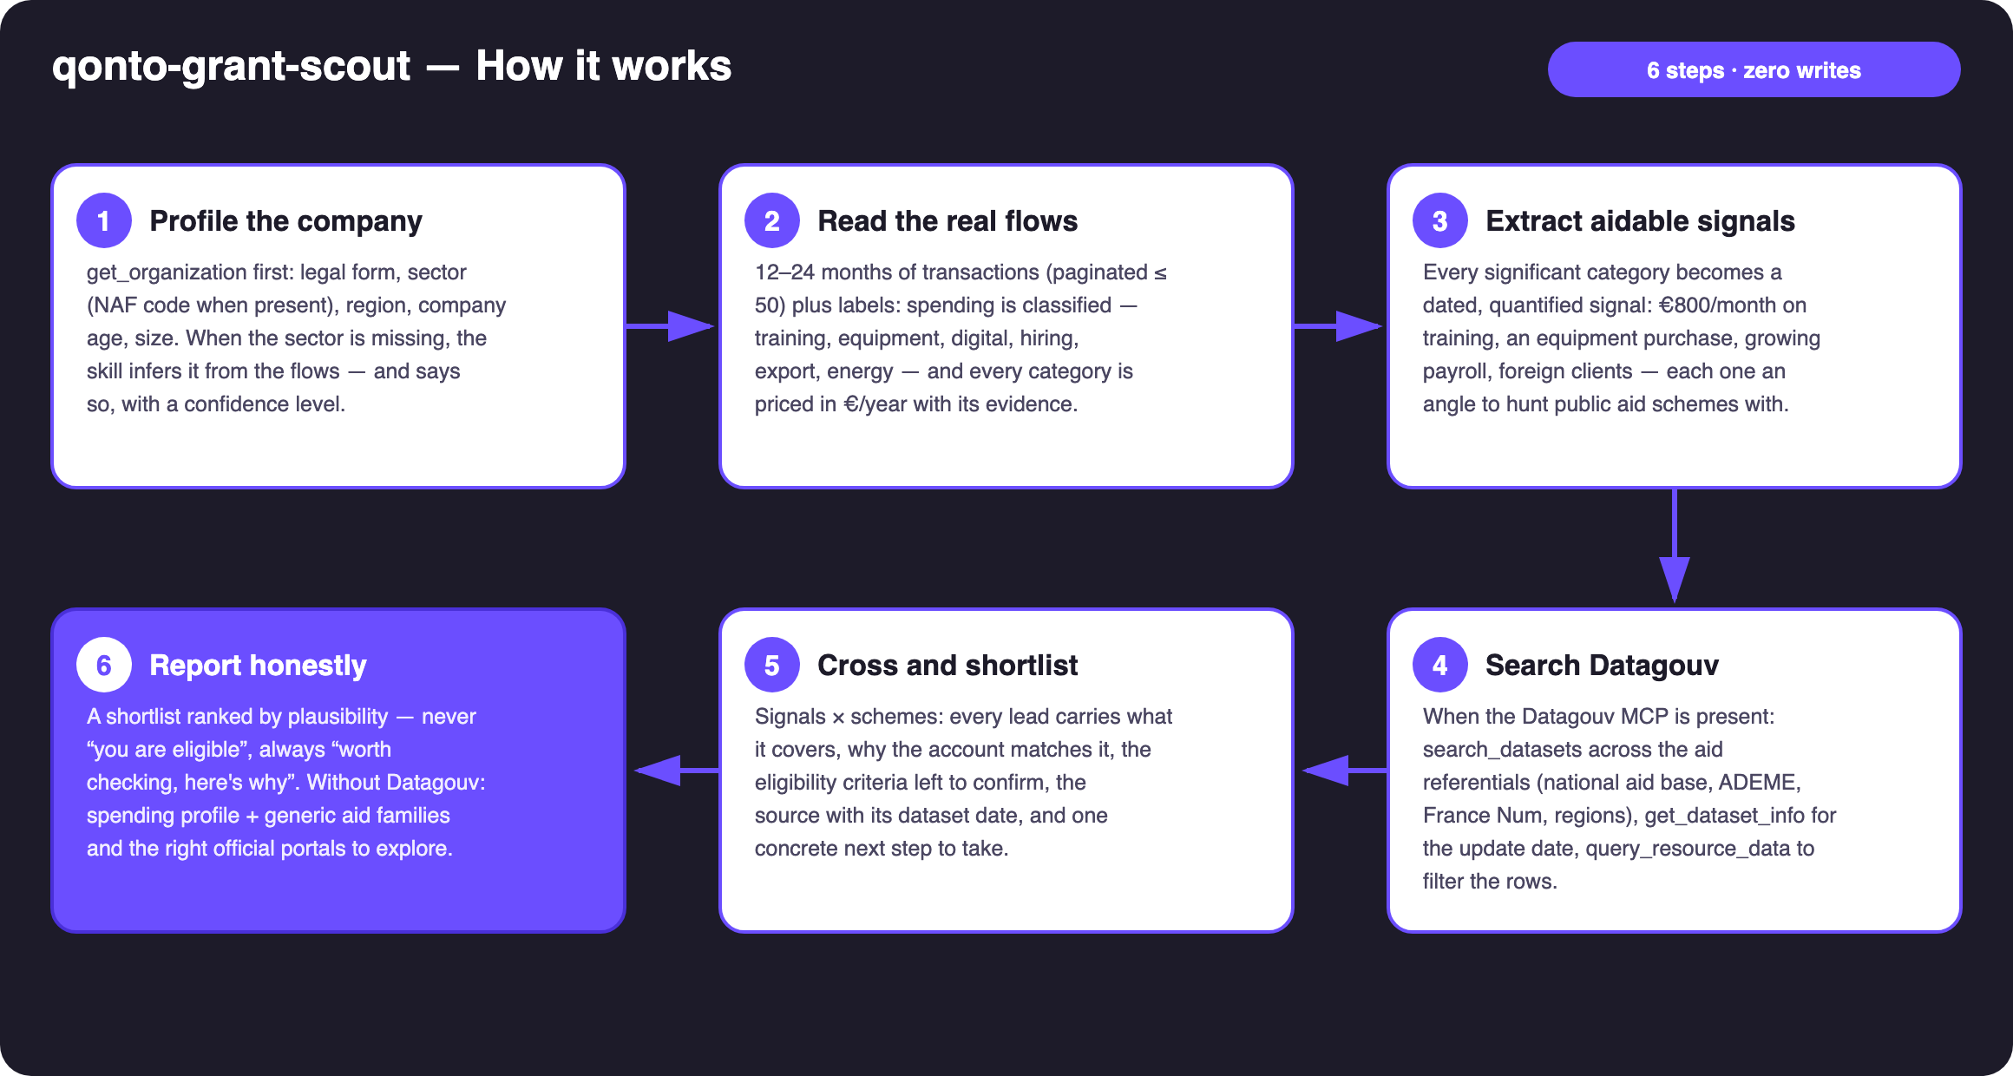
Diagram 1 — How it works, 6 steps (read-only, zero writes)
Structural honesty (what keeps it credible on uncertain data)
- Every lead carries its source AND its date: aid referentials on data.gouv.fr are heterogeneous and sometimes stale — get_dataset_info checks freshness; a dataset older than ~18 months degrades the lead's tag
- Never “you are eligible”: schemes open, close, and change criteria — every lead is “worth checking”, with the criteria the dataset exposes and the body to contact
- Non-queryable resource (PDF, malformed CSV) → the lead becomes a sourced link to the dataset page, stated as such
- Datagouv MCP absent or failing → spending profile + generic aid families + the right official portals, stated plainly
- Sector missing from get_organization → inferred from counterparties, confidence lowered, user can correct
- list_cash_flow_categories → 403 on the claude.ai connector: fallback to list_labels · card spending matched by emitted_at · pagination ≤ 50 everywhere

🏗 Functional diagram
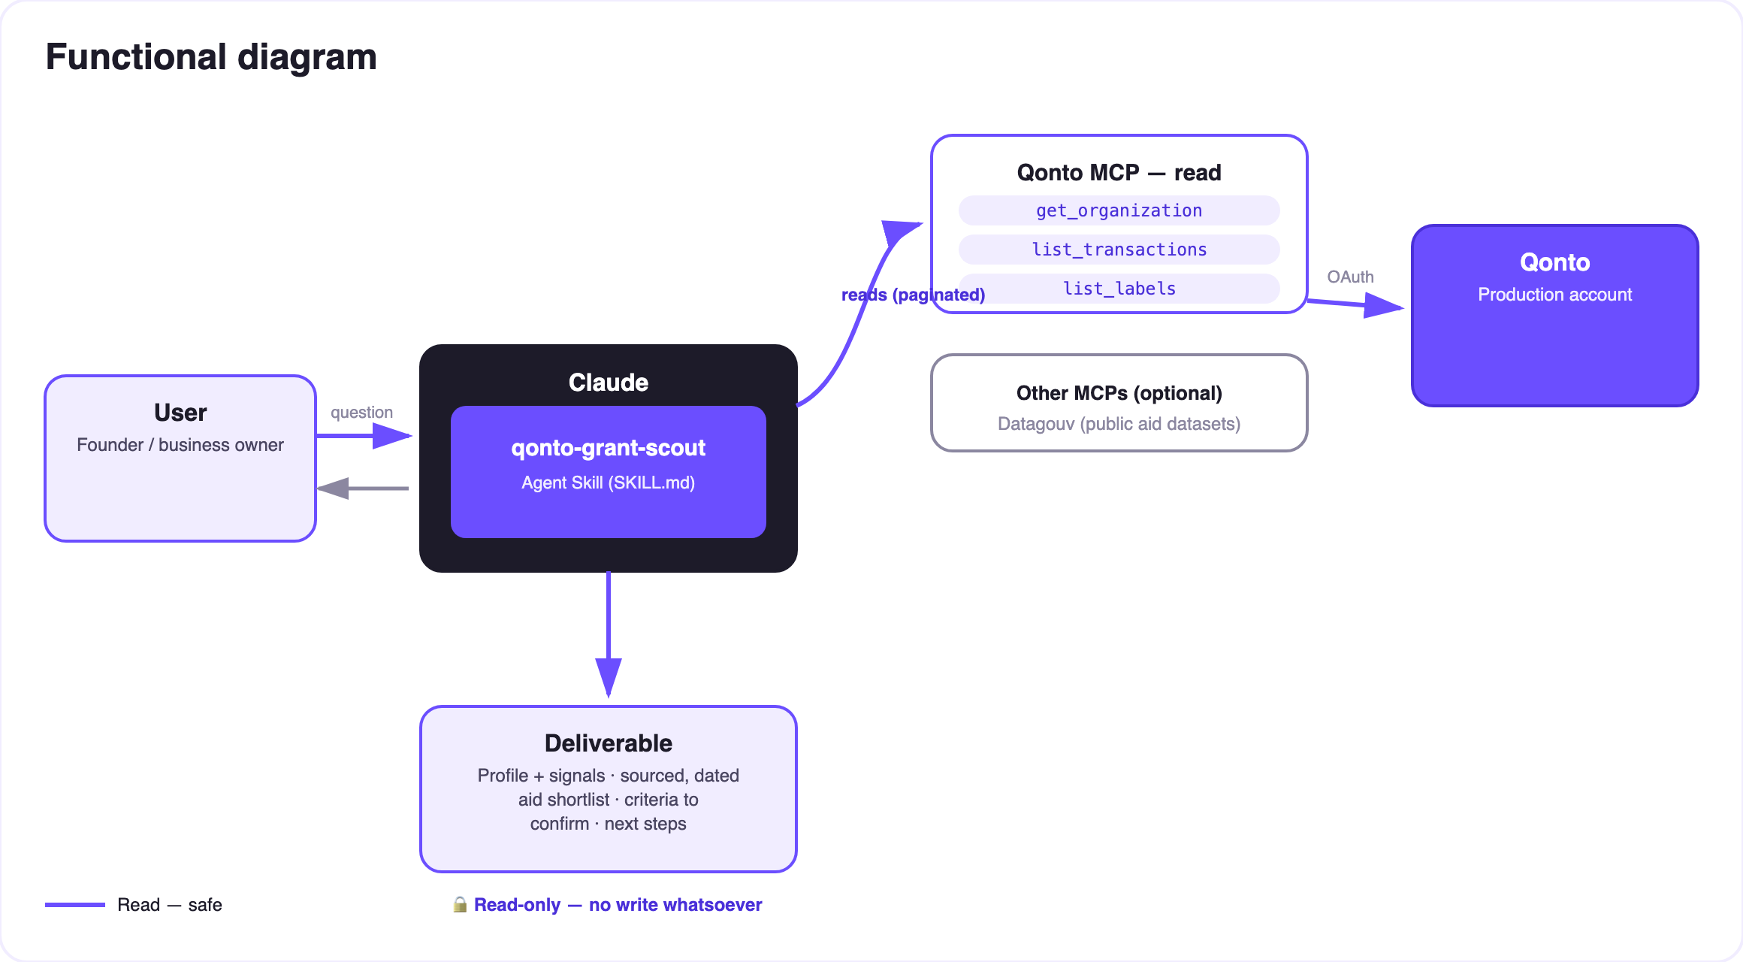
Diagram 2 — Actors and flows: read-only on the Qonto side, generic keywords only toward Datagouv
🔒 Zero writes, and the banking data stays with Qonto: the skill creates no transfer, no invoice, no application. Only generic search keywords (sector, region, aid family) ever reach Datagouv — never an amount, a counterparty name, or an IBAN.
🗂 Detected spending → aid families
Spending seen in the flows | Aid family | Examples (verify at the source) | Typical next step
Training (training bodies, e-learning, certifications) | Training funding | Training-fund (OPCO) coverage, FNE-Formation | Ask your training fund about coverage
Equipment / machinery | Regional investment aid | Regional council schemes | Check your region's economic desk
Digital (software, SaaS, website) | Digital transformation | France Num, regional digital vouchers | Go through a France Num advisor
R&D-like spending (prototyping, technical subcontracting) | Tax incentives | Research/innovation tax credits (CIR/CII), JEI status | Review with the accountant
Hiring / apprenticeship | Hiring aid | Apprenticeship aid, France Travail schemes | Simulate on the official portals
Energy / vehicles / works | Ecological transition | ADEME (Tremplin PME), energy-saving certificates | File on the ADEME portal
Export / foreign clients | International | Bpifrance Assurance Prospection, Team France Export | Contact the regional export advisor

📤 Output formats
Output | Format | When
Conversation reply | Markdown tables: profile + signals, sourced and dated shortlist, limits | Always — the baseline
Grant radar | HTML file/artifact: signals × aid families, leads at the intersections, 🟢🟡🔵 tags | When the host renders files; fallback to tables
Per-lead brief | Ready-to-send text block (training fund, accountant, regional desk): signal, scheme, criteria, source | On request, per retained lead

🎬 Demo video
The ≤ 3-minute demo attached to the PR walks through: the problem (aid nobody goes hunting for) → the profile emerging from the flows alone → the dated, sourced Datagouv search → the crossing (€9,600/year of training spend spotted → the exact scheme, the link, and what to ask the training fund) → honesty by design. It runs live on a real production account.
💡 Roadmap ideas
Idea | Effort | Note
Quarterly re-scan: re-cross the profile, alert only on new leads | Low | Reuses the profile already built
Aides-territoires enrichment (dedicated API) | Medium | Often fresher — same dating discipline
Pre-filled email draft to the training fund / regional desk with the account's numbers | Low | Still zero writes — the user sends it
Country modules (DE: KfW · ES: ENISA · IT: Invitalia…) | High | Qonto is pan-European; v1 = France + country detection

🛡 Guardrails
- Zero writes; only generic keywords reach Datagouv — never amounts, names, or IBANs
- Never “you are eligible” — every lead is dated, sourced, phrased “to verify”; confirmation with the issuing body or the accountant recommended
- Honest degradation: no Datagouv MCP, empty account, undetectable sector, non-FR country → the skill states its limits and never invents a scheme, an amount, or a deadline
- IBANs masked (last 4 digits) · pagination ≤ 50 everywhere
qonto-grant-scout · English documentation · Qonto × Anthropic MCP Hackathon · July 2026 · PR deliverable: SKILL.md · French version: doc-qonto-grant-scout.fr.docx

