qonto-shopify-bridge
What the store claims vs what the bank collects — e-commerce payout reconciliation for Qonto
Qonto × Anthropic MCP Hackathon · Multi-MCP: Qonto + Shopify · Zero writes — pure read

🎯 Why this matters
Every Shopify merchant lives with the same blind spot: gross sales in the store dashboard, net payouts on the bank account — and between the two, fees, refunds and delays. Most merchants never reconcile; they just trust. This skill checks:
- 1. Payout rhythm — each PSP's cadence (Shopify, Stripe, PayPal, SumUp…) learned from history; every break becomes an alert: missing or late payout
- 2. Real fees vs announced — effective rate computed payout by payout: (gross − net) ÷ gross, compared to the plan's advertised rate when the user provides it; no invented schedules
- 3. Refunds & chargebacks — refunded in the store but never reflected on the account (or the reverse): detected, documented, referenced
- 4. The true margin — net cash collected per period after every commission, not the flattering number on the store dashboard
The typical report: “14 payouts expected, 13 received, 1 late by 4 days; effective fees 2.9% + €0.30, in line with the plan; net collected this month: €X”. Would someone use this on a Monday morning? That's exactly when last week's payouts should have landed.
📋 Prerequisites
Prerequisite | Detail | Required
Qonto production account | Adapts to any organization — get_organization first, nothing hardcoded | ✅ Yes
Country | All Qonto countries (FR, DE, ES, IT, AT, NL, BE, PT) — payout reconciliation is universal. Multi-currency: reported per currency, never converted silently | ℹ️ Detected
Qonto MCP connected | Official connector (claude.ai / Claude Desktop), OAuth login | ✅ Yes
PSP inflows in the history | Identifiable SHOPIFY / STRIPE / PAYPAL / SUMUP… credits — the raw material of the Qonto-only core | ✅ Yes
Shopify (or Stripe) MCP | Detected dynamically. With it: fine-grained sales ↔ payouts reconciliation. Without it: Qonto-only mode, stated plainly | ⭕ Recommended
≥ 3 months of PSP history | Below that: cadence announced as low-confidence | ⭕ Optional

⚙️ How it works
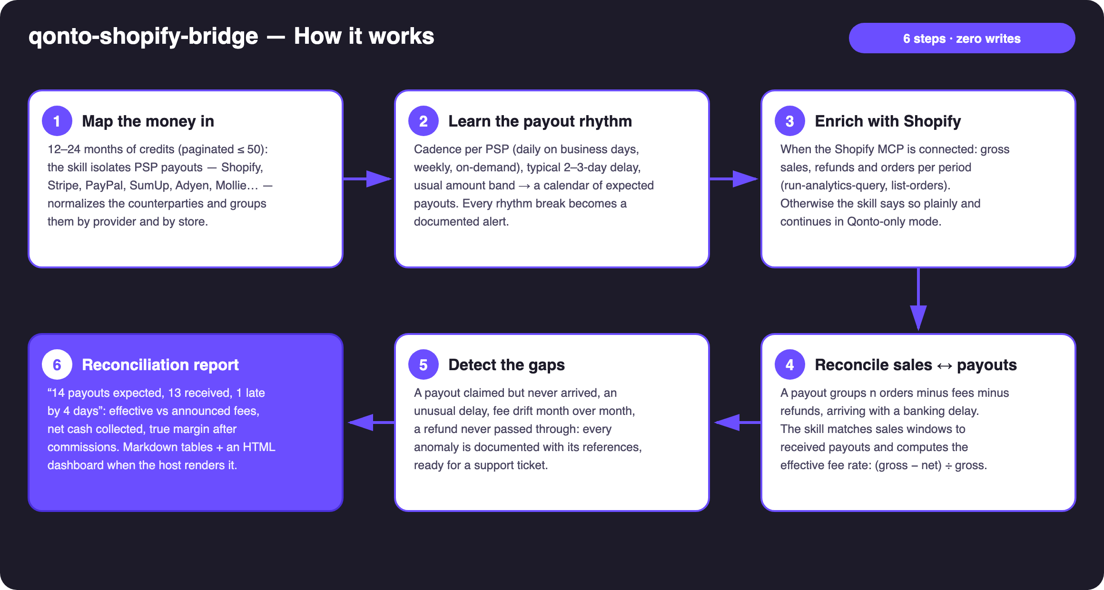
Diagram 1 — How it works, 6 steps (zero writes, pure read)
Holds up on messy data
- Grouped payouts handled: one transfer = n orders − fees − refunds; reconstructed by date window + amount proximity, never naive same-day equality
- 2–3 business-day banking delays: the Qonto date is settled_at — matched by window, not by the date the store claims
- PayPal manual withdrawals: the on-demand pattern is recognized and requalified — no false alarms
- Multi-store & multi-PSP: one reconciliation lane per store and per provider, consolidated summary on top
- No Shopify MCP → Qonto-only mode announced · history < 3 months → low confidence announced · pagination ≤ 50 everywhere

🏗 Functional diagram
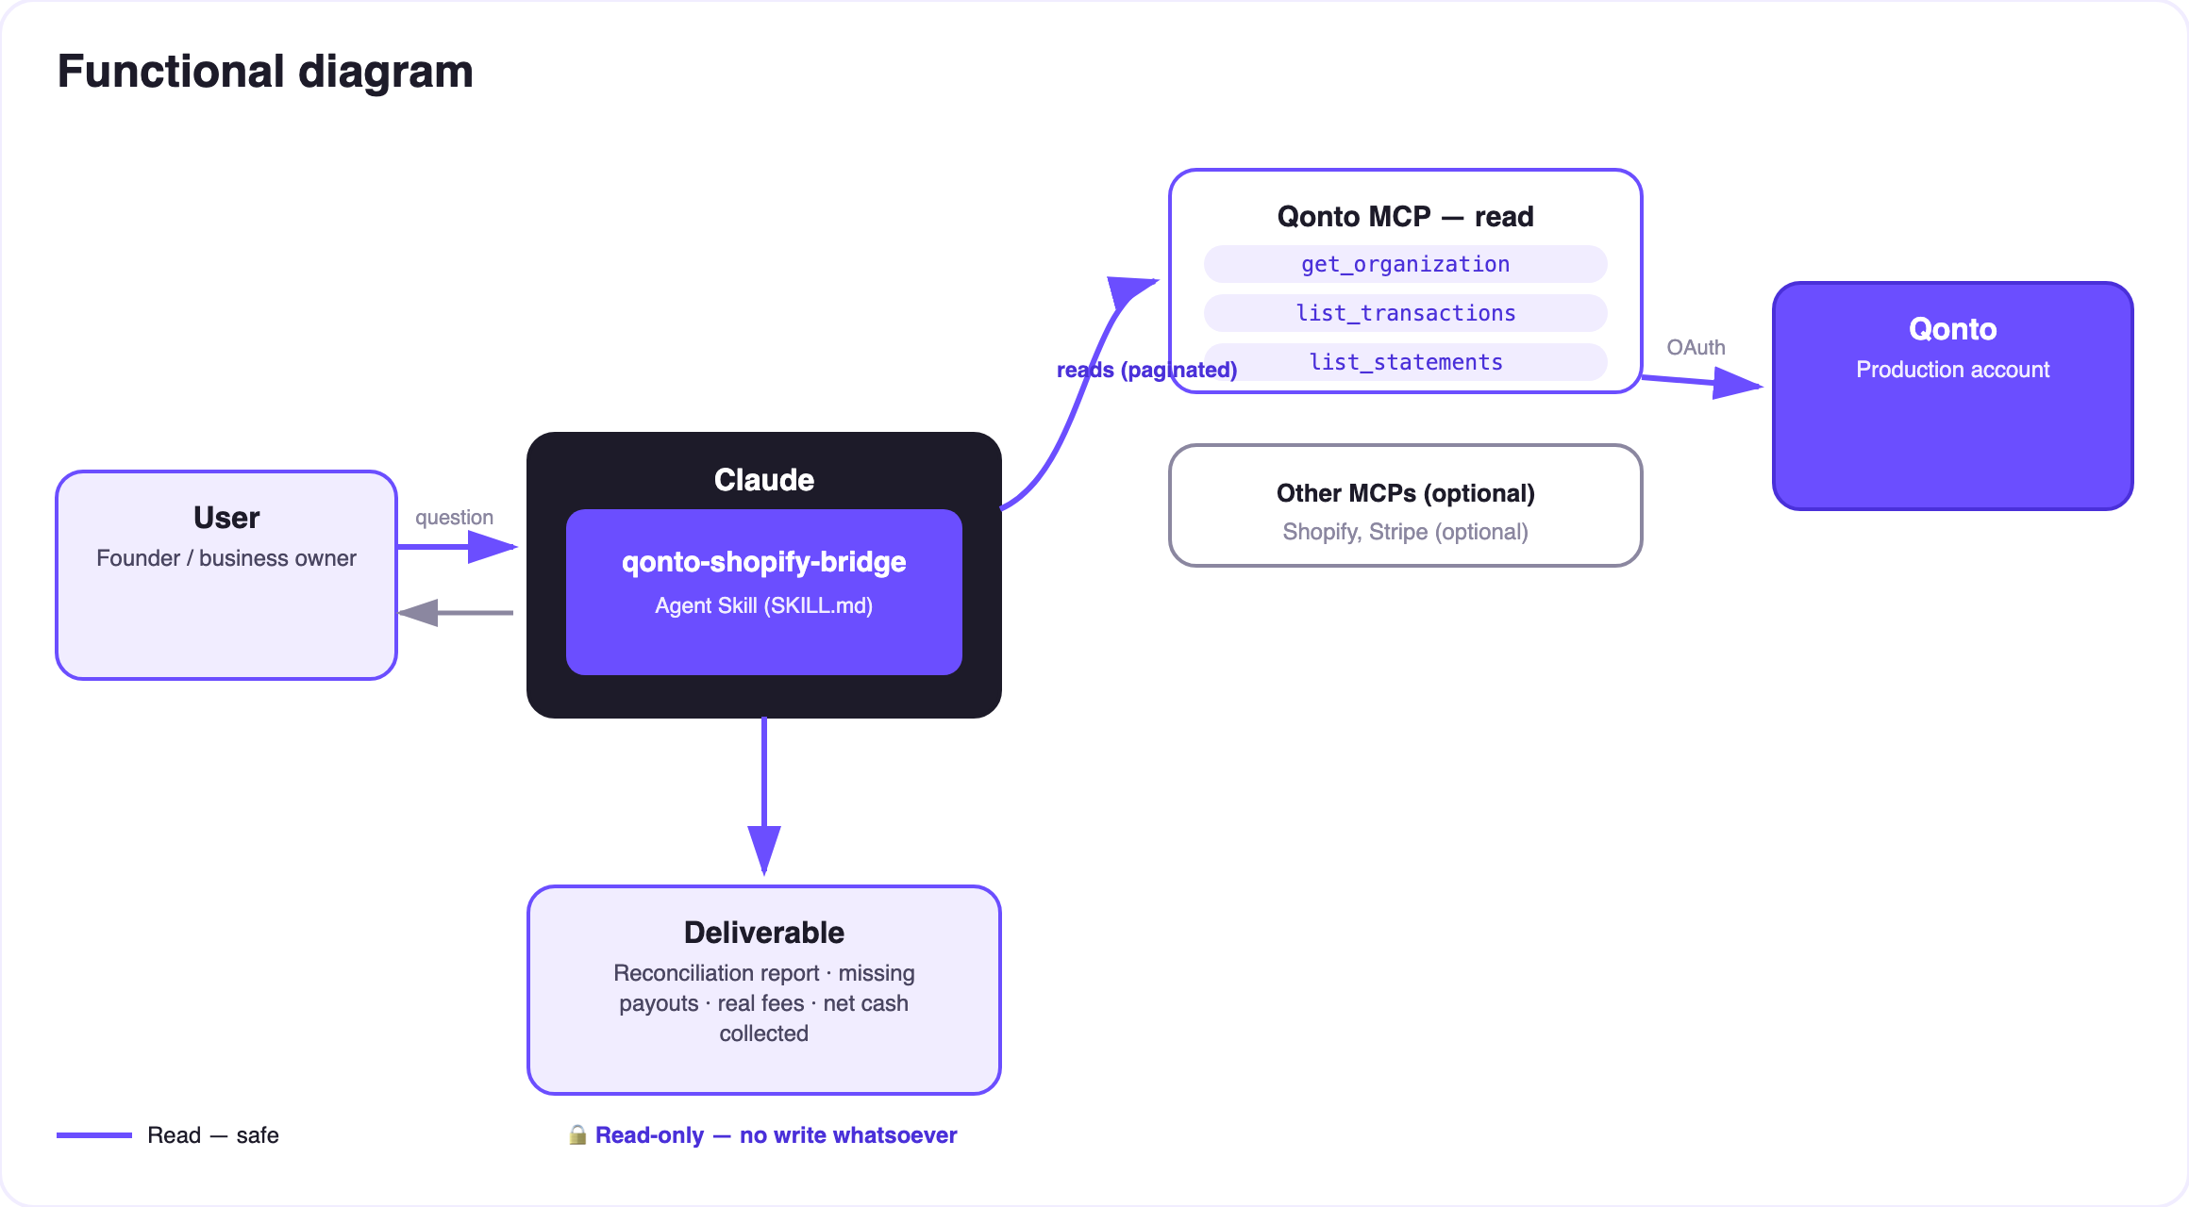
Diagram 2 — Actors and flows: Qonto + optional Shopify reads, zero writes
🔒 Pure read, zero risk: no write tool, on the Qonto side or the Shopify side. The skill reads, matches, documents. The only “action” it produces is text — the support-ticket draft that only the user decides to send.
🔍 What the skill detects
Anomaly | How | What you get
Missing payout | Expected from the learned cadence (and/or claimed by the store), nothing on the account past the typical delay | Support ticket draft: date, expected amount, order range, statement reference
Late payout | Arrived, but N days past the learned delay | Dated alert + delay history
Fee drift | Effective rate (gross − net) ÷ gross moving month over month | Trend curve, comparison against the plan's advertised rate (if provided)
Refund not passed through | Refunded in the store, no matching deduction on the account (or the reverse) | Case list, references from both sides
Manual withdrawals (PayPal) | On-demand pattern recognized | Cadence requalified — no false alarm

📤 Output formats
Output | Format | When
Conversation reply | Markdown tables (reconciliation, fees, net collected, anomalies) | Always — the baseline
Interactive dashboard | HTML file/artifact: payout timeline (gaps highlighted), fee-rate trend, net-per-month bars | When the host renders files; fallback to tables
Support ticket draft | Ready-to-send text for Shopify/Stripe support, every reference included | Every missing payout detected

🎬 Demo video
The ≤ 3-minute demo attached to the PR walks through: the problem (the store says X, the bank says Y) → payout rhythm in pure Qonto mode → Shopify-enriched reconciliation → the missing payout caught, support ticket ready → the final report with the true margin. It runs live on a real production store and account.
💡 Roadmap ideas
Idea | Effort | Note
Stripe MCP as a second, symmetric enrichment | Low | Same logic as Shopify — dynamic detection
Recurring Monday-morning check (“any payout missing?”) | Low | The skill is idempotent — just re-run it
Order-level payout breakdown (payout → exact order list) | Medium | get-order already allows it, costs extra calls
Net margin per product, commissions apportioned | Medium | Combines run-analytics-query + real fees
Consolidated multi-PSP view (Shopify + PayPal + SumUp) | Low | The Qonto-only core already does it per PSP

🛡 Guardrails
- Pure read: no write tool, nothing created or modified — on the Qonto side or the store side
- Never invents a fee schedule: computed rates only, sample size shown
- A “missing payout” is a documented hypothesis, not an accusation — support has the final word
- Per-currency reporting, no silent conversion · IBANs masked (last 4 digits) · pagination ≤ 50 everywhere
- Honest degradation: no Shopify MCP → Qonto-only announced; thin history → low confidence announced
qonto-shopify-bridge · English documentation · Qonto × Anthropic MCP Hackathon · July 2026 · PR deliverable: SKILL.md · French version: doc-qonto-shopify-bridge.fr.docx

