qonto-tax-pilot
Predict the taxman, then move the money out of harm's way — a tax copilot for Qonto
Qonto × Anthropic MCP Hackathon · Battle-tested on real data · Single write, behind SCA

🎯 Why this matters
The number-one cash killer for small businesses isn't revenue — it's VAT money that was already spent when the notice arrives. The skill turns a Qonto account into a tax copilot:
- 1. Dated, amount-estimated tax schedule — when each tax is due and how much (VAT, corporate tax instalments & balance, CFE, dividend flat tax), every line confidence-tagged 🟢 seen in history · 🟡 estimated · 🔵 conditional
- 2. 90-day cash projection per account — dated low point, threshold crossings, what-if simulations
- 3. Monthly provision — net VAT (computed on receipts when that's the detected regime) + IS/12 + CFE/12
- 4. One safe action — a transfer request to the tax sub-account; money moves only after the user's own SCA approval in the Qonto app
Would someone use this on a Monday morning? It's literally a first-of-the-month ritual.
📋 Prerequisites
Prerequisite | Detail | Required
Qonto production account | Adapts to any organization — get_organization first, nothing hardcoded | ✅ Yes
Country | Full tax calendar: France. Other Qonto countries (DE, ES, IT…): graceful degradation — generic projection + VAT provisioning, never invented deadlines | ℹ️ Detected
Qonto MCP connected | Official connector (claude.ai / Claude Desktop), OAuth login | ✅ Yes
A “tax” sub-account | Created once in the Qonto app (the MCP has no account-creation tool). Detected by name: tax / taxe / impôt / TVA | ⭕ Recommended
≥ 6 months of history | Below that: honest degradation (🟡 tags + warning) | ⭕ Optional
French company at IS | Default assumption; wording adapts otherwise | ⭕ Optional

⚙️ How it works
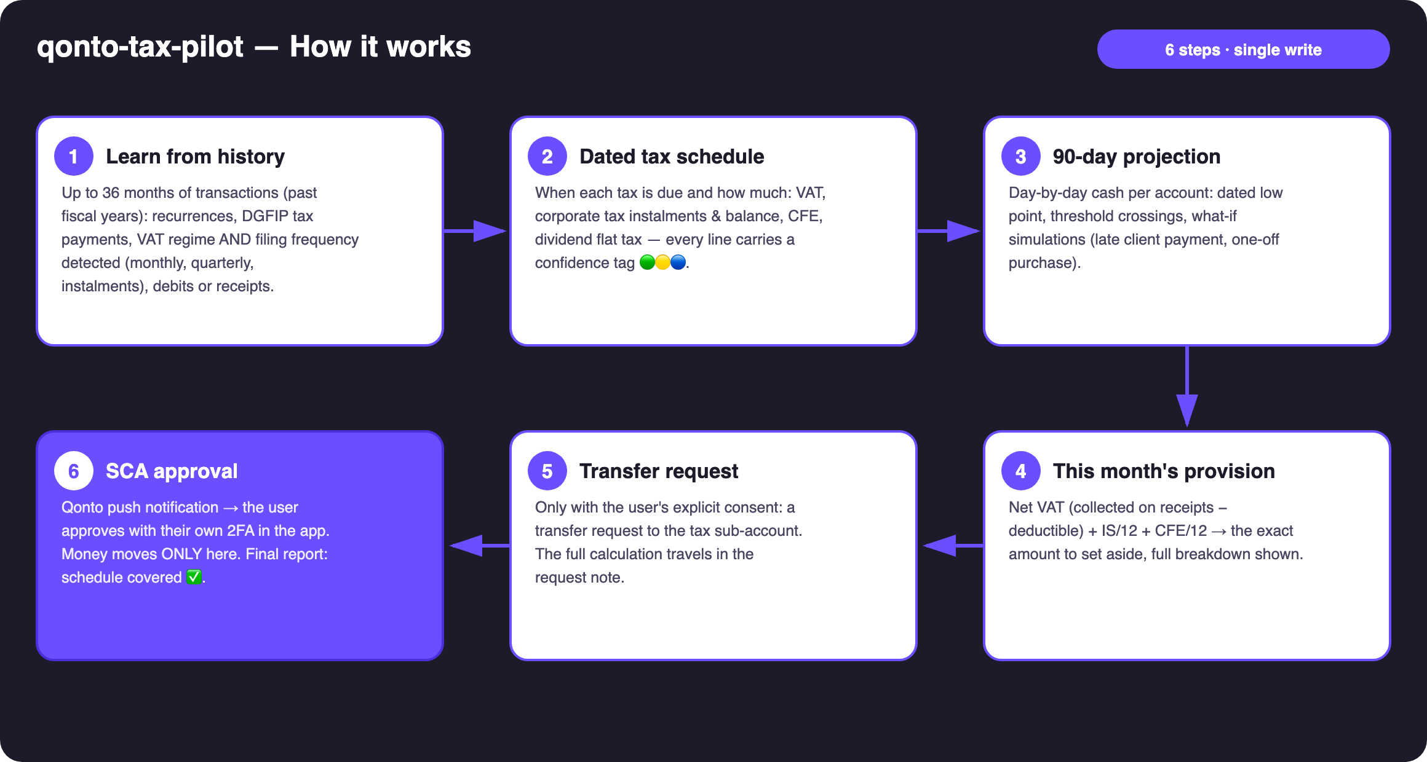
Diagram 1 — How it works, 6 steps (single write, behind SCA)
Holds up on messy data
- VAT regime AND filing frequency detected, never asked: monthly DGFIP debits → monthly CA3; quarterly → quarterly CA3 (annual VAT < €4,000); July + December instalments → simplified CA12, ABOLISHED on 2027-01-01 (2025 Finance Act, switch announced); “on_receipts” → VAT follows client payments, not issued invoices
- Multi-year analysis: up to 36 months, covering at least the two previous fiscal years — tax cadences only show across full years
- Deductible VAT = summed vat_amount, announced as a floor, with the count of untagged debits disclosed
- Empty account, no sub-account, non-French company: the skill says what it can and can't estimate instead of pretending
- Pagination ≤ 50 everywhere · card settlement delays (emitted_at vs settled_at) · refunds deducted from collected VAT

🏗 Functional diagram
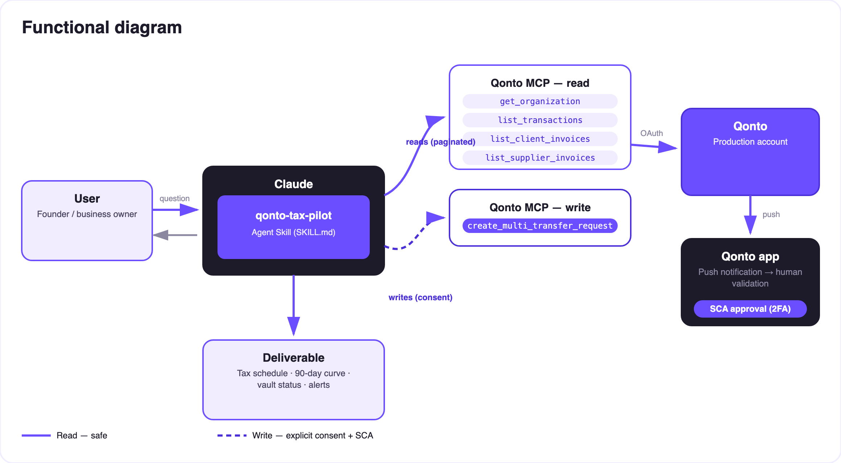
Diagram 2 — Actors and flows: risk-free reads (solid), write behind consent + SCA (dashed)
🔒 The security model, not a limitation: reads are risk-free; the write requires explicit consent in the conversation and only produces a request. The account holder's own SCA (2FA), in the Qonto app, is what moves money. Neither Claude nor the MCP can.
📅 Reference tax calendar (company at IS, Dec-31 close)
Deadline | Tax | Estimation
Monthly or quarterly ~15th–24th (standard; quarterly if annual VAT < €4,000) | VAT CA3 | Median of recent payments, refined by collected − deductible
July 55% + December 40% | VAT instalments (simplified — abolished 2027-01-01) | Last CA12 / historical payments
15/03 · 15/06 · 15/09 · 15/12 | Corporate tax instalments (2571) | Past instalments, else IS N-1 ÷ 4 — none if IS N-1 < €3,000
15/05 | Corporate tax balance (2572) | Estimated IS N-1 − instalments
15/06 (if ≥ €3,000) + 15/12 | CFE | Last year's payment
15th of month after distribution | Dividends — the skill asks who the shareholder is | Individual → 30% flat tax (2777) · Holding (parent-subsidiary) → no flat tax, 5% add-back at the holding's level — ~nothing here. Never assumed

📤 Output formats
Output | Format | When
Conversation reply | Markdown tables (schedule, provision, alerts) | Always — the baseline
Interactive dashboard | HTML file/artifact: 90-day curve, schedule ✅/⚠️, vault gauge | When the host renders files; fallback to tables
Qonto request note | Text attached to the request, visible at SCA approval | Every provision created

🎬 Demo video
The ≤ 3-minute demo attached to the PR walks through: the problem → tax schedule & projection → the provision → the SCA approval filmed on a phone → the final dashboard. It runs live on a real production account.
💡 Roadmap ideas
Idea | Effort | Note
URSSAF/social contributions for TNS managers (EURL) | Medium | Widens the audience beyond IS companies
European country modules (DE · ES · IT · AT · NL · BE · PT) | Medium | Qonto is pan-European; v1 = France + country detection, v2 = one tax-calendar module per country
Calendar reminders for tax deadlines (calendar MCP detected dynamically) | Low | Optional multi-MCP enrichment, in the spirit of the kickoff
Full-year corporate-tax landing estimate | Medium | Reuses the recurrence engine
Interactive what-if artifact (sliders) | Low | Dashboard already prototyped

🛡 Guardrails
- NEVER creates a transfer request without explicit confirmation in the current conversation; never presented as executed
- Estimates ≠ filings — accountant validation recommended in every report
- Honest degradation under 6 months of history · masked IBANs (last 4 digits) · pagination ≤ 50
- Rehearsals: decline_request after each test (request_type “multi_transfers”, plural)
qonto-tax-pilot · English documentation · Qonto × Anthropic MCP Hackathon · July 2026 · PR deliverable: SKILL.md · French version: doc-qonto-tax-pilot.fr.docx

