qonto-true-margin
Pricing from real banking costs — the dashboard's margin is a fiction; the bank account knows the real one
Qonto × Anthropic MCP Hackathon · Zero write on the Qonto side · Shopify prices applied line by line · Allocation announced as a heuristic

🎯 Why this matters
Every e-commerce dashboard shows a margin built from theoretical costs. What actually leaves the bank account — PSP fees really debited, FX costs, real carrier invoices, supplier purchases — tells a different story. The skill rebuilds the truth and turns it into a pricing decision:
- 1. Real costs classified from Qonto debits — observed PSP fees (or “unknown, not zero” when netted inside payouts), FX, carriers, supplier COGS — each family tagged 🟢 observed · 🟡 derived · ⚪ unknown
- 2. True contribution margin per product — Shopify per-product sales − real costs allocated pro-rata (an announced heuristic: revenue or units, method printed on every table)
- 3. Loss-making products identified — sorted first, with the gap vs the dashboard's theoretical margin in plain sight
- 4. New prices proposed, then applied — break-even + target price; applied in Shopify (update-product) only after explicit line-by-line validation, never in bulk
Would someone run this on a Monday morning? “Which of my products actually made money last month?” is THE Monday-morning question for a store owner.
📋 Prerequisites
Prerequisite | Detail | Required
Qonto production account | Adapts to any organization — get_organization first, nothing hardcoded | ✅ Yes
Country | Universal — identical for all Qonto countries (FR, DE, ES, IT, AT, NL, BE, PT); multi-currency reported per currency, never converted silently | ℹ️ Detected
Qonto MCP connected | Official connector (claude.ai / Claude Desktop), OAuth login | ✅ Yes
Shopify MCP connected | Per-product sales + price updates. Without it: announced degraded mode — global margin by cost family, no product granularity | ⭕ Recommended
Stripe MCP connected | Per-charge fee detail | ⭕ Optional
≥ 3 months of history | Below that: lower confidence tags + honest warning | ⭕ Optional

⚙️ How it works
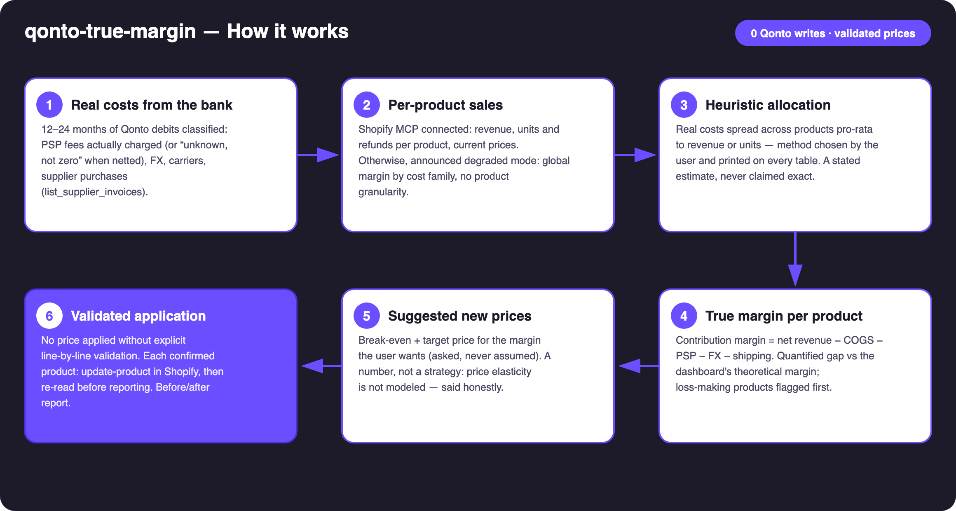
Diagram 1 — How it works, 6 steps (zero Qonto writes, prices validated line by line)
Holds up on messy data
- PSP fees netted inside payouts (the Shopify Payments case: no separate debit) → effective rate derived from gross vs net when the Shopify MCP is present, otherwise shown as “unknown, not zero” — never an announced rate passed off as observed
- Allocation = a stated heuristic: pro-rata revenue (default) or units, method printed on every table; supplier invoices naming a product are matched directly, allocation covers only the rest
- No Shopify MCP: announced degraded mode — true margin by cost family, no per-product claim
- Card-paid shipping reconciled on emitted_at (1–2 day drift vs settled_at) · refunds deducted from net revenue · foreign-currency debits → real FX cost isolated
- Thin history (< 3 months): lower confidence tags + a warning · pagination ≤ 50 everywhere · counterparty spellings normalized

🏗 Functional diagram
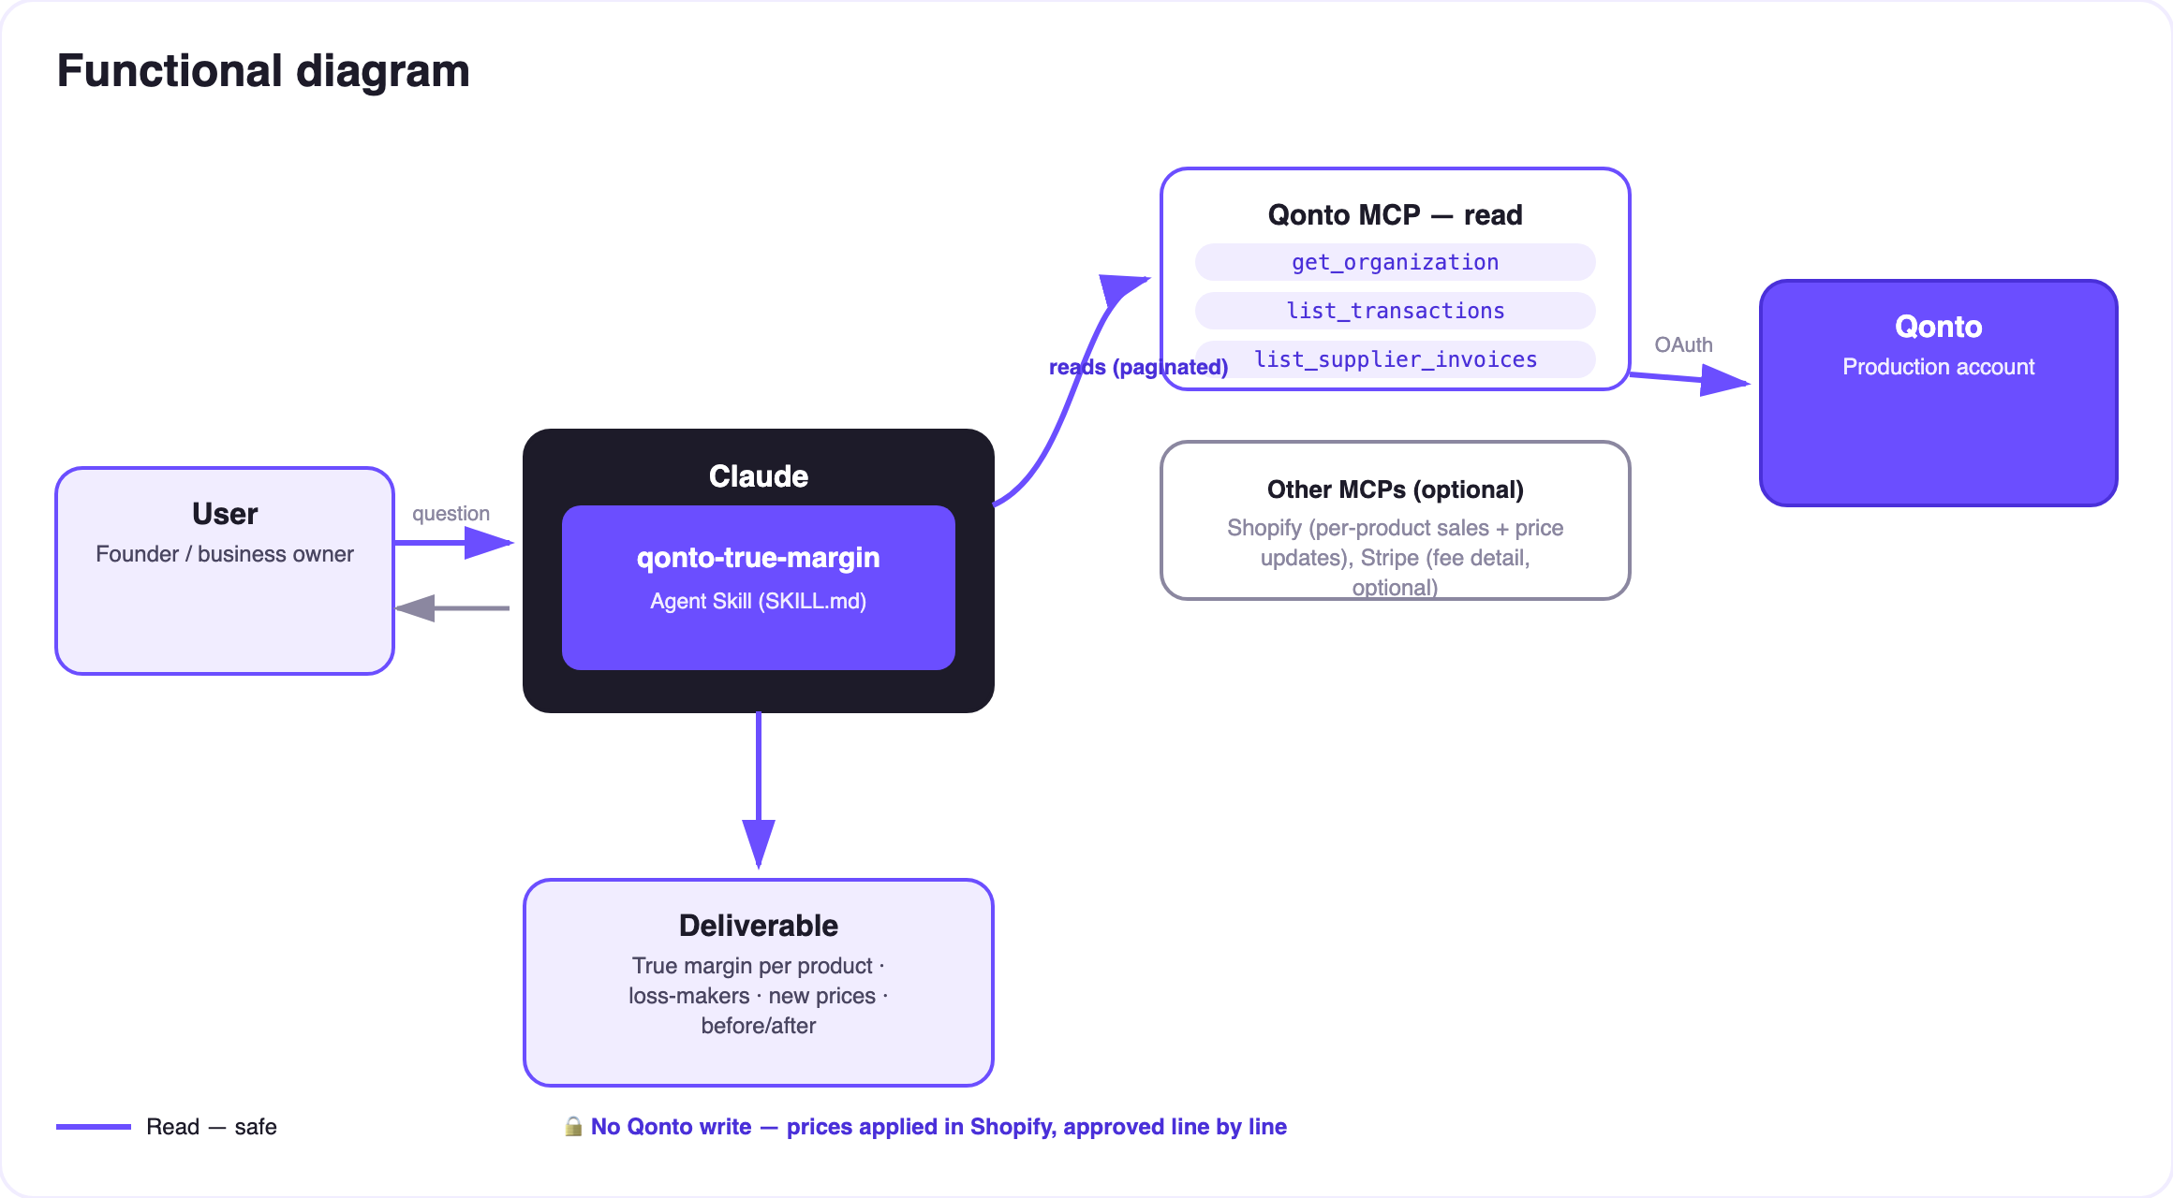
Diagram 2 — Actors and flows: Qonto side fully read-only; the only write is on the Shopify side, on line-by-line validation
🔒 On the Qonto side: read-only. No banking write tool exists in this skill — nothing can move on the account. The only write is on the Shopify side (price updates): each product requires explicit validation in the conversation, a global “apply everything” is refused, and the price is re-read after application before being reported.
🧾 Real-cost families (read from the Qonto debits)
Family | Source | Quirk handled
PSP fees | Separate fee debits (Stripe billing, PayPal…); otherwise gross vs net via Shopify | Shopify Payments nets its fees INSIDE the payout → “unknown, not zero” without Shopify
FX | Debits whose local currency ≠ account currency + explicit fee lines | Real conversion cost isolated, never estimated from a public rate
Shipping | Carrier counterparties (Colissimo, Chronopost, Mondial Relay, DHL, UPS, Sendcloud…) | Card payments reconciled on emitted_at (1–2 day drift)
Supplier COGS | list_supplier_invoices + recurring supplier debits | Invoice → product matched directly when named, otherwise pro-rata allocation
Fixed costs | Everything else (rent, SaaS, salaries) | Excluded from contribution margin, disclosed separately — stated plainly

🆚 How it differs from qonto-shopify-bridge
 | qonto-shopify-bridge | qonto-true-margin
Nature | Accounting record of the past | Pricing decision for the future
Question | “Did Shopify actually pay me?” | “Does this product actually make me money?”
Core | Reconciles payouts ↔ bank, observes effective fees | Consumes those observed costs → true margin per product → new prices
Writes | None (fully read-only) | None on Qonto; Shopify prices on line-by-line validation

Shared input, opposite output: run the bridge when a payout looks wrong; run true-margin when a price needs fixing. The two skills reference each other.

📊 Sample output (invented data)
Product | Price | Dashboard margin | True margin | Verdict
Enamel mug | €24.90 | 38% | −4% | 🔴 sold at a loss (real shipping)
Tote bag | €19.90 | 45% | 22% | 🟠 fees + FX underestimated
A2 poster | €34.90 | 42% | 11% | 🟠 recommended price: €39.90

Every figure in this table is invented for the example — the skill only shows numbers computed on the user's own account, with the allocation method in the caption.
📤 Output formats
Output | Format | When
Conversation reply | Markdown tables (cost families, per-product margins, proposals, before/after) | Always — the baseline
Interactive dashboard | HTML file/artifact: waterfall from dashboard to real margin, loss-makers, price simulator | When the host renders files; fallback to tables
Shopify confirmation | get-product re-read after every update-product | Every validated application

🎬 Demo video
The ≤ 3-minute demo attached to the PR walks through: the dashboard margin that lies → the real costs read from the bank debits → the reveal (the best-seller showing 42%… actually 11% — invented demo figures) → the new price validated line by line and applied in Shopify → the final dashboard. (Shooting script kept internal, out of the repo.)
💡 Roadmap ideas
Idea | Effort | Note
Weight/order-based shipping allocation (Shopify data) | Medium | Replaces the pro-rata for the shipping family
Per-charge fee detail via the Stripe MCP | Low | Already planned as optional — upgrades 🟡 to 🟢
Monthly true-margin drift tracking | Low | Alert when a product slips under its threshold
Compared pricing scenarios (2–3 target-margin hypotheses) | Low | In the HTML simulator

🛡 Guardrails
- NEVER applies a price without explicit validation of that specific product in the current conversation; never reported as done without a Shopify re-read
- The allocation is a stated heuristic — method (pro-rata revenue or units) printed on every table; true margins are estimates, not accounting
- Suggestion ≠ pricing strategy: elasticity not modeled — said honestly with every proposal
- Zero Qonto write tool · invisible fees → “unknown, not zero” · masked IBANs (last 4 digits) · pagination ≤ 50 · per-currency reporting
qonto-true-margin · English documentation · Qonto × Anthropic MCP Hackathon · July 2026 · PR deliverable: SKILL.md · French version: doc-qonto-true-margin.fr.docx

