qonto-approval-brief
Instruct every team request like a CFO — only you approve, in the app, behind SCA
Qonto × Anthropic MCP Hackathon · Every brief cites its evidence · Zero MCP approval · Universal (all Qonto countries)

🎯 Why this matters
Team transfer and card requests pile up in Qonto — and the owner approves half-blind, or three days late. Every request deserves five minutes of digging; nobody has them. The skill does a CFO's instruction work on every pending request:
- 1. Beneficiary history — paid N times before? usual amounts? cadence? A 3rd identical payment isn't judged like a first-ever transfer
- 2. IBAN signal — seen before in the account's history (reassuring, dated) or never seen (a vigilance signal, not an accusation)
- 3. Coherence & context — amount vs habit (×4 → strong flag), budget/label fit, the quote found in Gmail when that MCP is connected
- 4. One decision brief per request — ✅ recommended / 🔶 verify, every claim citing its evidence; motivated declines via MCP (confirmed), approvals in the Qonto app with the owner's own 2FA
Would someone use this on a Monday morning? Monday morning is exactly when the weekend's request pile is waiting. Sample brief lines (invented): "✅ recommended: 3rd identical payment to this provider" · "🔶 verify: never-seen IBAN, amount ×4 the usual".
📋 Prerequisites
Prerequisite | Detail | Required
Qonto production account | Adapts to any organization — get_organization first, nothing hardcoded | ✅ Yes
Country | Universal — the instruction relies on the account's own history, not national rules; every Qonto country (FR, DE, ES, IT…) | ℹ️ Detected
Qonto MCP connected | Official connector (claude.ai / Claude Desktop), OAuth login | ✅ Yes
A role that reviews requests | Owner/Admin/Manager: pending requests must be visible — otherwise list_requests comes back empty and the skill says which case it is | ✅ Yes
Pending requests | Otherwise nothing to instruct — the skill says so and stops cleanly | ⭕ Optional
A few months of history | Below that, every payee looks “new” — degradation announced | ⭕ Optional
Slack · Gmail (optional MCPs) | Digest and email context — detected dynamically, never required | ⭕ Optional

⚙️ How it works
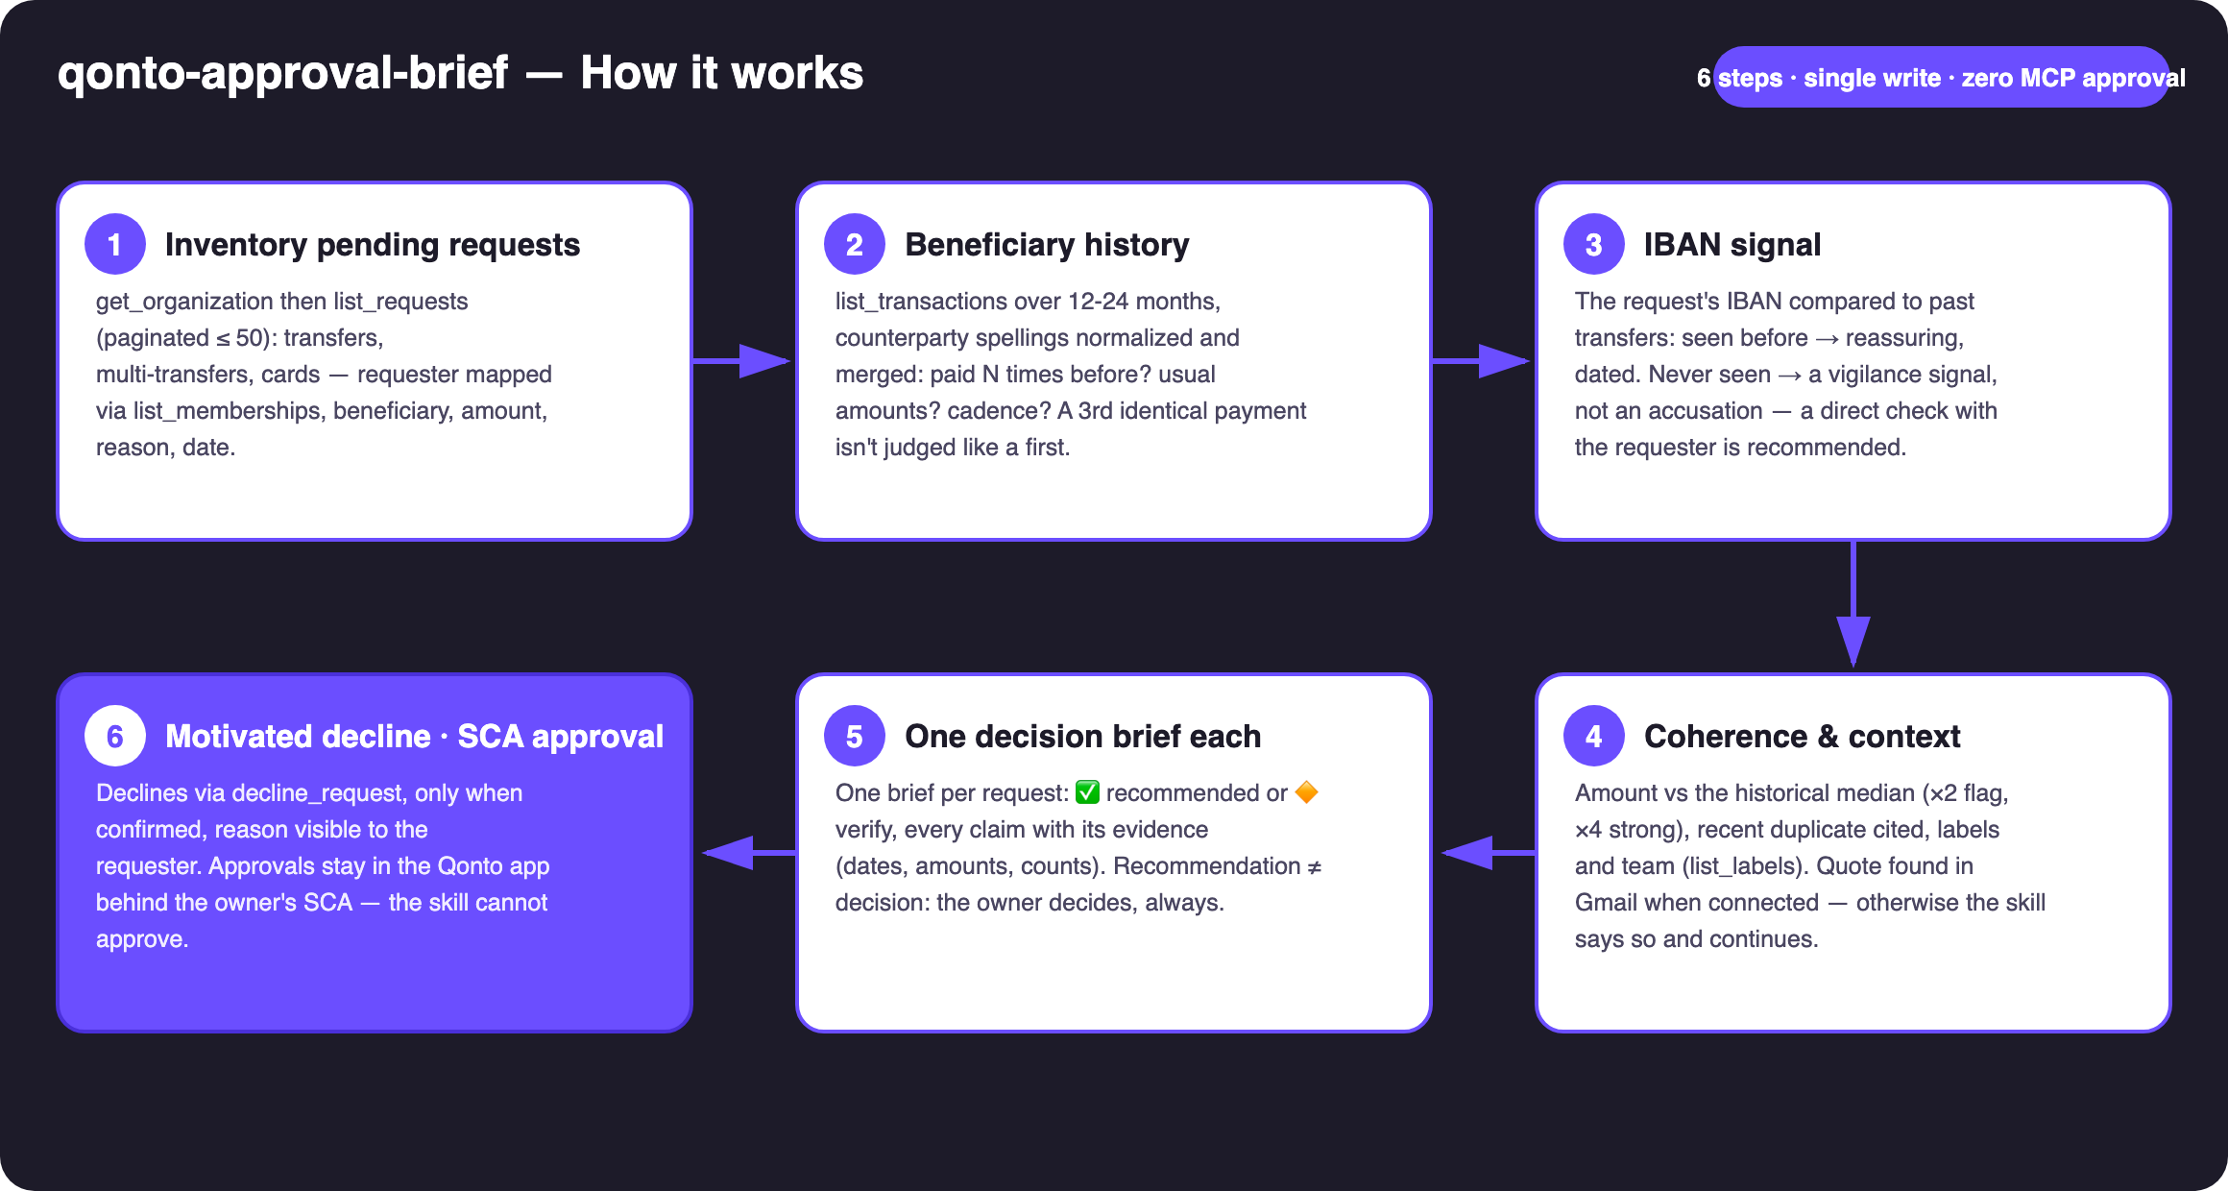
Diagram 1 — How it works, 6 steps (single write: the motivated, confirmed decline)
Holds up on messy data
- No pending requests? → says so and stops cleanly — nothing invented
- Empty list_requests because of the role? → says it's a visibility issue, never pretends “all clear”
- Short history? → every payee looks “new”: degradation announced instead of crying wolf
- Same supplier under three spellings (caps, accents, abbreviations)? → normalized and merged into one counterparty
- Card requests carry no IBAN → the brief adapts: requested limits vs the team's usual card spend
- Gmail or Slack MCP absent → said once, then the core continues on Qonto data alone · pagination ≤ 50 everywhere · masked IBANs

🏗 Functional diagram
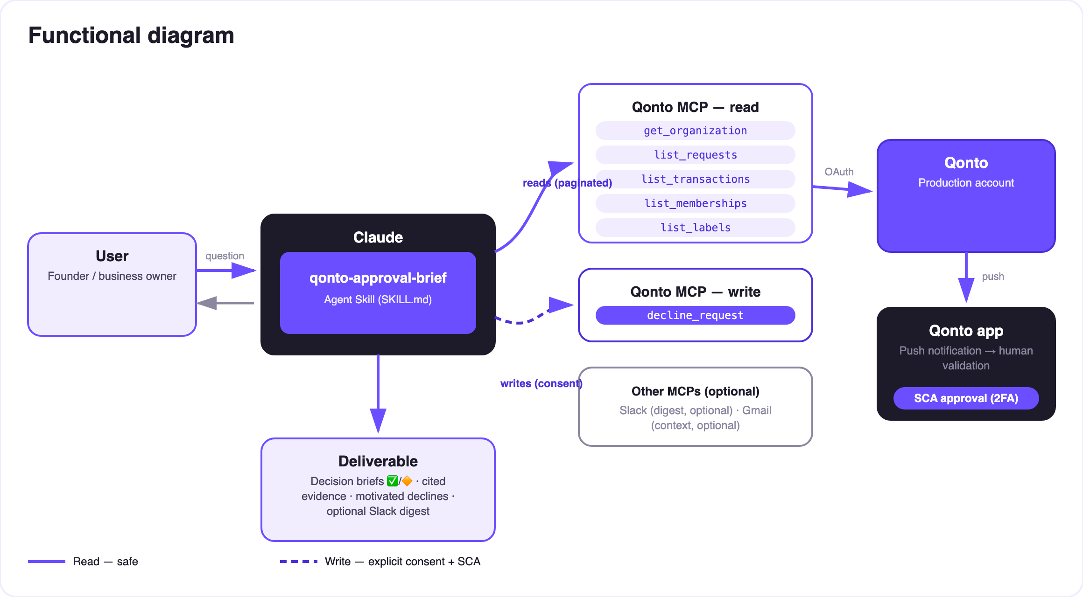
Diagram 2 — Actors and flows: risk-free reads (solid), motivated decline behind consent (dashed), approval = Qonto app + SCA
🔒 The security model, not a limitation: reads are risk-free; the only write is a motivated decline, confirmed in the conversation. Approval doesn't exist in this skill — approve_request is never called. Approving = the Qonto app + the owner's own SCA (2FA). Nothing this skill does can move a euro.
🔍 The signals in a brief
Signal | How it's checked | Reading
Known beneficiary | list_transactions over 12-24 months, spellings normalized: N payments, amounts, cadence | ✅ reassuring when stable and dated
Never-seen IBAN | Compared to IBANs in past outgoing transfers | 🔶 vigilance, not accusation — a new supplier is normal, once
Unusual amount | Ratio vs the same beneficiary's historical median | 🔶 ×2 flagged, ×4 strong flag, both numbers shown
Possible duplicate | Same beneficiary + same amount paid in the last ~10 days | 🔶 transaction cited (date, amount)
Budget/label coherence | list_labels + the requester's team | ℹ️ soft signal, never decisive alone
Email context | Quote/thread found in Gmail (when that MCP is connected) | ℹ️ cited in the brief (subject, date)
Card request | No IBAN: requested limits vs the team's usual card spend | ℹ️ instruction adapted

📤 Output formats
Output | Format | When
Conversation reply | Brief table + one expanded brief per 🔶 request + the explicit next step | Always — the baseline
Brief board | HTML file/artifact: one card per request, verdict and evidence | When the host renders files; fallback to tables
Decline reason | Text attached to the decline, visible to the requester in Qonto | Every decline (confirmed)
Slack digest | Brief summary posted to the channel of your choice | When a Slack MCP is connected (optional)

🎬 Demo video
The ≤ 3-minute demo attached to the PR walks through: the request pile → the sourced briefs → the dubious request (never-seen IBAN, ×4 the usual) declined in one word → the approvals in the Qonto app, behind SCA, filmed on a phone → wrap-up. All demo requests are invented. (Shooting script kept internal, outside the repo.)
🤝 Companion skills
- qonto-fraud-sentinel — watches past transactions; qonto-approval-brief instructs future requests: two sides of the same vigilance
- qonto-reimburse-batch — creates grouped reimbursement requests; this skill then instructs them like any other pending request
💡 Roadmap ideas
Idea | Effort | Note
Learned approval policy (per-category/label thresholds) | Medium | Briefs become “within / outside policy”
Supplier-invoice matching (list_supplier_invoices) | Low | A request backed by its invoice is one more cited proof
Scheduled daily Slack digest | Low | Optional multi-MCP, detected dynamically
Memory of past verifications | Medium | An IBAN checked once with the requester becomes “known”

🛡 Guardrails
- Recommendation ≠ decision: every brief cites its evidence; the skill never says “approved” or “safe” — it says “recommended, because…”
- NEVER declines without explicit confirmation in the current conversation; the reason always travels with the decline (the requester sees it)
- “Never-seen IBAN” is a signal, not an accusation — phrased that way in every brief
- The skill never approves: approve_request is not used — approving = the Qonto app + the owner's own SCA
- Masked IBANs (last 4 digits) · pagination ≤ 50 · decline_request requires request_type “multi_transfers” (plural) · invented examples labelled as such
qonto-approval-brief · English documentation · Qonto × Anthropic MCP Hackathon · July 2026 · PR deliverable: SKILL.md · French version: doc-qonto-approval-brief.fr.docx

