qonto-money-calendar
Your cash flow in your calendar, both ways — deadlines become events, tagged days become invoices
Qonto × Anthropic MCP Hackathon · Two directions: calendar ↔ Qonto · Confirmed writes only · Day rate never guessed

🎯 Why this matters
Money lives in deadlines, not in lists. And users live in their calendar — not in an accounting export. The skill turns Google Calendar into the dashboard of the money month:
- 1. Direction 1 — push: every upcoming money date lands in the calendar — supplier invoices to pay, client invoices to collect, recurrences detected over 24-36 months (rent, subscriptions, tax direct debits; monthly, quarterly, yearly cadences) — amount in the title, D-3 reminder
- 2. Direction 2 — read: billable days tagged [Client] in event titles are counted, and the end-of-month invoice (days × confirmed day rate) is drafted in Qonto
- 3. Recap before writing: no event created without a confirmed recap; idempotent re-runs (marked events updated, never duplicated)
- 4. The day rate is never guessed: deduced from the Qonto invoicing history, then always confirmed before any math
Would someone use this on a Monday morning? Open the calendar: the week's money is already there — and last month's work is already invoiced.
📋 Prerequisites
Prerequisite | Detail | Required
Qonto production account | Adapts to any organization — get_organization first, nothing hardcoded | ✅ Yes
Qonto MCP connected | Official connector (claude.ai / Claude Desktop), OAuth login | ✅ Yes
Google Calendar MCP | Required for both directions. Absent: direction 1 degrades to a markdown table, direction 2 is unavailable — and the skill says so | ⭕ Strongly recommended
Country | Universal — invoice due dates and history-detected recurrences, never invented local tax rules. Full French tax schedule → the qonto-tax-pilot skill | ℹ️ All Qonto countries
24-36 months of history | Needed to see yearly cadences; below that, honest degradation | ⭕ Optional
The [Client] tag convention | For direction 2: an event titled “[Acme] onsite sprint” = 1 billable day | ⭕ Direction 2 only

⚙️ How it works
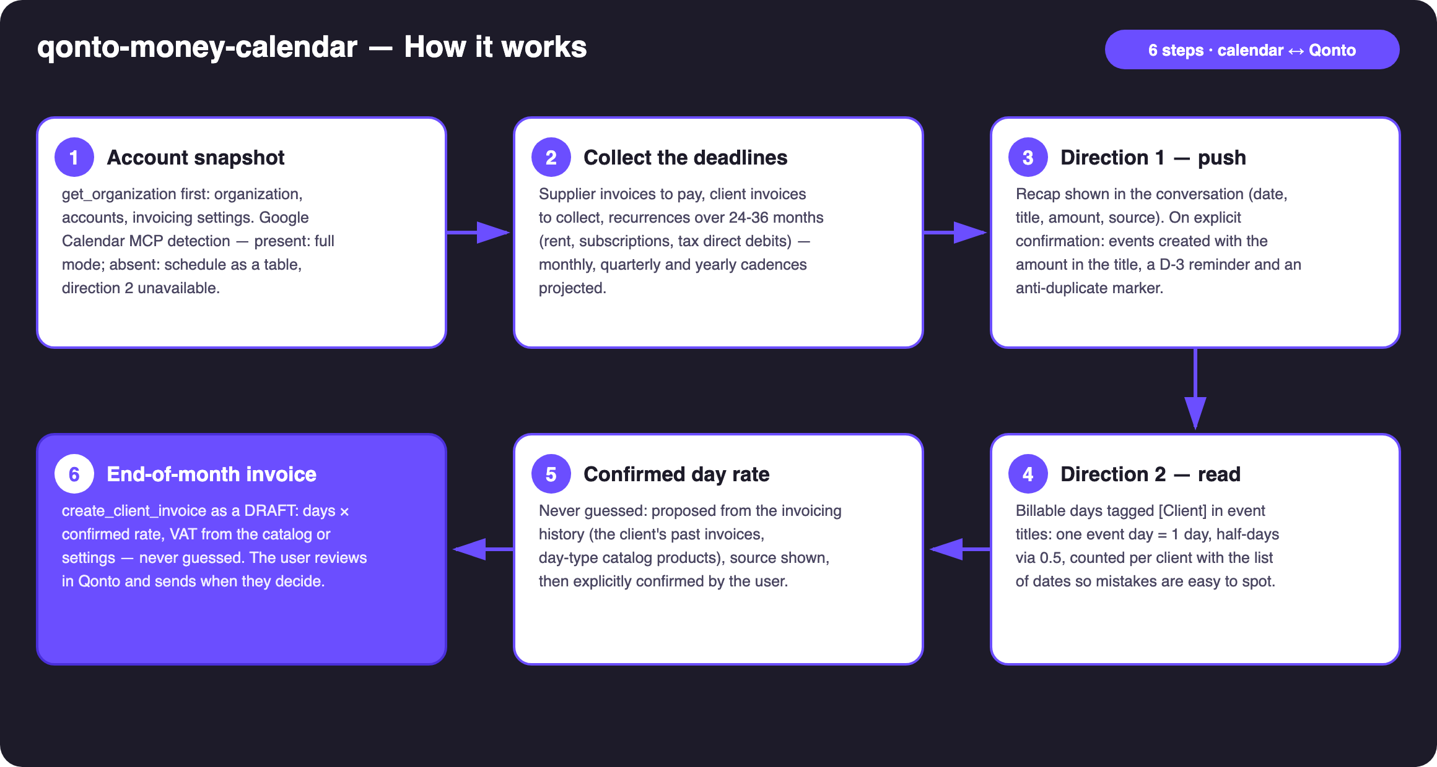
Diagram 1 — How it works, 6 steps (calendar ↔ Qonto, confirmed writes)
Holds up on messy data
- No Calendar MCP? The schedule ships as a markdown table, direction 2 declares itself unavailable — no pretending
- Short history? Yearly cadences flagged as unreliable, monthly ones still detected; everything estimated is labeled 🟡
- Tagged client not found in Qonto? The skill lists close candidates and asks — it never creates a client on its own
- No past invoice and no day-type catalog product? The rate is asked outright, never defaulted
- Re-run after edits? Events carrying the skill's marker are updated in place, never duplicated
- Empty account, zero invoices? Direction 1 says what it found (nothing), direction 2 still works from the calendar

🏗 Functional diagram
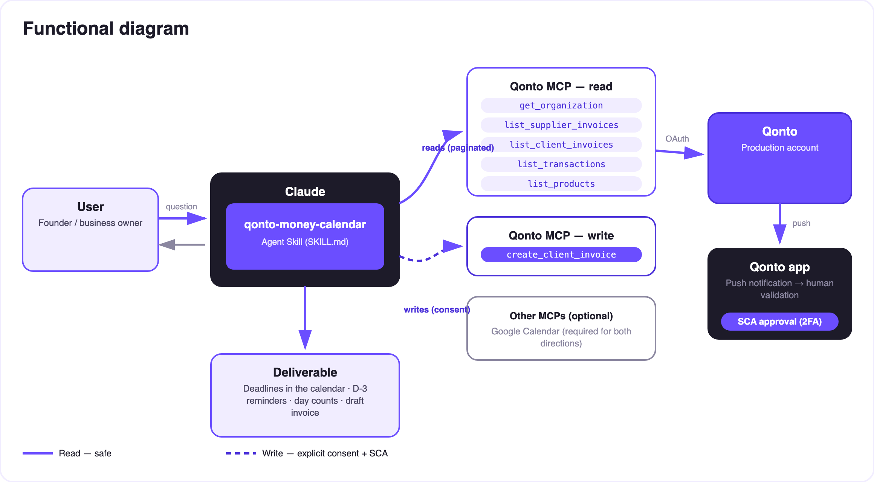
Diagram 2 — Actors and flows: risk-free reads (solid), confirmed writes (dashed)
🔒 Two writes, two locks: calendar events exist only after a recap confirmed in the conversation; the Qonto invoice exists only as a draft, after the day rate and lines are confirmed. The skill moves no money and sends nothing: paying happens in the Qonto app (SCA), sending happens after review. That's the security model, not a limitation.
📆 What lands in the calendar (direction 1)
Event type | Qonto source | Example title (invented) | Reminder
Supplier invoice to pay | list_supplier_invoices (due date) | 💸 Nimbus supplier — €890 | D-3
Client invoice to collect | list_client_invoices (unpaid) | 💰 Invoice INV-2026-042 due — €4,800 | D-3
Monthly recurrence | 24-36 months of history | 💸 Rent — €1,200 | D-3
Quarterly / yearly recurrence | 24-36 months of history | 💸 Yearly insurance — €640 (estimated) | D-3
Detected tax direct debit | History (direct debits) | 💸 VAT debit — ~€2,100 (estimated) | D-3

All amounts above are invented examples. Recurrence-based amounts are labeled “estimated” in the event.
🏷 The tag convention (direction 2)
In the event title | Counted as
[Acme] onsite sprint | 1 billable day for Acme
[Acme] event spanning 3 days | 3 days
[Acme] 0.5 workshop | half a day
No brackets | Ignored (not billable)

📤 Output formats
Output | Format | When
Conversation reply | Markdown tables: schedule, pre-write recap, day counts, invoice summary | Always — the baseline
Google Calendar | Dated events, amount in the title, D-3 reminder, anti-duplicate marker | MCP present + recap confirmed
Qonto invoice | create_client_invoice draft, Invoicing section | Direction 2, after rate & lines confirmed

🎬 Demo video
The ≤ 3-minute demo attached to the PR walks through: the problem (money lives in deadlines) → direction 1: the recap, then the calendar filling up → the [Client] convention and the confirmed day rate → the split-screen moment: 12 tagged days on one side, a draft invoice appearing in Qonto on the other → wrap-up. It runs live on a real production account; all figures shown in the docs are invented examples.
💡 Roadmap ideas
Idea | Effort | Note
Live reconciliation: mark events ✅ once the payment clears | Medium | Reuses list_transactions + the event marker
A dedicated “Money” calendar, separate from the personal one | Low | Simple creation-time option
Full estimated tax schedule pushed as events | Low | Cross-skill: qonto-tax-pilot computes, this skill schedules
Quote-before-invoice for newly tagged clients | Low | create_quote exists in the MCP
A “your money week” recap event every Monday | Medium | The Monday-morning ritual, ready to read

🛡 Guardrails
- No calendar event without a confirmed recap in the current conversation; idempotent re-runs (marked events updated, no duplicates)
- The day rate is never guessed: deduced from history, then explicitly confirmed — every time
- Invoices created via MCP are real → always DRAFT, review before sending; rehearsals use a fictional client + draft + delete_client_invoice
- Estimated amounts (recurrences) always labeled as estimates — never presented as booked
- The skill moves no money: paying stays in the Qonto app (SCA), sending an invoice stays an explicit decision
- Masked IBANs (last 4 digits) · pagination ≤ 50 everywhere
qonto-money-calendar · English documentation · Qonto × Anthropic MCP Hackathon · July 2026 · PR deliverable: SKILL.md · French version: doc-qonto-money-calendar.fr.docx

