qonto-project-burn
What project X actually cost — real burn per project, written where the team lives
Qonto × Anthropic MCP Hackathon · Qonto read-only · Linear/Jira optional, detected · Universal (all Qonto countries)

🎯 Why this matters
Teams plan in Linear or Jira; the money lives in Qonto. So nobody knows what project X actually cost — the dedicated SaaS, the freelancers, the ads, the hardware. The skill closes that gap:
- 1. Label ↔ project mapping — a simple config table proposed from existing Qonto labels, correctable line by line, remembered in the conversation or the Claude project
- 2. Real burn per project vs declared budget — up to 36 months scanned (annual renewals included), refunds deducted, orphan transactions listed apart — never silently attributed
- 3. Projected overrun date — current monthly run rate → “at this pace, Alpha crosses on Aug 12”, confidence tags 🟢🟡, thresholds ⚠️ 80% · 🔴 100%
- 4. Status written where the team lives — with consent: an “X € / Y € — Z %” comment on the Linear/Jira project + an alert issue when a threshold is crossed, backed by Qonto transactions
Would someone use this on a Monday morning? It's the sprint-planning question — “where is Alpha, really?” — with the money in the answer. Qonto side: read-only; the one notable write happens in Linear, always previewed first.
📋 Prerequisites
Prerequisite | Detail | Required
Qonto production account | Adapts to any organization — get_organization first, nothing hardcoded | ✅ Yes
Country | Universal — labels + transactions, no tax rules: every Qonto country (FR, DE, ES, IT, AT, NL, BE, PT) | ℹ️ All
Qonto MCP connected | Official connector (claude.ai / Claude Desktop), OAuth login | ✅ Yes
Qonto labels | A few transactions labelled per project. No labels: mapping proposed from recurring suppliers (🟡 tags) | ⭕ Recommended
Linear or Jira/Atlassian MCP | Detected dynamically — otherwise degraded mode: full report + HTML dashboard in the conversation | ⭕ Optional
Declared budgets | Provided by the user in the mapping (or read from the Linear project description) — never invented | ✅ At setup

⚙️ How it works
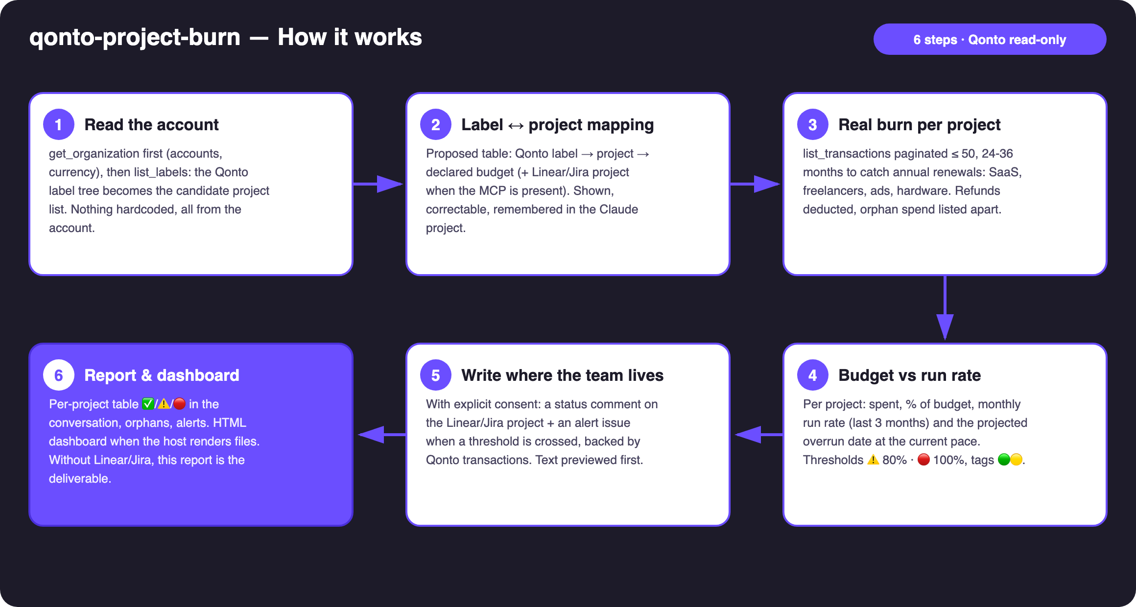
Diagram 1 — How it works, 6 steps (Qonto read-only)
Holds up on messy data
- No labels at all? Mapping proposed from recurring counterparties, everything tagged 🟡, with app labelling instructions
- Orphans: listed with count and total, two clean-up paths — never silently attributed. The MCP has no tool to attach a label: a paste-ready list for the app, or optional filing via modify_transaction_cash_flow_category (light, reversible, confirmed write)
- Multi-label transaction: counted once, under the mapping's first matching label — disclosed in the report
- Annual cadences: 24–36-month scan when history allows — yearly SaaS licences don't slip through
- Refunds deducted · card settlement delays (emitted_at vs settled_at) · multi-account orgs · pagination ≤ 50 everywhere
- No Linear/Jira MCP? The skill says so and delivers the full report + dashboard — the core runs on Qonto alone

🏗 Functional diagram
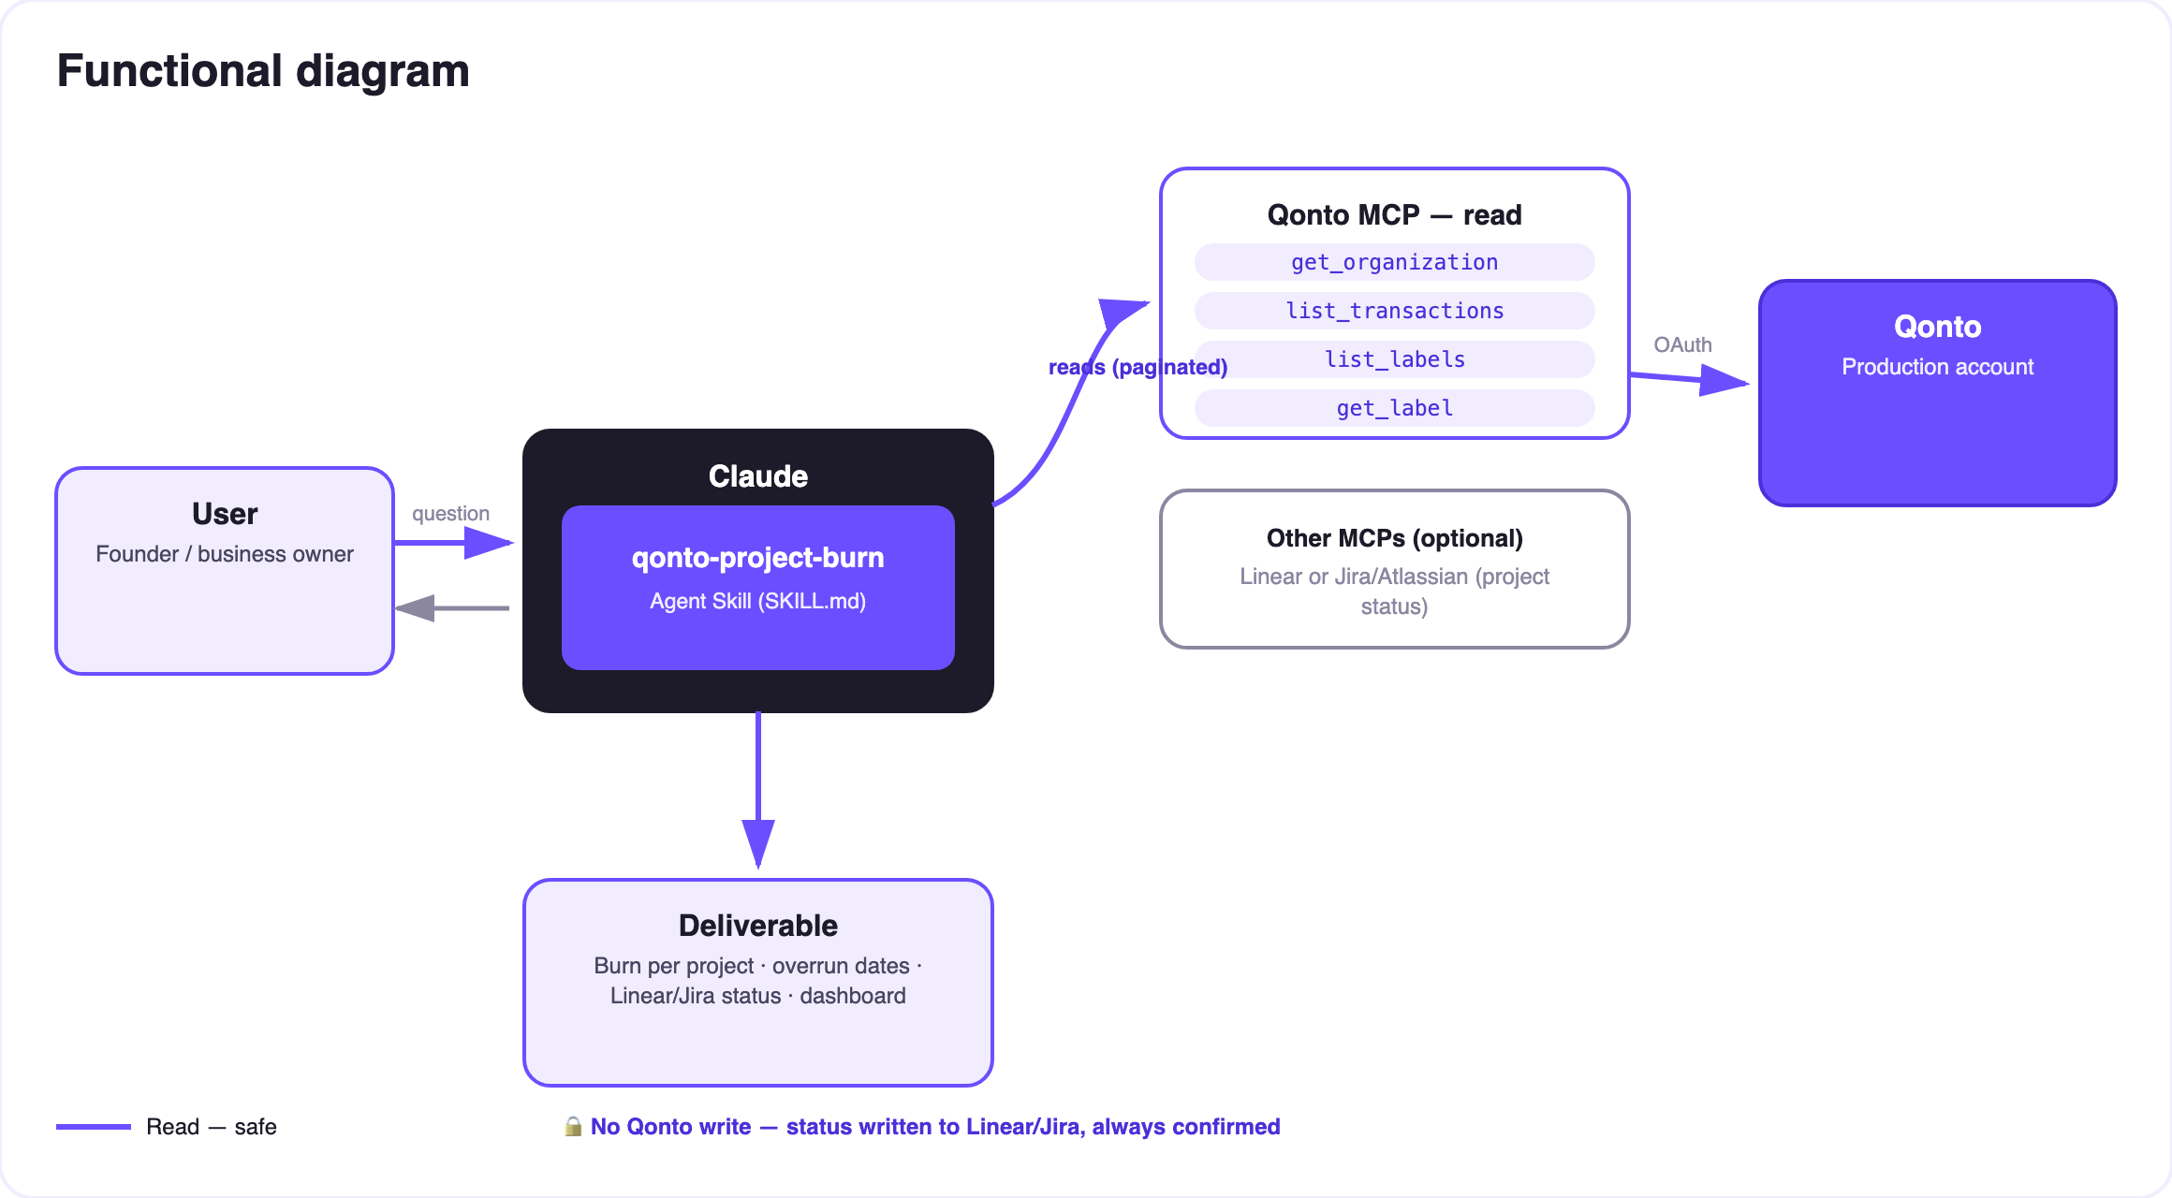
Diagram 2 — Actors and flows: risk-free Qonto reads (solid), Linear/Jira write behind consent (dashed)
🔒 On the Qonto side, everything is a read — no transfer, no payment, nothing touches the money. The dashed (write) arrow points at Linear/Jira, not at the bank: a comment or an issue, always previewed in full and posted only after explicit consent in the conversation.
📊 Sample report (invented data)
Project | Spent | Budget | % | Run rate | Projected overrun | Status
Alpha | €10,440 | €12,000 | 87% | €1,950/mo | Aug 12 | ⚠️
Kepler | €3,100 | €8,000 | 39% | €620/mo | — | ✅
Odyssey | €21,500 | €20,000 | 108% | €1,400/mo | crossed | 🔴

Entirely fictional example — projects, amounts and dates invented for illustration.
📤 Output formats
Output | Format | When
Conversation reply | Markdown tables (burn per project, orphans, alerts) | Always — the baseline
Linear/Jira comment | “X € / Y € — Z % · projected overrun on [date] · top 5 lines” on the mapped project | Tracker MCP detected + explicit consent
Linear/Jira alert issue | “⚠️ Budget [project] Z %” + the Qonto transactions that justify it | Threshold crossed + explicit consent
Interactive dashboard | HTML file/artifact: spent-vs-budget bars, run rate, overrun markers | When the host renders files; fallback to tables

🎬 Demo video
The ≤ 3-minute demo attached to the PR walks through: the problem → the mapping → burn & overrun dates → opening Linear and finding the “⚠️ Budget Alpha 87 %” issue Claude created, backed by the Qonto transactions → the final dashboard. The finance comes to the team — not the other way around. (The detailed shooting script is kept internal, outside the repo.)
💡 Roadmap ideas
Idea | Effort | Note
Budget per sprint/cycle, not just per project | Medium | Reuses the mapping, sliced by Linear cycle dates
Real per-project margin: cross with list_client_invoices | Medium | Burn − invoiced = project margin
Weekly ritual: status posted every Monday | Low | Same write, same consent
Slack/Notion as alternative status targets | Low | Optional multi-MCP, detected dynamically

🆚 Not to be confused: qonto-project-burn = costs vs budget with Linear/Jira alerts · qonto-project-pnl = the full P&L (revenue AND costs, margin) in Notion.
🛡 Guardrails
- NEVER writes to Linear/Jira without showing the exact content and getting explicit confirmation in the current conversation; never presented as done if the call failed
- The label → project attribution is always shown and correctable — no silent reassignment
- Budgets are user-declared, spend is Qonto data — the skill invents neither
- list_cash_flow_categories → 403 on the claude.ai connector: expected, labels are the fallback
- IBANs masked (last 4 digits) · pagination ≤ 50 · honest degradation (no labels, short history, no tracker MCP)
- Company-wide view (runway, all-costs cockpit): see the qonto-ceo-cockpit skill — this one is the project-level granularity
qonto-project-burn · English documentation · Qonto × Anthropic MCP Hackathon · July 2026 · PR deliverable: SKILL.md · French version: doc-qonto-project-burn.fr.docx

