Installing a Qonto skill
From file to first prompt in 2 minutes — claude.ai, Claude Desktop or Claude Code
Qonto × Anthropic MCP Hackathon · Install guide · 22-second video included

🗺 The journey
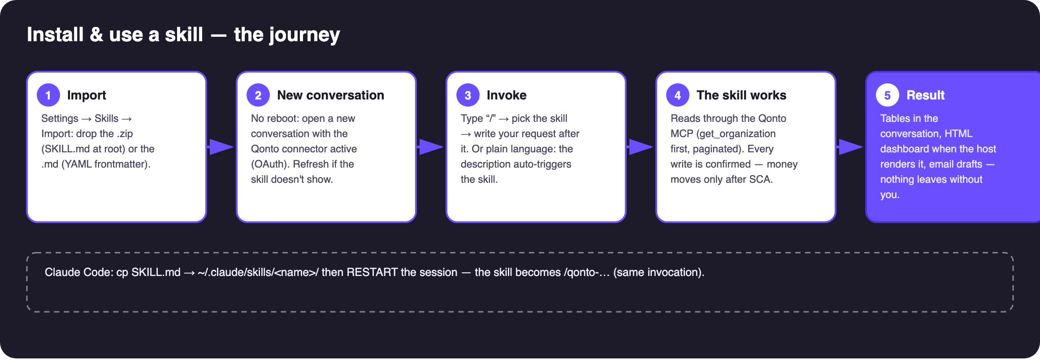
The 5 steps: import → new conversation → invoke → the skill works → result
On video: video/qonto-skill-import.mp4 — the full import in 22 seconds.
📋 Prerequisites
Prerequisite | Detail
The file: .md OR .zip | The .md alone is enough when it carries name and description in YAML frontmatter (every skill in this repo does). A .zip must contain a SKILL.md at its root — ready-made zips live in each skill's skill/ folder.
Qonto connector connected | Settings → Connectors → Qonto → OAuth. Without it the skill installs fine but has nothing to read.
Optional MCPs | Gmail, Drive, Datagouv, Shopify… detected dynamically; graceful degradation when absent.

1️⃣ Import (claude.ai / Claude Desktop)
Settings → Skills → Import a skill, then drop the .zip (or the .md). Claude reads the YAML frontmatter and registers the skill.
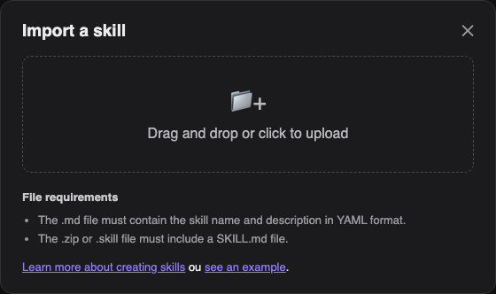
The claude.ai import dialog

2️⃣ Use it: the “/” key
In a NEW conversation (no restart — refresh + new chat if the skill doesn't show), type “/”, pick the skill and write your request after it — or just write the sentence in plain language: the skill's description auto-triggers it.
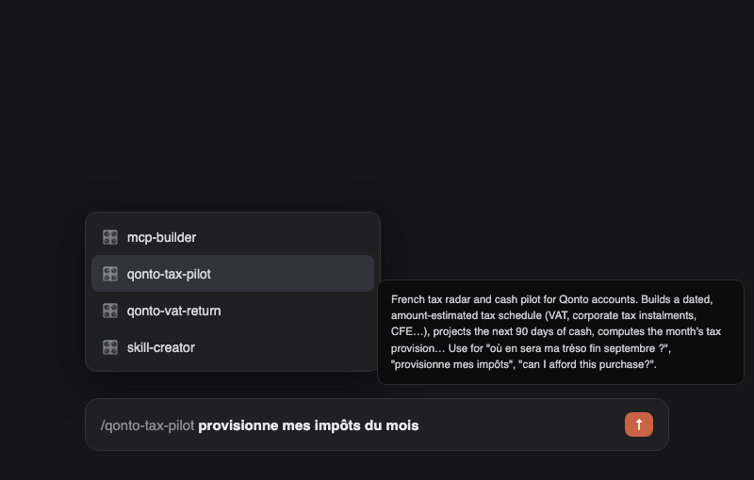
The “/” picker with a Qonto skill and its description
3️⃣ Claude Code (CLI / VS Code)
- Copy the SKILL.md into ~/.claude/skills/<skill-name>/
- Restart the session (skills load at startup)
- Type /qonto → the skill shows in the autocomplete
✅ Check in 2 minutes
- “List my Qonto accounts” → the connector answers (if not: reconnect the connector, not the skill)
- Run the skill's example prompt (see its PROCEDURE)
- The skill announces what it does, paginates properly, and says plainly what it cannot do
⚠️ The 3 classic pitfalls
Pitfall | Fix
.md without YAML frontmatter → rejected | Use the repo files (all compliant)
SKILL.md inside a zip subfolder → rejected | It must sit at the root (provided zips are compliant)
Qonto connector missing from the conversation | Connect it first — the skill runs on empty otherwise

Install guide · Qonto × Anthropic MCP Hackathon · July 2026 · Video: video/qonto-skill-import.mp4

