qonto-prescription-guard
Every unpaid invoice has a legal death date — the skill finds it, and tells you by when to act
Qonto × Anthropic MCP Hackathon · 100% read-only — zero writes · French rules built in, articles cited · Not legal advice

🎯 Why this matters
An unpaid invoice doesn't die when you forget it — it dies when the limitation period runs out: 5 years between businesses (art. L110-4 French Commercial Code), 2 years against a consumer (art. L218-2 French Consumer Code). After that, no court will help you. And the reverse trap is just as real: a partial payment counts as an acknowledgment of the debt and resets the clock — receivables you wrote off may still be alive. The skill puts an expiry date on every receivable:
- 1. Full scan — every unpaid client invoice, across the entire history (old, messy invoices are exactly the point)
- 2. B2B/B2C qualification — SIREN or VAT number on the client record → likely a business (5 years); otherwise the skill asks, certainty is never claimed
- 3. Clock-resetting events — a partial payment spotted in the transactions → “period probably reset on [date] — confirm with a lawyer”; acknowledgments of debt or legal actions declared by the user
- 4. The “act before…” schedule — a death date per receivable, time left, sorted by urgency × amount: 🔴 < 6 months · 🟠 < 12 months · 🟡 < 2 years · ⚫ probably time-barred
Would someone run this on a Monday morning? Once a quarter, before writing anything off — and the first run on an account with years of history is usually a revelation.
📋 Prerequisites
Prerequisite | Detail | Required
Qonto production account | Adapts to any organization — get_organization first, nothing hardcoded | ✅ Yes
Country | Limitation rules: France only. Other Qonto countries (DE, ES, IT…): age-of-receivables report, no legal qualification, never an invented rule | ℹ️ Detected
Qonto MCP connected | Official connector (claude.ai / Claude Desktop), OAuth login | ✅ Yes
Client invoicing in Qonto | The skill reads list_client_invoices — invoices issued outside Qonto aren't visible | ✅ Yes
Client records filled in | SIREN / VAT number → automatic B2B qualification; otherwise the skill asks | ⭕ Recommended

⚙️ How it works
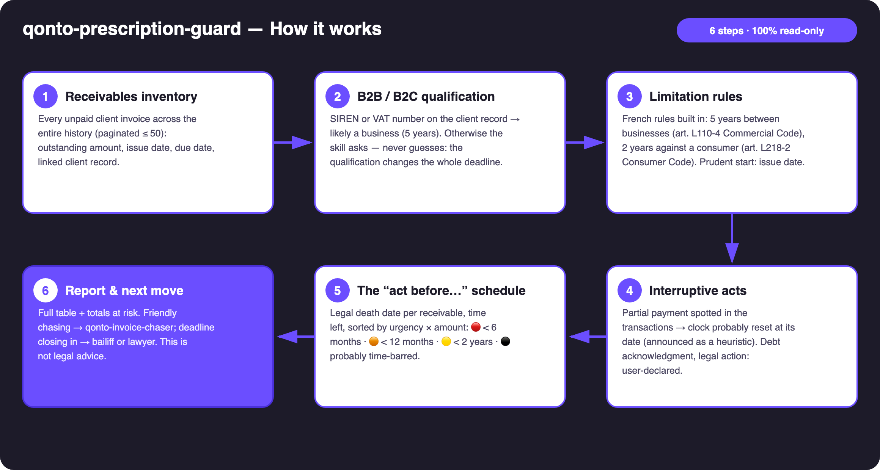
Diagram 1 — How it works, 6 steps (100% read-only)
Holds up on messy data
- Rules embedded statically (no external dependency): 5 years L110-4 / 2 years L218-2, prudent starting point = the issue date (art. 2224 Civil Code) — never overstate time left
- Misconception #1 corrected: a dunning letter, even registered, does NOT interrupt the period — only an acknowledgment of the debt, a partial payment, or a legal act restarts the clock (art. 2240–2244)
- Qualification never guessed: ambiguous client → the skill asks, and computes both dates meanwhile, highlighting the shorter one
- Heuristic stated as such: payments matched to invoices via normalized counterparty (case/accents), reference and amount — payments collected outside Qonto are invisible, the skill says so and asks
- Invoice paid but not updated → flagged, never modified · empty account → the skill says so and stops cleanly
- Pagination ≤ 50 everywhere · history windowed by quarter · masked IBANs

🏗 Functional diagram
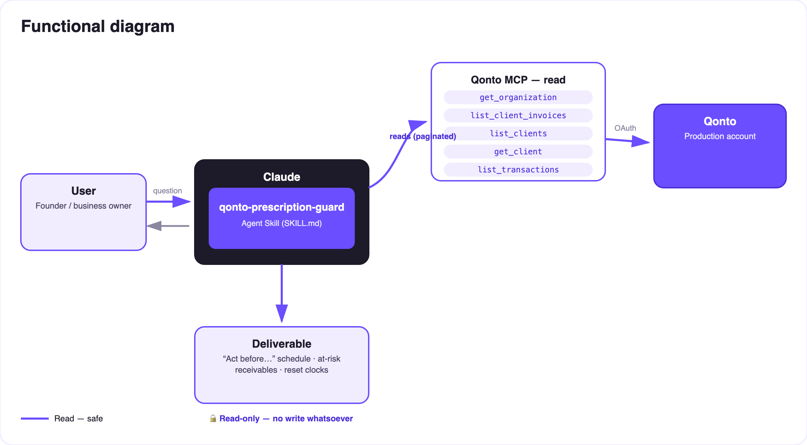
Diagram 2 — Actors and flows: reads only, no dashed arrow (zero writes)
🔍 100% read-only — there is nothing to approve: the skill creates nothing, modifies nothing, moves nothing. The risk isn't in the tool, it's in the calendar: time is what acts here, not the skill. And the report is NOT legal advice — a lawyer validates before acting or writing off.
⚖️ Embedded limitation rules (France)
Situation | Period | Legal basis
Debt between businesses (or arising from the debtor's commercial activity) | 5 years | art. L110-4 Commercial Code
Professional against a consumer (private individual, non-professional purpose) | 2 years | art. L218-2 Consumer Code
Starting point: day the creditor knew the facts — for an invoice, prudently the issue date | — | art. 2224 Civil Code
Interruption → the clock fully restarts: acknowledgment of the debt (a partial payment counts as a tacit one), legal action, enforcement act | new full period (art. 2231) | art. 2240–2244 Civil Code
⚠️ NOT interruptive: reminders, emails, even a registered dunning letter | — | settled case law

Worth knowing: limitation must be raised by the debtor — a judge won't apply it automatically (art. 2247). In practice, treat the date as the death of the claim; the skill itself never declares a receivable definitively dead… nor definitively alive.
📤 Output formats
Output | Format | When
Conversation reply | Markdown tables: “act before…” schedule, totals at risk within 6/12 months, detected resets | Always — the baseline
Interactive timeline | HTML file/artifact: one bar per receivable (start → death date), today marker, color by urgency | When the host renders files; fallback to tables
“Probably time-barred” list | Separate section, never mixed with living receivables | Every scan

🎬 Demo video
The ≤ 3-minute demo attached to the PR walks through: the problem (receivables dying silently) → the scan and the schedule → the highlight: a detected partial payment resurrecting an invoice the user had written off → the final timeline and the pipeline with qonto-invoice-chaser. (Shooting script kept internal, outside the repository.)
🔗 Pipeline with other skills
qonto-invoice-chaser chases invoices amicably; qonto-prescription-guard tells you until when amicable chasing still makes sense — and when to go legal. Together: chase → sue → never let a receivable die. Structural reminder: chaser reminders do NOT interrupt the limitation period — one more reason to watch both.
💡 Roadmap ideas
Idea | Effort | Note
Calendar reminders on “act before…” dates (calendar MCP detected dynamically) | Low | Optional multi-MCP — activates if present, otherwise the skill says so and continues
Country modules (DE: 3 years §195 BGB, ES, IT…) | Medium | Same engine, per-country period tables
Suspension tracking (mediation, art. 2238 Civil Code) | Medium | Declarative — refines the dates
Draft handoff letter for the bailiff | Low | Text output, still zero MCP writes

🛡 Guardrails
- Not legal advice — every report says so: prudent dates, validated by a lawyer or bailiff before acting or writing off
- Never certain on B2C: always an assumption to confirm (a sole trader buying for business → back to 5 years)
- Interruption detection announced as a heuristic: “partial payment detected on [date] → period probably reset — confirm with a lawyer”
- France only for legal dates; elsewhere → plain aging report, clearly labeled
- 100% read-only · masked IBANs (last 4 digits) · pagination ≤ 50 everywhere
- All examples in the documentation are invented (INV-YYYY-NNN numbers, fictional amounts)
qonto-prescription-guard · English documentation · Qonto × Anthropic MCP Hackathon · July 2026 · PR deliverable: SKILL.md · French version: doc-qonto-prescription-guard.fr.docx

