qonto-vat-return
Your French VAT return, box by box, ready to copy — prepared from real Qonto data
Qonto × Anthropic MCP Hackathon · Zero writes — entirely read-only · A preparation aid, NOT a filing

🎯 Why this matters
Every month, the same chore: reconstruct collected and deductible VAT, then copy the right amounts into the right boxes on the tax portal. The skill does the preparation work from the Qonto account:
- 1. Collected VAT per rate — bases and tax at 20 / 10 / 5.5 / 2.1% → boxes 08, 09, 9B, 11, line 16; on debits or on receipts per the detected chargeability (vat_payment_condition “on_receipts” → collected VAT follows received payments, matched to invoices)
- 2. Deductible VAT — vat_amount on debits + deduped supplier invoices, fixed assets (box 19) when detectable — announced as a floor with the count of untagged debits
- 3. Net VAT — line 28 payable, or lines 25/27 credit to carry forward; cents plus the form's whole-euro rounding
- 4. Consistency checks — vs previous months, vs past DGFIP payments, vs statements — every discrepancy flagged ⚠️ before you copy anything
Would someone use this on filing morning? It replaces the spreadsheet ritual entirely.
📋 Prerequisites
Prerequisite | Detail | Required
Qonto production account | Adapts to any organization — get_organization first, nothing hardcoded | ✅ Yes
Country | The CA3 is a French form. Other Qonto countries (DE, ES, IT…): generic VAT summary, never foreign VAT mapped onto French boxes | ℹ️ Detected
Qonto MCP connected | Official connector (claude.ai / Claude Desktop), OAuth login | ✅ Yes
Standard VAT regime (CA3) | The simplified regime (CA12 + instalments) is out of scope — detected, stated, with the 2027-01-01 abolition reminder (art. 38, 2025 Finance Act) | ℹ️ Detected
Invoices in Qonto | The more client/supplier invoices live in Qonto, the sharper the table; otherwise transactions only, limits stated | ⭕ Recommended
≥ 6 months of history | Feeds frequency detection and the checks; below that, honest degradation | ⭕ Optional

⚙️ How it works
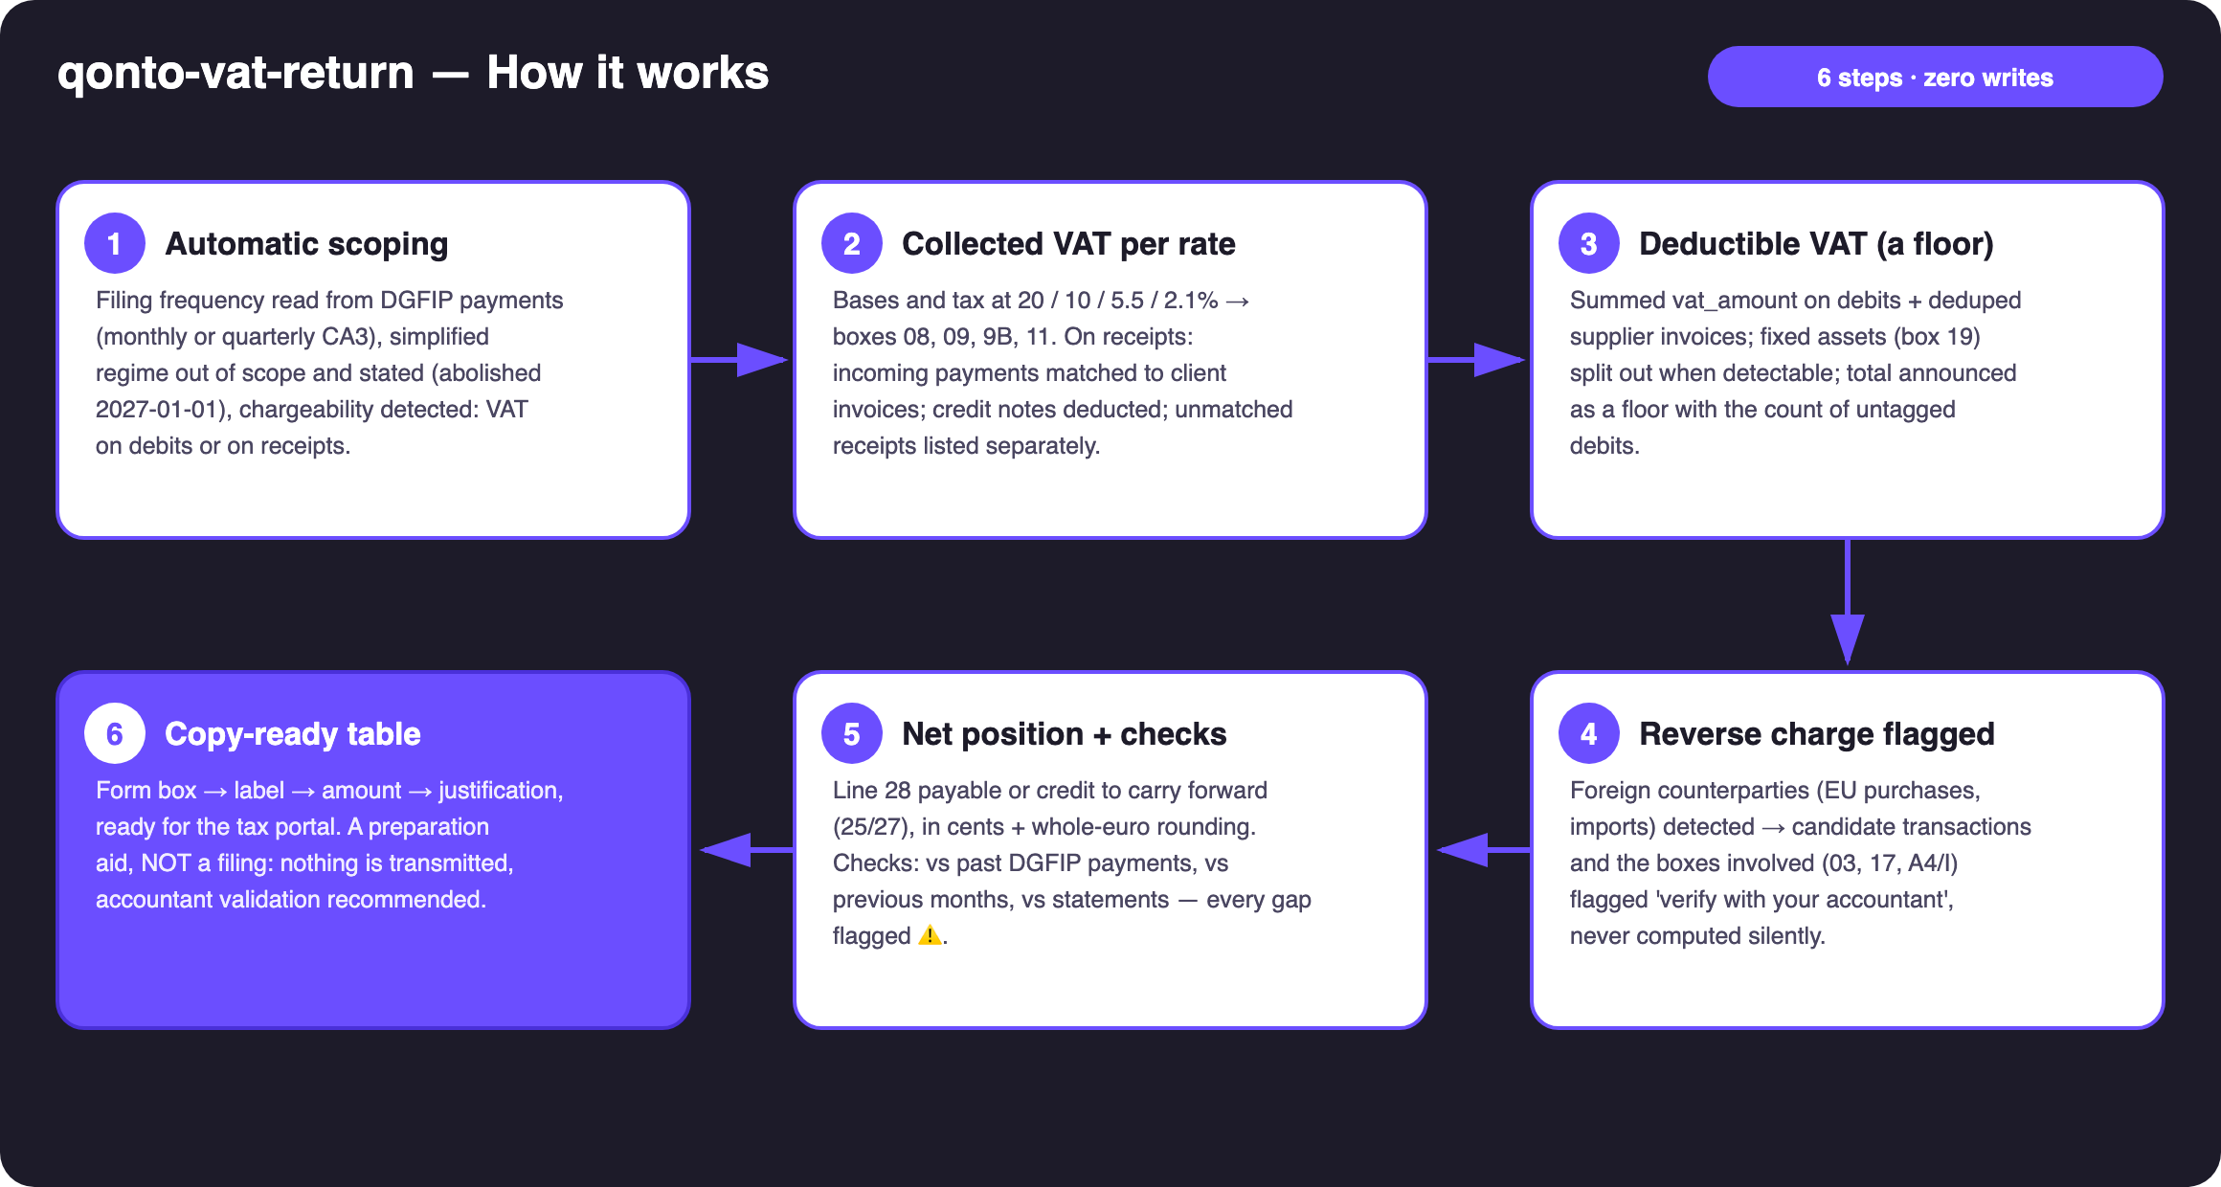
Diagram 1 — How it works, 6 steps (zero writes — read-only)
Holds up on messy data
- Chargeability detected, never asked: “on_receipts” → collected VAT follows the month's received payments, matched to invoices (amount + counterparty + reference) — the case most tools miss; mixed portfolios handled per invoice
- Filing frequency from DGFIP history: monthly debits → monthly CA3; quarterly → quarterly CA3 (allowed when annual VAT < €4,000); July + December instalments → simplified regime, out of scope, stated
- Debits with no VAT info → deductible announced as a floor, count of unknowns disclosed, no rate ever guessed
- Receipts with no matching invoice → listed separately with amounts, never silently taxed or ignored
- Reverse charge (EU purchases / imports): foreign counterparties → flagged “verify with your accountant”, NEVER computed silently
- Credit notes deducted · card settlement delays (emitted_at vs settled_at) · pagination ≤ 50 · non-French company or empty account: the skill says what it can and can't prepare

🏗 Functional diagram
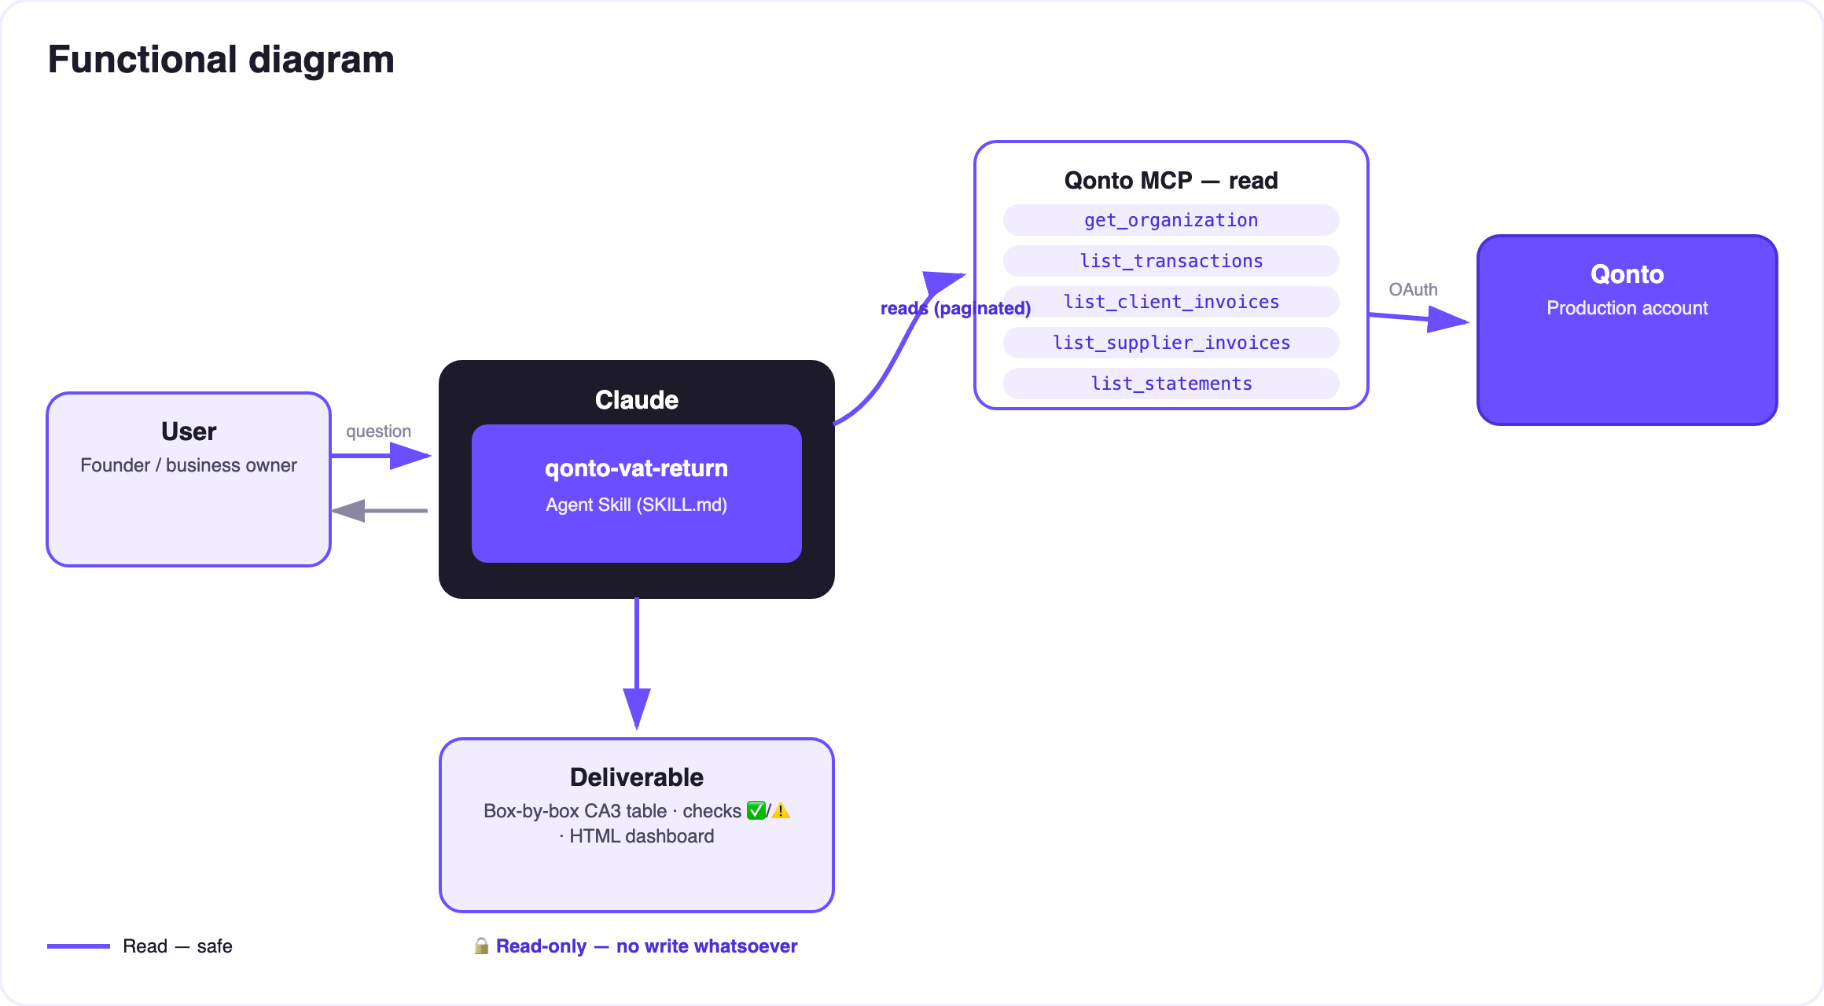
Diagram 2 — Actors and flows: entirely read-only, no write
🔒 Entirely read-only: no write tool, no transmission. The skill prepares, cross-checks and justifies — it cannot file, pay or modify anything. The only action that follows is the user's: copying the boxes into the tax portal, ideally after the accountant's review.
🧾 CA3 boxes covered
Box / line | Official label | How the skill fills it
01 | Sales and services (taxable base, excl. VAT) | Sum of the period's taxed bases (debits or receipts)
08 · 09 · 9B · 11 | Base and tax per rate 20 / 5.5 / 10 / 2.1% | VAT breakdown of the invoices (issued, or matched to received payments), credit notes deducted
16 | Total gross VAT due | Sum of the per-rate taxes
03 · 17 · A4/I | Intra-EU acquisitions · imports (reverse charge) | Never computed — candidate transactions flagged “verify with your accountant”
19 | Deductible VAT — fixed assets | Only when detectable (label, supplier description, equipment purchase); otherwise explained
20 | Deductible VAT — other goods & services | vat_amount on debits + supplier invoices, deduped — announced floor
22 | Prior credit carried forward | From the previous CA3 (provided, or inferred 🟡, to confirm)
23 | Total deductible VAT | 19 + 20 + 21 + 22
25 · 27 (· 26) | VAT credit · credit to carry forward (· refund) | When deductible > collected; the refund stays the user's call
28 · 32 | Net VAT due · total payable | When collected > deductible — cents plus the form's whole-euro rounding

🧪 Consistency checks
Check | Against | Output
This period's net VAT | Median of past DGFIP payments | ⚠️ if deviation > 30% — explained (seasonality? big invoice? missing data?)
Bases and rate mix | Previous months / quarters | ⚠️ on mix changes or base jumps
Analysed transactions | Statement totals (list_statements) | ⚠️ if the period isn't fully covered
Receipts (on_receipts) | Client invoices | Unmatched receipts listed with amounts
Untagged debits | — | Count + total → the “floor” disclaimer on deductible VAT

📤 Output formats
Output | Format | When
Conversation reply | Box-by-box CA3 table (box → label → amount → justification) + checks ✅/⚠️ | Always — the baseline
Interactive dashboard | HTML file/artifact: form-like view, per-rate split, history vs DGFIP payments | When the host renders files; fallback to tables
Nothing else | No transmission, no Qonto write | Never — by design

🎬 Demo video
The ≤ 3-minute demo attached to the PR walks through: the monthly chore → regime detection (cash-basis!) → the box-by-box table → the net VAT matching the accountant's manual calculation to the cent → consistency checks + dashboard. It runs live on a real production account.
💡 Roadmap ideas
Idea | Effort | Note
Receipt pre-check: list_transaction_attachments on deducted debits, missing receipts flagged | Low | A stronger audit trail
Chains with qonto-tax-pilot: the prepared CA3 feeds the tax-vault provision | Low | Both skills share the same chargeability detection
Draft email to the accountant (mail MCP detected dynamically) | Low | Optional multi-MCP — the core stays 100% Qonto
European VAT modules (DE USt-VA, ES modelo 303, IT LIPE…) | Medium | Qonto is pan-European; same engine, different box mapping

🛡 Guardrails
- A preparation aid, NOT a filing: no write tool, no transmission — the skill cannot submit anything
- Accountant validation recommended in every report — especially reverse charge, fixed assets and prior credit
- Never invents: no French boxes for non-French organizations, no guessed VAT rate on untagged debits, no reverse charge computed silently
- Deductible = announced floor · unmatched receipts listed · masked IBANs (last 4 digits) · pagination ≤ 50
qonto-vat-return · English documentation · Qonto × Anthropic MCP Hackathon · July 2026 · PR deliverable: SKILL.md · French version: doc-qonto-vat-return.fr.docx

