qonto-brand-shield
Is the brand you're funding actually protected? — your Qonto account's brand exposure, in numbers
Qonto × Anthropic MCP Hackathon · 100% read-only — zero writes · INPI · Nice classes suggested

🎯 Why this matters
Every month, the account pays for things that build a brand: a logo, domain names, ad campaigns, packaging. Meanwhile, nobody checks whether the name itself is protected. The skill does both:
- 1. Investment total per brand — design/logo, domains, advertising, packaging, print, detected in real expenses: "you invested €X in brand [Name] over N months", every attachment tagged 🟢 evidenced · 🟡 assumed
- 2. Intellectual-property cross-check — is the brand registered at INPI (the French trademark office)? By you? Do close marks exist in your Nice classes? Is the 10-year renewal approaching?
- 3. Financial exposure — the "uncovered" investment: everything already spent on a name that nothing protects
- 4. Pre-filing dossier — name, Nice classes suggested from real activity, indicative cost (~€190-270 for 1-3 classes), ready for inpi.fr
Would someone use this on a Monday morning? It's the check every founder postpones — one question, one number, one €190-270 decision.
Example (invented brand and amounts): "You spent €4,320 over 8 months on the brand Nordlys (logo €900, domains €120, ads €3,300). It is not registered. A close mark has existed in class 42 since 2021. Filing in 2 classes: ~€230 — about 5% of what's already invested, unprotected."
📋 Prerequisites
Prerequisite | Detail | Required
Qonto production account | Adapts to any organization — get_organization first, nothing hardcoded | ✅ Yes
Country | Registry: INPI = France. Other Qonto countries (DE, ES, IT…): the financial exposure stays valid everywhere; for the registry side, EUIPO is the lead — registry data is never invented | ℹ️ Detected
Qonto MCP connected | Official connector (claude.ai / Claude Desktop), OAuth login | ✅ Yes
INPI access | The data.inpi.fr API requires an account + an access request. Without it: pre-filled search link + guided manual check (~2 min). No scraping | ⭕ Optional
≥ 12 months of history | 24-36 months recommended — yearly cadences (domains) only show across full years | ⭕ Optional

⚙️ How it works
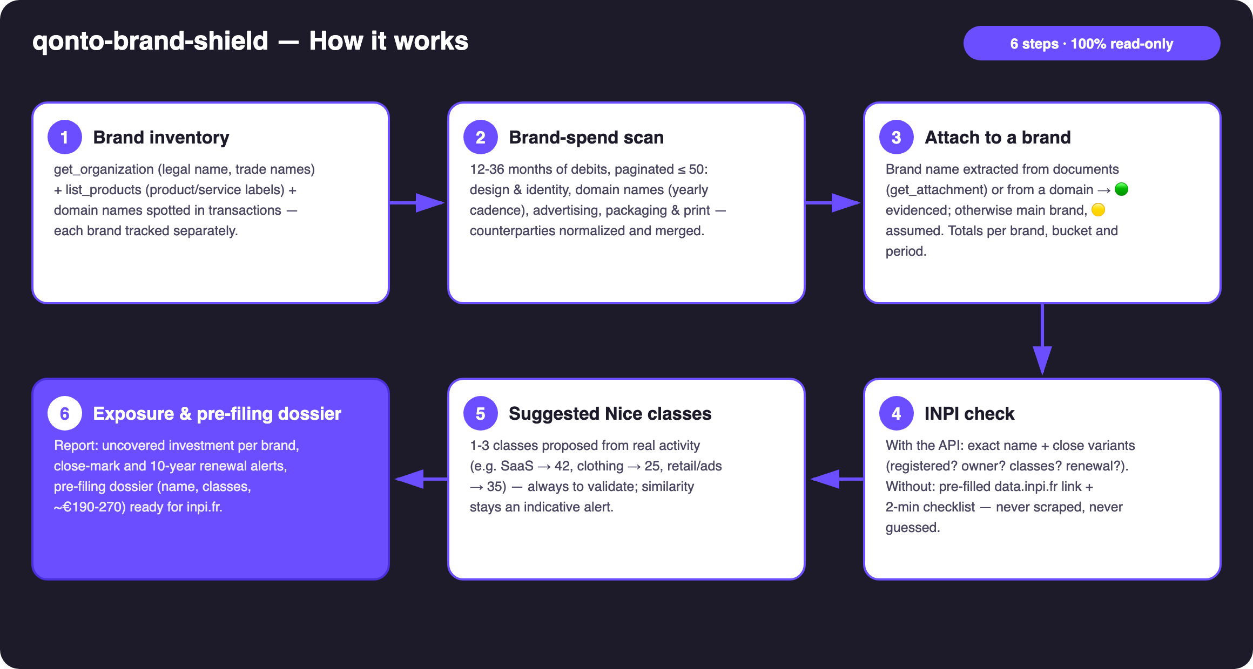
Diagram 1 — How it works, 6 steps (100% read-only)
Holds up on messy data
- Normalized counterparties: case, accents, multiple spellings of the same vendor merged into one counterparty before any total
- Evidenced or assumed attachment: brand name extracted from documents (get_attachment) or from a domain → 🟢; otherwise main brand, tagged 🟡 — never presented as certain
- Registry never guessed: without INPI API access, pre-filled data.inpi.fr link + 2-minute checklist, and the skill only integrates what the user reports back — unverified lines stay "unverified"
- Short history: annual cadences (domain renewals) are detected over 24-36 months — the skill says what it can't see yet
- Empty account, non-French company, no design invoices: the skill says what it can and can't quantify, announces totals as floors
- Pagination ≤ 50 everywhere · list_supplier_invoices for clean supplier names · masked IBANs

🏗 Functional diagram
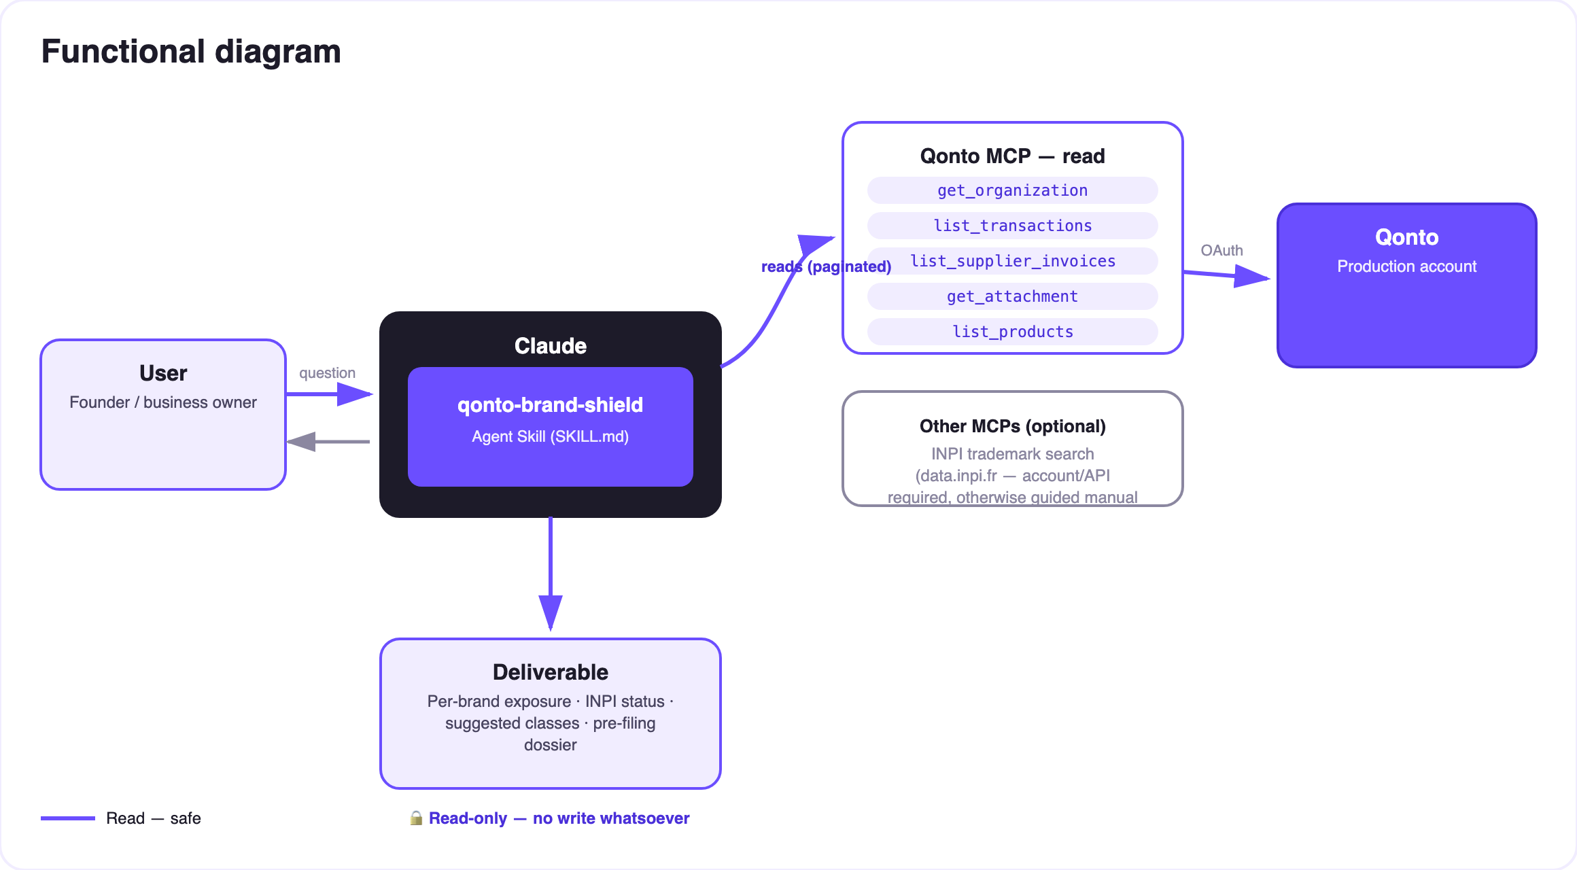
Diagram 2 — Actors and flows: 100% read-only, no MCP write; the filing happens on inpi.fr, decided by the user
🔒 100% read-only: the skill creates no MCP write — no transfer, no invoice, nothing to approve. The only possible "action", the trademark filing, happens on inpi.fr, decided by the user, after human validation. Trademark similarity is an indicative alert, not legal advice — an IP professional is recommended.
💼 Detected spend buckets
Bucket | Signals | Example counterparties
Design & identity | Labels: logo / branding / identity / brand guidelines / naming | Freelance platforms, agencies, independent designers
Domain names | Registrars, yearly cadence (cross-ref qonto-subscription-audit) | OVH, Gandi, Namecheap, GoDaddy, IONOS…
Advertising | Ad platforms | Google Ads, Meta, TikTok, LinkedIn…
Packaging & print | Labels: print / packaging / labels / stickers | Online printers, packaging suppliers

🏷 Nice classes & INPI costs (indicative)
Activity detected in the account | Suggested classes (to validate)
SaaS / software services | 42 (+9 for downloadable software)
Clothing / print-on-demand | 25
Retail, advertising services | 35
Education / content | 41

Indicative costs: filing €190 for the first class + €40 per extra class (~€190-270 for 1-3 classes) · renewal every 10 years (~€290 + €40/class) · source of truth: inpi.fr.
📤 Output formats
Output | Format | When
Conversation reply | Markdown tables (investment per brand, status, exposure, alerts) | Always — the baseline
Interactive one-pager | HTML file/artifact: exposure gauge, buckets, INPI status, dossier | When the host renders files; fallback to tables
Pre-filing dossier | Structured text: name, suggested classes, indicative cost, inpi.fr link | Every unprotected brand detected

🎬 Demo video
The ≤ 3-minute demo attached to the PR walks through: the problem → the per-brand investment total → the INPI check (the guided manual mode, shown honestly) → the exposure number + the pre-filing dossier. It runs live on a real production account. (Shooting script kept internal, out of the repo.)
💡 Roadmap ideas
Idea | Effort | Note
Dedicated INPI MCP (data.inpi.fr API integrated) | Medium | Removes the manual step; dynamically detected, the core works without it
EUIPO / WIPO extension (EU & international marks) | Medium | Qonto is pan-European; same logic, other registries
Watch for new close filings | Medium | The INPI opposition window is short (2 months after publication) — a timely alert matters
Automatic cross-reference with qonto-subscription-audit | Low | Domains are already detected annual subscriptions
Renewal deadline pushed into qonto-tax-pilot | Low | The 10-year renewal joins the dated-outflows schedule

🛡 Guardrails
- 100% read-only: no write tool, ever — filing stays a human decision on inpi.fr
- Trademark similarity = indicative alert, not legal analysis — an IP professional is recommended before any filing
- Nice classes are suggestions to validate; costs are indicative — the source of truth is inpi.fr
- Never a registry fact without a source (API or the user's check); no scraping
- Honest degradation (short history, empty account, non-FR country) · masked IBANs · pagination ≤ 50
qonto-brand-shield · English documentation · Qonto × Anthropic MCP Hackathon · July 2026 · PR deliverable: SKILL.md · French version: doc-qonto-brand-shield.fr.docx

