qonto-supplier-detective
The detective for your supplier payments — duplicates, double payments, gaps and IBAN changes
Qonto × Anthropic MCP Hackathon · 100% read-only, zero writes · IBAN watch vs wire fraud

🎯 Why this matters
In most companies, a small share of supplier payments are simply mistakes — duplicates, invoices paid twice, overpayments — and nobody ever goes looking. The skill sweeps every supplier invoice and every debit, hunting 4 anomalies:
- 1. Duplicate invoices — same supplier + same amount within days, or same invoice number; the native has_duplicates signal double-checked; subscriptions excluded by cadence detection (same amount every month ≠ duplicate!)
- 2. Paid twice — 1 invoice, 2 debits: the finding that pays. Partial payments and deposits recognized as legitimate (the debits sum to the invoice, not 2×)
- 3. Invoice ↔ payment gaps — paid more than invoiced beyond rounding; credit notes and refunds checked before anything is flagged
- 4. IBAN watch 🚨 — a known supplier whose payment IBAN changed is a security alert pinned on top: the number-one wire-fraud pattern. Instruction: verify by phone at the number you already know — never the one in the email
Would someone run this on a Monday morning? It's the audit nobody has time to do by hand — and it can literally pay for itself on the first run.
📋 Prerequisites
Prerequisite | Detail | Required
Qonto production account | Adapts to any organization — get_organization first, nothing hardcoded | ✅ Yes
Country | No national rules involved: the detectors compare the account's own data with itself. Every Qonto country (FR, DE, ES, IT, AT, NL, BE, PT) | ℹ️ Detected
Qonto MCP connected | Official connector (claude.ai / Claude Desktop), OAuth login | ✅ Yes
Supplier invoices imported | The more there are, the larger the detection surface. Without them: a transaction-only pass, stated plainly | ⭕ Recommended
≥ 6 months of history | Below that: subscription cadences and IBAN tracking are less reliable — the skill says so | ⭕ Optional

⚙️ How it works
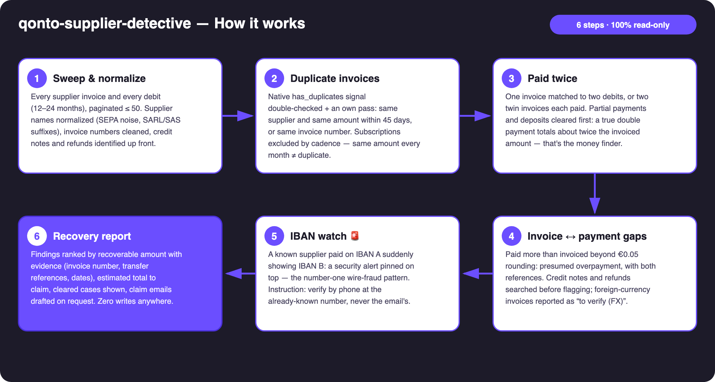
Diagram 1 — How it works, 6 steps (100% read-only)
Holds up on messy data
- Supplier names normalized before any matching: SEPA noise, payment references, legal suffixes — “OVH SAS”, “OVH.COM” and “VIR SEPA OVH” merge; raw labels kept for display
- THE false-positive trap: subscriptions — same amount every month at a regular cadence (3+ hits at ~30/90-day intervals) = legitimate recurrence, excluded before anything is flagged; true duplicates sit off-cycle
- Partial payments and deposits cleared first: several debits that sum to the invoice = a legitimate instalment plan, not a double payment
- Credit notes and refunds identified up front: exculpatory evidence — a refund already received closes the case (“recovered”, not “recoverable”)
- Card payments matched by emitted_at (1–2 day drift on settled_at) · status filters not exposed on this MCP → client-side filtering on status
- No supplier invoices, no exposed IBAN, empty account: the skill says what it can and cannot check — never an invented finding

🏗 Functional diagram
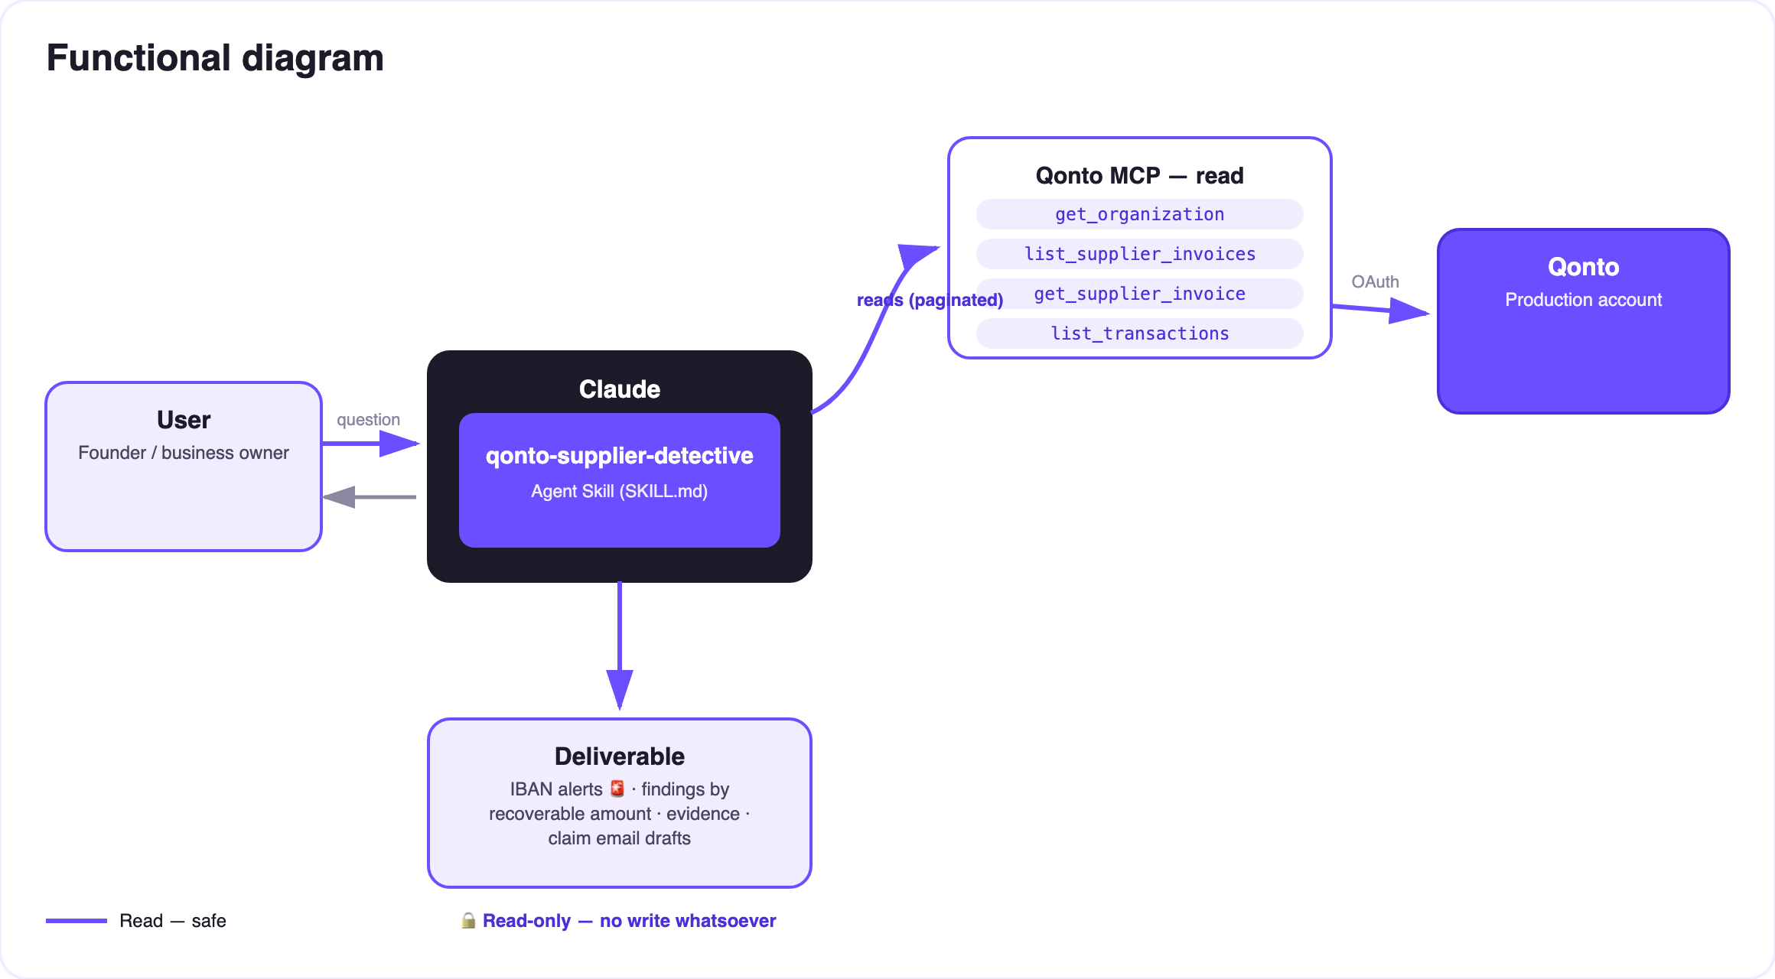
Diagram 2 — Actors and flows: reads only, no write arrow anywhere
🔒 100% read-only — the detective touches nothing; it hands you the case file. No Qonto write tool is ever called: nothing to approve, nothing executed. And for an IBAN change the instruction never varies: verify by phone at the number you already know — never the one in the email announcing the change.
🕵️ The 4 detectors — and the traps they avoid
Detector | What it hunts | The false positive it clears first
D1 · Duplicates | Same supplier + same amount within 45 days, or same invoice number; native has_duplicates | Subscriptions: same amount at a regular monthly cadence = recurrence, not duplicate
D2 · Paid twice | 1 invoice ↔ 2+ debits; two twin invoices each paid | Partials / deposits: debits sum to the invoice (≠ 2×); refund received = case closed
D3 · Gaps | Paid > invoiced beyond €0.05 rounding | Credit notes explaining the gap; foreign currency → “to verify (FX)”
D4 · IBAN watch 🚨 | Known supplier paid on IBAN A → suddenly IBAN B | Legitimate bank switch: the alert demands verification, it doesn't accuse — but always before the next payment

📤 Output formats
Output | Format | When
Conversation reply | Markdown report: IBAN alerts 🚨 on top, findings ranked by recoverable amount, estimated total, cleared cases | Always — the baseline
Interactive case file | HTML file/artifact: findings board, evidence cards, recoverable gauge | When the host renders files; fallback to markdown
Claim email | Ready-to-send draft: invoice number, both transfer references, dates, amount — IBANs masked | On request, finding by finding

🎬 Demo video
The ≤ 3-minute demo attached to the PR walks through: the problem → the sweep (the volume on screen) → the case file with an IBAN alert → the double payment, quantified, with its claim email ready to send → the read-only wrap-up. It runs live on a real production account.
💡 Roadmap ideas
Idea | Effort | Note
Send the claim through a Gmail MCP detected dynamically | Low | Optional multi-MCP enrichment — the core stays Qonto-pure
Flag disputed invoices (change_supplier_invoice_status) | Medium | Would leave read-only territory — strictly opt-in
Post-cancellation billing detection: a subscription still charging after a declared cancellation | Medium | Reuses the cadence engine
Scheduled quarterly audit with a diff vs the previous report | Low | Turns the IBAN watch into true monitoring
Multi-currency reconciliation with daily FX rates | Medium | Turns “to verify (FX)” into verdicts

🛡 Guardrails
- 100% read-only: no Qonto write tool is ever called — nothing to approve, nothing executed
- Wording discipline: “presumed”, “to verify” — never “fraud” or “error” asserted as fact; every finding shows its evidence
- The IBAN alert always carries the instruction: verify by phone at the known number, never through the contact details in the email announcing the change
- Subscriptions, instalments, deposits, credit notes and refunds are cleared BEFORE anything is flagged — a false accusation costs more trust than a duplicate costs money
- IBANs masked (last 4 digits) · pagination ≤ 50 everywhere · progress summarized on large sweeps
qonto-supplier-detective · English documentation · Qonto × Anthropic MCP Hackathon · July 2026 · PR deliverable: SKILL.md · French version: doc-qonto-supplier-detective.fr.docx

