qonto-injonction
When reminders stop working — a French payment-order court file, ready to sign
Qonto × Anthropic MCP Hackathon · Pre-filled CERFA 12946 · BODACC checked first · Zero writes, by design

🎯 Why this matters
Reminders failed (see qonto-invoice-chaser), the formal notice went unanswered. The French payment-order procedure costs ~€35 and needs no lawyer — yet almost nobody dares: an intimidating form, interest to compute, the right court to find. Most founders just write the invoice off. The skill builds the whole file from the Qonto account:
- 1. BODACC check first (public API, no key) — debtor in collective proceedings → NO injunction: the skill reorients to a proof of claim (2-month deadline) and drafts it
- 2. The claim, computed to the day — principal (payments on account deducted), late-payment interest (ECB + 10 pts, floor 3× the French legal rate — art. L441-10), the €40 recovery indemnity (art. D441-5), formula shown
- 3. CERFA 12946 pre-filled field by field + a numbered exhibit list (invoice, reminders, formal notice — pulled from Qonto receipts) + the competent commercial court identified from the debtor's registered office
- 4. Infogreffe filing guide — online filing ~€35, exhibits as PDF < 2 MB, and what happens next: order → service → 1-month opposition window
Would someone use this on a Monday morning? It's the Monday you finally stop waiting for that invoice.
📋 Prerequisites
Prerequisite | Detail | Required
Qonto production account | Adapts to any organization — get_organization first, nothing hardcoded | ✅ Yes
Country | CERFA procedure: France. Other Qonto countries (DE, ES, IT…): full factual dossier but no form — foreign forms or rates are never invented | ℹ️ Detected
Qonto MCP connected | Official connector (claude.ai / Claude Desktop), OAuth login | ✅ Yes
Web access (public APIs, no key) | BODACC + the French company registry. Without web access the skill asks for the two missing facts instead of guessing | ⭕ Recommended
Amicable stage done | Formal notice already sent (registered mail) — otherwise the skill points to qonto-invoice-chaser first | ⭕ Advised
Debtor's SIREN | From the Qonto client record; otherwise looked up by name + city and confirmed by the user (homonyms) | ⭕ Optional

⚙️ How it works
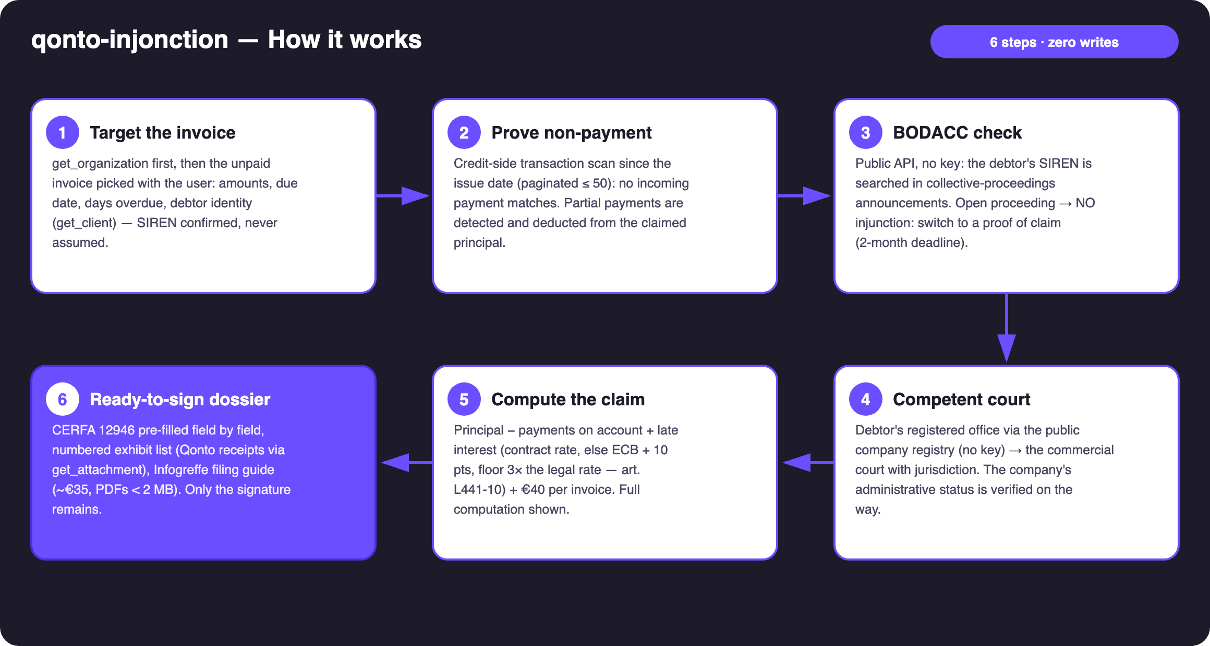
Diagram 1 — How it works, 6 steps (zero writes)
Holds up on messy data
- The invoice might already be paid: credit-side scan since the issue date — an unreconciled transfer is caught, the skill stops and proposes reconciliation instead of a lawsuit
- Partial payments: detected, listed as exhibits and deducted from the principal — only the balance is claimed
- No SIREN on the client record: registry lookup by name + city, match confirmed by the user (homonyms) — never assumed
- Debtor in liquidation: automatic switch to the proof of claim, with its 2-month deadline stated (art. L622-24)
- Receipt missing from Qonto: listed as “to provide” in the exhibit list — never invented
- Disputed claim or limitation risk (5 years, art. L110-4): flagged, never silenced — see qonto-prescription-guard
- No web access, foreign debtor, empty account: the skill says what it can and can't build · pagination ≤ 50 everywhere

🏗 Functional diagram
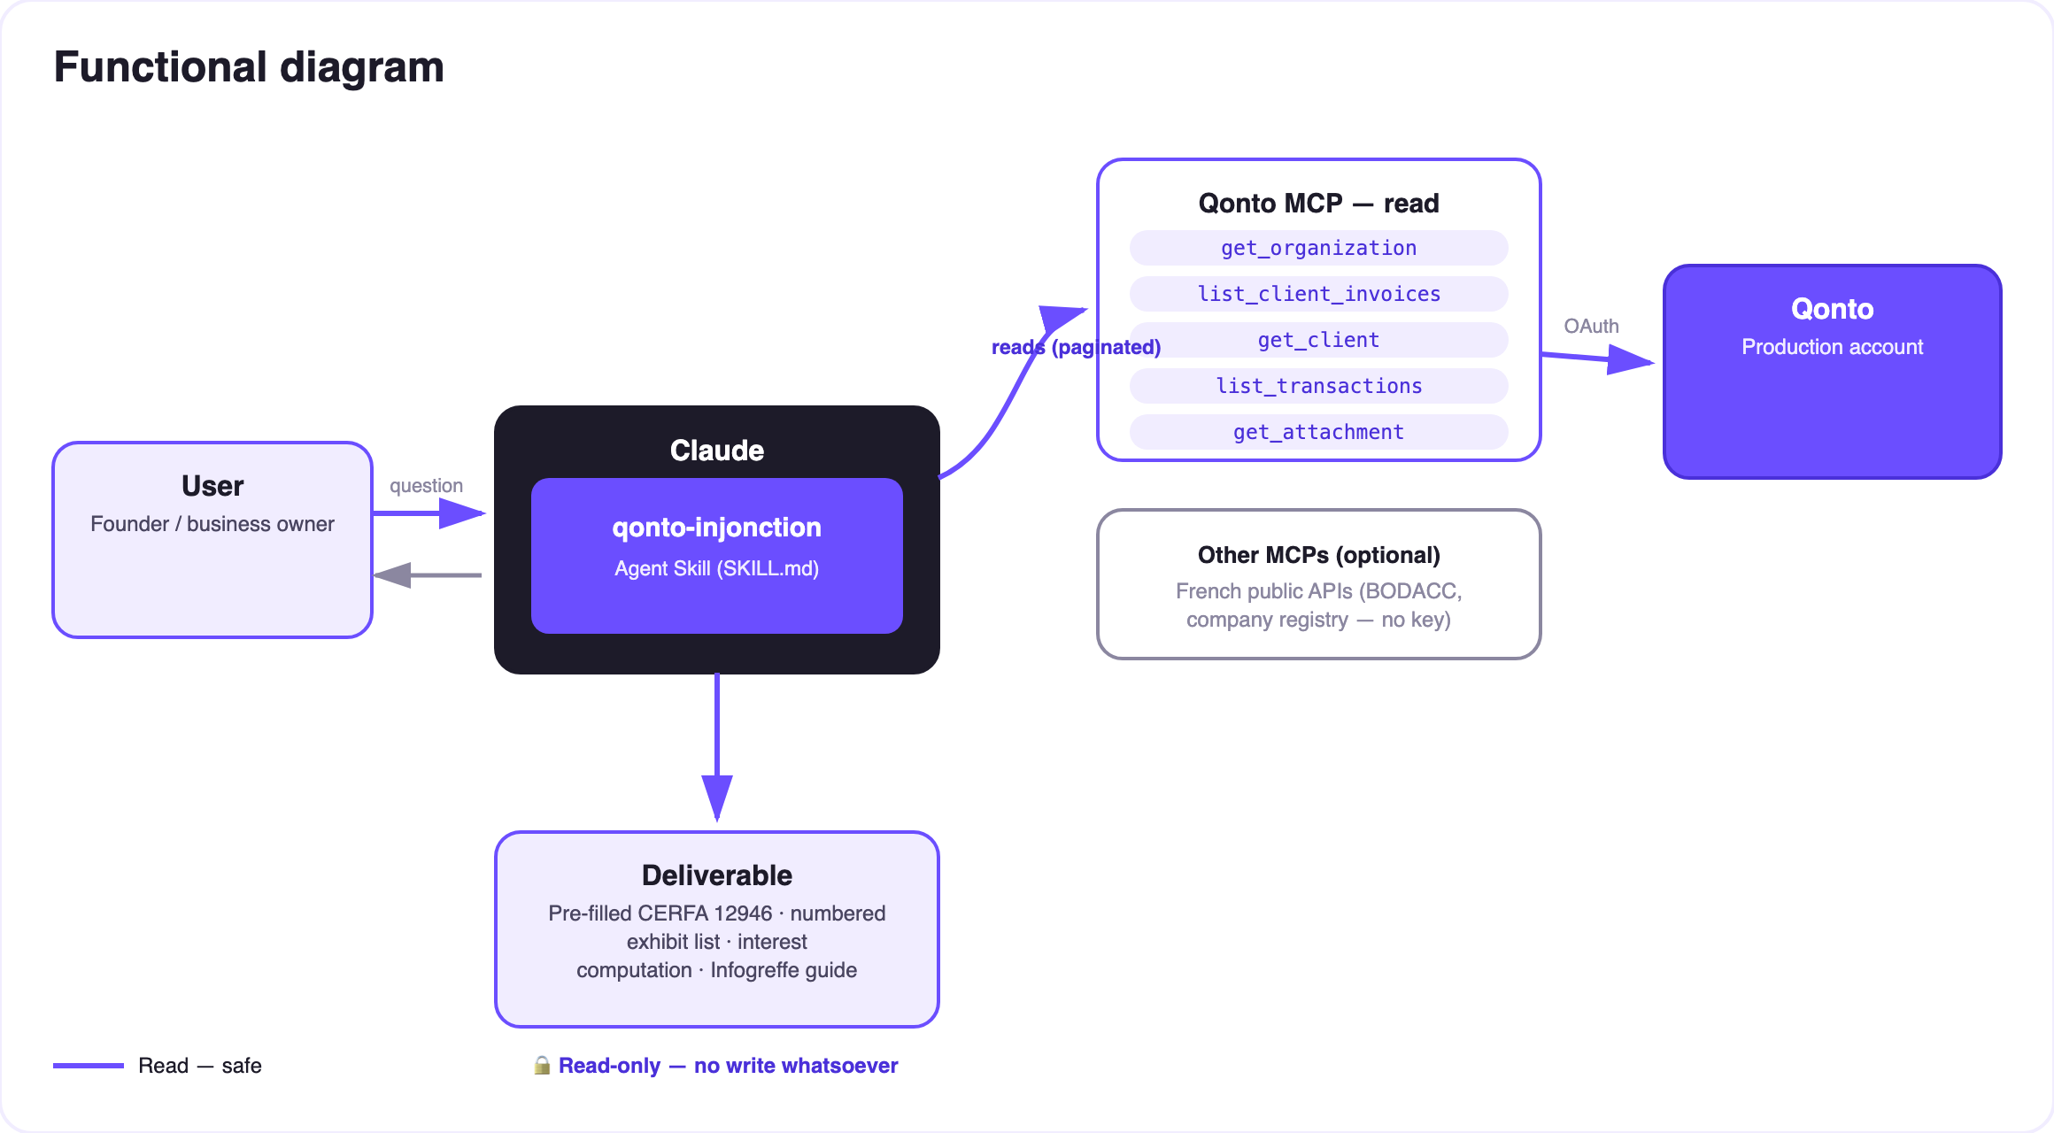
Diagram 2 — Actors and flows: Qonto + 2 public APIs, read-only, zero writes
🔒 Zero writes, by design: the skill reads Qonto and two keyless public APIs, computes, assembles — and stops at a ready-to-sign dossier. Nothing is filed, nothing is served, nothing is signed. Filing on Infogreffe is the user, with their own signature. No legal act is ever executed by an AI.
⚖️ Two routes, picked automatically
Debtor's situation | Route | What the skill produces | Key deadline
Solvent (nothing in BODACC) | Payment order (injonction de payer, art. 1405 CPC) | Pre-filled CERFA 12946 + exhibit list + claim computation + Infogreffe guide (~€35) | 5-year limitation (art. L110-4)
Collective proceedings | Proof of claim (art. L622-24) | Drafted claim statement: principal, interest stopped at the judgment, exhibits, receiver's address when published | 2 months after BODACC publication
Company struck off / unreachable | Neither | Factual finding + advice to consult a professional | —

💶 The interest computation (indicative, to be validated)
Item | Rule | Invented example: INV-2026-017, €4,800 incl. VAT, 92 days overdue
Principal | Total incl. VAT − proven payments on account | €4,800.00
Late-payment interest | Contract rate, else ECB refi + 10 pts (floor 3× the legal rate), from the day after the due date to filing, /365 | 4,800 × 12.15% × 92/365 ≈ €147.00 (illustrative rate)
Recovery indemnity | €40 per invoice (art. D441-5) | €40.00
Total claimed | Each line separate on the form | ≈ €4,987.00

📤 Output formats
Output | Format | When
Conversation reply | Markdown tables: claim computation, CERFA field→value pre-fill, exhibit list ✅/📋, route banner | Always — the baseline
Printable dossier | HTML file/artifact: cover sheet, computation, pre-filled form, exhibit list — save as PDF | When the host renders files; fallback to tables
Exhibits | Qonto receipts retrieved (get_attachment) + a “to provide” list | Every dossier

🎬 Demo video
The ≤ 3-minute demo attached to the PR walks through: the problem → proven non-payment + the BODACC check → interest computation + the right court → the complete dossier, ready to sign → filing on Infogreffe. All figures shown are invented examples. (Shooting script kept internally, out of the repository.)
💡 Roadmap ideas
Idea | Effort | Note
European order for payment (form A, Regulation 1896/2006) | Medium | For debtors in another member state — same computation engine
Post-filing follow-up: service (6 months) and opposition (1 month) reminders | Low | Reuses the qonto-prescription-guard clock
Multi-invoice claims: one request per debtor stacking N invoices | Low | The exhibit list and the computation already stack
Draft email to the court clerk / bailiff (email MCP detected dynamically) | Low | Optional multi-MCP enrichment, in the spirit of the kickoff

🛡 Guardrails
- Not legal advice — stated on every dossier; interest = indicative computation to be validated (lawyer, court bailiff, or the court clerk)
- Zero writes: never presented as filed, served, or granted — the skill stops at the ready-to-sign dossier
- Debtor in collective proceedings → the injunction is never suggested; systematic reorientation to the proof of claim
- Disputed claims and limitation risks are flagged, never silenced
- France-only procedure; elsewhere, a factual dossier without a form
- IBANs masked (last 4 digits) · pagination ≤ 50 · examples invented (INV-YYYY-NNN)
qonto-injonction · English documentation · Qonto × Anthropic MCP Hackathon · July 2026 · PR deliverable: SKILL.md · French version: doc-qonto-injonction.fr.docx

