qonto-oss-navigator
EU e-commerce VAT, before it catches up with you — the One-Stop Shop on a Qonto account
Qonto × Anthropic MCP Hackathon · One-Stop Shop · 27 member states · €10,000 threshold watched · One optional write, behind SCA

🎯 Why this matters
Past €10,000 of cross-border B2C sales to other EU countries in a year (one single threshold, ALL distance sales cumulated — not per country), VAT is due at the customer's country rate, declared through the One-Stop Shop. Most e-commerce sellers discover this too late. The skill turns a Qonto account into an OSS watchtower:
- 1. Sales by shipping country — real order-level countries when the Shopify MCP is connected; otherwise inference from client invoices and Qonto payment data — announced as partial
- 2. The €10,000 gauge — cumulated cross-border B2C sales this year (with the previous-year check): 'you're at X € of 10,000 €', crossing dated or estimated
- 3. Quarterly OSS draft — country by country: net base, the customer country's rate (vintage-dated table for all 27 member states), VAT due, total, deadline and filing portal
- 4. Optional provision — a transfer request to the tax sub-account; money moves only after the user's own SCA approval in the Qonto app
And intra-EU B2B sales (valid VAT number)? Excluded from OSS — reverse charge, reported separately, never mixed into the gauge. Would someone use this on a Monday morning? Every EU seller shipping abroad has this exact blind spot.
📋 Prerequisites
Prerequisite | Detail | Required
Qonto production account | Adapts to any organization — get_organization first, nothing hardcoded | ✅ Yes
Country | Designed for a seller established in the EU. Threshold and rates: EU-wide rules, valid for every Qonto country. Only the filing portal is national (France: impots.gouv.fr; Germany: BZSt; otherwise your national OSS portal) | ℹ️ Detected
Qonto MCP connected | Official connector (claude.ai / Claude Desktop), OAuth login | ✅ Yes
Shopify MCP | Optional, detected dynamically: real shipping countries (list-orders, run-analytics-query). Absent → Qonto-only mode, announced as partial | ⭕ Recommended
A “tax” sub-account | Created once in the Qonto app (the MCP has no account-creation tool). Detected by name: tax / taxe / impôt / TVA / OSS | ⭕ Recommended
Cross-border EU sales | No B2C sales to other EU countries → the skill says so and stops — no invented gauge | ℹ️ Detected

⚙️ How it works
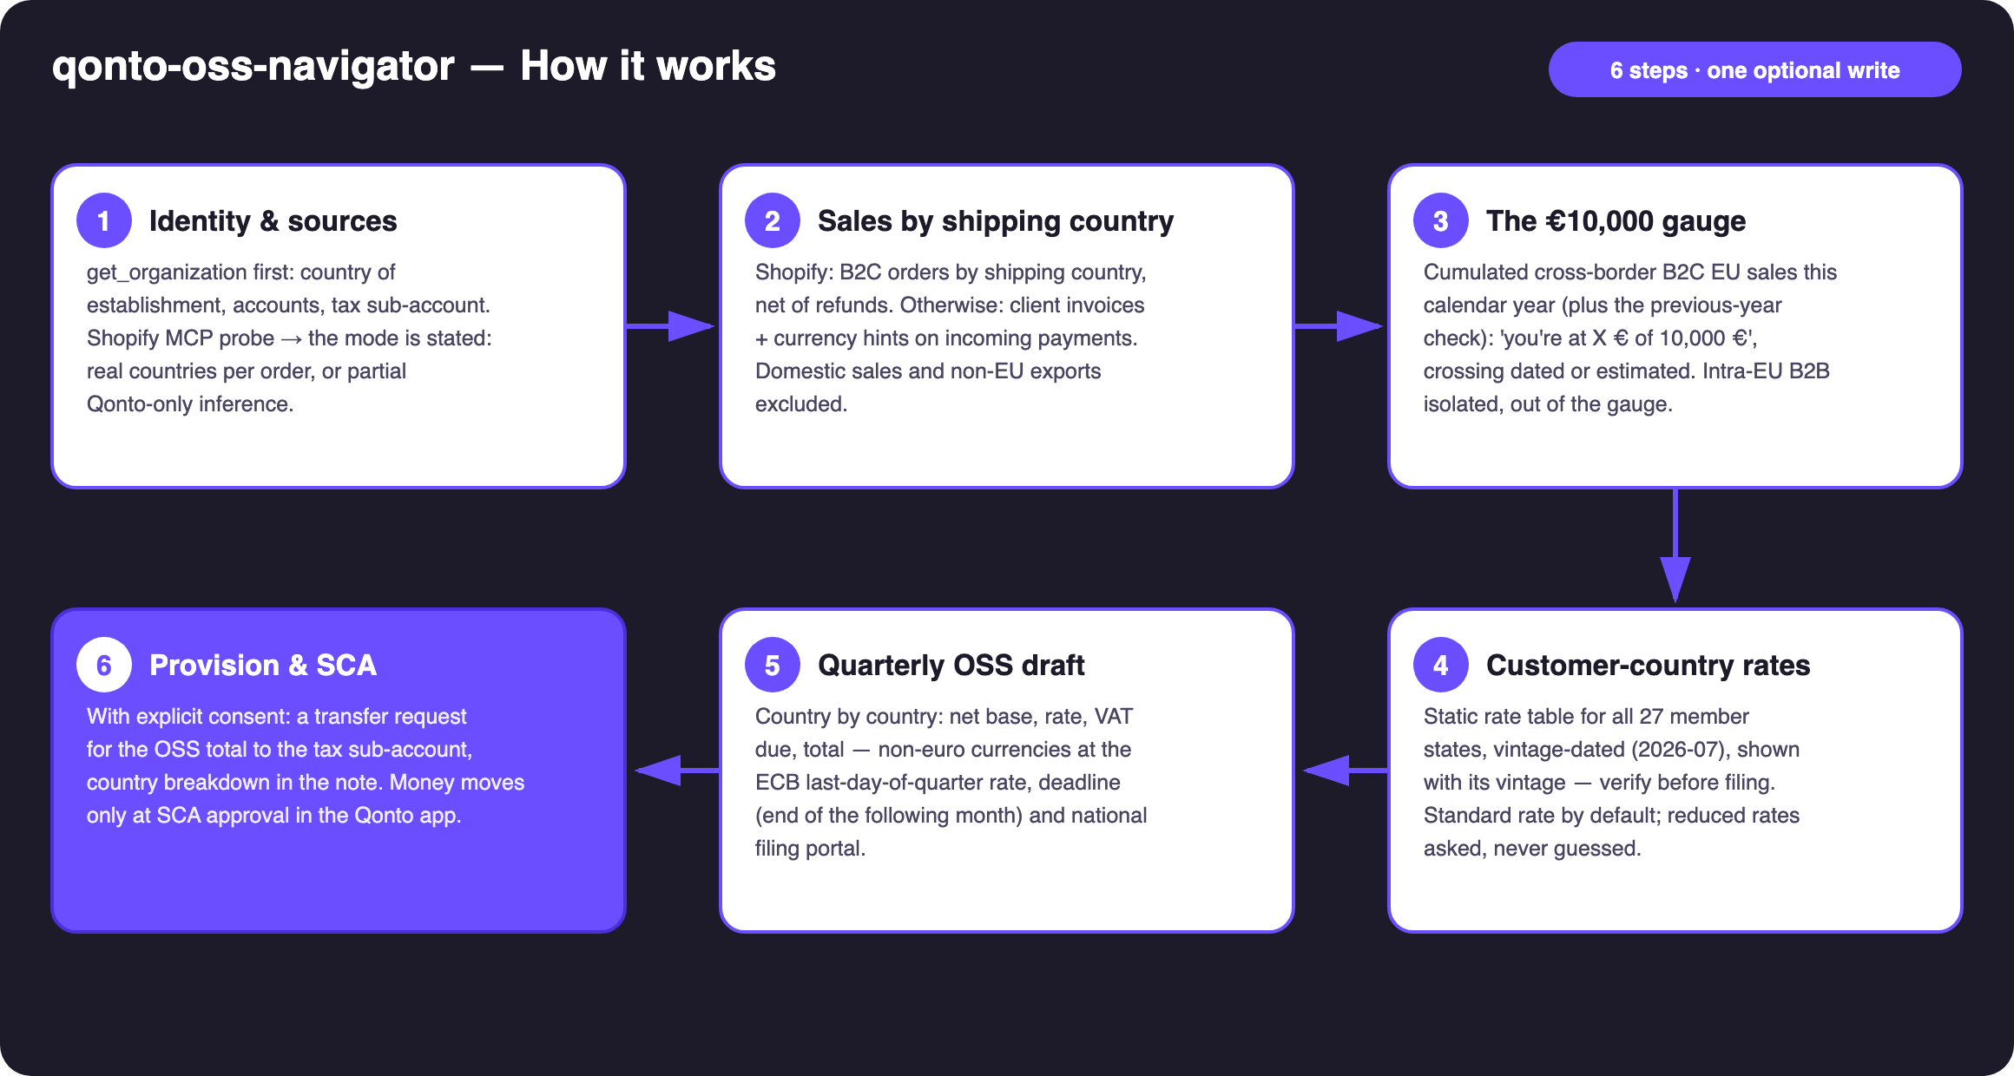
Diagram 1 — How it works, 6 steps (one optional write, behind SCA)
Holds up on messy data
- Mode stated up front: Shopify connected → real countries per order; otherwise Qonto-only — client invoices, currency hints (SEK, PLN, DKK, CZK, HUF, RON, BGN) — partial coverage announced, the gauge presented as a floor
- PSP payouts (Shopify Payments, Stripe, PayPal…) aggregate orders and hide the country: the skill says so instead of pretending
- Intra-EU B2B isolated: valid customer VAT number → reverse charge, out of the gauge and the draft, listed separately
- Domestic sales (→ domestic VAT, see qonto-vat-return) and non-EU exports excluded from the computation
- Invoice without a country or VAT number → counted as 'unattributed', disclosed, never guessed
- Seller established outside the EU → the skill says the scheme differs and stops estimating · pagination ≤ 50 everywhere

🏗 Functional diagram
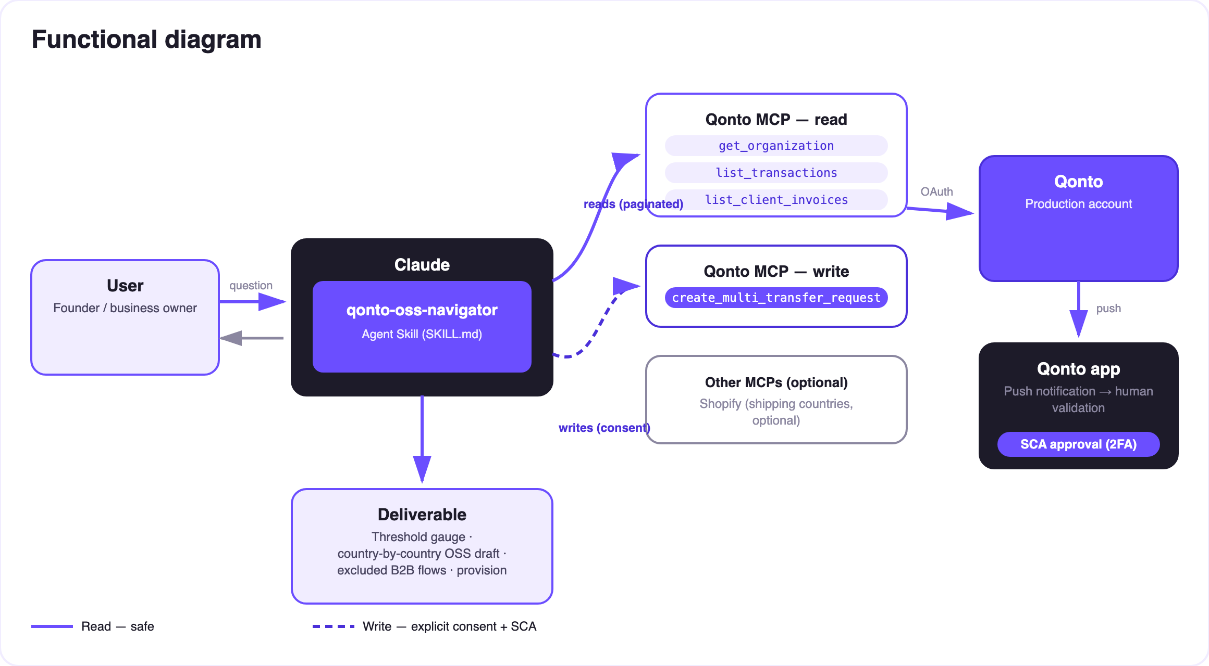
Diagram 2 — Actors and flows: risk-free reads (solid), write behind consent + SCA (dashed)
🔒 The security model, not a limitation: reads are risk-free; the write requires explicit consent in the conversation and only produces a request. The account holder's own SCA (2FA), in the Qonto app, is what moves money. Neither Claude nor the MCP can.
📅 OSS reference (the rules the skill applies)
Rule | Detail
Single threshold | €10,000 net / calendar year, ALL intra-EU cross-border B2C distance sales cumulated (goods + digital TBE services) — assessed on the current AND the previous calendar year
Below | Home-country VAT allowed (voluntary OSS opt-in possible, binds for 2 years)
Above | VAT at the customer's country rate, from the transaction that crosses it — country-by-country registration OR the One-Stop Shop
OSS return | Quarterly, filed by the end of the month following the quarter: 30/04 · 31/07 · 31/10 · 31/01 — corrections of past quarters go into the current return; non-euro currencies at the ECB last-day-of-quarter rate
Exclusions | Domestic sales (→ qonto-vat-return) · intra-EU B2B (reverse charge, EC sales list — not OSS) · non-EU exports
Rates 2026-07 | 17% LU · 18% MT · 19% DE, CY · 20% AT, BG, FR · 21% BE, CZ, ES, LT, LV, NL, RO · 22% IT, SI · 23% IE, PL, PT, SK · 24% EE, EL · 25% DK, HR, SE · 25.5% FI · 27% HU — verify before filing

✨ The 'it just works' moment: "EU B2C sales: you're at €8,420 of €10,000 — estimated crossing in October at the current pace. Here's your OSS draft for the quarter, country by country, and the €612 provision to set aside." (invented figures)
📤 Output formats
Output | Format | When
Conversation reply | Markdown tables (gauge, country-by-country draft, excluded flows) | Always — the baseline
Interactive dashboard | HTML file/artifact: gauge bar, per-country table, quarter timeline | When the host renders files; fallback to tables
Qonto request note | Country-by-country breakdown attached to the request, visible at SCA approval | Every provision created

🎬 Demo video
The ≤ 3-minute demo attached to the PR walks through: the threshold trap → the gauge → the country-by-country OSS draft → the provision + SCA approval filmed on a phone → the dashboard. It runs live on a real production account.
💡 Roadmap ideas
Idea | Effort | Note
IOSS (imports ≤ €150) | Medium | The import twin of the One-Stop Shop — same engine, different scheme
Reduced rates by product category | Medium | Cross Shopify products with each country's reduced-rate categories
OSS deadline reminders in the calendar (calendar MCP detected dynamically) | Low | Optional multi-MCP enrichment, in the spirit of the kickoff
Quarter-by-quarter gauge history | Low | Reuses the existing scan windows
WooCommerce / other order sources | Medium | Same interface: 'shipping country per order'

🛡 Guardrails
- Preparation aid, NOT a filing: the OSS return is filed on the national portal; accountant validation recommended in every report
- The rate table carries its vintage (2026-07) and must be verified before filing; reduced rates asked about, never guessed
- Intra-EU B2B excluded from OSS (reverse charge) — reported separately, never in the gauge
- Qonto-only inference announced as partial (a floor); never an invented country breakdown
- NEVER creates a transfer request without explicit confirmation; never presented as executed — pending the user's SCA approval
- Masked IBANs (last 4 digits) · pagination ≤ 50 · rehearsals: decline_request after each test (request_type “multi_transfers”, plural)
qonto-oss-navigator · English documentation · Qonto × Anthropic MCP Hackathon · July 2026 · PR deliverable: SKILL.md · French version: doc-qonto-oss-navigator.fr.docx · See also: qonto-vat-return · qonto-tax-pilot

