qonto-monthly-close
The month-end CFO in 3 minutes — one prompt, the full month reviewed, read-only
Qonto × Anthropic MCP Hackathon · The monthly orchestrator · 100% read-only · Zero side effects

🎯 Why this matters
Every month-end, small-business owners burn 2–4 hours compiling statements, receipts, VAT and unpaid invoices for their accountant. One prompt — “close my month” — triggers the full review:
- 1. Missing receipts, prioritized by stakes — ranked by amount and recoverable VAT at risk, with a month completeness score
- 2. The month's VAT — collected (on cash receipts when on_receipts is detected) − deductible (disclosed as a floor) = net to provision
- 3. Anomalies — unusual spend, duplicate direct debit, never-seen-before beneficiary — flagged with evidence, never accused
- 4. The rest of the review — unlabeled transactions (category proposed), unpaid client invoices (overdue + payer history), month-over-month comparison
→ An actionable closing report with a fix-it to-do sorted by priority (P1 money at risk → P2 compliance → P3 hygiene). Would someone use this on a Monday morning? It's literally the first Monday of the month, every month.
🧭 Where it sits in the family
qonto-monthly-close is the monthly orchestrator: it detects and prioritizes, read-only. Each finding then has its specialist:
It detects… | The specialist that acts
Missing receipts | qonto-receipt-hunter — chase + upload
Unpaid client invoices | qonto-invoice-chaser — dunning drafts
VAT to provision | qonto-tax-pilot — tax schedule + SCA-gated provisioning

📋 Prerequisites
Prerequisite | Detail | Required
Qonto production account | Adapts to any organization — get_organization first, nothing hardcoded | ✅ Yes
Country | Receipts, anomalies, unpaid invoices, comparisons: every Qonto country. VAT module: French logic; other countries (DE, ES, IT…) → generic estimate, stated as such | ℹ️ Detected
Qonto MCP connected | Official connector (claude.ai / Claude Desktop), OAuth login | ✅ Yes
≥ 3 months of history | The anomaly detectors and the comparison need a baseline; below that, honest degradation | ⭕ Optional
Gmail MCP | Optional, detected dynamically: hunts the inbox for missing receipts; otherwise the skill says so and continues | ⭕ Optional

⚙️ How it works
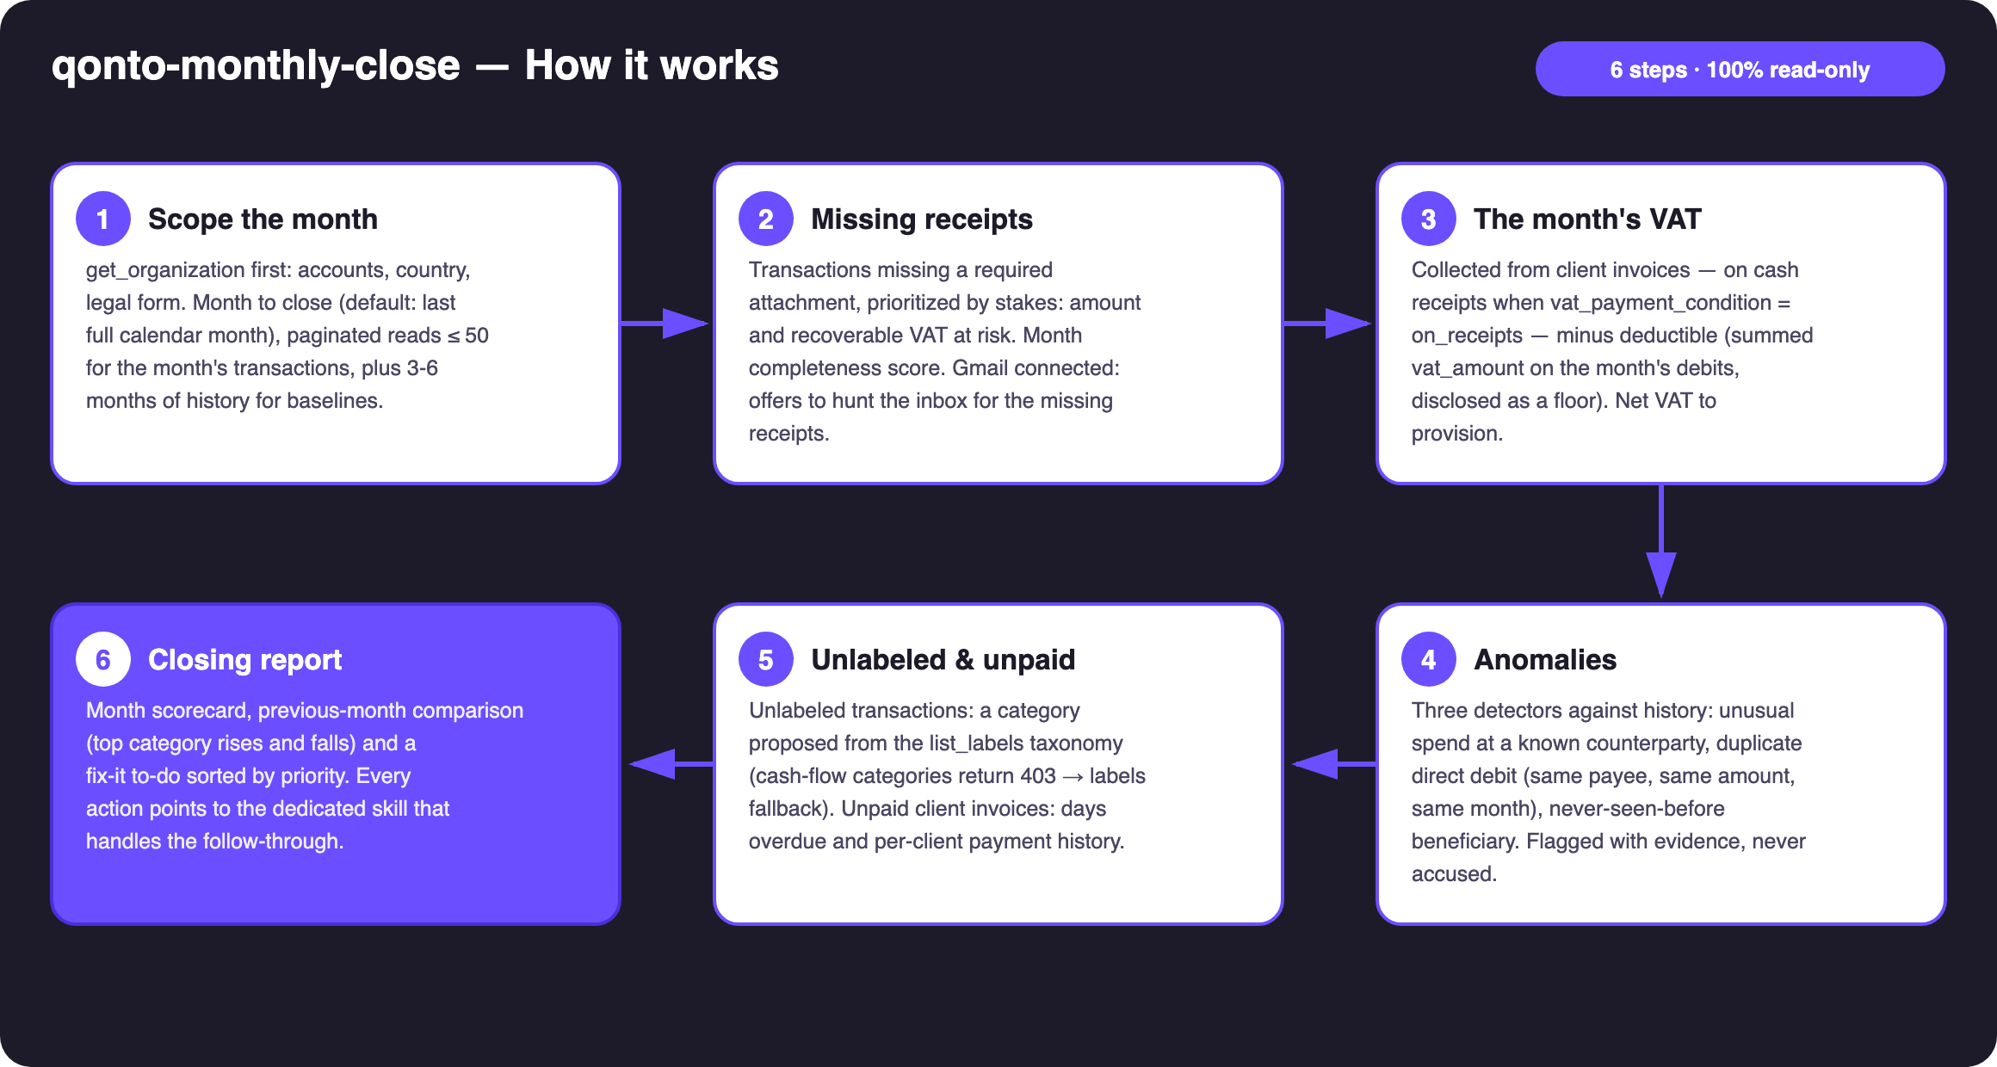
Diagram 1 — How it works, 6 steps (100% read-only)
Holds up on messy data
- Baselines before judgments: 3–6 months of history read on top of the month — the detectors compare against the account's own habits and always show the evidence (dates, amounts, baseline)
- Cash-basis VAT handled: vat_payment_condition “on_receipts” detected on the invoices → collected VAT follows client payments, not issued invoices
- Deductible VAT = a floor: summed vat_amount, count of untagged debits disclosed — and the cost of missing receipts quantified (no invoice = VAT not deductible)
- list_cash_flow_categories returns 403 on the claude.ai connector → list_labels fallback, handled silently
- Card operations reasoned on emitted_at (1–2 day lag vs settled_at) · empty month or non-French org: the skill says what it could compute · pagination ≤ 50 everywhere

🏗 Functional diagram
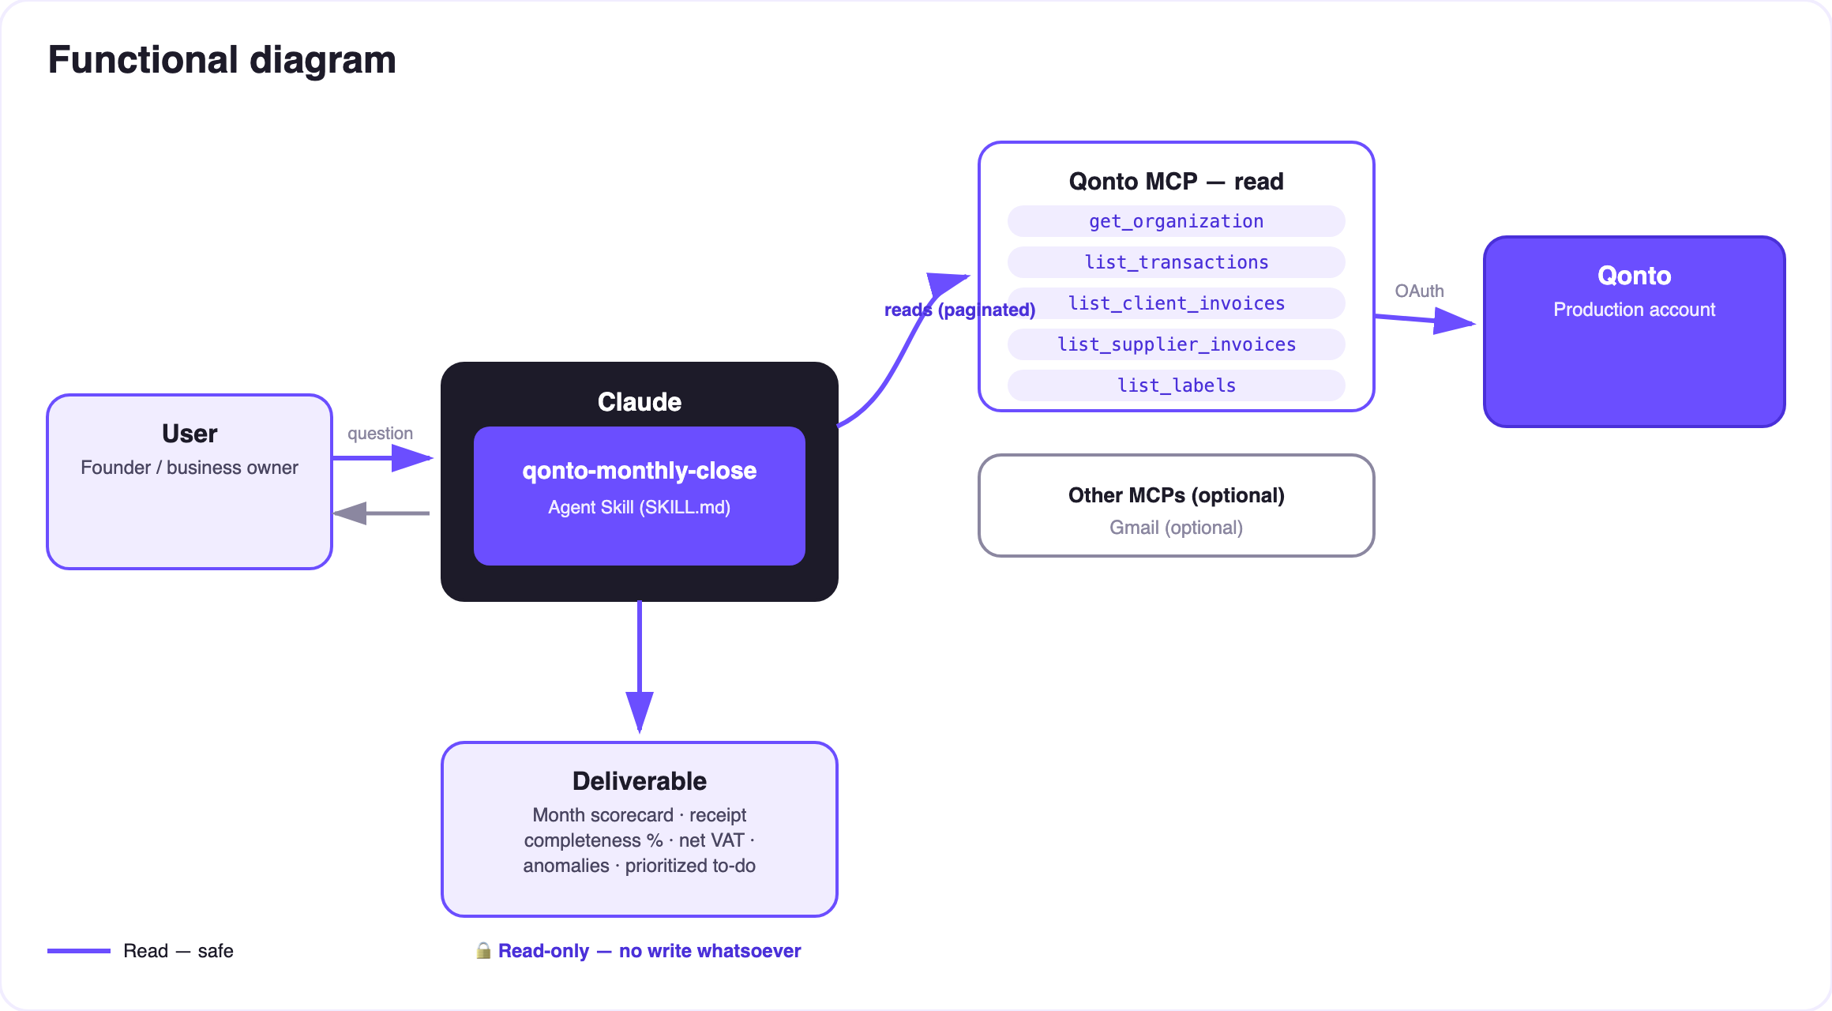
Diagram 2 — Actors and flows: fully read-only, no write arrow
🔒 Fully read-only: this skill calls no write tool — nothing is created, modified, sent or moved. The report proposes; the user disposes, in the Qonto app or via the dedicated skills. You can run it on any account, any time, with zero side effects.
🕵️ The three anomaly detectors
Detector | Signature | Evidence shipped
Unusual spend | A known counterparty whose month total deviates strongly from its baseline (> 2× median), or a lone debit far outside the usual range | Amount vs the counterparty's historical median, reference window
Duplicate direct debit | Same payee, same amount (±1%), twice or more in the month, as a direct debit | Both dates, both amounts, the payee's identity
New beneficiary | A counterparty never seen in the prior months receiving a meaningful outbound amount | Dated first appearance, amount, absence from history

📤 Output formats
Output | Format | When
Conversation reply | Markdown tables: scorecard, receipts, VAT, anomalies, comparison, unpaid, to-do | Always — the baseline
Closing dashboard | HTML file/artifact: month scorecard, completeness gauge, VAT tile, anomaly cards, to-do checklist | When the host renders files; fallback to tables

🎬 Demo video
The ≤ 3-minute demo attached to the PR walks through: the month-end chore → one prompt → the live review → the full report landing in one pass (“96 transactions reviewed, 3 missing receipts, 1 duplicate caught, this month's VAT: €717 — here's your 10-minute to-do”) → the dashboard. It runs live on a real production account.
💡 Roadmap ideas
Idea | Effort | Note
Accountant-ready export (structured PDF) | Low | The content exists, only the firm-friendly layout is missing
Closing memory: scorecards compared month after month | Medium | Completeness going up means the books are getting healthy
Zombie-subscription detector (recurring direct debit, never labeled, never justified) | Low | Reuses the anomaly baselines
Multi-MCP: receipts from Google Drive in addition to Gmail | Low | Same dynamic-detection pattern as Gmail

🛡 Guardrails
- Fully read-only: no write tool is ever called — the report proposes, the user disposes
- Anomalies are flags with evidence, not accusations: the baseline that triggered each flag is always shown
- VAT figures are estimates, not filings — accountant validation recommended in every report
- Honest degradation (empty month, short history, non-FR country) · masked IBANs (last 4 digits) · pagination ≤ 50
qonto-monthly-close · English documentation · Qonto × Anthropic MCP Hackathon · July 2026 · PR deliverable: SKILL.md · French version: doc-qonto-monthly-close.fr.docx

