qonto-ceo-cockpit
"My Company" — the founder's cockpit, generated on demand from the Qonto account
Qonto × Anthropic MCP Hackathon · 100 % read-only · Live recalc, no MCP call

🎯 Why this matters
A bank shows you a list of lines. To actually see your company — where the money comes from, where it goes, where you'll stand in three months — you need a spreadsheet… or three weeks of your accountant's time. The skill does it in one prompt: "show me my company" → an interactive, self-contained HTML dashboard:
- 1. Flow view (Sankey-style) — revenue sources → company → spending categories, ribbon thickness proportional to amounts, month/year toggle, hover tooltips
- 2. Month / year / forecast cards per category + KPIs: consolidated balance, month net, tax-vault gauge, 3-month forecast — 🟢 real / 🟡 estimated
- 3. 3-month forecast — detected recurring flows + open client invoices (usual payment delay factored in) + supplier invoices
- 4. Day-rate × billable-days hypothesis panel — day rate detected from invoices, sliders, live recalc without any new MCP call (everything is embedded in the page)
- 5. Eye toggle 👁 on sensitive lines — present the dashboard without showing everything, typically in a banker meeting
Would someone use this on a Monday morning? It's the Monday-morning screen: open, look, decide.
📋 Prerequisites
Prerequisite | Detail | Required
Qonto production account | Adapts to any organization — get_organization first, nothing hardcoded | ✅ Yes
Country | Universal core: flows, cards, recurrences and forecast work in every Qonto country. Only tax-line naming is refined for France; neutral labels elsewhere, no invented local rules | ℹ️ Detected
Qonto MCP connected | Official connector (claude.ai / Claude Desktop), OAuth login | ✅ Yes
Qonto labels | Grouping key for spending categories (the cash-flow categories endpoint returns 403 on the connector); without labels: normalized counterparties | ⭕ Recommended
≥ 6 months of history | Below that: honest forecast degradation (🟡 tags + warning) | ⭕ Optional
Day-based invoicing | Needed for the hypothesis panel; otherwise the panel is omitted, reason shown | ⭕ Optional

⚙️ How it works
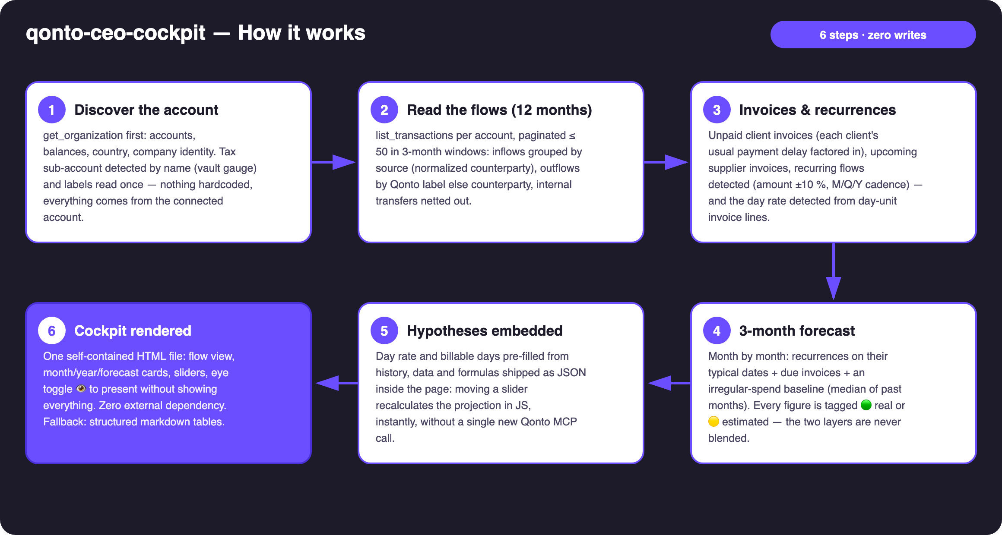
Diagram 1 — How it works, 6 steps (100 % read-only, zero writes)
Holds up on messy data
- No labels? Grouping falls back to normalized counterparties, clearly announced — plus an explicit "Uncategorized" bucket with its transaction count, never silently spread
- Internal transfers netted out: moves between the org's own accounts are neither income nor spend; the one to the tax sub-account feeds the vault gauge
- No day-based invoicing? The hypothesis panel is omitted, with the reason — the rest of the cockpit is complete
- No tax sub-account? Vault gauge hidden, everything else intact · empty or young account? honest empty state, 🟡 tags, never an invented number
- Pagination ≤ 50 everywhere, 3-month windows · non-French company → neutral tax naming, zero invented local rules

🏗 Functional diagram
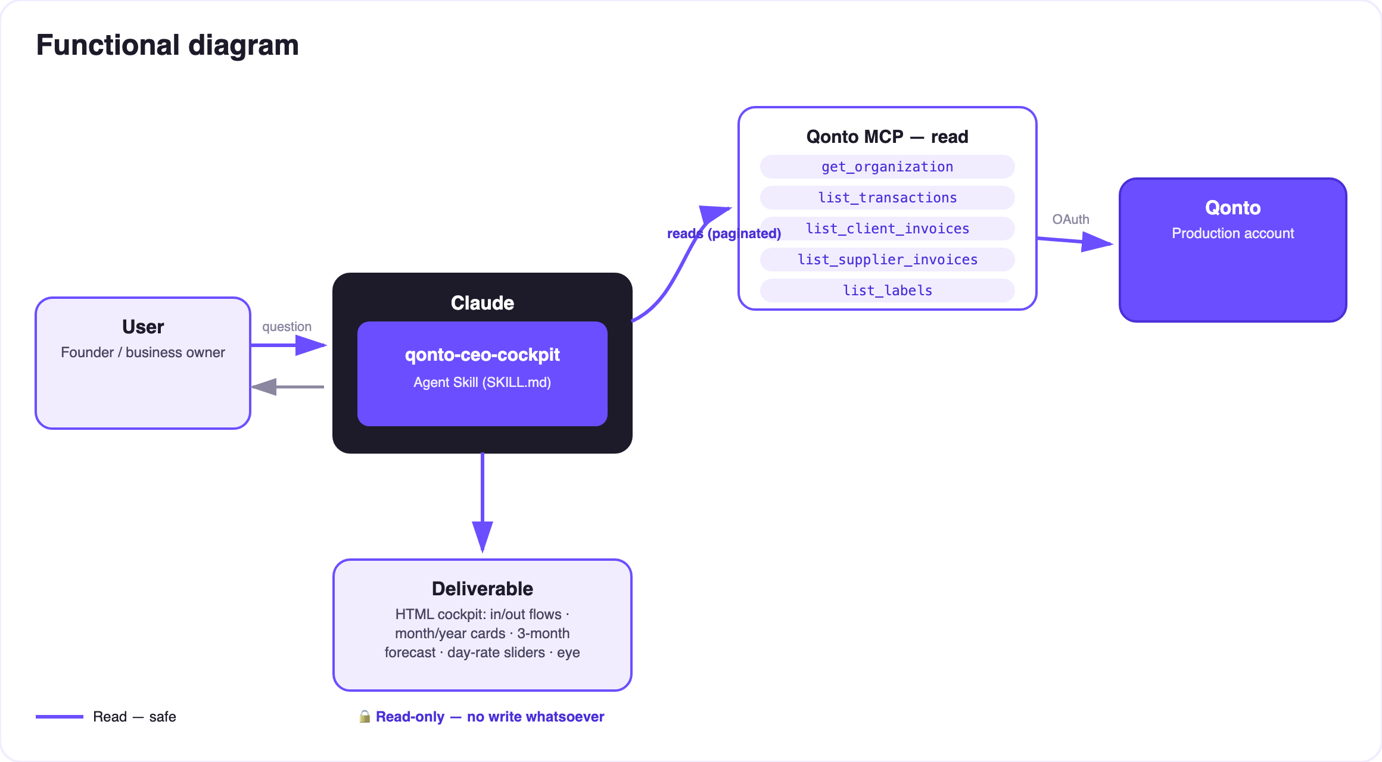
Diagram 2 — Actors and flows: all reads, the deliverable is a local HTML file
🔒 100 % read-only: no write, no transfer, nothing to approve. The deliverable is a local, self-contained HTML file — the data never leaves the machine, no external code loads. The eye toggle 👁 is a presentation convenience (the data stays in the file's source); for sharing, the skill regenerates an export where hidden lines are genuinely excluded.
🧭 The cockpit zones
Zone | Content | Source | Interactive
Flow view | Sources → company → categories, ribbons ∝ amounts | 12 months of transactions, labels | Month/year toggle, hover, click → detail card
KPIs | Consolidated balance · month net · tax vault · 3-month forecast | Balances + flows + tax sub-account | Recomputed as lines are hidden
Category cards | Month / year / forecast, cadence badges, 🟢🟡 tags | Flows + recurrences + invoices | Eye toggle per card
Hypothesis panel | Day rate × billable days (3 months + rest of year) | Day rate detected from invoices | Sliders, live recalc, no MCP call

📤 Output formats
Output | Format | When
Interactive dashboard | One self-contained HTML file: inline CSS/JS, zero external dependency, pure CSS+SVG bars/ribbons, light/dark theme | The deliverable — when the host renders files
Conversation reply | Markdown tables: KPIs, month + year flows, 3-month forecast, priced day-rate scenarios | Automatic fallback otherwise
"Presentation" export | The same HTML regenerated without sensitive lines in the data | On request, for sharing

🎬 Demo video
The ≤ 3-minute demo attached to the PR walks through: the problem (a bank = a list of lines) → "show me my company" → the dashboard building itself → the day-rate slider: +€50 and the annual projection moves live, without a single API call → the eye icon hiding a line for the banker → the skill-family wrap-up. It runs live on a real production account.
💡 Roadmap ideas
Idea | Effort | Note
Skill-family slot-ins: tax-pilot → vault gauge + deadlines, subscription-guardian → subscriptions card | Low | Already in SKILL.md — detected in the conversation, never required
Year-over-year comparison per category (trend arrows) | Low | The 12-month history is already read
Multi-currency consolidation | Medium | get_organization exposes account currencies
"Board meeting" mode: print-ready PDF | Low | window.print() + print CSS, still zero dependencies
New-hire / salary / purchase sliders | Medium | The client-side recalc engine is already there

🛡 Guardrails
- 100 % read-only skill: no write tool, no transfer, nothing to approve — said plainly when asked
- Eye toggle 👁 = presentation, not security: never presented as a redacted document; a genuinely excluded export is offered for sharing
- Forecast and hypotheses are 🟡 estimates, not accounting — accountant validation recommended
- IBANs masked (last 4 digits) · pagination ≤ 50 everywhere · never an invented category, tax rule, or number
qonto-ceo-cockpit · English documentation · Qonto × Anthropic MCP Hackathon · July 2026 · PR deliverable: SKILL.md · French version: doc-qonto-ceo-cockpit.fr.docx

