qonto-subscription-guardian
One capped virtual card per subscription — an action utility, nothing more
Qonto × Anthropic MCP Hackathon · One card per subscription · Single write, behind SCA

🎯 Why this matters
Every subscription charges whatever it wants on the main card. This skill does one thing, well: generate capped virtual cards, one per subscription — nothing more.
- 1. Light detection — recurring charges across 24–36 months (wide enough to catch yearly ones): normalized counterparty, monthly/quarterly/yearly cadence, amount stable ±15 %. A candidate list, no verdicts
- 2. The user picks — the skill counts existing cards (list_cards), recalls the plan grid and proposes a number of cards that fits — never a bulk run
- 3. One capped card PER chosen subscription — virtual create_card + payment_monthly_limit = price + a small margin (yearly: payment_transaction_limit), one at a time, explicit consent + SCA every time
- 4. Nickname SUB-<Vendor> via update_card — existing SUB- cards are recognized, never proposed twice (idempotence)
The honest pitch: dedicated-card protection is a feature Qonto will probably ship natively one day — this skill gives it to the user today.
For the full recurring-spend audit (annual cost, duplicates, price increases…): see the qonto-subscription-audit skill — here, we only do the cards.
📋 Prerequisites
Prerequisite | Detail | Required
Qonto production account | Adapts to any organization — get_organization first, nothing hardcoded | ✅ Yes
Qonto MCP connected | Official connector (claude.ai / Claude Desktop), OAuth login | ✅ Yes
Owner/Admin/Manager role | To create cards directly; other roles fall back to create_card_request (approved by an admin) | ⭕ For the action
Plan virtual-card allowance | Basic: 2 included (€2/month beyond) · Smart/Premium: 50 included (€1/card beyond) · Essential/Business/Enterprise: unlimited. Plan not readable via MCP (get_subscription → 403): the skill counts cards, states the grid and asks for the plan | ℹ️ Checked before proposing
≥ 24 months of history recommended | To catch yearly subscriptions; below that, yearly ones can slip under the radar — stated honestly | ⭕ Optional

⚙️ How it works
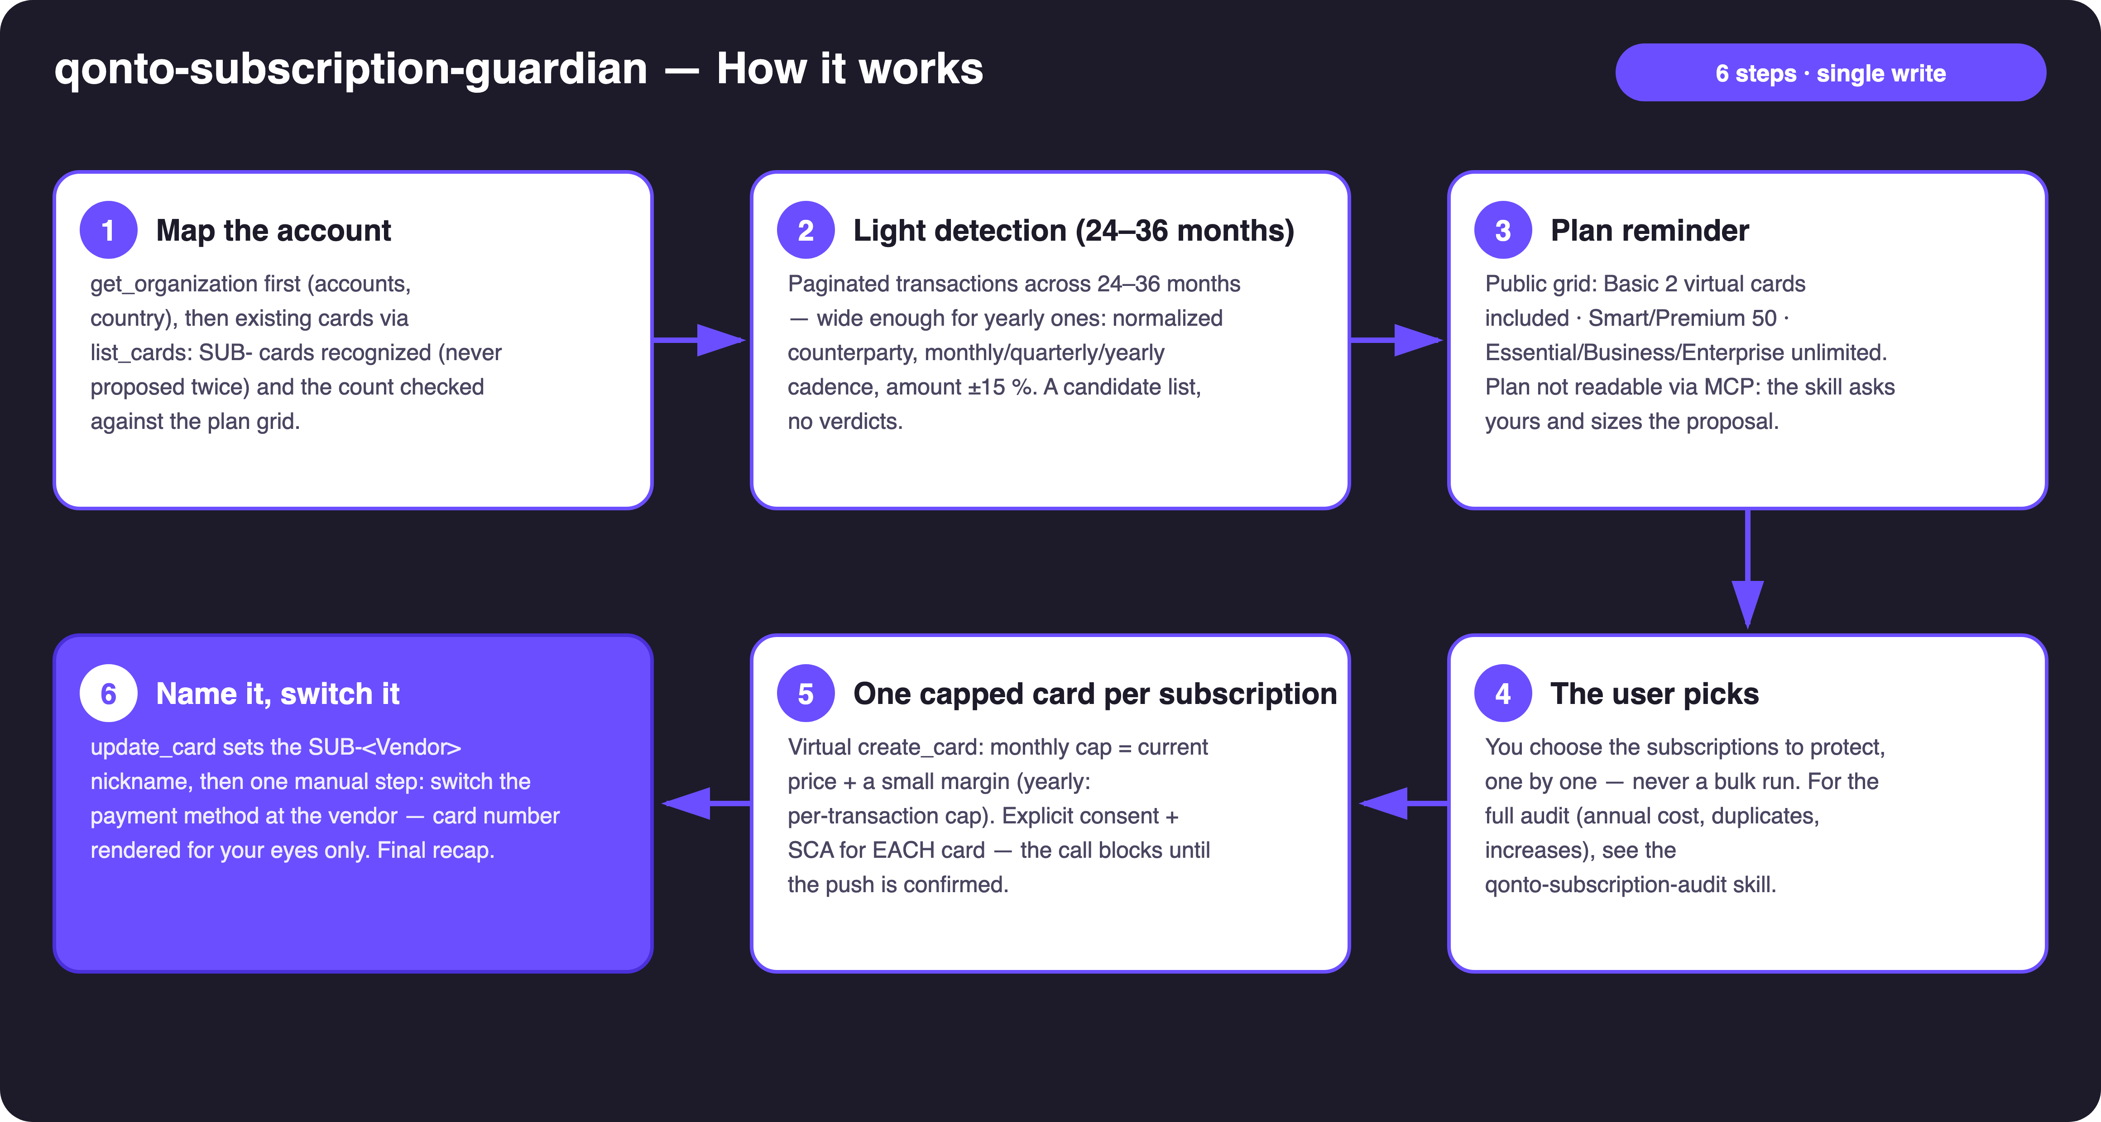
Diagram 1 — How it works, 6 steps (single write, behind SCA)
Holds up on messy data
- Noisy merchant names (ADOBE *CC PARIS, GOOGLE*CLOUD IE): normalized before matching — one vendor = one line
- Wobbling amounts (VAT rounding, FX, seat changes): ±15 % stability band
- Card settlement delays: cadence matched on emitted_at — settled_at lags 1–2 days and breaks the math
- Short history: below 24 months, the skill warns that yearly subscriptions can slip under the radar
- Empty account or restricted role: graceful one-line degradation — detection works for everyone
- Pagination ≤ 50 everywhere · 3-month windows · IBANs and card numbers masked

🏗 Functional diagram
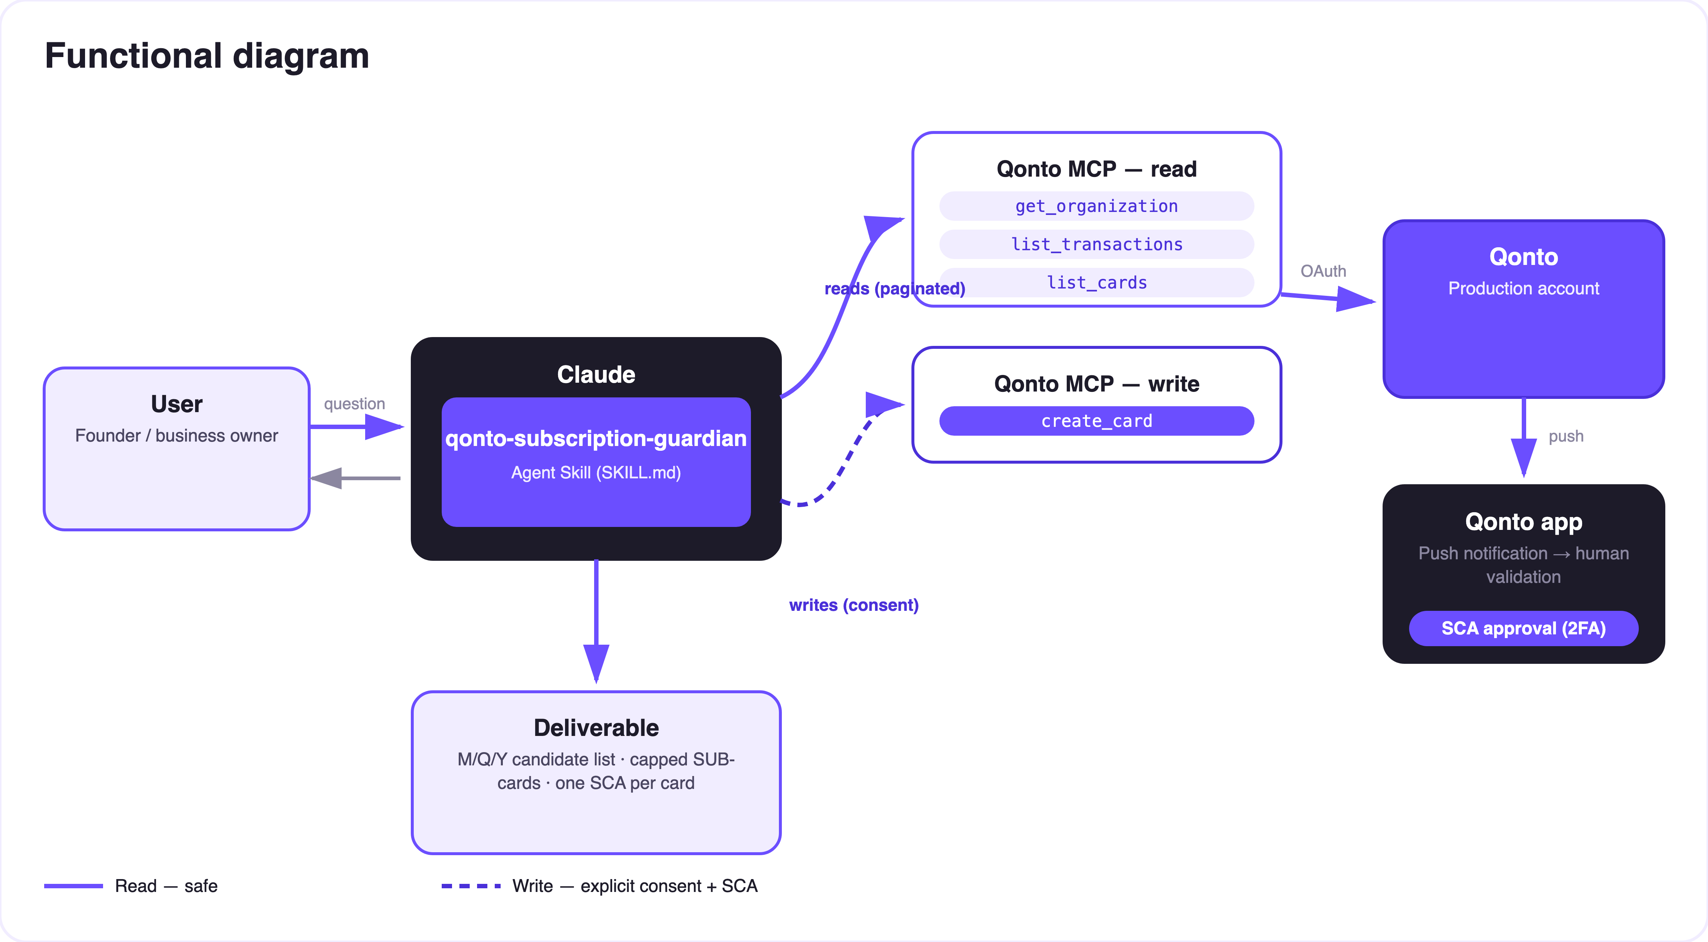
Diagram 2 — Actors and flows: risk-free reads (solid), write behind consent + SCA (dashed)
🔒 The security model, not a limitation: reads are risk-free; the write requires explicit consent in the conversation AND the user's SCA — the create_card call blocks until the push notification is confirmed on the paired Qonto device, for EACH card. Depending on the role, it falls back to create_card_request. Neither Claude nor the MCP can spend a euro.
🔁 A SUB- card's lifecycle
Step | Tool | Note
Capped creation | create_card (virtual, cap = price + margin) | Explicit consent + SCA, one card at a time
Naming | update_card → SUB-<Vendor> | create_card has no nickname field
Switch at the vendor | get_card_iframe_url (PAN/CVV) | Manual step — short-lived URL, for the user's eyes only
Reversible pause | change_card_status → lock | Warns first: a declined charge can suspend the service
Permanent removal | change_card_status → discard | The contract survives — capping ≠ cancelling
Adjusting a cap | Qonto app only | Card limits are not editable via MCP — stated plainly

📤 Output formats
Output | Format | When
Candidate list | Markdown table: vendor · price · cadence M/Q/Y · paying card · already guarded | After light detection
Created-cards recap | Markdown table: card · cap · vendor · still to switch | End of session

🎬 Demo video
The ≤ 3-minute demo attached to the PR walks through: the problem → the candidate list (M/Q/Y cadences) + the plan grid → the user's pick → THE capped card created live, SCA confirmation filmed on a phone, the card visible in the app with its cap → "every subscription now has its own box" + wrap-up. It runs live on a real production account.
💡 Roadmap ideas
Idea | Effort | Note
Auto-categorize protected subscriptions in Qonto (modify_transaction_cash_flow_category) | Low | SUB- lines read in the app too
Public price benchmark per tool (web search) | Medium | To size the cap at the fair price
Multi-currency subscriptions (USD/GBP) | Medium | Amount normalization before the stability check

🛡 Guardrails
- NEVER creates a card (or card request) without explicit confirmation for THAT card in the current conversation; never presented as done while SCA confirmation is pending
- Plan check first, always: list_cards count + the 2/50/unlimited grid before any proposal — a number of cards that fits, never a bulk run
- Capping ≠ cancelling: the contract survives the card — a declined charge can trigger vendor dunning or service suspension, stated BEFORE acting
- Rehearsals: at most one demo card, discarded at the end of the session · never show a full PAN
- IBANs and card numbers masked (last 4 digits) · pagination ≤ 50 everywhere
qonto-subscription-guardian · English documentation · Qonto × Anthropic MCP Hackathon · July 2026 · PR deliverable: SKILL.md · French version: doc-qonto-subscription-guardian.fr.docx

