qonto-board-pack
The monthly investor update, ready before your coffee gets cold — numbers, highlights, narrative, deck and email
Qonto × Anthropic MCP Hackathon · Read-only on Qonto · Nothing ships without review

🎯 Why this matters
The monthly investor/banker update is the task every founder postpones to the last evening — then rushes, half from memory. One prompt → the complete pack, while you watch:
- 1. The month's numbers, straight from Qonto — cash in, spend by category (labels), end-of-month cash (official statement when it exists), net burn and runway
- 2. Month-over-month and rolling-year comparisons — deltas in amount and %, seasonality flagged, outstanding receivables as a forward signal — never a trend from a single month
- 3. Auto-detected highlights — big contract collected, new significant expense, missing recurring client payment — every fact cites its transactions
- 4. Executive narrative (3 §: highlights, numbers, outlook) reviewed and edited BEFORE anything is formatted, then a self-contained 5-6 slide HTML deck (or Canva) + the send email (Gmail draft)
Confidentiality is a feature: your banker, your investors and your team don't get the same pack — the user picks the audience and the detail level (exact figures vs trends). Would someone use this on a Monday morning? It's the end-of-month ritual every founder already dreads.
📋 Prerequisites
Prerequisite | Detail | Required
Qonto production account | Adapts to any organization — get_organization first, nothing hardcoded | ✅ Yes
Country | Every Qonto country (FR, DE, ES, IT, AT, NL, BE, PT) — financial facts are universal; only currency formatting and wording adapt | ℹ️ Detected
Qonto MCP connected | Official connector (claude.ai / Claude Desktop), OAuth login | ✅ Yes
≥ 2 months of history | Below that: the month's numbers only, comparisons skipped and said so (≥ 12 months for the rolling year) | ⭕ Optional
Canva MCP | Deck exported to Canva — detected dynamically, self-contained HTML deck otherwise | ⭕ Optional
Gmail MCP | Email draft in the mailbox — detected dynamically, paste-ready text otherwise | ⭕ Optional

⚙️ How it works
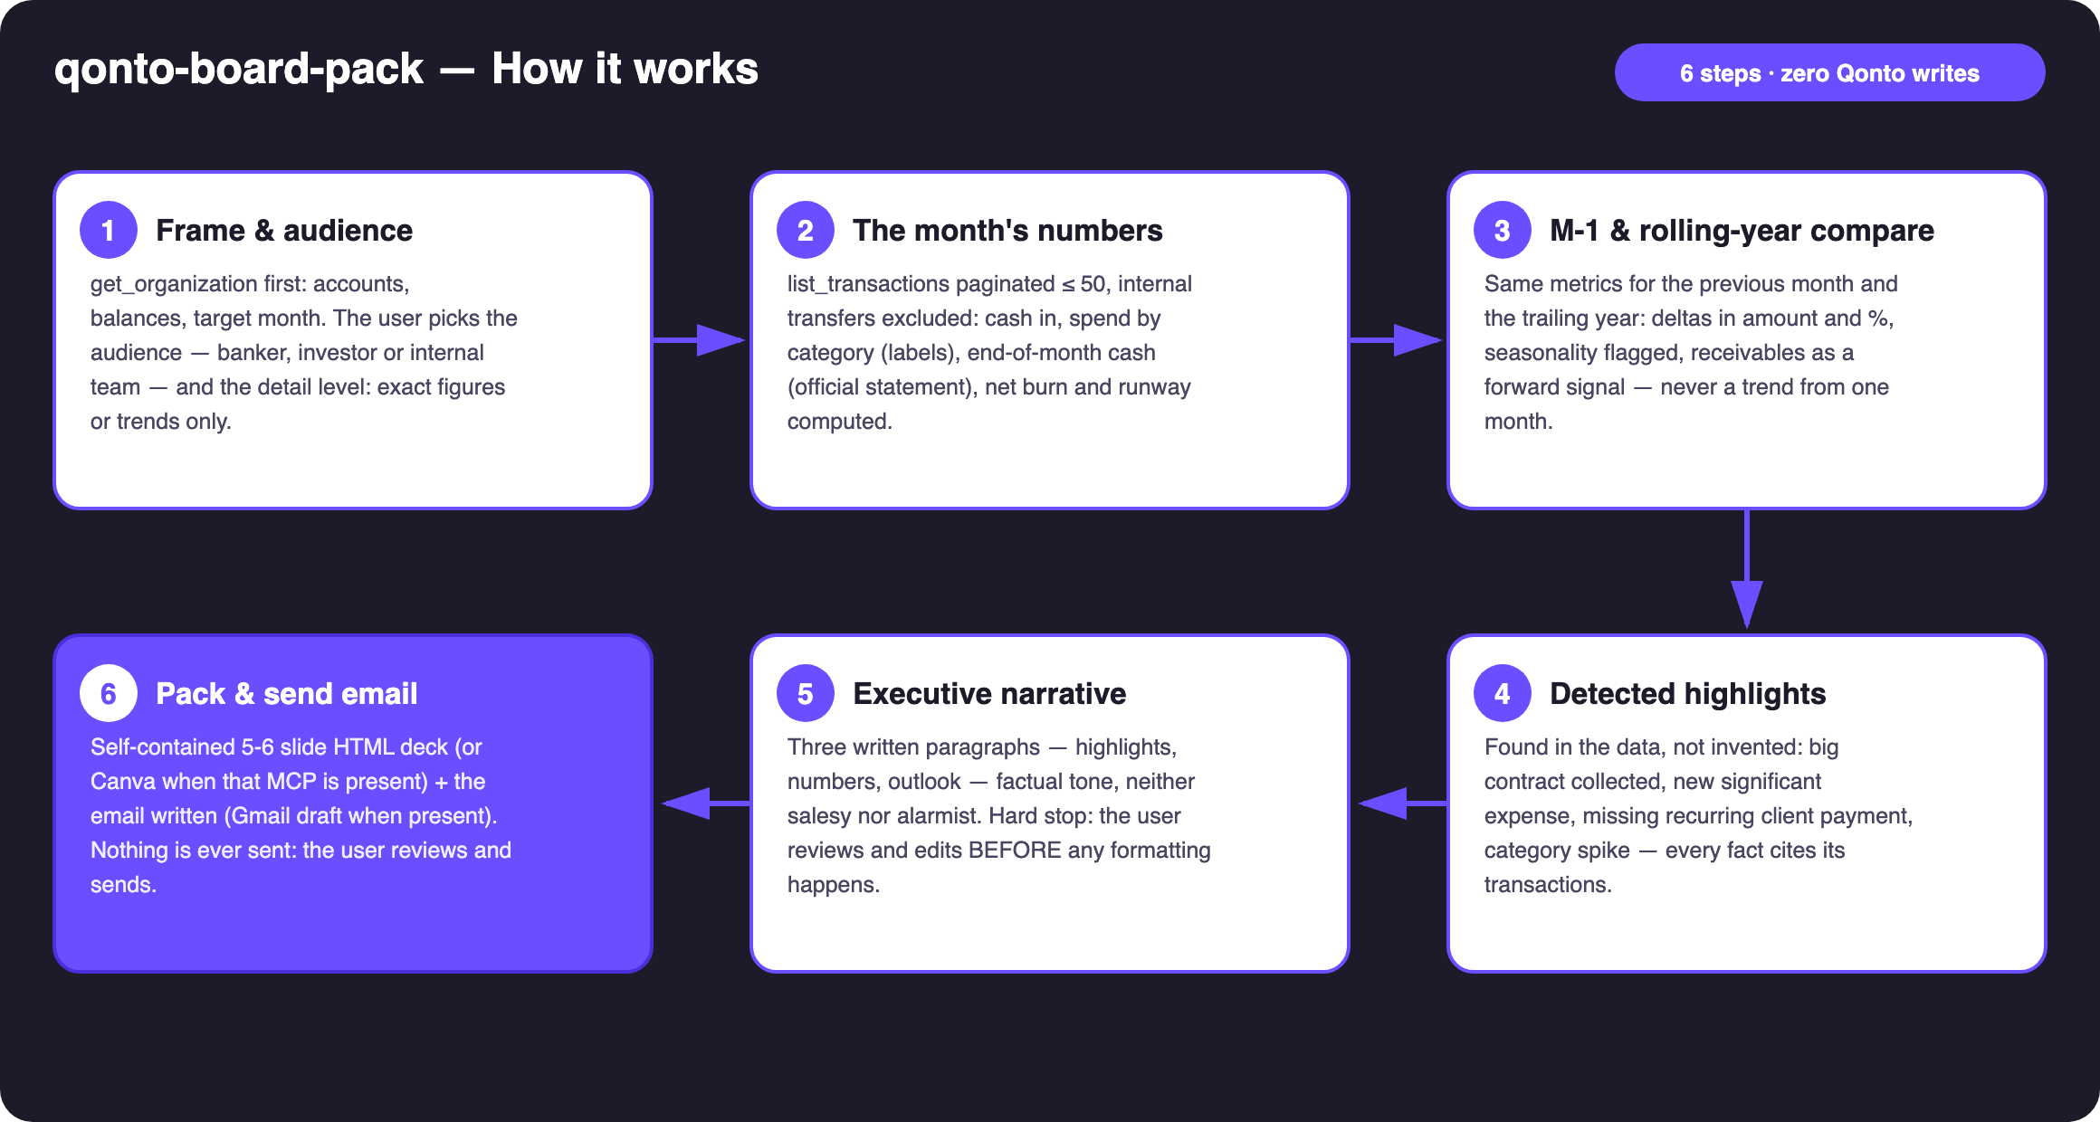
Diagram 1 — How it works, 6 steps (zero Qonto writes)
Holds up on messy data
- Internal transfers excluded from revenue and burn (paired debit/credit on the organization's own IBANs) — the classic way to accidentally double your “revenue”
- Month boundaries handled: card payments settle 1–2 days late — window on settled_at, cross-checked with emitted_at
- Spend grouped by labels (list_cash_flow_categories returns 403 on the claude.ai connector); untagged spend lands in “Other”, share disclosed
- End-of-month balance: official statement (list_statements) when it exists, computed otherwise — the method is always stated
- Empty month or brand-new account: numbers only, comparisons skipped and said — never invented trends; runway only when burn > 0
- Canva or Gmail absent: stated once, then fallback to HTML deck + email text — the core runs on Qonto alone

🏗 Functional diagram
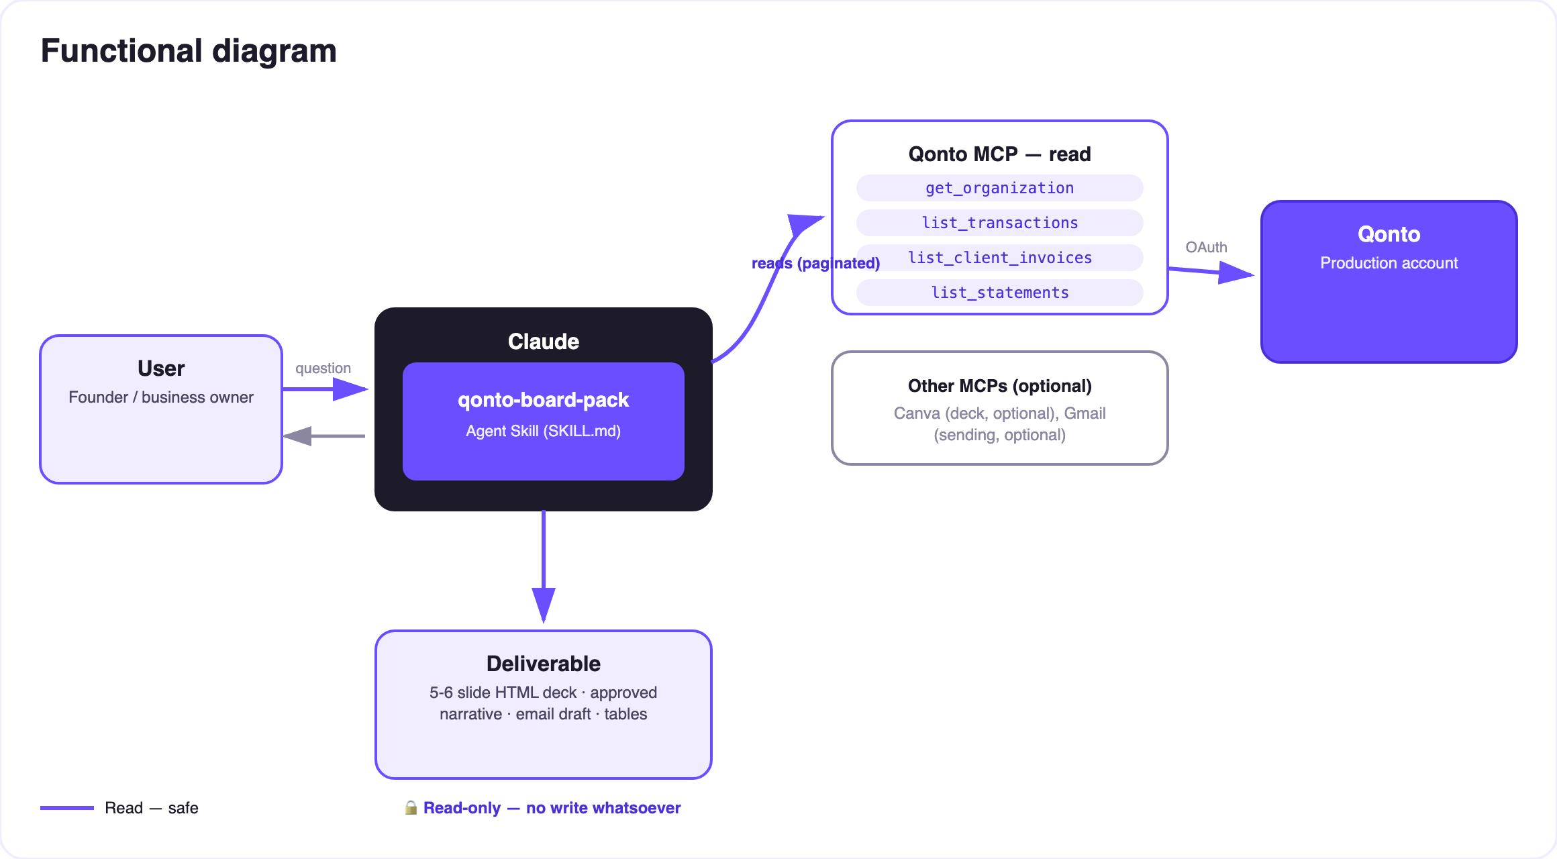
Diagram 2 — Actors and flows: read-only on Qonto; outputs = local file + draft
🔒 Nothing ever ships itself: the skill is read-only on Qonto — no write, ever. The only outputs are a local file (the HTML deck) and a draft (Gmail). The narrative always goes through the user's review before formatting, and the user does the sending. That's the product, not friction.
👥 Three audiences (confidentiality as a feature)
Audience | What they want | Pack content | Detail level
Banker | Stability: the account is healthy, obligations are covered | Cash, inflows, expense coverage, regularity | Exact figures
Investor | Trajectory: growth, controlled burn, runway | Highlights, M-1/YoY growth, burn & runway, outlook | Exact or trends — user's call
Internal | Everything | The full pack, unfiltered, detailed spend included | Everything

📊 Deck structure (5–6 slides, sober theme)
# | Slide | Content
1 | Cover | Organization · month · audience
2 | Highlights | 2–4 detected facts, tied to transactions
3 | Key figures | Cash in · spend · EoM cash · burn/runway, with M-1 deltas
4 | Spend by category | Label breakdown, “untagged” share disclosed
5 | Cash & runway | Rolling 12-month curve, runway when burn > 0
6 | Outlook | The user-approved “outlook” paragraph

Self-contained deck: pure CSS, light/dark theme, zero external dependencies — it opens anywhere, forever.
📤 Output formats
Output | Format | When
Conversation reply | Markdown tables (figures + deltas, spend, highlights) + the 3-paragraph narrative | Always — the baseline
Self-contained HTML deck | 5–6 slides, pure CSS, light/dark, zero dependencies | When the host renders files; fallback to tables
Canva export | Design generated through the Canva MCP | When the Canva MCP is present
Send email | Gmail draft (never sent) or paste-ready text | Gmail present → draft; otherwise text

🎬 Demo video
The ≤ 3-minute demo attached to the PR walks through: the update postponed for three days → one prompt → numbers, highlights, narrative → one adjective fixed live → deck and email draft ready before the coffee is finished. It runs live on a real production account.
💡 Roadmap ideas
Idea | Effort | Note
Pack history: deltas against last month's pack (“what we told them last time”) | Medium | Session memory or local folder
User-declared business KPIs (MRR, active customers) | Low | Merged into the key-figures slide
Calendar reminder “your monthly pack is ready to generate” | Low | Calendar MCP detected dynamically
Bilingual packs (FR deck for the banker, EN for investors) | Low | Same data, two narratives

🛡 Guardrails
- Read-only on Qonto — no Qonto write tool is ever used
- Nothing is sent, ever: emails are drafts, decks are files — the user sends
- The narrative review is a hard stop before any formatting
- Audience confidentiality: exact figures never appear in a trends-level pack; the investor pack is never recycled for the banker without asking again
- Every number traceable to transactions · untagged shares disclosed · honest degradation on short history (< 2 months: no comparisons; < 12: no rolling year)
- IBANs masked (last 4 digits) · pagination ≤ 50 everywhere
qonto-board-pack · English documentation · Qonto × Anthropic MCP Hackathon · July 2026 · PR deliverable: SKILL.md · French version: doc-qonto-board-pack.fr.docx

