qonto-cash-to-stock
Restocking, constrained by cash — how many units you can order without endangering the account, and by when
Qonto × Anthropic MCP Hackathon · Shopify optional — clean degraded mode · Single write, behind SCA

🎯 Why this matters
The real ceiling on an e-commerce restock isn't demand — it's cash. Order too much and the account is in danger the day VAT hits; order too little and a stock-out kills the momentum. The skill answers THE question — how many units, and by when:
- 1. Truly free cash — every account balance − upcoming supplier invoices − tax deadlines detected in history − recurring fixed costs − a safety buffer. The dated minimum of the curve
- 2. Velocity & stock-out date — Shopify when connected (units/day and on-hand stock per product); otherwise estimated from Qonto receipts + the catalog, clearly labeled
- 3. The four decision numbers — free cash · stock-out date · fundable units · latest order date, every figure tagged 🟢 seen in data · 🟡 estimated · 🔵 depends on your input
- 4. One safe action — the supplier transfer request, prepared when the user decides; money moves only after their own SCA approval in the Qonto app
Would someone use this on a Monday morning? That's exactly when store owners look at the weekend's sales and wonder whether they can afford to reorder.
📋 Prerequisites
Prerequisite | Detail | Required
Qonto production account | Adapts to any organization — get_organization first, nothing hardcoded | ✅ Yes
Country | Tax deadlines detected from history everywhere; calendar refinement: France. Other Qonto countries (DE, ES, IT…): only observed debits are projected — never invented deadlines | ℹ️ Detected
Qonto MCP connected | Official connector (claude.ai / Claude Desktop), OAuth login | ✅ Yes
Shopify MCP | Optional, detected dynamically: units/day + on-hand per product. Without it: clean degraded mode (🟡 estimate from receipts + catalog) | ⭕ Recommended
≥ 3–6 months of history | Below that: honest degradation (🟡 tags + warning); 24–36 months to catch annual tax cadences | ⭕ Optional
E-commerce activity with suppliers | Otherwise the skill still works as a truly-free-cash calculator | ⭕ Optional

⚙️ How it works
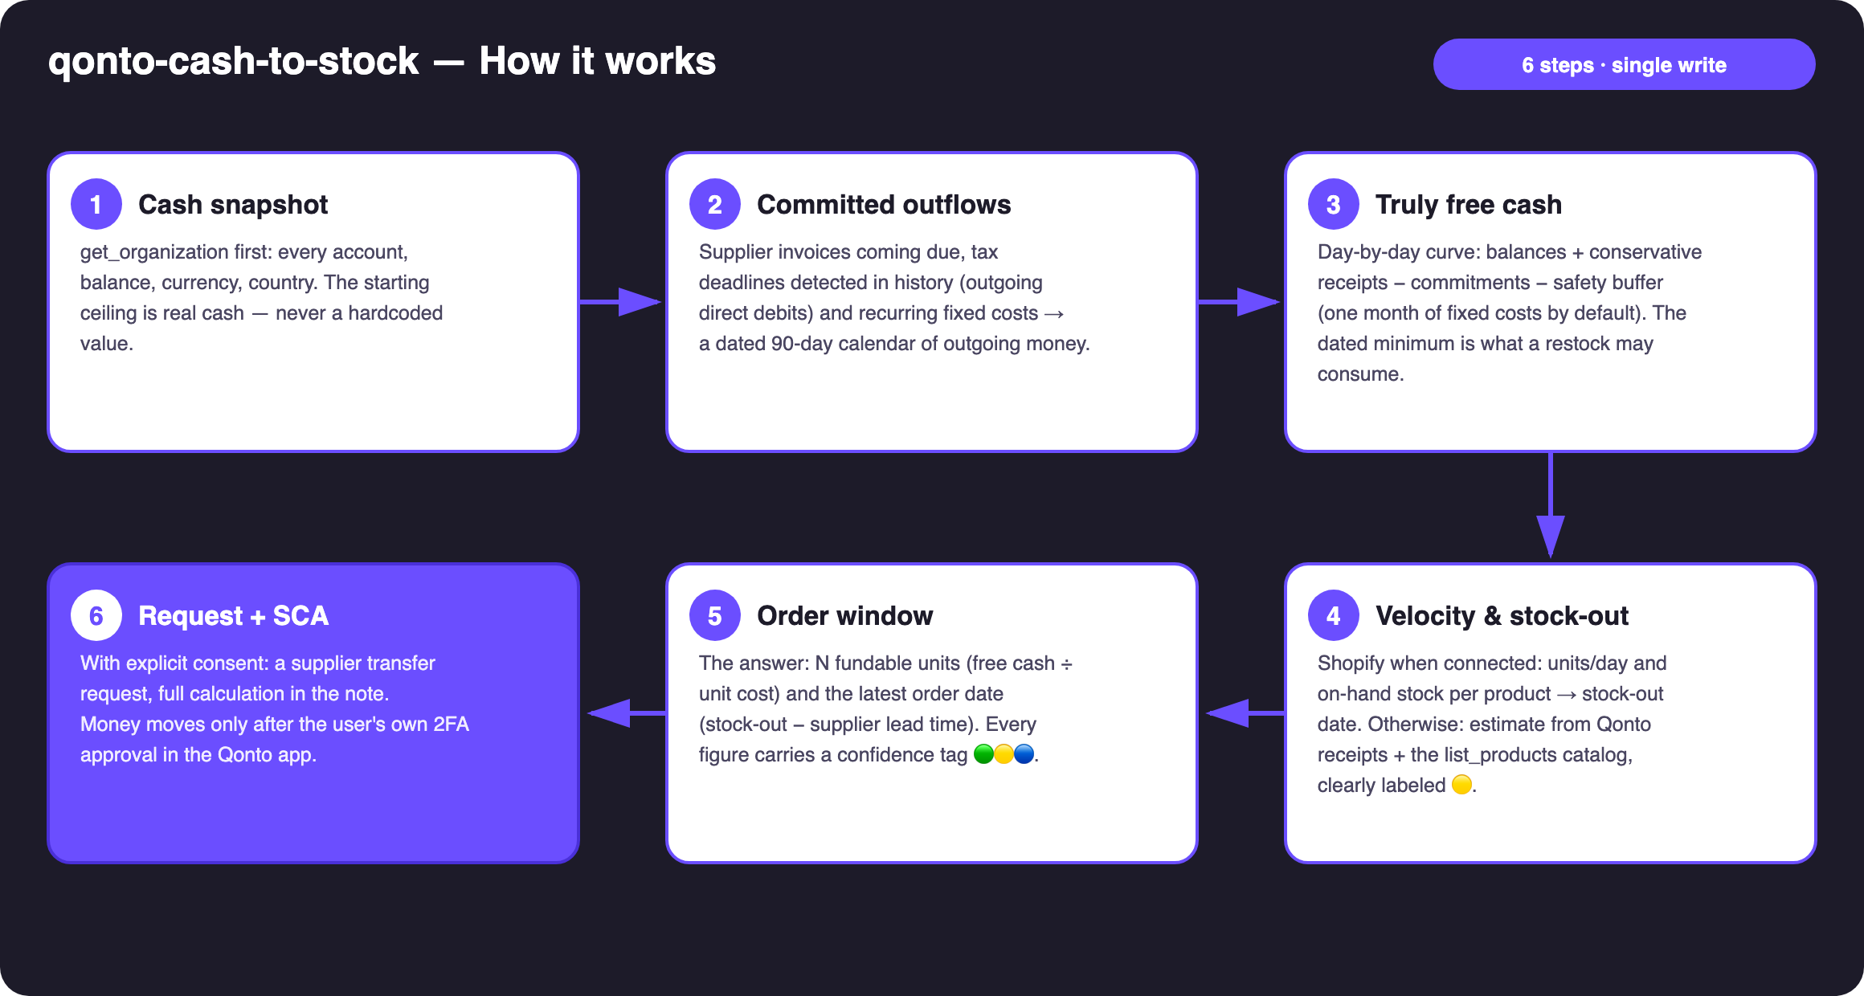
Diagram 1 — How it works, 6 steps (single write, behind SCA)
Holds up on messy data
- No Shopify MCP? The skill says so and switches to the receipts-based estimate + the list_products catalog — every derived figure tagged 🟡, never dressed up as inventory data
- No supplier invoices in Qonto? Commitments are built from recurring debits only, stated plainly
- Unit cost or supplier lead time unknown? Asked once — never silently guessed
- Tax deadlines: outgoing direct debits first, the tax office merged under all its spellings — the qonto-tax-pilot logic, reused as-is when that skill is installed
- Empty account, history < 3 months, non-French company: the skill says what it can and can't compute instead of pretending
- Pagination ≤ 50 everywhere · multi-account orgs handled · all documentation examples fictitious and labeled as such

🏗 Functional diagram
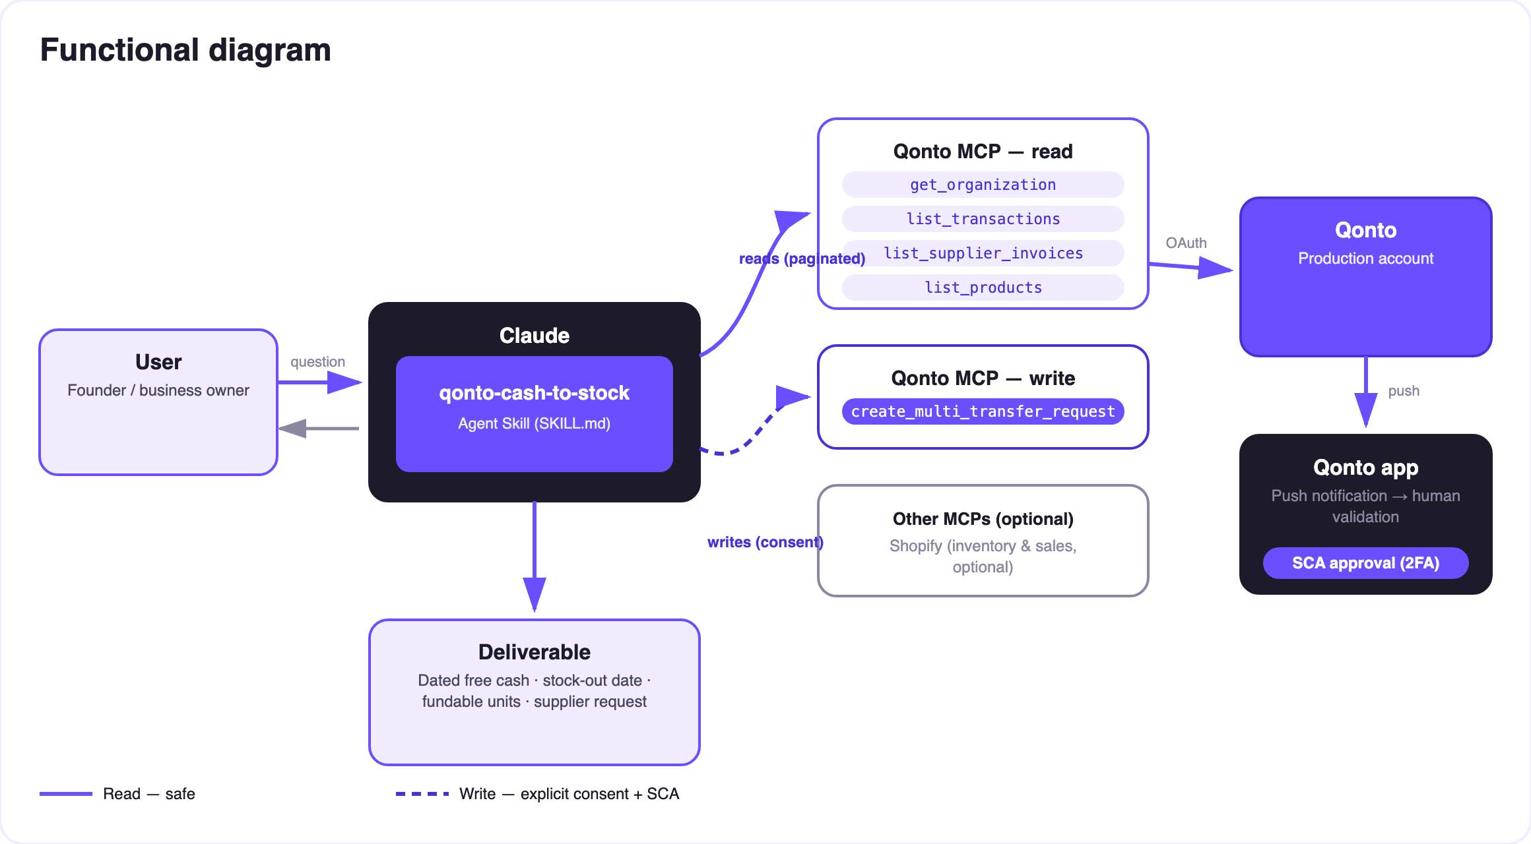
Diagram 2 — Actors and flows: risk-free reads (solid), write behind consent + SCA (dashed)
🔒 The security model, not a limitation: reads are risk-free; the write requires explicit consent in the conversation and only produces a request. The account holder's own SCA (2FA), in the Qonto app, is what moves money. Neither Claude nor the MCP can.
🔢 The four decision numbers
Number | How it's built | Tag
Free cash after commitments | Minimum of the 90-day curve: balances − suppliers − detected taxes − fixed costs − buffer (one month of fixed costs by default, adjustable) | 🟢/🟡
Stock-out date | On-hand stock ÷ velocity (Shopify run-analytics-query + get-inventory-levels), or receipts + catalog estimate | 🟢 with Shopify · 🟡 without
Fundable units | Free cash at the payment date ÷ landed unit cost (confirmed by the user) | 🔵 depends on the cost
Latest order date | Stock-out date − supplier lead time (asked once) | 🔵

Example (fictitious figures, for illustration): "Free cash after commitments: €8,400. Stock-out expected on Sept 28. Unit cost €6.50 → 1,290 fundable units; your supplier ships in 3 weeks → order by Sept 7." It just works — and the last word is always a human thumb on SCA.
📤 Output formats
Output | Format | When
Conversation reply | Markdown tables (commitments calendar, curve summary, four numbers, request recap) | Always — the baseline
Interactive dashboard | HTML file/artifact: free-cash curve, deadlines as markers, stock-out countdown, fundable-units gauge | When the host renders files; fallback to tables
Qonto request note | Text attached to the request, visible at SCA approval: the full calculation | Every request created

🎬 Demo video
The ≤ 3-minute demo attached to the PR walks through: the restock dilemma → commitments & truly free cash → dated stock-out & fundable units → the SCA approval filmed on a phone → the final dashboard. The detailed shooting script is kept internal (outside the repository).
🔗 Companion skills
- qonto-tax-pilot — tax deadlines come from the same detection logic; installed together, cash-to-stock reuses its schedule instead of recomputing
- qonto-shopify-bridge — reconciles the past (Shopify payouts vs Qonto); cash-to-stock decides the future (the next order)
💡 Roadmap ideas
Idea | Effort | Note
Multi-supplier arbitration: one budget split across several orders | Medium | Reuses the free-cash curve
Finer seasonality (velocity weighted by month, sales events) | Medium | Shopify run-analytics-query over 12 months
"Latest order date" reminder pushed to a calendar (calendar MCP detected dynamically) | Low | Optional multi-MCP enrichment, in the spirit of the kickoff
Supplier payment scenarios (30% deposit + balance on delivery) | Low | Two dated requests instead of one

🛡 Guardrails
- NEVER creates a transfer request without explicit confirmation in the current conversation; never presented as executed
- Estimates ≠ purchase advice — the stock decision stays human; every assumption is displayed (unit cost, lead time, buffer)
- Honest degradation without Shopify, without a catalog, without supplier invoices, or on thin history — nothing is invented
- Masked IBANs (last 4 digits) · pagination ≤ 50 · rehearsals: decline_request after each test (request_type "multi_transfers", plural)
qonto-cash-to-stock · English documentation · Qonto × Anthropic MCP Hackathon · July 2026 · PR deliverable: SKILL.md · French version: doc-qonto-cash-to-stock.fr.docx

