qonto-infra-margin
What does your infra really cost, per user? — true unit economics, straight from the Qonto account
Qonto × Anthropic MCP Hackathon · 100% read-only, zero writes · €/user measured, never invented · Multi-MCP detected dynamically

🎯 Why this matters
A SaaS founder recites their MRR by heart. Their infra cost per user? Silence. Vercel, Supabase, OpenAI and AWS bills drown in the card debits, and gross margin drifts with nobody watching. The skill answers with what actually left the bank account:
- 1. Infra debits isolated and classified — Vercel, Supabase, Sentry, OpenAI, Anthropic, AWS, Scaleway, OVH… recognized from Claude's world knowledge at the first occurrence, spellings normalized, grouped by family (cloud, data, AI, observability, tooling)
- 2. Cross-referenced with product telemetry — from connected MCPs: Vercel (projects, deployments), Supabase (projects, users via a read-only SELECT count), Sentry optional
- 3. True unit economics — €/user, €/project (proration announced), month-by-month gross-margin drift against receipts
- 4. The side-projects that bleed — billed every month with zero deployments in 90 days, empty databases on paid tiers, AI API spend growing faster than users
Would someone use this on a Monday morning? It's the question every technical founder asks in the shower and never answers.
📋 Prerequisites
Prerequisite | Detail | Required
Qonto production account | Adapts to any organization — get_organization first, nothing hardcoded | ✅ Yes
Country | Universal — identical analysis for every Qonto country (FR, DE, ES, IT, AT, NL, BE, PT). Truth = the account-side debit (EUR side of USD bills, FX included) | ℹ️ Detected
Qonto MCP connected | Official connector (claude.ai / Claude Desktop), OAuth login | ✅ Yes
Vercel MCP | list_projects + list_deployments → per-project allocation, dead projects detected | ⭕ Recommended
Supabase MCP | list_projects + execute_sql (read-only SELECT count, user-confirmed table) → measured €/user | ⭕ Recommended
≥ 12 months of history | Trends and yearly plans only show over 12-36 months; below that, honest degradation | ⭕ Optional

⚙️ How it works
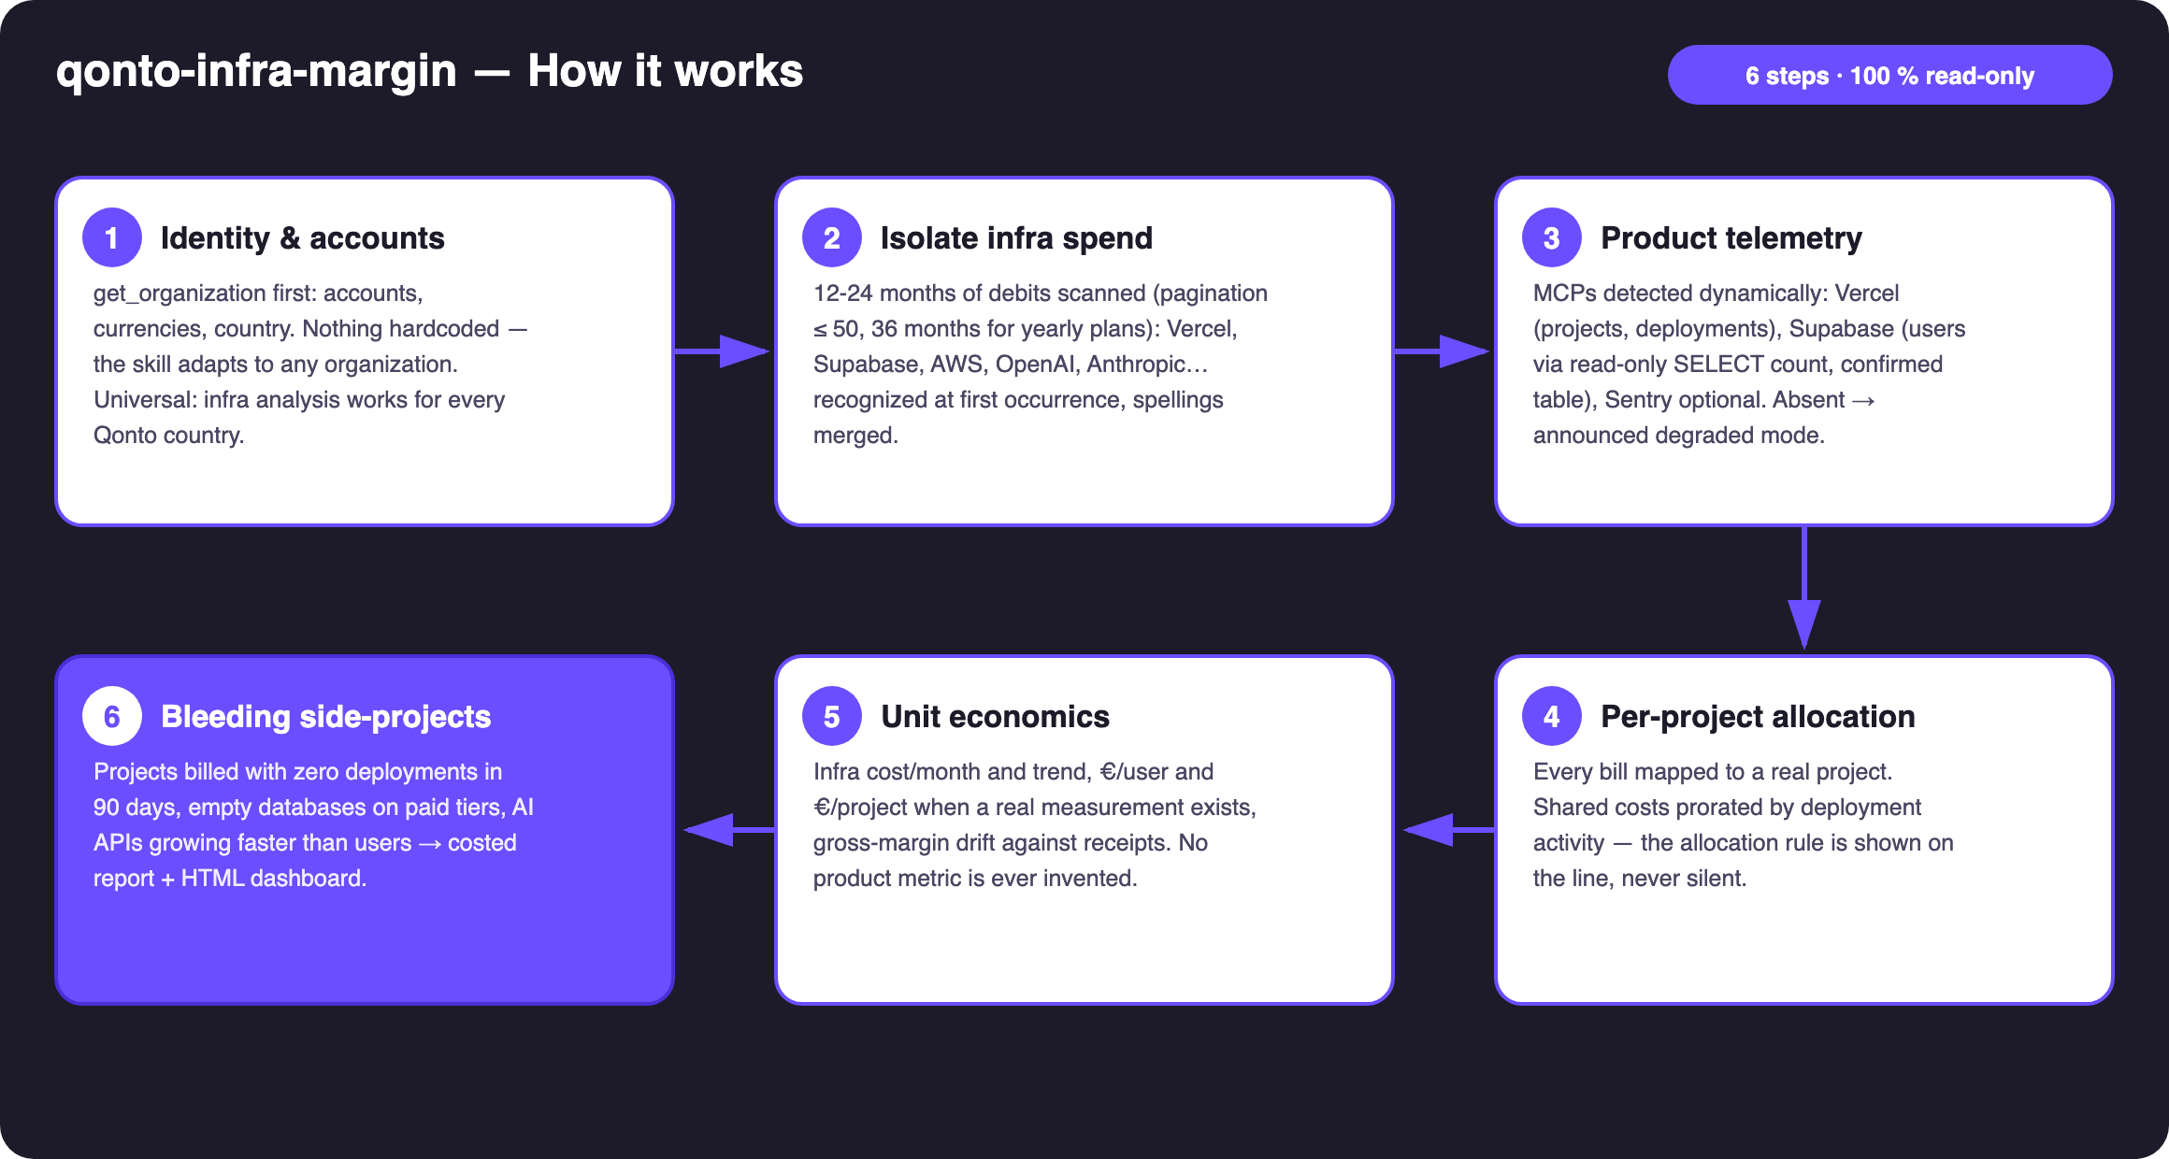
Diagram 1 — How it works, 6 steps (100% read-only)
Holds up on messy data
- No dictionary to maintain: vendors identified at their first invoice — an AI API that launched last month is recognized without any update. Spellings merged (AWS EMEA SARL = AMZN WEB SERVICES = AWS; OPENAI *CHATGPT = OpenAI)
- Billed in USD, debited in EUR: the skill totals the EUR debit (FX included) and explains why vendor dashboards show a different number
- Card payments: invoice ↔ debit matching by emitted_at, not settled_at (1-2 day gap)
- Yearly plans: cadences detected across 24-36 months before any cost is called a “one-off”
- Ambiguous counterparty (reseller, agency) → asked once, never silently classified
- No product MCP → announced degraded mode: classification + monthly totals + trend, already useful. No measured count → no €/user, said plainly

🏗 Functional diagram
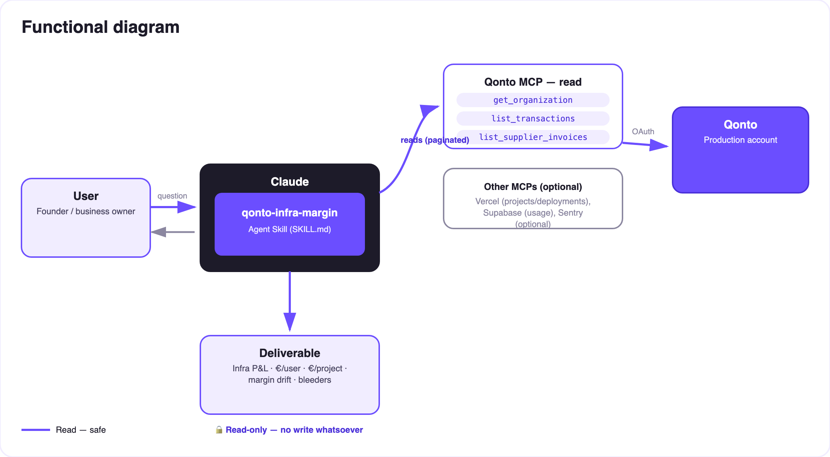
Diagram 2 — Actors and flows: read-only on both sides (Qonto + product MCPs)
🔒 100% read-only, on both sides. Qonto side: no write tool is ever called — nothing to approve, nothing executed. Product side: execute_sql is capped at single read-only SELECT count queries, on a table the user confirms before it runs — never DDL/DML, never a guessed table.
🗂 Recognized vendor families (examples, never exhaustive)
Family | Typical vendors
Cloud & hosting | AWS, Google Cloud, Azure, Scaleway, OVHcloud, Hetzner, DigitalOcean, Fly.io, Railway, Render, Heroku
Frontend & edge | Vercel, Netlify, Cloudflare
Data & backend | Supabase, MongoDB Atlas, Neon, PlanetScale, Firebase, Upstash
AI APIs | OpenAI, Anthropic, Mistral, Replicate, ElevenLabs, fal.ai, Hugging Face
Observability | Sentry, Datadog, Better Stack, Grafana Cloud
Dev tooling | GitHub, GitLab, Docker, npm, JetBrains

📊 What the report contains (fictional example — invented figures)
Metric | Example (fictional) | Condition
Infra cost / month + trend | €412/month, +18% over 12 months | Always (Qonto alone is enough)
€/user | Supabase €180/month ÷ 1,240 users = €0.15/user | Only when a real count was measured
€/project | Vercel bill prorated by deployment activity — rule shown | Vercel MCP present
Margin drift | Infra: 3.1% → 4.8% of receipts in 6 months | Stated MRR, or receipts as an announced proxy
Bleeders | 1 side-project = 80% of the Vercel bill, 0 deployments in 3 months | Product MCP present

📤 Output formats
Output | Format | When
Conversation reply | Markdown tables: infra P&L (vendor × month), unit economics, bleeders | Always — the baseline
Interactive dashboard | HTML file/artifact: bars per family, €/user gauge, drift curve, bleeders spotlight | When the host renders files; fallback to tables
Degraded mode | Same tables minus €/user and per-project allocation — announced | Without the Vercel/Supabase MCPs

🎬 Demo video
The ≤ 3-minute demo attached to the PR walks through: the MRR everyone knows → the infra debits isolated from a real account → product telemetry plugged in → the reveal (the real €/user, and the side-project that had been bleeding for months) → the final dashboard. (Shooting script kept internal, out of the repository.)
💡 Roadmap ideas
Idea | Effort | Note
Stripe/payments MCP for a measured MRR (no more proxy) | Low | Dynamic detection, same logic as Vercel/Supabase
Monthly alert: “your gross margin drifted +N points” | Medium | First-of-the-month ritual, pairs with qonto-tax-pilot
Internal benchmark: €/user vs 12 months ago | Low | Reuses the history already scanned
Per-vendor rightsizing (pricing checked online at analysis time) | Medium | Never from model memory
Cross-check with qonto-subscription-audit | Low | Both skills share recurrence detection

🛡 Guardrails
- Never invents a product metric: no measured count → no €/user, said plainly. Doc examples are fictional and flagged as such
- Allocation is an editorial choice, shown: every shared-cost proration is announced on the line, never silent
- Read-only SQL: execute_sql limited to single SELECT count queries on a user-confirmed table
- Vendor pricing never asserted from memory — the account's numbers, yes; “wrong plan”, no
- Masked IBANs (last 4 digits) · pagination ≤ 50 everywhere · honest degradation
qonto-infra-margin · English documentation · Qonto × Anthropic MCP Hackathon · July 2026 · PR deliverable: SKILL.md · French version: doc-qonto-infra-margin.fr.docx

