qonto-counterparty-watch
Know who owes you money… and who's sinking — a counterparty radar for Qonto
Qonto × Anthropic MCP Hackathon · 100% read-only, zero writes · SIRENE + BODACC cross-checked

🎯 Why this matters
An unpaid invoice hurts. An unpaid invoice from a client already in receivership may be gone forever — and nobody told you. The skill turns a Qonto account into a counterparty radar:
- 1. Exposure per counterparty — unpaid client invoices (amounts, 0-30 / 31-60 / 61-90 / 90+ day ageing), supplier commitments, annualized recurring spend
- 2. Real payment behavior — observed payment date vs due_date across history: average delay, worst delay, worsening trends
- 3. Legal health (when a Datagouv MCP is present) — SIRENE (deregistrations, cessations) and BODACC (receivership, liquidation, safeguard), with the verification date on every line
- 4. A justified 🟢🟡🔴 risk score — exposure × legal health × payment delay, and cross-signal alerts like: "client X owes you N € AND just entered receivership → chase TODAY, by registered mail"
Would someone run this on a Monday morning? That's exactly when you triage who to chase this week.
📋 Prerequisites
Prerequisite | Detail | Required
Qonto production account | Adapts to any organization — get_organization first, nothing hardcoded | ✅ Yes
Country | Legal health: France (SIRENE + BODACC). Other Qonto countries (DE, ES, IT…): graceful degradation — the Qonto-pure core (exposure + delays) works everywhere, no registry ever invented | ℹ️ Detected
Qonto MCP connected | Official connector (claude.ai / Claude Desktop), OAuth login | ✅ Yes
Datagouv MCP (data.gouv.fr) | Detected dynamically. Absent → the skill says so and delivers Qonto-only scoring | ⭕ Recommended
Counterparty SIREN | Extracted from Qonto client records (tax_identification_number: a French VAT number embeds the SIREN) or exact legal name. No SIREN → "not verifiable", stated plainly | ⭕ Optional
Invoice history | The more paid invoices, the more reliable each client's measured delay | ⭕ Optional

⚙️ How it works
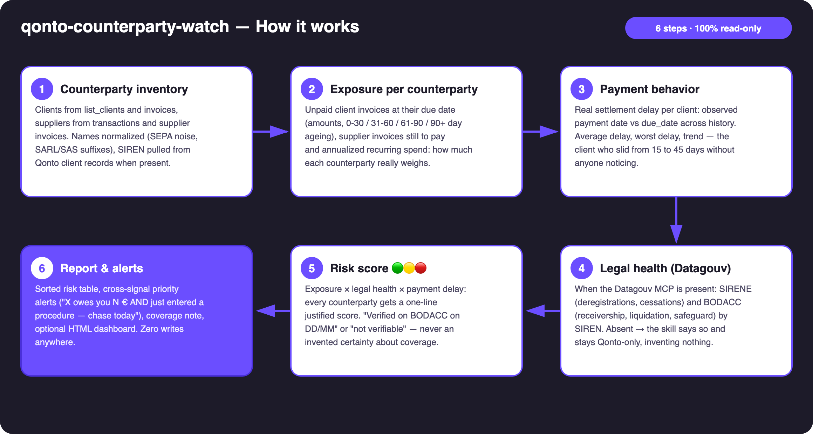
Diagram 1 — How it works, 6 steps (100% read-only)
Holds up on messy data
- Counterparty name normalization: messy bank labels (SEPA noise, payment references, SARL/SAS/EURL suffixes) — Qonto client records and transaction counterparties merged on a normalized key, raw label kept for display
- SIREN extracted, never guessed: a French VAT number is 2 keys + a 9-digit SIREN; without a SIREN → exact-name match flagged as lower confidence, or "not verifiable"
- Honest about coverage: "verified on BODACC on DD/MM, nothing found" ≠ "guaranteed healthy" — coverage through data.gouv can be partial and the skill says so
- No Datagouv MCP: announced once, Qonto-pure scoring delivered (exposure + measured delays are already actionable)
- Empty account, no invoices, non-French counterparties: the skill says what it can and can't assess instead of pretending
- Pagination ≤ 50 everywhere · multi-account organizations handled per account · masked IBANs

🏗 Functional diagram
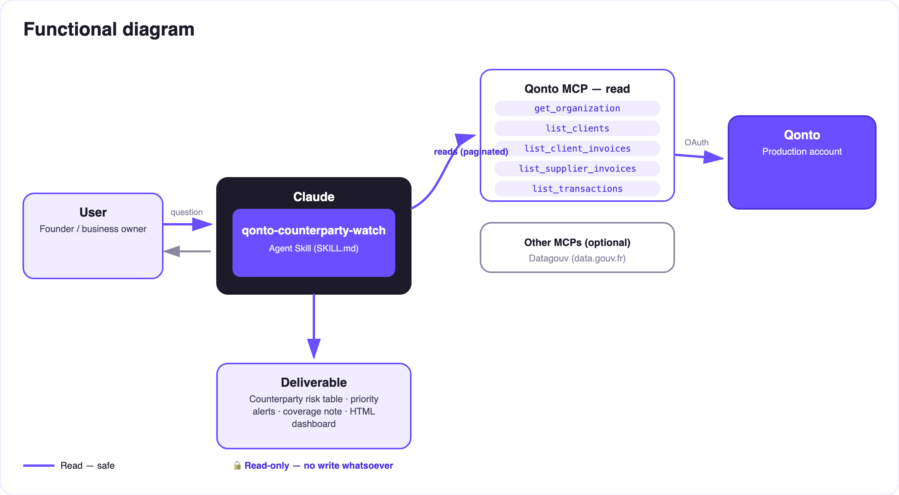
Diagram 2 — Actors and flows: 100% read-only, data flows out, nothing flows in
🔍 100% read-only, zero writes: the skill calls no Qonto write tool — nothing to approve, nothing to execute. It crosses two worlds that never talk to each other: the Qonto account (who owes you what) and the French public registries (who is going under). Data flows out; nothing flows in.
📊 Scoring grid (exposure × legal health × delay)
Score | Triggers | Alert example
🔴 Critical | Open collective procedure or deregistration WITH money at stake; significant 90+ day overdue | "Owes €9,700, receivership published recently → declare the claim (2-month deadline) + registered-mail dunning"
🟡 Watch | Worsening payment trend; high exposure not verifiable; procedure found with no current exposure | "Average delay slid from 12 to 38 days over the last 3 invoices"
🟢 Healthy | Verified with no signal (dated) and payments on time | "✅ BODACC checked 11/07, nothing found · average delay 4 days"

📤 Output formats
Output | Format | When
Conversation reply | Markdown tables (sorted risk table, alerts, coverage) | Always — the baseline
Interactive dashboard | HTML file/artifact: exposure × health matrix, ageing chart, alert cards | When the host renders files; fallback to tables
Coverage note | Verified / not verifiable / registry unavailable counters | Every report — honesty is part of the deliverable

🎬 Demo video
The ≤ 3-minute demo attached to the PR walks through: the problem → the risk table on a real account → the cross-signal moment (a real overdue invoice meeting a BODACC procedure) → the final dashboard. It runs live on a real production account.
💡 Roadmap ideas
Idea | Effort | Note
European registry modules (Handelsregister DE, Registro Mercantil ES…) | Medium | Qonto is pan-European; v1 = France, v2 = one registry module per country
Dunning-email draft when a Gmail MCP is detected (draft only, never auto-sent) | Low | Optional multi-MCP enrichment, in the spirit of the kickoff
Scan-over-scan diff ("new 🔴 since Monday") | Medium | The Monday ritual becomes a delta, not a full report
Supplier-dependency score (share of spend) | Low | Same inventory, highlights single-point-of-failure suppliers

🛡 Guardrails
- 100% read-only — no Qonto write tool is ever called; nothing to approve, nothing to execute
- Never a legal status without source + date; "nothing found" ≠ "guaranteed healthy" when coverage is partial
- Alerts are signals, not legal advice: open procedure → confirm on bodacc.fr and talk to a lawyer/accountant
- Honest degradation: no Datagouv → Qonto-pure scoring, announced; non-French counterparties → exposure + delays only
- IBANs masked (last 4 digits) · pagination ≤ 50 everywhere
qonto-counterparty-watch · English documentation · Qonto × Anthropic MCP Hackathon · July 2026 · PR deliverable: SKILL.md · French version: doc-qonto-counterparty-watch.fr.docx

