qonto-rebill
The expenses you advanced for clients, literally recovered — a line-by-line rebill invoice
Qonto × Anthropic MCP Hackathon · Pure Qonto, end to end · Single write = a draft · Receipts inventoried

🎯 Why this matters
Freelancers and agencies advance money for their clients — plugins, stock photos, hosting, travel, mission meals — and forget to rebill half of it. The skill goes and gets that money back:
- 1. Finds client-attributable expenses — client-named Qonto labels, teams, or history-assisted attribution, one transaction at a time (nothing is ever attributed silently)
- 2. Groups them per client and period — and inventories the receipts already attached to each transaction (gaps flagged per line)
- 3. Explains the VAT choice, never decides it — disbursement (client's name, no margin, outside VAT) vs rebilled expense (VAT at the main service's rate): the skill compares and asks
- 4. Drafts the rebill invoice line by line — create_client_invoice as a draft, optional 5-10% handling fee, sent only after explicit confirmation
Would someone use this on a Monday morning? It's the end-of-quarter ritual that pays for itself the first time it runs.
📋 Prerequisites
Prerequisite | Detail | Required
Qonto production account | Adapts to any organization — get_organization first, nothing hardcoded | ✅ Yes
Country | Universal mechanics (find → group → draft). The disbursement regime is French law (art. 267 II-2° CGI): outside France, local VAT treatment is deferred to a local accountant — never invented rules | ℹ️ Detected
Qonto MCP connected | Official connector (claude.ai / Claude Desktop), OAuth login | ✅ Yes
Client-named labels | Qonto labels named after clients (or teams per mission). No labels: interactive attribution, one transaction at a time | ⭕ Recommended
Clients in Qonto invoicing | list_clients — the invoice needs an existing client; otherwise the skill explains how to create one | ⭕ Optional
Receipts attached | Inventoried automatically; for the gaps: qonto-receipt-hunter before rebilling | ⭕ Optional

⚙️ How it works
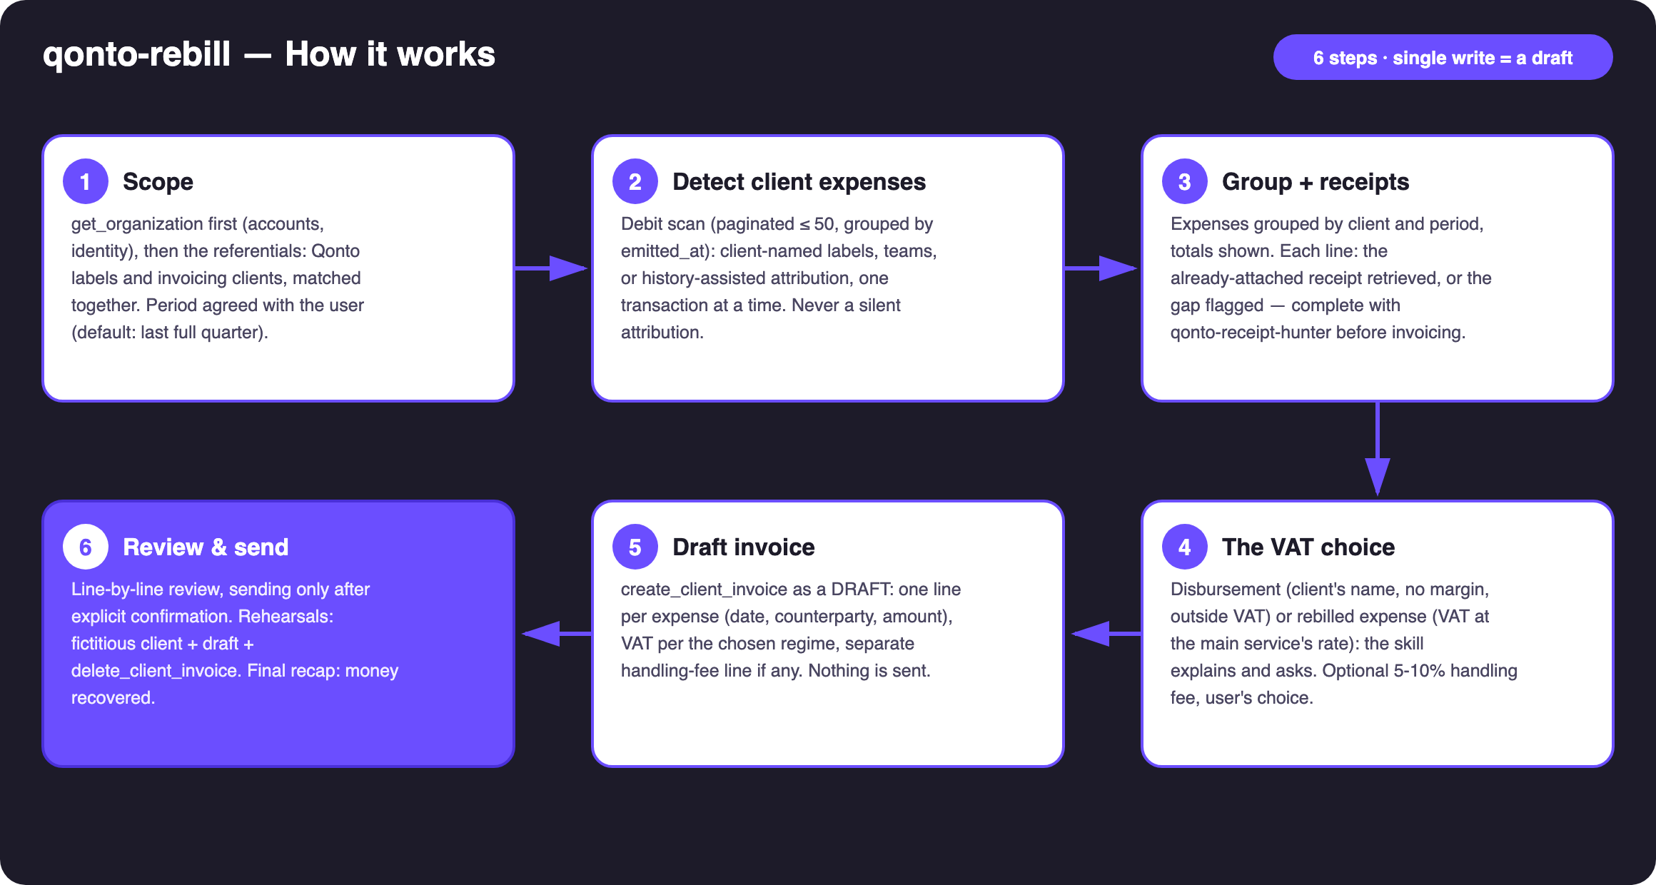
Diagram 1 — How it works, 6 steps (single write = a draft)
Holds up on messy data
- No client labels? → interactive attribution: shortlisted candidates (counterparties previously attributed, mission-typed spend: SaaS, stock photos, hosting, transport, meals), asked one transaction at a time — then an offer to label going forward so next quarter is automatic
- Labels matched to invoicing clients: case/accent normalization — the label “acme studio” = the client “ACME Studio”
- Card expenses straddling two periods: grouped by emitted_at, not settled_at (settlement lands 1-2 days later)
- Receipt missing on a line → flagged, with a pointer to qonto-receipt-hunter before sending
- Empty account, expense-free period, client missing from invoicing, non-French company: the skill says what it can and cannot do
- Pagination ≤ 50 everywhere · get_organization always first (bank_account_id required by list_transactions)

🏗 Functional diagram
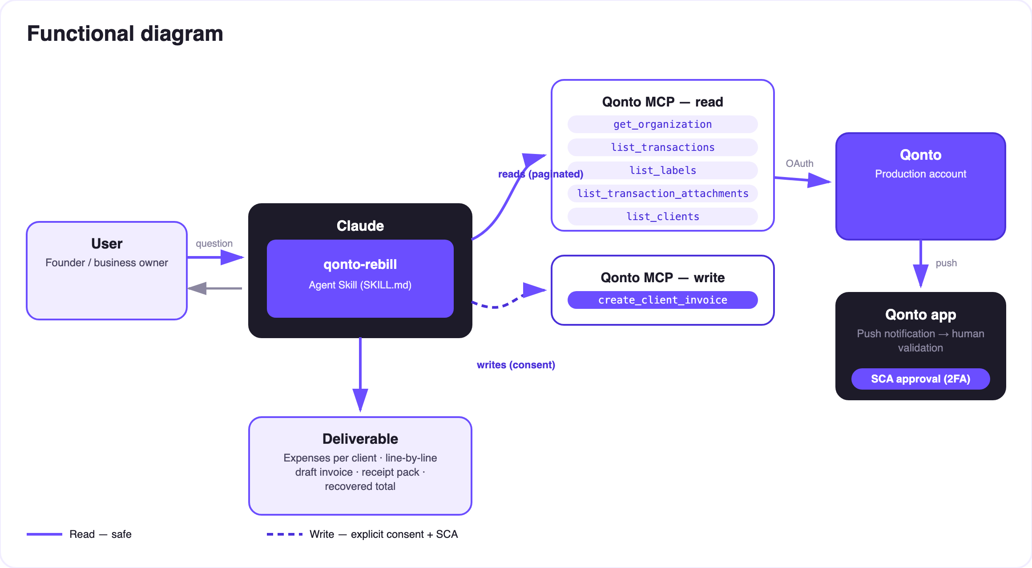
Diagram 2 — Actors and flows: risk-free reads (solid), write = a draft behind confirmation (dashed)
🔒 One write, and it's a draft: reads are risk-free; the write (create_client_invoice) only produces a draft inside Qonto. Sending it to the client requires explicit confirmation in the conversation. Since MCP-created invoices are real, rehearsals run on a fictitious client and end with delete_client_invoice.
⚖️ Disbursement vs rebilled expense (the table the skill shows)
Criterion | Disbursement (débours, art. 267 II-2° CGI) | Rebilled expense (standard)
Principle | Paid in the client's name and on their behalf (mandate) | Paid in your own name, recharged as part of your price
Margin | Forbidden — exact amount, euro for euro | Allowed (handling fee 5-10%…)
VAT | Outside VAT scope: no VAT on the line, input VAT not deductible | VAT at the main service's rate (often 20%) — even if the underlying cost was 10% or VAT-free
Receipt | Original invoice in the client's name, handed over | Original invoice in your name, kept in your books
Books | Third-party account (not revenue) | Revenue
Country | French regime | Universal mechanics; outside France → local accountant

The skill explains and asks — it never picks a regime on its own (per line when regimes are mixed), and every report recommends accountant validation.
📤 Output formats
Output | Format | When
Conversation reply | Markdown tables: expenses per client (receipt ✅/⚠️), invoice line by line, recovered total | Always — the baseline
Draft invoice in Qonto | create_client_invoice as a draft, visible in Invoicing | After the regime is agreed; sent only on explicit confirmation
Receipt pack | Download links (get_attachment, time-limited) to forward with the invoice | Every prepared invoice
HTML recap | Per-client cards, receipts gauge, recovered amounts | When the host renders files; fallback to tables

🎬 Demo video
The ≤ 3-minute demo attached to the PR walks through: the problem (advanced expenses everyone forgets) → detection through labels → the VAT choice explained → the draft invoice, line by line, receipts inventoried → confirmed send and recap. Example figures shown in the docs are invented.
💡 Roadmap ideas
Idea | Effort | Note
Learning “rebillable” counterparties per client | Medium | Accepted attributions pre-fill the next quarter
Pre-approval quotes (create_quote) for large advances | Low | The client signs off before you pay
A scheduled monthly/quarterly ritual | Low | “Anything to rebill this month?” on autopilot
Chaining qonto-receipt-hunter → qonto-rebill → qonto-invoice-chaser | Low | Complete receipts → invoice → payment chasing
Multi-currency expenses | Medium | Converted at transaction rate, disclosed per line

🛡 Guardrails
- MCP-created invoices are REAL: draft until explicit confirmation, never presented as sent, rehearsals on a fictitious client + delete_client_invoice
- No silent attribution, ever: every uncertain expense is asked; nothing invented — no amount, no receipt, no client
- The disbursement/rebill choice belongs to the user (with their accountant) — the skill explains and asks
- Honest degradation (no labels, empty account, non-French country) · IBANs masked (last 4 digits) · pagination ≤ 50
qonto-rebill · English documentation · Qonto × Anthropic MCP Hackathon · July 2026 · PR deliverable: SKILL.md · French version: doc-qonto-rebill.fr.docx

