qonto-crew-onboard
One-sentence financial onboarding for every new hire — invitation, capped card, welcome pack
Qonto × Anthropic MCP Hackathon · Per-role policy, user-decided · Writes confirmed one by one, card behind SCA · Offboarding = freeze, never delete

🎯 Why this matters
Every new hire triggers the same manual ritual: invite them on Qonto, create their card with the right caps, prepare day one — and every departure triggers the reverse, usually too late. The skill turns both into one sentence:
- 1. A per-role policy — defined once with the user (card type, caps, online-only, team), applied to every arrival. Never invented: an unknown role triggers questions
- 2. One-sentence onboarding — "Alex starts Monday as a developer": create_membership (the invitation goes out), create_team if the team is new, create_card_request — a capped card REQUEST that conforms to the policy, approved in the app (SCA)
- 3. Multi-MCP welcome pack — Notion page, day-1 Google Calendar event, Gmail draft — when those MCPs are connected; otherwise announced, the core continues
- 4. Mirror offboarding — "Sam is leaving Friday": cards frozen (change_card_status, reversible) + recovery checklist. Nothing deleted — definitive revocations stay in the app
Would someone use this on a Monday morning? That's literally when new hires show up.
📋 Prerequisites
Prerequisite | Detail | Required
Qonto production account | Adapts to any organization — get_organization first, nothing hardcoded | ✅ Yes
Country | Universal — memberships, teams and cards work the same in every Qonto country (FR, DE, ES, IT, AT, NL, BE, PT) | ℹ️ No fiscal logic
Qonto MCP connected | Official connector (claude.ai / Claude Desktop), OAuth login | ✅ Yes
Admin/Owner role | Inviting and requesting cards require it — checked via get_authenticated_membership, honestly announced otherwise | ✅ Yes
Per-role policy | Decided by the user, never by the skill | ✅ User-decided
Seats left on the plan | Grid not readable via MCP (get_subscription → 403) — the skill asks the plan and counts members before inviting | ℹ️ Verified by asking
Notion · Google Calendar · Gmail | Optional welcome pack, detected dynamically | ⭕ Optional

⚙️ How it works
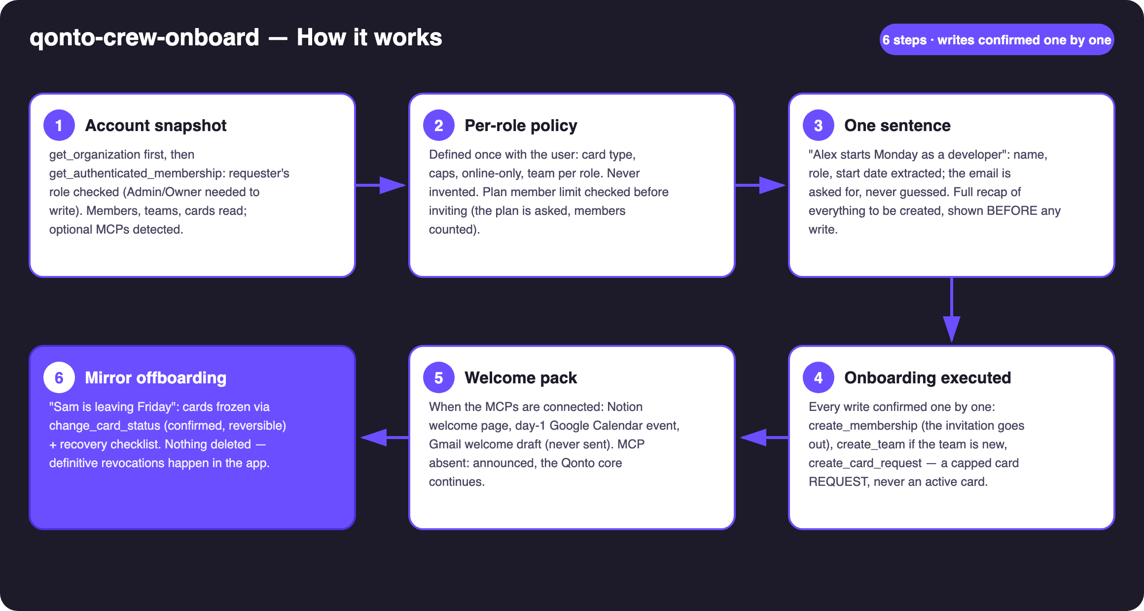
Diagram 1 — How it works, 6 steps (writes confirmed one by one, card behind SCA)
Holds up on messy data
- Requester's role checked first: not Admin/Owner → honest warning and a read-only preview of what would be done
- Emails never guessed: missing → asked for; already invited → caught in list_memberships, invitation skipped with the reason
- Teams matched before creation ("tech" vs "Tech") — create_team only when the team truly doesn't exist
- Plan member limits: get_subscription returns 403 on the connector → the plan is asked, members counted, warning before inviting
- Notion / Calendar / Gmail MCP absent → one honest line each, the Qonto core continues
- Offboarding a member with no cards → checklist only, with what the app must handle · pagination ≤ 50 everywhere

🏗 Functional diagram
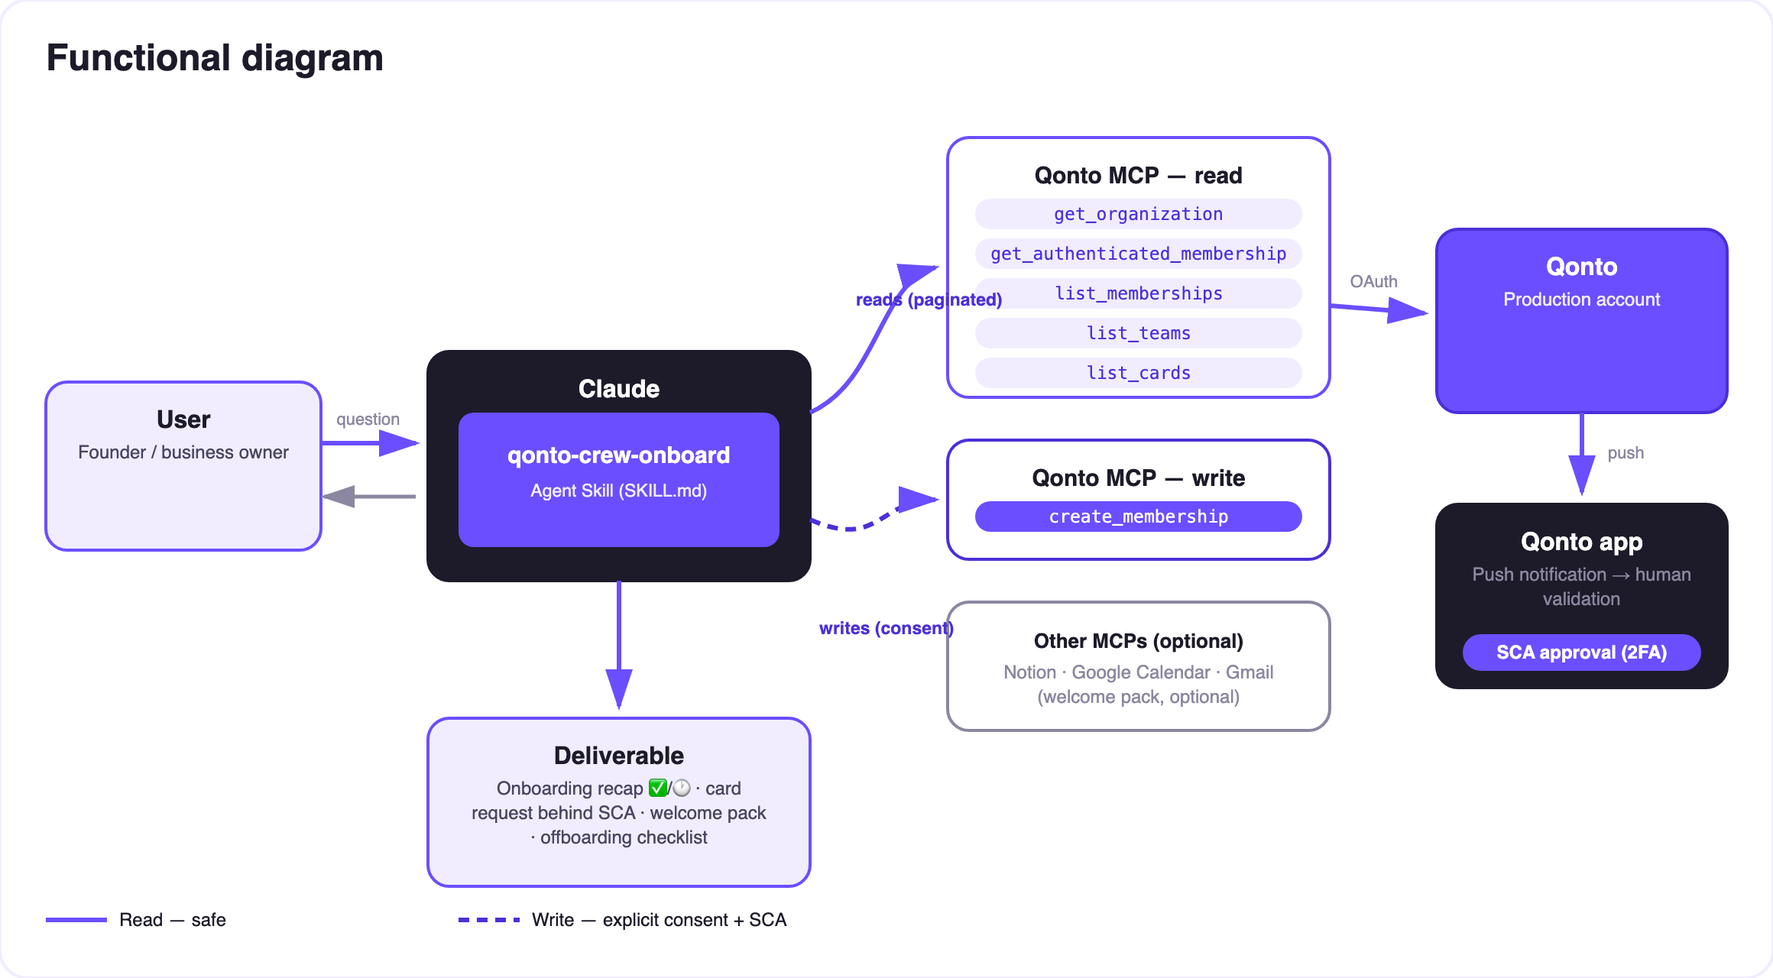
Diagram 2 — Actors and flows: risk-free reads (solid), writes behind consent, card behind SCA (dashed)
🔒 The security model, not a limitation: reads are risk-free; every write requires explicit consent in the conversation. The card is never created directly — create_card_request files a policy-compliant capped request, approved in the Qonto app by an Admin/Owner with their own SCA. And offboarding freezes, it doesn't delete.
🗂 The per-role policy (illustrative example — the real one is user-defined)
Role | Card | Monthly cap | Online-only | Team
Developer | Virtual | €200 | Yes | Tech
Account executive | Physical | €1,000 | No | Sales
Ops | Virtual | €500 | Yes | Operations

⚠️ This table is made up for illustration. The policy is always decided by the user — an unknown role triggers questions, never a guess.
❄️ Offboarding — the mirror checklist
Step | Who | Detail
Freeze the cards | The skill (change_card_status, confirmed) | Reversible — that's the point: nothing irreversible
Physical card recovered | Checklist | Along with equipment (laptop, badge…)
Accesses and tools | Checklist | Internal apps, pending expense claims, email forwarding
Member deactivation | The Qonto app | Definitive revocation — never done by the skill

📤 Output formats
Output | Format | When
Conversation reply | Markdown tables: recap (✅ done / 🕐 pending SCA / ⏭ skipped), card-request status, checklist | Always — the baseline
Onboarding sheet | One-page HTML file/artifact: who arrives, when, what's ready, what's pending | When the host renders files; fallback to tables
Notion page · Calendar event · Gmail draft | Welcome pack (the draft is never sent by the skill) | When those MCPs are connected

🎬 Demo video
The ≤ 3-minute demo attached to the PR walks through: the manual ritual → the policy defined once → "Alex starts Monday as a developer" → the invitation out, the capped card request awaiting SCA, the welcome page ready → the one-command offboarding freeze. Fictional names, test accounts. (Shooting script kept internal, outside the repo.)
💡 Roadmap ideas
Idea | Effort | Note
Policy persisted in a Notion doc, re-read on every arrival | Low | Optional multi-MCP — the policy lives with the user
Batch onboarding ("3 interns start on the 1st") | Low | Same workflow, grouped recap, one-by-one confirmations
D-1 reminder to the manager (Google Calendar) | Low | Dynamic MCP detection
Card-request tracking (list_requests) | Low | "Where is Alex's card?"
Bridge with qonto-reimburse-batch | Medium | The new hire's first expense claims — shared member reads

🛡 Guardrails
- NEVER writes without explicit confirmation: full recap first, then each write (create_membership, create_team, create_card_request, change_card_status) confirmed one by one; a pending request is never presented as done
- The policy is user-decided, never invented — unknown role = questions
- Plan member limits: grid not readable (get_subscription 403) → plan asked, members counted, warning before inviting
- Offboarding never deletes anything: reversible freeze + checklist; definitive revocations in the app
- Admin/Owner checked first · emails never guessed · pagination ≤ 50 everywhere
qonto-crew-onboard · English documentation · Qonto × Anthropic MCP Hackathon · July 2026 · PR deliverable: SKILL.md · French version: doc-qonto-crew-onboard.fr.docx

