qonto-sector-benchmark
"Am I normal?" — your real ratios next to your sector's official statistics
Qonto × Anthropic MCP Hackathon · INSEE via the Datagouv MCP · 100 % read-only

🎯 Why this matters
"Am I normal?" is the question every founder quietly asks and never gets answered. You feel your costs are heavy or your clients pay slowly — but heavy compared to what? The skill answers in one prompt:
- 1. Your real ratios, computed from the Qonto account — fixed-cost share, software subscription weight, observed client payment delay, revenue seasonality, cash in days of expenses
- 2. The official sector reference — French public statistics (INSEE structural data, payment delays) fetched live through the Datagouv MCP, at the finest NAF level available
- 3. Statistical honesty as the core feature — every comparison carries its source + vintage + granularity ("NAF 62.02A, INSEE Ésane, 2023 data"); a sector figure is never made up
- 4. You vs you a year ago — a temporal self-benchmark computed every time, doubling as the full degraded mode when Datagouv is absent or the company isn't French
Typical output: "your clients pay you at 38 days; your sector's median is 51 — you collect FASTER than your peers" / "your fixed costs weigh 61 % vs ~45 % in your sector: that's where to dig." Would someone use this on a Monday morning? It's the quarterly Monday — the one where you ask how the business is really doing.
📋 Prerequisites
Prerequisite | Detail | Required
Qonto production account | Adapts to any organization — get_organization first, nothing hardcoded | ✅ Yes
Country | Sector comparison: France only (INSEE). Other Qonto countries (DE, ES, IT…): internal ratios + temporal self-benchmark, never mapped onto French data | ℹ️ Detected
Qonto MCP connected | Official connector (claude.ai / Claude Desktop), OAuth login | ✅ Yes
Datagouv MCP | Detected dynamically: present → live sector references; absent → the skill says so and switches to self-benchmark mode | ⭕ Recommended
NAF activity code | Read from get_organization when exposed; otherwise asked or inferred from the activity and confirmed before use | ⭕ Optional
≥ 12 months of history | Seasonality needs a full year; the self-benchmark ~24 months. Below: computes what it can, tags the rest unavailable | ⭕ Optional

⚙️ How it works
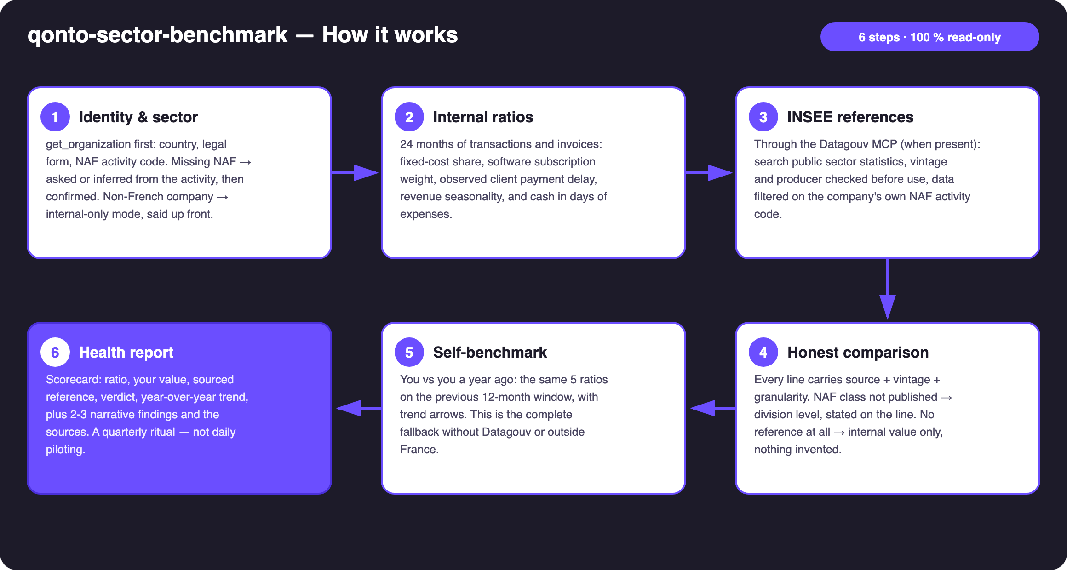
Diagram 1 — How it works, 6 steps (100 % read-only)
Holds up on messy data
- The golden rule: source + vintage + granularity on every comparison — or no figure at all
- NAF class not published → comparison at division level (62 instead of 62.02A), announced on the very line it affects; no reference at all → internal value only, marked "no public reference found"
- NAF missing from account data → asked or inferred from the activity, and confirmed before use — the sector is never guessed silently
- list_cash_flow_categories returns 403 on the claude.ai connector — classification via recurrence detection + labels instead
- Client payment delay computed on Qonto-issued invoices only (disclosed); SaaS subscriptions: detected list shown, correctable in one sentence
- History < 12 months → seasonality tagged "unavailable" rather than computed on noise · card settlement delays (emitted_at vs settled_at) · pagination ≤ 50 everywhere

🏗 Functional diagram
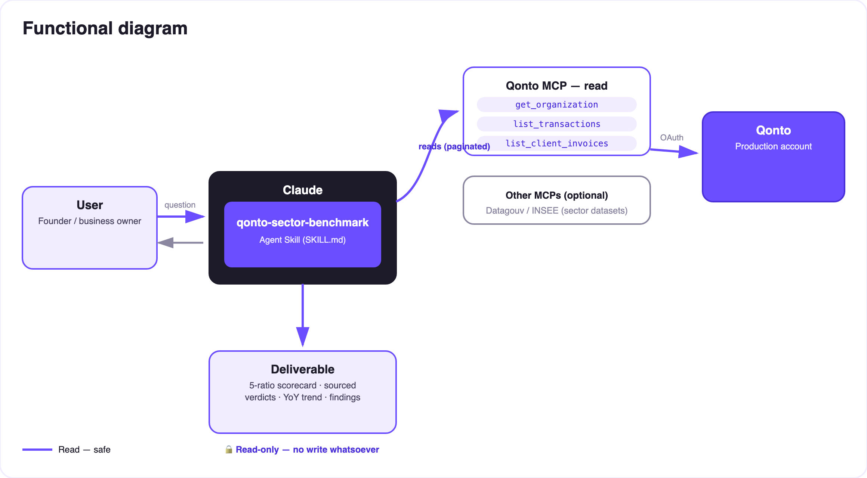
Diagram 2 — Actors and flows: Qonto account + public open data, zero writes
🔒 Zero writes, by design: the skill only reads — the Qonto account on one side, public open data on the other. Nothing to approve, nothing that can move. The only "risk" here is statistical, and it's handled by the golden rule: source + vintage + granularity on every figure, or no figure at all.
📐 The 5 ratios of the check-up
Ratio | Computation (Qonto data) | Sector reference
Fixed-cost share | Recurring debits (normalized counterparty, amount stable ±10 %, ≥ 3 hits) ÷ total debits, 12 months | Cost structure by NAF (INSEE Ésane)
Software subscription weight | Recurrences whose counterparty matches SaaS patterns ÷ total debits — detected list shown, correctable | Order of magnitude by NAF division when published; otherwise internal value only
Client payment delay | Median invoice issue → observed payment (list_client_invoices + transaction matching) | Average payment delays by sector and size, when the dataset exists
Revenue seasonality | Coefficient of variation of monthly receipts over 24 months + peak/trough months | Sector activity indices when available; otherwise self-benchmark
Cash in days of expenses | Consolidated balance ÷ average daily debits (12 months) | Mostly temporal (you vs you) — little reliable public reference, and the skill says so

🏛 The public references used
Reference | What it provides | Known pitfall
INSEE Ésane (structural business statistics) | Margin rates, cost structure, sector ratios — NAF class or division (announced fallback) | Vintage lags 2–3 years — always printed
Payment-delay datasets (data.gouv.fr) | Average/median delays by sector and size — granularity checked via get_dataset_info | Prefer official producers over third-party uploads
Datagouv MCP access chain | search_datasets → get_dataset_info → query_resource_data, filtered on the NAF code | Non-tabular/oversized resource → try another resource, never a number from memory

📤 Output formats
Output | Format | When
Conversation reply | Markdown scorecard: ratio · value · sourced reference · verdict · YoY trend, + findings + sources | Always — the baseline
Interactive scorecard | HTML file/artifact: 5 gauges against the sector ranges, sources footnoted | When the host renders files; fallback to markdown

🎬 Demo video
The ≤ 3-minute demo attached to the PR walks through: the "am I normal?" question → real ratios computed → sourced INSEE references → the reveal (the subscriptions were fine all along; the client payment delays were the real problem) → the final health report. It runs live on a real production account.
💡 Roadmap ideas
Idea | Effort | Note
Size-adjusted references (NAF × headcount/revenue bracket) | Medium | INSEE publishes some breakdowns by company size — an even fairer comparison
Country modules (Destatis DE, INE ES, ISTAT IT…) | High | Same architecture, one open-data connector per country
Check-up history: trajectory across 4–8 quarters | Low | Reuses the self-benchmark engine, simple run memory
Anonymized peer-basket benchmark | High | Beyond the current MCP — a Qonto product idea more than a skill

🛡 Guardrails
- 100 % read-only: no write tool is ever called — nothing to approve, nothing that can move money
- NEVER invents a sector figure: no dataset → the line says so; degraded granularity → announced; vintage always printed
- Bank-data ratios ≠ accounting records: an honest approximation, restated in every report — the accountant's figures prevail
- Sector confirmed, not assumed, when the NAF code isn't in the account data
- A quarterly/annual check-up, not a daily-piloting tool — for day-to-day: qonto-ceo-cockpit
- IBANs masked (last 4 digits) · pagination ≤ 50 everywhere
qonto-sector-benchmark · English documentation · Qonto × Anthropic MCP Hackathon · July 2026 · PR deliverable: SKILL.md · French version: doc-qonto-sector-benchmark.fr.docx

