qonto-invoice-chaser
Chase late invoices without burning the relationship — the chaser that checks the bank before it writes
Qonto × Anthropic MCP Hackathon · Never chases an already-paid invoice · Drafts only, never silent sends

🎯 Why this matters
B2B invoices in France get paid 11+ days late on average — and chasing them is the chore everyone postpones: awkward, repetitive, easy to forget. The skill turns a Qonto account into a collections assistant that never damages a client relationship:
- 1. Overdue detection — late client invoices by due_date, days overdue, total outstanding, aging buckets 0-30 / 31-60 / 60+
- 2. Cross-check against real cash — an "unpaid" invoice may already be paid (transfer outside a payment link): amount / counterparty / reference matching → mark_client_invoice_as_paid proposed, never silent
- 3. Payer profile & graduated reminders — a reliable payer having a bad month ≠ a chronic late payer; courteous nudge ~D+7 → firm reminder ~D+21 → formal notice ~D+45 with legal interest and the €40 recovery indemnity (French Commercial Code, art. L441-10)
- 4. Gmail drafts — when the Gmail MCP is connected, the reminder lands as a draft: the user reviews and sends. Otherwise ready-to-copy text. Nothing ever leaves on its own
Would someone use this on a Monday morning? Chasing receivables IS the Monday-morning chore — this makes it a two-minute review instead of an hour of awkward writing.
📋 Prerequisites
Prerequisite | Detail | Required
Qonto production account | Adapts to any organization — get_organization first, nothing hardcoded | ✅ Yes
Country | Full legal kit (interest + €40 indemnity, art. L441-10): France. Other Qonto countries (DE, ES, IT…): identical graduated reminders, generic reference to EU Directive 2011/7/EU — never invented rates | ℹ️ Detected
Qonto MCP connected | Official connector (claude.ai / Claude Desktop), OAuth login | ✅ Yes
Client invoices in Qonto | The skill reads list_client_invoices; with no Qonto invoicing there is nothing to chase — and it says so | ✅ Yes
Gmail MCP | Optional, detected dynamically: present → reminder drafts; absent → copy-ready text | ⭕ Recommended
Invoicing history | Feeds the payer profile; without it: standard tone + a warning | ⭕ Optional

⚙️ How it works
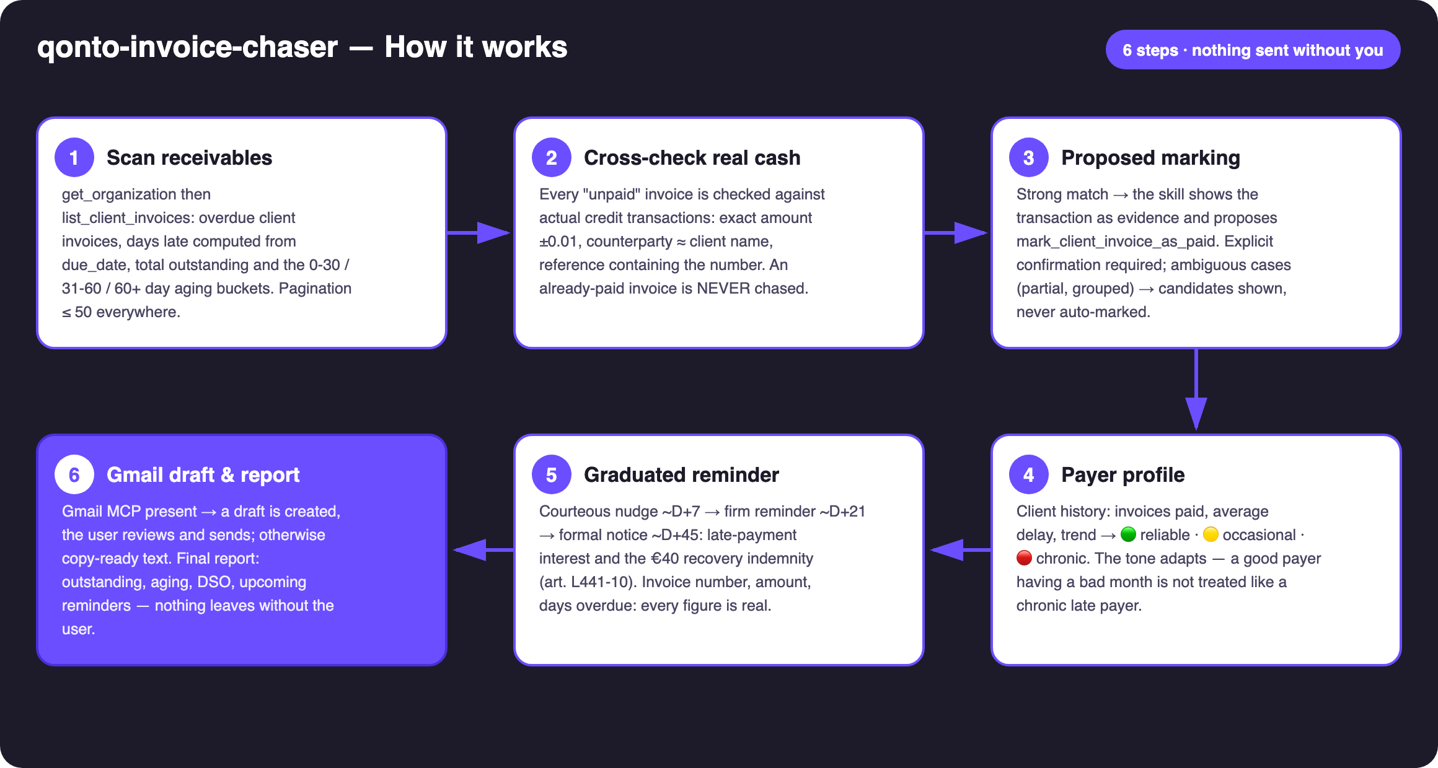
Diagram 1 — How it works, 6 steps (nothing sent without the user)
Holds up on messy data
- The paid-but-never-marked invoice: a transfer received outside a payment link → the list_transactions cross-check catches it (exact amount ±0.01, counterparty ≈ client name, reference containing the number) and proposes the marking with the transaction as evidence
- Partial payment or grouped transfer (one payment covering several invoices): candidates presented with amounts, never auto-marked, never chased blindly
- No payer history for a client: standard tone, stated honestly
- Email missing from the client record: flagged via get_client, with a suggestion to complete it — never a guessed address
- Non-French organization: same graduated reminders, no invented legal rates
- Empty account or no client invoices: the skill says so and stops · pagination ≤ 50 everywhere

🏗 Functional diagram
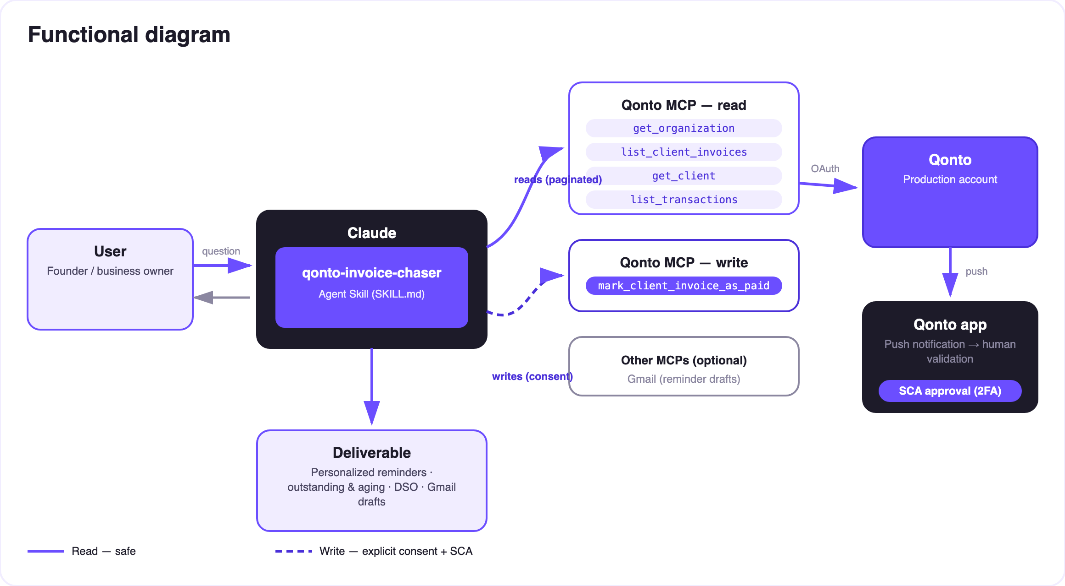
Diagram 2 — Actors and flows: risk-free reads (solid), proposed writes behind consent (dashed)
🔒 The skill writes; the user decides: reads are risk-free; the two writes are proposed actions — marking an invoice paid requires explicit confirmation in the conversation, and the reminder only ever exists as a draft that the user alone reviews and sends. No email leaves without them.
📨 The reminder ladder (France, B2B)
Step | When | Register | Must contain
Courteous nudge | ~D+7 | Warm, assumes oversight | Invoice number, amount incl. VAT, due date, payment means as stated on the invoice
Firm reminder | ~D+21 | Firm, factual | Same + days overdue, reference to the first reminder, announced next step
Formal notice | ~D+45 | Formal, legal | Same + late-payment interest (contract rate, else ECB refi + 10 pts, floor 3× the French legal rate) computed to the day + €40 recovery indemnity per invoice (art. L441-10 & D441-5 French Commercial Code) + payment deadline + registered mail advised

The tone adapts to the payer profile
Profile | Detected from | Effect on the reminder
🟢 Reliable, exceptionally late | Invoices always paid, low average delay | Warmest register, benefit of the doubt ("24 invoices, always paid, avg 5 days late → warm tone")
🟡 Occasionally late | Sporadic delays in history | Standard ladder
🔴 Chronically late | High average delay, repeated reminders | Never the warmest register — but always correct and factual

📤 Output formats
Output | Format | When
Conversation reply | Markdown tables (outstanding, aging, per-invoice action table) | Always — the baseline
Gmail draft | Complete email: recipient, subject with the invoice number, personalized body | When the Gmail MCP is connected; fallback to copy-ready text
Copy-ready text | Subject + body, paste into any email client | Without the Gmail MCP
Interactive dashboard | HTML file/artifact: aging bars, top late clients, reminder pipeline | When the host renders files; fallback to tables

🎬 Demo video
The ≤ 3-minute demo attached to the PR walks through: the problem → the scan + cross-check (an already-paid invoice caught before any reminder) → the payer profile → the draft appearing in Gmail with the exact numbers → the receivables report. It runs live on a real production account.
💡 Roadmap ideas
Idea | Effort | Note
Payment link inside the reminder (create_payment_link) | Low | The client pays in one click from the email — payment links work despite the MCP doc
Per-country legal kits (DE · ES · IT · AT · NL · BE · PT) | Medium | Each country's transposition of EU Directive 2011/7/EU
Scheduled Monday-morning run | Low | The ritual becomes an appointment
Full order-to-cash cycle upstream (quote → invoice → payment matching) | Medium | Feeds the chaser

🛡 Guardrails
- NEVER marks an invoice paid without showing the matching transaction and getting explicit confirmation in the conversation
- NEVER sends an email on its own: drafts by default, direct send only on explicit request — never presented as sent when it isn't
- Below full matching confidence: a question, not an action — chasing a client who paid costs more than asking
- Legal computations are France-only and informative, not legal advice — professional review recommended before a formal notice goes out, registered mail advised
- Rehearsals: fictional client + draft invoices + delete_client_invoice; test Gmail drafts cleaned up
- Masked IBANs (last 4 digits) · pagination ≤ 50 everywhere
qonto-invoice-chaser · English documentation · Qonto × Anthropic MCP Hackathon · July 2026 · PR deliverable: SKILL.md · French version: doc-qonto-invoice-chaser.fr.docx

