qonto-tax-radar
The tax pre-audit that works FOR you — the 8 real DGFIP axes on your Qonto account
Qonto × Anthropic MCP Hackathon · 100% read-only · Every finding sourced

🎯 Why this matters
The number-one fear of French company directors is the tax audit — and nobody knows where they're vulnerable until the letter arrives. The skill flips the roles: it screens Qonto transactions against the 8 verification axes real auditors use, and hands over the report first:
- 1. The 8-axis screen — lavish expenses, personal spending booked as business, director's current account, VAT deducted vs receipts actually on file, benefits in kind, duplicate charges, cash, recurring round amounts
- 2. Sourced findings — every point = a precise transaction + the tax rule cited + a risk level + a corrective action. 'Points of attention', never accusations
- 3. Priced exposure — reclaimable VAT, corporate-tax reintegrations, interest and penalties, as educational orders of magnitude
- 4. Remediation plan — the fixes to make BEFORE the tax office asks, then re-run: the grade improves
Would someone run this on a Monday morning? It's the quarterly 'sleep well' ritual — and priceless the week before the accountant's annual review. And it's the only tax inspector that is fully read-only: it looks, it explains, it de-dramatizes.
📋 Prerequisites
Prerequisite | Detail | Required
Qonto production account | Adapts to any organization — get_organization first, nothing hardcoded | ✅ Yes
Country | 8 axes and cited rules: France (CGI, Code de commerce, CMF). Other Qonto countries (DE, ES, IT…): universal axes only, French articles never cited outside their scope | ℹ️ Detected
Qonto MCP connected | Official connector (claude.ai / Claude Desktop), OAuth login | ✅ Yes
≥ 12 months of history | Below that: partial coverage announced, no invented findings | ⭕ Optional
Write access, consent | None — fully read-only, there is literally nothing to authorize | —

⚙️ How it works
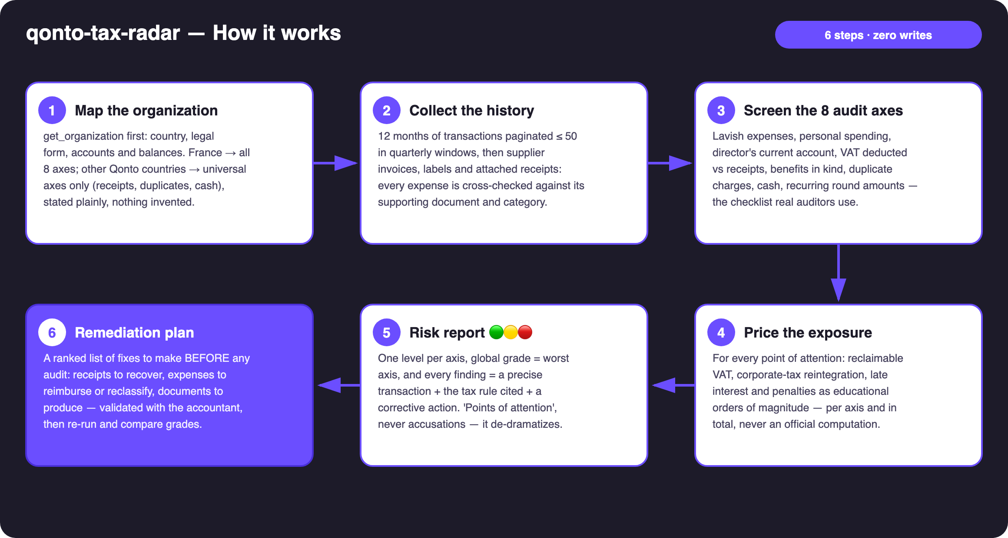
Diagram 1 — How it works, 6 steps (zero writes)
Holds up on messy data
- No labels, no categories → the skill screens raw counterparties and merchant names; a user's own 'perso' label, when present, is surfaced gently
- No attachments anywhere → axis 4 becomes the headline finding with the full VAT amount at stake — that IS the value, not a failure mode
- Detection lives in native fields (attachment_ids, attachment_required, vat_amount); list_transaction_attachments only verifies transactions about to be flagged
- Card patterns read on emitted_at (settled_at lags 1–2 days) · 403 on list_cash_flow_categories → labels fallback · pagination ≤ 50 everywhere
- Empty or young account, non-French company: the skill says what it can and can't verify — false positives are owned up front, in as many words

🏗 Functional diagram
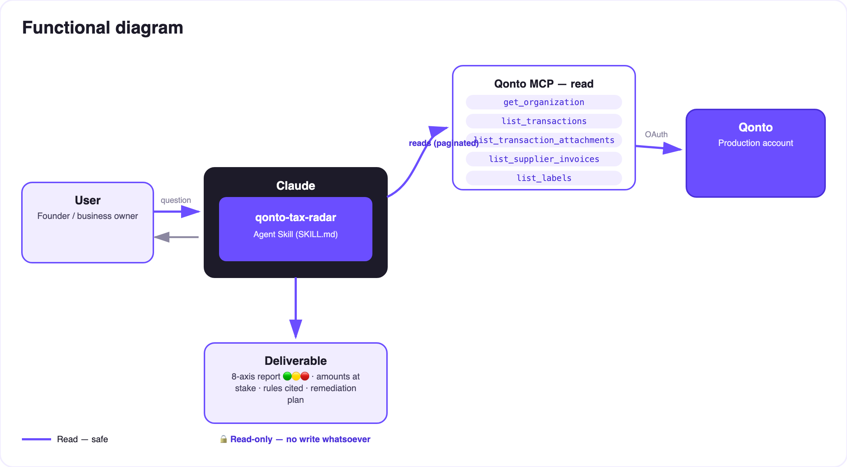
Diagram 2 — Actors and flows: reads only, no write path at all
🔒 Fully read-only — the key point: there are only solid arrows (reads). No write tool is ever called: the skill cannot modify a transaction, set a label, or move a cent. It's the auditor sitting on your side of the desk.
📊 The 8 verification axes (reference grid)
# | Axis | What the skill detects | Rule cited
1 | Lavish expenses | High-end restaurants, travel, gifts above thresholds (VAT on gifts recoverable ≤ €73 incl. tax /yr/beneficiary; statement 2067 if gifts > €3,000/yr) | art. 39-4 CGI; art. 28-00 A ann. IV CGI
2 | Personal spending as business | Weekend purchases, merchants inconsistent with the business purpose, consumer subscriptions | art. 39-1 CGI; abnormal management act
3 | Director's current account | Transfers to personal-looking beneficiaries, back-and-forth flows, debit-balance patterns | art. L223-21 C. com.; art. 111-a CGI
4 | VAT deducted vs receipts | vat_amount > 0 and no attachment on file → VAT deducted with no invoice to show | art. 271 II CGI
5 | Benefits in kind | Vehicle, phone, housing, mixed-use subscriptions with no sign of declaration | art. 82 CGI; BOSS
6 | Duplicate charges | has_duplicates on supplier invoices; same counterparty + same amount within ±72 h | art. 54 CGI; art. 1729 (context)
7 | Cash | Recurring round withdrawals; professional cash payments > €1,000 | art. L112-6 + D112-3 CMF
8 | Recurring round amounts | Regular round transfers to one beneficiary with no matching invoice | art. 54 CGI — burden of proof

🟢🟡🔴 per axis, driven by the count AND the amounts. Global grade = worst axis: a real audit follows the weakest point. Enforced wording: 'point of attention', never 'fraud'.
📤 Output formats
Output | Format | When
Conversation reply | Global banner + 8-axis table + findings detail + remediation plan (markdown) | Always — the baseline
Interactive 'pre-audit notice' | HTML file/artifact: global grade, per-axis gauges, checklist | When the host renders files; markdown fallback
Comparative re-run | Same report, with the grade's evolution | Every re-run — the retention loop

🎬 Demo video
The ≤ 3-minute demo attached to the PR walks through: the fear → launching the pre-audit → findings axis by axis (rule cited on screen) → the report dropping ('2 red flags: €1,430 of VAT deducted with no receipt on file, and 3 expenses to reclassify — fix that this month and your file is clean') → the guardrails. It runs live on a real production account.
💡 Roadmap ideas
Idea | Effort | Note
Assisted remediation: request_attachment_upload + 'to document' labels, behind explicit consent | Low | The writes exist in the MCP — v1 is deliberately read-only, that's the positioning
Country-specific audit grids (DE · ES · IT…) | Medium | Qonto is pan-European; v1 = France + universal axes
Optional multi-MCP enrichment: cross-check axis 4 against invoices in Gmail/Drive | Medium | Detected dynamically — otherwise the skill says so and continues
Grade tracking over time (re-run history) | Low | The retention loop, quantified
9th axis: revenue coherence (paid invoices vs actual inflows) | Medium | Already in the original proposal's DNA

🛡 Guardrails
- Fully read-only: no write tool is ever called — a commitment, not a setting
- Never an accusation: 'point of attention', not 'fraud'; a flagged expense may be perfectly legitimate — the skill may under- or over-estimate for lack of context, and says so
- Not tax advice, not the administration's position: educational simulation, accountant validation recalled in every report
- Non-French org → universal axes only, French articles never cited outside their scope
- IBANs masked (last 4 digits), sensitive names masked in any export · pagination ≤ 50 everywhere
qonto-tax-radar · English documentation · Qonto × Anthropic MCP Hackathon · July 2026 · PR deliverable: SKILL.md · French version: doc-qonto-tax-radar.fr.docx

