qonto-accountant-handoff
The monthly handoff to your accountant, minus the chore — the complete pack, prepared from the Qonto account
Qonto × Anthropic MCP Hackathon · Zero writes on Qonto · Drive filing + Gmail draft — never auto-sent

🎯 Why this matters
Every month, the same message: “could you send me March's documents?” — followed by an evening of digging through emails and download folders. The skill builds the complete handoff pack straight from the Qonto account:
- 1. Statements & invoices, gathered — the period's official statements (list_statements / get_statement) plus every client and supplier invoice, with statuses
- 2. Receipt completeness report — each transaction checked against its attachments: ✅ attached · ⚠️ missing · ➖ not needed, with the precise list of what's missing (date, counterparty, amount)
- 3. Annotated, never booked — labels, VAT, factual notes (“this refund corresponds to the May 12 payment”); no accounting entry is ever invented — the accountant stays the professional
- 4. A drafted handoff letter + organized filing — the month in ten lines, the attention points, the open questions; a YYYY/MM tree on Google Drive plus a recap email draft via Gmail
Would someone use this on a Monday morning? It's literally the first Monday of the month — and the first time it ran, the accountant asked if someone new had been hired.
📋 Prerequisites
Prerequisite | Detail | Required
Qonto production account | Adapts to any organization — get_organization first, nothing hardcoded | ✅ Yes
Country | Works for every Qonto country — statements, invoices and receipts are universal. Local tax remarks only when detected, never invented rules | ℹ️ Detected
Qonto MCP connected | Official connector (claude.ai / Claude Desktop), OAuth login | ✅ Yes
A closed month | Statements only exist once the month is over; in-progress month → partial pack, stated plainly | ℹ️ Detected
Google Drive MCP | For the YYYY/MM filing tree — otherwise a structured local pack (markdown + CSV) | ⭕ Optional
Gmail MCP | For the recap email draft to the firm — otherwise the letter stays in the pack | ⭕ Optional

⚙️ How it works
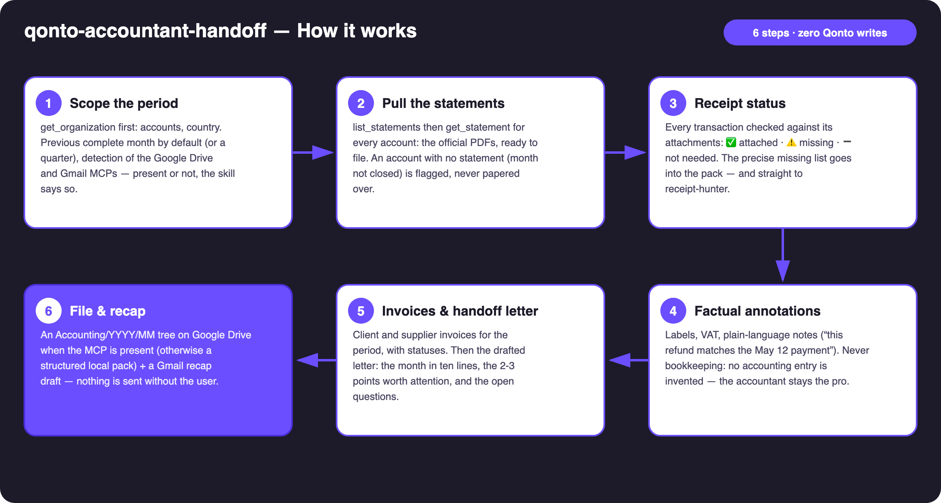
Diagram 1 — How it works, 6 steps (zero writes on Qonto)
Holds up on messy data
- Month not closed yet: a partial pack, clearly labelled, statements listed as “pending month close” — never presented as complete
- Missing receipts: the headline of the letter, not a footnote — precise list (date · counterparty · amount) + a pointer to qonto-receipt-hunter
- Untagged VAT: the VAT view is announced as a floor, with the count of untagged debits disclosed
- Refunds and internal transfers: matched and named factually, never allocated to an account
- No Drive/Gmail: the same pack lands as a structured local folder — the skill says so and carries on
- Pagination ≤ 50 everywhere · card settlement delays (emitted_at vs settled_at) handled at month boundaries · masked IBANs

🏗 Functional diagram
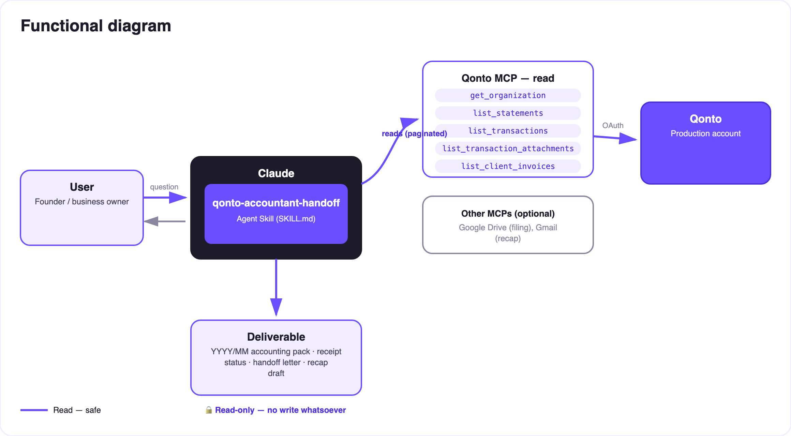
Diagram 2 — Actors and flows: read-only on Qonto; Drive filing and Gmail draft on the user's side
🔒 Zero writes on Qonto: on the Qonto side, everything is a read — nothing to approve. The only two “writes” happen on the user's side: a folder filed on THEIR Google Drive (announced first) and a DRAFT in THEIR Gmail — the user always hits send themselves. And the skill does not do the accounting: factual annotation only, the accountant stays the professional.
🗂 What's in the pack
Item | MCP source | Shape in the pack
Handoff letter | Drafted by the skill (from the data it read) | 00-handoff-letter — markdown + Gmail draft body
Bank statements | list_statements + get_statement | 01-statements — official PDFs per account
Client invoices | list_client_invoices | 02-client-invoices — list + statuses (paid / pending)
Supplier invoices | list_supplier_invoices | 03-supplier-invoices — list + statuses
Receipt status | list_transactions + list_transaction_attachments | 04-receipts-status — coverage table + missing list (CSV)
Annotated transactions | list_transactions (labels, VAT, factual notes) | CSV/markdown attached to the status

📤 Output formats
Output | Format | When
Conversation reply | Markdown tables: pack contents, coverage, missing list, the letter | Always — the baseline
Google Drive folder | Accounting/YYYY/MM tree: letter, statements, invoices, receipt status | When the Drive MCP is detected — filing announced first
Gmail draft | Recap email to the firm, letter as body, link to the folder | When the Gmail MCP is detected — never sent by the skill
Local pack | Structured folder of markdown + CSV, described file by file | Without Drive/Gmail

🎬 Demo video
The ≤ 3-minute demo attached to the PR walks through: the monthly chore → the pack building itself (statements, invoices, missing receipts listed) → the factual annotations and the letter → the Drive tree filling up + the Gmail draft → the local fallback. It runs live on a real production account.
💡 Roadmap ideas
Idea | Effort | Note
Automatic chaining with qonto-receipt-hunter | Low | The missing list goes straight to the receipt chase before the handoff
qonto-monthly-close verdict embedded in the letter | Low | The closed month's quality check, as a badge
Normalized CSV export for the firm's software | Medium | The format changes, the facts don't
Start-of-month reminder (calendar MCP detected dynamically) | Low | Optional multi-MCP enrichment, in the spirit of the kickoff
Pack history + open-question tracking | Medium | March's question doesn't get lost again in June

🛡 Guardrails
- The skill does NOT do the accounting: no journal entries, no chart-of-accounts allocation, no tax advice — factual annotation only, the accountant validates everything
- Nothing leaves without the user: the Gmail recap is a draft, the Drive filing is announced, no data flows to an MCP that wasn't detected and named
- A pack with missing pieces is NEVER presented as complete — the missing list leads the letter
- Masked IBANs (last 4 digits) · pagination ≤ 50 everywhere · 403 on list_cash_flow_categories → label fallback
qonto-accountant-handoff · English documentation · Qonto × Anthropic MCP Hackathon · July 2026 · PR deliverable: SKILL.md · French version: doc-qonto-accountant-handoff.fr.docx

